

Ethan Stainsby   
Darrick Wood School   
2025

Skybound Natural Aptitude and Future Aptitude Selection Tool (FAST) Practise Test

Contents

1

Analysis 6

Problem Identification 6

Why it is suited to a computational solution 6

Computational Methods utilized by the solution: 7

Stakeholders 8

Interview 10

Interview results 13

Research 19

Similar Solutions 19

Proposed Solution 25

Requirements 27

Hardware Requirements 27

Software Requirements 27

Stakeholder Requirements/Inputs 27

Success Criteria 28

Design 31

Top-Down design 31

Overall – Decomposition, Explanation and Justifications 31

Plane Minigame – First Decomposition 34

Pseudocode Algorithms 61

Plane Minigame 61

Active Reasoning Challenges 62

Report 64

Difficulty 65

Terrain + Event Rendering 65

Passive Recall Questionnaire 68

How these algorithms form a complete solution: 69

Analysis of Object-Oriented Design, Key Variables and Data Structures 69

Class Diagrams 69

Data Structures 73

Key Variables 74

Product Design 76

Branding Designs 83

Colour Scheme 84

Accessibility and Usability 84

Test Plan 86

Iterative (White box) Testing and Test Data 86

Post-development Testing 87

Implementation and Testing 95

Plane Minigame 95

Setup, Plane, Movement, and main. 95

Clouds pt1 98

Hitboxes 109

Difficulty 119

Menu 119

Clouds pt2 130

Information Button 132

Active Reasoning Challenges 135

Databases and Main 135

Terrain + Event Rendering 151

Events – Background and Terrain 151

Events – Aircraft 157

Events – Waypoints 166

Important Note about the Design vs the Implementation 179

Buttons 180

Flashing Lights 191

Events – Further Waypoint Interaction 194

Finishing Event Additions 201

Passive Recall Questionnaire 207

Question Form 207

Report 220

Data Report/Foundations of the Report 220

Report Navigation and Adaptations 226

Post-Development Testing 232

Test Data for Function and Robustness 232

Final Testing 242

Stakeholder Testing 247

Evaluation 251

Criteria 251

Success Criteria 251

Evidence 253

Usability Features 260

Difficulty 260

Information Button 261

Report 262

Limitations 263

How I could address partially/unmet criteria and usability features 264

System Maintenance 272

Future Updates 273

Code Appendix 274

Plane Minigame 274

PM_setup.py 274

PM_plane.py 275

PM_clouds.py 276

PM_hitbox.py 276

PM_main.py 277

Active Reasoning Challenges 278

ARC_button.py 278

ARC_DB.py 279

ARC_main.py 282

Passive Reasoning Challenges 284

PRC_main1.py 284

Terrain + Event Rendering 286

TER_aircraft.py 286

TER_buttons.py 287

TER_lights.py 288

TER_main.py 289

TER_setup.py 293

TER_waypoints.py 294

Difficulty / GUI 295

button.py 295

DifficultyMain.py 296

File Organization 298

__pycache__ 298

Active Reasoning Challenges 298

Plane_Minigame 299

TerrainEvent_Rendering 300

UI_Sprites 302

Bibliography 302

# Analysis

## Problem Identification

Integrated flight schools have a challenging and specific application process, testing a large variety of soft and hard skills, such as standard physics and maths tests, personality tests, and finally, the biggest dream-killer, the Multi-Tasking and Natural Aptitude tests: soft skill test which is designed to test your multi-tasking and observation skills to its limits.

After conversing with many attendees of these flight schools, pilots that had graduated, and inspired applicants, it was clear that there were no programs which could help simulate the specific activities of the tests given, and that nearly all applicants cannot prepare due to the lack of readily accessible aptitude tests.

The FAST is a common example of this, used by one of the most popular flight schools in the world – CAE. In most versions of the FAST, multiple tasks occur simultaneously in an abstracted cockpit’s view. The user can only see out of the front window, where waypoints or planes will appear in the distance, requiring button presses labelled “waypoint” and “airplane” respectively. A simple arrow-key game which involves guiding an airplane to avoid clouds –comparable in difficulty and resolution to ‘Snake’. Simple maths questions will occupy the right quarter, where you must complete several questions by the end to pass, and finally there is a set of 4 small, red lights in the middle of the screen, which flash at random, and you must take count of the number of flashes throughout the exam.

After 3-5 minutes of the simulator, a questionnaire which will recall parts of the exam, such as details of a waypoint, the number of flashes from the lights, etc. The exam is then repeated, and your scores from both will be compared, where your second result must show improvement from your first whilst remaining above a threshold.

Currently, those who want to join the “Generation EasyJet MPL”, which is an integrated school program which easyJet themselves interview and tag all students of (upon passing extenuating tests) must perform this FAST test, and currently, there are no free programs which allow students to practise this.

### Why it is suited to a computational solution

A computational solution would be ideal for this problem as the FAST is a digitised test, therefore users aiming to practise the test would likely wish that they are practising something as close as possible to the actual exam. Creating the system computationally would also allow for easy global access, as those that wish to use the software can easily access and download it at their own leisure onto their own device.

### Computational Methods utilized by the solution:

#### Abstraction

Abstraction is used when rending the terrain view from the cockpit. Constantly rendering an ever-growing large scene will be very physically demanding, so I will only model very low polygon terrain: consisting of only mountains made as large pyramids, city terrain featuring very few modelled cuboids, with the rest of the “city” being 2d squares in the background to give the illusion of constantly modelled terrain. All textures for the terrain will also be low bit.

#### Problem Recognition

The problem identified for the project is to provide users with software to practise their soft skills for the FAST, however the problem which requires solving is to ?????

#### Problem Decomposition

The software can be decomposed into several sections which can be created separately, a general idea of the base-level decomposed problems is:

1. Create the arrow-key dodging cloud game to play in the bottom left quarter of the screen during the exam.
2. Use the random module to output a large dataset of simple maths questions and solutions.
3. Program “flashing” red lights to randomly alight during the exam.
4. Create the moving terrain with random waypoints and planes for the front cockpit view.
5. Add the input buttons for the waypoints and planes.

When these basic steps are created and put together, we should have a very accurate running program included with all the basic simulations of the actual test.

#### Divide and Conquer

The smaller steps showed above show the general idea of how I would divide the whole solution into still complex, however doable steps to conquer. We could slightly further divide each individual bullet point as such:

“Create the arrow-key dodging cloud game to play in the bottom left quarter of the screen during the exam.”

1. Create a movement system for the plane by utilizing the arrow keys to move up or down and left and right.
2. Create a system to fairly generate clouds sequentially so that the plane can dodge them with relative ease.
3. Create a collision system with the plane to register when the plane and clouds contact.

“Use the random module to output a large dataset of simple maths questions and solutions.”

1. Create a large 2D dataset of simple maths questions with solutions.
2. Create a function to pull random questions from this dataset and output them.

“Program ‘flashing’ red lights to randomly alight during the exam.”

1. Create simple graphics to imitate how a red alarm would look.
2. Use the random module to change the graphics into a similar graphic which looks evidently alight.
3. Ensure that the lights do not flash too often, or too many times overall.

“Create the moving terrain with random waypoints and planes for the front cockpit view.”

1. Create simple terrain using a 3d modelling software for a city, mountainous area, and plains.
2. Program a random terrain generator.
3. Program a separate generator to place a waypoint or airplane in view.

“Add the input buttons for the waypoints and planes.”

1. Create two obviously different graphics for the buttons.
2. Allow the inputs of the buttons to be recorded separately.

These are still only scratching the surface of the decomposition that can be done, as each of these steps can further be divided and then conquered, easing the process of creating the software by splitting them into simple, easy tasks that can be checked off to contribute to the overall product / solution.

## Stakeholders

The demographic for this project would be aspiring pilot cadets, specifically those considering entering an integrated flight school. Luckily, the clients of this project comprise of a wide variety of ages and experience with flying. I will be asking three friends I have met who are interested in applying for the CEA MCL integrated course, and then a few friends who are interested in general aviation / separate paths in the industry.

|  |  |  |
| --- | --- | --- |
| Stakeholder | Demographic | Availability |
| Zhang | * 38 years old * Wants to apply for the CEA MCL Integrated course * Previous flight attendant for 10 years * Applied to CEA ATPL course 19 years ago | Weekly |
| Jack | * 16 years old * Wants to apply for the CEA MCL Integrated course * No aviation experience * Not applied anywhere yet | Daily |
| Liu | * 17 years old * Wants to apply for the CEA MCL Integrated course * Demo flights * Not applied anywhere yet | Daily |
| Tolupe | * 16 years old * Interested in the aviation industry * Only experience in air cadets * Not applied anywhere | Weekly |
| Tiffany | * 16 years old * Interested in the aviation industry * Only experience in air cadets * Not applied anywhere | Weekly |
| Isaac | * 17 years old * Interested in aerospace engineering * Demo flight * Applying for university courses | Daily |

### Interview

#### Interview questions

The interview questions outlined in this section will vary depending on the demographic targeted, and during the interview I may ask follow-up questions to further delve into a topic I believe will be interesting for the project

##### Commercial Cadets

The question for the clients who are looking to apply for the CEA MCL integrated academy (Zhang, Jack and Liu) are as follows:

1. How are you preparing for the entrance exams to CEA?
2. Do you know of the contents of the FAST test? (if not, it will be explained to them)
3. Are you worried about the Natural Aptitude tests you will be given?
4. Are you satisfied with the current resources to help you prepare for the FAST / similar tests?
5. What features of the FAST do you believe help prove a person’s aptitude for being a commercial pilot?
6. When have you had to use the skills demonstrated in the FAST?
7. Do you have any measure of improvement when practicing aptitude tests?
8. How accurate do you require the solution to be compared to the actual FAST exam, and what features would you like to differ or stay the same?

Questions 1 and 2 generally scout the level of preparation the cadets have been doing, inquiring about the methods of their revision for the application process, which includes a few personality tests, maths and physics exams at GCSE level, a few non-verbal reasoning tests, and finally the FAST / Natural Aptitude test. By analysing their preparation, we can see how likely they are to need help practising the FAST to ensure their interview.

We can use questions 3 and 4 to examine their satisfaction and confidence about the exam, understanding these can show us whether they appreciate the test’s skill focus and help us ensure our solution aligns with the actual skills evaluated.

Question 5 and 6 identifies prior instances they have had to apply the relevant skills trained in the solution and delves into their perception of the FAST’s relevance to pilot aptitude, emphasising to them the value of the program as they realise what they can improve in their day-to-day life and pilot aptitude by using our software.

Questions 7 investigates trackable metrics they’ve been set when/if they have been practising aptitude tests, which can be useful to gauge how they measure their own progress and what methods help them improve.

Question 8 asks their expectations for a practise solutions accuracy relative to the actual FAST exam, this reveals their preferences which can allow me to adapt my solution to the likings of the people that will actually use it, and creating a solution tailored to their requirements.

##### General Aviation Students

These will be questions for those interested in the aviation industry in general, but not any specific roles (including Tolupe and Tiffany.) The project will be explained to them before the questions:

1. Are you interested in piloting any aircraft for the industry?
2. If so, which aircraft are you interested in piloting? And would these aircraft require many natural aptitude tests to start learning?
3. Do you believe that skills such as multitasking and time management are important life skills?
4. How would you rank the following skills in importance: multitasking, time management, memory recall, adaptivity, problem solving, and focusing under pressure?
5. Would you like any features of the software to be prioritised over others as a result of your rankings?

Questions 1 and 2 help understand the student’s interest in piloting specific aircraft outside of commercial planes, showing us if there is value in developing aspects that simulate a variety of aviation scenarios and different aircraft, even for users not directly preparing for aptitude exams.

Questions 3 and 4 focus on essential life skills such multitasking, time management, and adaptability, skills useful both inside and outside the cockpit. By ranking these skills, students will indicate which areas are valuable to them, and thus which features we must curate and train more in the solution, and question 5 outright asks for their inputs as a result of their rankings, helping us create a program with versatile benefits, enhancing its appeal to general aviation students interested in improving skills which are broadly useful.

##### Aerospace Engineering Students

I will ask the previous questions for ‘general aviation students’ to our aerospace engineering students as I believe there is significant overlap in demographic in regard to the project. On top of this, I will ask some more specific questions specifically targeting features of the aerospace industry for Isaac, including:

1. What aspects of the aerospace industry do you find challenging or exciting?
2. What key factors must you consider when designing or improving aircraft?
3. How important is the relationship between the pilot and engineers during the design process?
4. What design considerations are most critical when creating user controls for pilots?

Question 1 explores their personal interests within aerospace, helping to align program features with elements they find compelling.

Questions 2 and 3 get an input on how and why the FAST tests specific skills like multitasking, time management, and problem-solving. Understanding these aspects from an engineer’s perspective helps us gain valuable input on the design standards engineers adhere to, clarifying the thought process behind these skill focuses, and shows us how to design features which align closely with real world aviation requirements.

Question 4 addresses usability from an engineering perspective, guiding the program to focus on interface design, ergonomics, and user experience.

We are clearly limited by the lack of experience our engineer has; however, Isaac has had a heavy passion for aircraft and their cockpits since very young, visiting many flight simulators and taking a flying lesson in a light aircraft, which I believe justifies the complexity of the questions.

### Interview results

#### Commercial Cadets

##### Zhang

1. **How are you preparing for the entrance exams to CEA?**

“I have been taking basic GCSE level physics and maths courses in preparation for the knowledge exams, and have been doing online non-verbal reasoning papers to practise for the pattern-recognition exams.”

1. **Do you know of the contents of the FAST test? (if not, it will be explained to them)**

“I have heard of the FAST through some colleagues, who mention how stressful it is”

1. **Are you worried about the Natural Aptitude tests you will be given?**

“I am slightly worried about them, however I hope my multi-tasking skills from being a flight attendant will help carry me through them.”

1. **Are you satisfied with the current resources to help you prepare for the FAST / similar tests?**

“I am not satisfied, as I have found very little resources help practise the specific tasks of the FAST for a reasonable price.”

1. **What features of the FAST do you believe help prove a person’s aptitude for being a commercial pilot?**

“Generally the FAST does test very relevant skills needed to be a pilot, such as multitasking and splitting your focus, problem solving, fast reactions and the ability to improve and adapt.”

1. **When have you had to use the skills demonstrated in the FAST?**

“Often during flights, many passengers would give me separate tasks at the same time, from ordering more food or requesting help with their seats, I had to demonstrate my ability to multi-task everyday on the job.”

1. **Do you have any measure of improvement when practicing aptitude tests?**

“I unfortunately do not have any access to practising aptitude tests so I couldn’t tell you.”

1. **How accurate do you require the solution to be compared to the actual FAST exam, and what features would you like to differ or stay the same?**

“I think as long as your project generally encompasses the basic skills required for taking the test, it should be very useful. For features, I would like different difficulty modes, so I can work myself up to the required amount.”

##### Jack

1. **How are you preparing for the entrance exams to CEA?**

“I have kinda just been using microsoft flight simulator in my spare time and hoping that ticks the boxes for like the skills tests”

1. **Do you know of the contents of the FAST test? (if not, it will be explained to them)**

“is that the test which they test your pilot skills?” (he did not know the FAST)

1. **Are you worried about the Natural Aptitude tests you will be given?**

“yeah it does sound quite worrying tbh *(to be honest)* but im hoping my microsoft flight sim skills will carry me through it”

1. **Are you satisfied with the current resources to help you prepare for the FAST / similar tests?**

“not really” “I have found like a few like flying simulator websites I could use but some ones like flighttest cost like 100 quid”

1. **What features of the FAST do you believe help prove a person’s aptitude for being a commercial pilot?**

“all the multi-tasking skills are useful for pilots because if something goes wrong youll need to manage that and still fly”

1. **When have you had to use the skills demonstrated in the FAST?**

“I guess when I play overwatch I have to consider like my teams status, my cooldowns, my positioning and stuff”

1. **Do you have any measure of improvement when practicing aptitude tests?**

“nope”

1. **How accurate do you require the solution to be compared to the actual FAST exam, and what features would you like to differ or stay the same?**

“to be honest I don’t think it needs to be that accurate” “if it helps practise similar skills it should be fine”

##### Liu

1. **How are you preparing for the entrance exams to CEA?**

“I am doing a lot of work revising gcse content”

1. **Do you know of the contents of the FAST test? (if not, it will be explained to them)**

“I have heard about the test in an open day” “it is the aptitude one correct?”

1. **Are you worried about the Natural Aptitude tests you will be given?**

“yes I am very worried” “apparently it is the hardest test out of all academic tests”

1. **Are you satisfied with the current resources to help you prepare for the FAST / similar tests?**

“I think there is only paid resources no?” “no I am not happy with the content available.”

1. **What features of the FAST do you believe help prove a person’s aptitude for being a commercial pilot?**

“like probably all of them” “like hand eye coordination, basic maths, identification skills and yeah”

1. **When have you had to use the skills demonstrated in the FAST?**

“I guess I use them all the time, like when identification skills when I look at anything”

1. **Do you have any measure of improvement when practicing aptitude tests?**

“no as I do not have any aptitude practise content”

1. **How accurate do you require the solution to be compared to the actual FAST exam, and what features would you like to differ or stay the same?**

“probably the closer the better” “like the general UI should be pretty similar with all the stuff in the same place so you get used to it”

##### Conclusions

The interviews that the candidates for the MCL Integrated Academy face challenges in preparing for the FAST test due to limited resources, high costs and a lack of practise options. Zhang, Jack and Liu each expressed concern about the test’s difficulty, especially in terms of multitasking, problem-solving, and hand-eye coordination – skills they all recognise as essential for pilot aptitude. While Zhang and Liu have pursued some preparation through GCSE level practise, Jack relies on flight simulators, which may not be the most optimal practise methods, revealing a varied gap in preparation guidance. All candidates noted dissatisfaction with available resources, highlighting the need for a more affordable, targeted preparation tool.

Key recommendations for the practise solution include customisable difficulty settings, interface elements similar to those of the FAST test, and progress-tracking features to help users monitor improvement. Such features would help candidates build confidence in the required skills and bridge the current gap in accessible, effective preparation.

#### General Aviation Students

##### Tolupe

1. **Are you interested in piloting any aircraft for the industry?**

“I’ve been looking at piloting in the RAF”

1. **If so, which aircraft are you interested in piloting? And would these aircraft require many natural aptitude tests to start learning?**

“I m interested in piloting for rotorcopters, I believe when you are in the RAF they will choose those with the highest scores in aptitude tests to be put forward.”

1. **Do you believe that skills such as multitasking and time management are important life skills?**

“Definitely, my mum always shouts at me for not doing my chores on time, and if I had better time management skills, I could probably avoid those situations”

1. **How would you rank the following skills in importance: multitasking, time management, memory recall, adaptivity, problem solving, and focusing under pressure?**

“I would probably rank problem solving, time management and memory recall as the main priorities, and the rest in no particular order yet not that far behind”

1. **Would you like any features of the software to be prioritised over others as a result of your rankings?**

“I think you should ensure that the lights on the little dashboard thing don’t flash too frequently, as it is important that there is a balance between trying to force the user to memorise so many impossible little things, and ensuring it is just challenging enough that they can still feasibly do it and manage the other tasks at the same time”

##### Tiffany

1. **Are you interested in piloting any aircraft for the industry?**

“I am interested in the path of piloting, but I am unsure of any specifics.”

1. **If so, which aircraft are you interested in piloting? And would these aircraft require many natural aptitude tests to start learning?**

N/A

1. **Do you believe that skills such as multitasking and time management are important life skills?**

“yes definitely, balancing my personal life and academic life can be a struggle, but the scheduling aspect of it is essential to keeping stress-free and balancing my hobbies.”

1. **How would you rank the following skills in importance: multitasking, time management, memory recall, adaptivity, problem solving, and focusing under pressure?**

“I believe you cannot blanky list the skills in importance, as it really depends on what the task requires, If I were assuming you were piloting an aircraft, I would say problem solving/adaptivity and focusing under pressure are the main skills, as in the event of an emergency, everyone will turn to the pilot to solve it swiftly and successfully.”

1. **Would you like any features of the software to be prioritised over others as a result of your rankings?**

“I don’t think you need to prioritise any features because of those events, because the FAST doesn’t really account for errors and emergencies, but only tests your multi-tasking, so I think you can just keep it the same and balanced throughout.”

##### Conclusions

The interviews with the general aviation students reveal differing perspectives on skill priorities and software features for a pilot preparation tool. Both agree that life skills like multitasking, time management, and problem-solving are essential, however their emphasis on these skills varies. Tolupe highlights problem-solving, time management and memory recall as top priorities, suggesting that whilst these are the most important skills, this does not translate as to overloading those aspects of the program, and to instead ensure that they are challenging yet manageable. Tiffany, while interested in piloting, believes that skill importance is task dependant, and that the FAST should remain a balanced, consistent test.

#### Aerospace Engineering / Systems Students

##### Isaac

1. **What aspects of the aerospace industry do you find challenging or exciting?**

“I think adapting to modern technology and creating new solutions as a result is the most interesting part.”

1. **What key factors must you consider when designing or improving aircraft?**

“You must consider aerodynamics, weight etc. but ensuring that the pilot of the aircraft is capable of conveniently accessing all controls, similar controls being grouped together, everything being labelled correctly etc is equally as important.”

1. **How important is the relationship between the pilot and engineers during the design process?**

“There isn’t much interaction between the pilot and engineer during the design process, however there are general guidelines given by pilots historically which are heavily considered when designing the cockpits and such.”

1. **What design considerations are most critical when creating user controls for pilots?**

“Again, I guess the main considerations are convenient access of often used controls, and especially easy access and usability of emergency systems. Further user controls such as dials and reports must all be visible at once for safety etc.”

##### Conclusions

Isaac emphasises that while factors like aerodynamics are important, pilot-centered design is equally important, controls must be logically grouped, clearly labeled, and easily accessible. Though pilots are not directly involved in the design of aircraft, their feedback has historically influenced cockpit layouts, usability and safety priorities. Key considerations include convenient access to frequently used controls, clear visibility of instruments etc. This shows that the layout / format of the solution must be very similar or near identical to the actual FAST, as aircraft are often designed similarly to allow for easy transitions for specialized pilots, so the easy translations from practise test and actual must be seamless, at least in terms of which similar activity is placed; such as the maths part should be placed in the same place as in the actual exam.

## Research

### Similar Solutions

#### Symbiotics “Future Aptitude Selection Tool (FAST) Practise Test”

##### Analysis

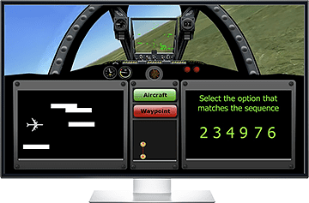Symbiotics are the providers of the FAST test that CAE uses to measure pilot aptitude in the entrance exam process. It tests your ability to “measure a dynamic environment.” This solution is identical to the actual test, as it is the same program. It consists of a 15~ minute attempt of the test, in which you must manage the four sections of the exam including low gcse level maths problems, a simple retro arcade game, identifying waypoints and airplanes and counting flashes of light as shown in the image.

As you can see, it features a view from a simplistic cockpit with about a 180-degree view of a low-resolution rendered landscape, in which the said waypoints and airplanes may appear. Every feature included in this solution is identical to the features of the test from start to finish. There are 2 phases in each attempt, both being identical to one another and consisting of the game above for 5~ minutes, then a test will ask you for details of your time, such as waypoint information, the number of flickers the two red lights show etc.

the FAST during the middle of the exam.

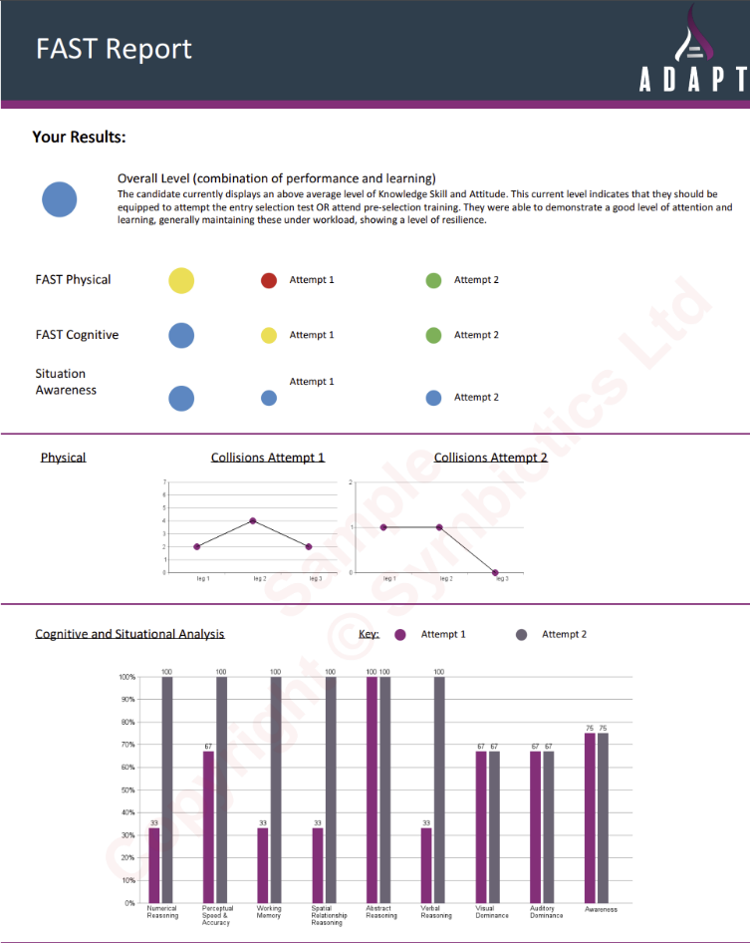The FAST practise tests also come with a report which summarizes your level in the individual sections tested against your own two attempts, and against a database of other participants to give you a vague rating system including “High”, “Above Average”, “Average”, “Below Average”, and “Low”, which they have determined from a sample of participants.

The image to the left shows a portion of the “FAST Report” given to the user after a practise test. It gives the user a summary of their result per section using different graphical visualizations to show the comparison of results between the attempts. In the exam, you will be expected to get an “Overall Level” of ‘Average’ or above, and show reasonable improvement throughout the sections.

the FAST Report given after each test

##### **Limitations – Accessibility and Usability – and how I will improve them**

Whilst the “Future Aptitude Selection Tool (FAST) Practise Test” by Symbiotics is the provided resource for helping you practise the FAST, its limitations eliminate a huge portion of the target audience. Limitations such as cost, static difficulty, and being hard to decipher whether you would have passed or not can impact the number of customers and could be the difference between users passing the actual exam or not.

**Cost and Accessibility**

The software costs £42.00 to use, and upon payment, you will receive 15 attempts at the FAST Practise Test, which is the same test, but it will only allow you to take it 15 times before you will either be blocked from the service or must pay another £42.00 pounds. After purchasing you will also have only 3 months to complete the 15 attempts, after that, they will expire. This limits the target audience significantly, adding such a high-cost barrier ensures only those with significant money to practise, but they only get such a limited number of attempts and a short timeframe for using it which only further dissuades lower income parties from purchasing.

I aim to improve upon this in my solution by removing the cost barrier entirely. This also eliminates issues of the limited timeframe users get access to the FAST Practise test, and the limited number of attempts. Creating my solution to be free ensures that those who want to practise for the exam are able to, with no worries about conforming to deadlines or using too many attempts.

Another issue with accessibility is the requirements to run the practise test. Symbiotics require you to have a stable “internet connection”, and the “latest chrome web browser” This also will severely limit the audience capable of running / using the software, as not all interested parties will have access to high-speed internet, or the latest chrome web browser.

I will solve these issues by making my solution downloadable software with no connections to anything internet based, such as domains. This ensures that the user will not need the latest chrome web browser, as my solution will be application-based and not browser based, also ensuring you do not need an internet connection as all programs will be completely downloaded on the client’s device.

**Static Difficulty**

The FAST Practise test does not offer adaptive difficulty settings, meaning that a few of the 15 given attempts per purchase will be spent attempting to adapt to the entire test’s difficulty, and the practise test also has an identical pattern and features between each attempt. This means that in the users’ paid 15 attempts, each and every attempt will be identical to every other attempt, yet in the actual test, the pattern is different. As suggested by one of our stakeholders, creating varying difficulty levels in our solution will be of significant help to the users, allowing them to build up their familiarity with the test before needing to attempt the test at full difficulty.

**Understandable Reports**

For first time users, the extensive report delivered by Symbiotics may be very overwhelming. On top of this, users have no idea whether the scores they have received would translate into a Pass in the actual exam. We will improve on this in our solution, aiming to use the practise exam’s gradings to predict whether the user would pass the actual exam or not, and how close they are to failing. This will allow the user to know directly how confident their pass/fail was, and indicate to them how much more practise they require.

##### Branding

The Symbiotics branding combines the “Balboa Plus-Fill” font and a carefully chosen colour pallet to convey professionalism, reliability and a modern edge – key traits for an aviation-focused brand. The bold and geometric style of the font aligns with the industry’s focus on precision and clarity, making the logo strong and easily readable.

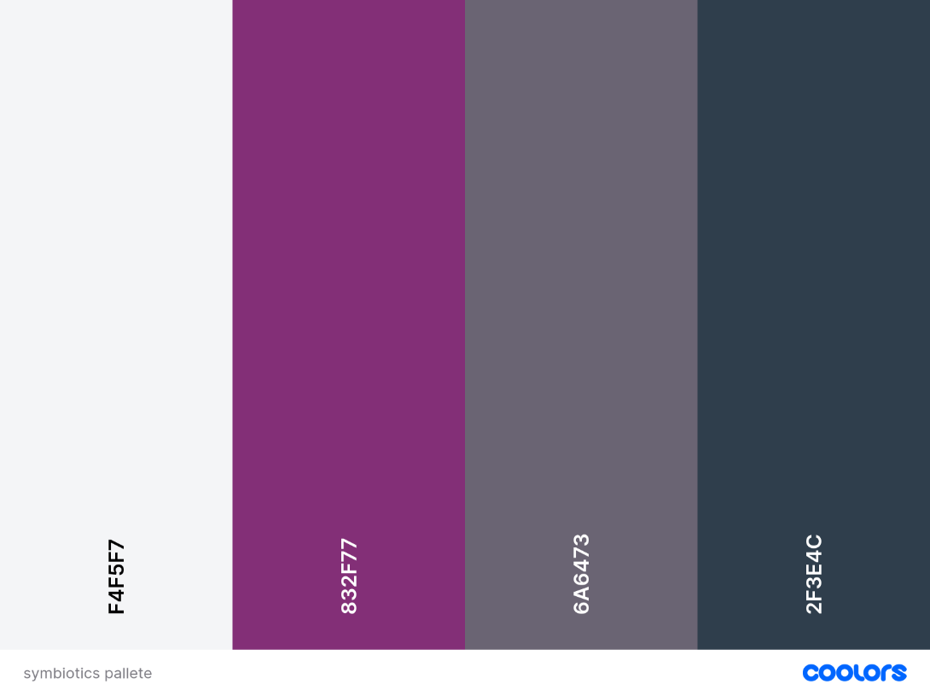The colour scheme of soft greyish white allows the brand’s bolder colours to stand out while providing a clean, professional look. The rich plum injects creativity with sophistication, aligning with the strategic and skill-based nature of pilot training. The muted grey introduces balance and calmness, reflecting the steady nature of the industry, and paired with the dark black-grey, trust and stability are emphasised, establishing Symbiotics as a dependable resource in the industry.

##### What I can take inspiration from

Overall, Symbiotics’ FAST Practise Test is an ideal solution for preparing for the FAST, and being completely identical to the actual test provided, there are many features that I can take inspiration from for my own solution. First of all, we should take inspiration from the placement of all details during the active test phase. We should attempt to mimic the sizing, placement and features of all details in the middle of the testing phase, such as where the multi-tasking mini programs are organised on the screen, and the type of questions in the maths test, the biomes the ‘plane’ flies through, etc.

We should also take inspiration from the report given at the end. The statistics given on user abilities throughout different portions of the test and their level at different skills, such as “Cognitive” thinking, should be used as a guideline on how to help the user improve on each test.

The branding of Symbiotics and their report is also very consistent with their ideals, and I believe my solution should attempt to embody the same ideals – of stability, precision, and professionalism – in our colour scheme, font and logo choices.

#### SkyTest® “Preparation Software for UK Pilot Aptitude Screenings”

##### Analysis

The SkyTest® Preparation Software is a useful tool for all things to do with Pilot Aptitude tests, allowing users to practise every possible subject and type of exam that may be used to test applicants. It features a huge range of subjects to practise with – and 41 modules, with key topics such as “UK Pilot Aptitude Preparation” for general Aptitude test practise, “BA Supplements” for users looking to apply for and undertake the British Airways Speedbird 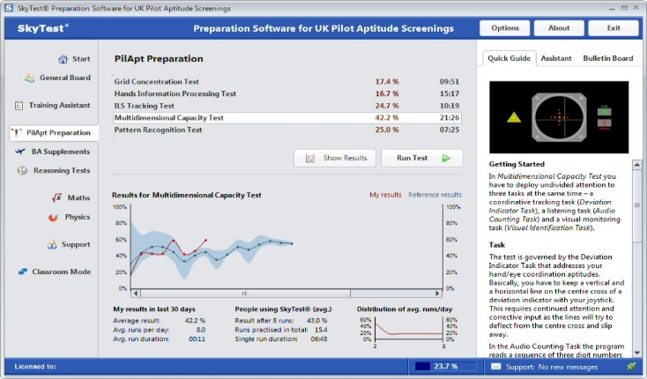examination, “Reasoning Tests” for non-verbal reasoning assessments, and many more.

The software provides customised difficulty levels, allowing users to progressively improve their skills and simulate real test scenarios. There are also features which include performance-tracking tools, which lets users monitor their performance through graphical feedback, as well as cloud-based functionality for data synchronisation across devices.

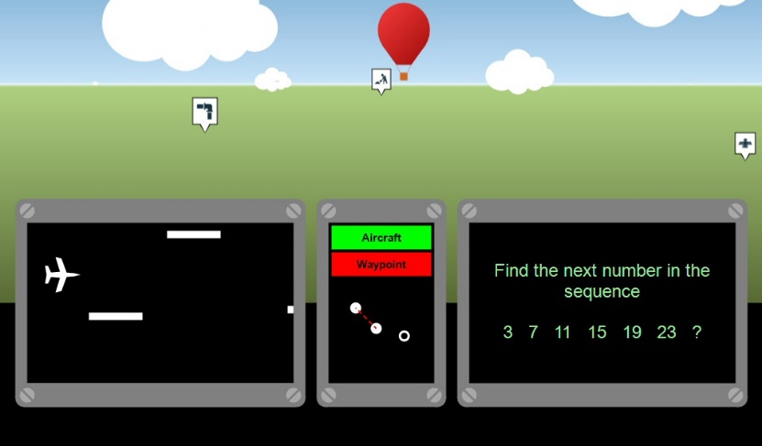While the software does not specifically focus on the FAST test, however it does have a section labelled “Multi-Flight Sim”, which when selected, you may choose between different difficulty settings, known as “Easy”, “Medium”, and “Difficult”. When you start the game, the following (image to the right) will be shown on the screen, this test appears to be a simplified version of the FAST by Symbiotics, featuring the same (but slightly simplified) plane minigame on the bottom left, the same non-verbal reasoning exams in the bottom, the same labels for Airport and Waypoint in the middle, . A free numpad controller is included in the purchasing of this software, which helps to assist with taking the tests.

Overall, SkyTest’s versatility is unmatched amongst pilot aptitude tests, with a vast range of inclusions, helpful reports and resources allowing you to monitor your improvement, and a huge question database solidifies SkyTest’s reputation in the pilot cadet community.

##### **Limitations – Accessibility, Usability and Navigation – and how I will improve them**

**Cost and Accessibility**

The main limitation of SkyTest is the price point – being roughly £76.00, the most expensive pilot training software to my knowledge, there is very limited accessibility which narrows the audience significantly. This price however does include the free controller with shipping, but this does not change the fact that the audience is drastically reduced. It has already been mentioned that my solution will be free, so this will remove that issue from our program.

**Navigation**

Another issue from SkyTest is a lack of user-friendly design, to new users focused only on practising the FAST or basic skills, using the software will be very overwhelming at first, with many complex sections. The unfriendly, harsh and dated user interface will be a limiting factor for users, dissuading users from exploring the other sections of the program.

I aim to improve this by creating modernised and friendly user interface, with only essential and key features being options when opening our software. This ensures that users know exactly what each component of our software does what, and only keeps content relevant to practising the FAST available, as to not distract the user.

##### Branding

SkyTest uses a straightforward and professional branding style which aligns well with the industry it targets, the clean sans-serif font in white, set against a soft and calming blue background, can easily be associated with the sky, which is also mentions in its name. This combination of colours also creates a sense of reliability and openness, and the minimalistic and direct design reflects the precision and focus required in aptitude tests, whilst already creating an approachable image for users who may be in high-stress preparation phases. The brand’s simplicity suggests efficiency and ease of use, which is important for users aiming to develop core skills like multitasking, time management and situational awareness.

##### What I can take inspiration from

Taking inspiration from SkyTest’s aesthetics, we could adapt this to our solution, with calming colour schemes which evoke a sense of trust and reflect the core values of our solution and the aviation industry. A clean font adds to the reliability and approachability of our solution, signalling our product is user-friendly and focused on delivering essential tools for training. Simplifying the design and colour scheme would reinforce the idea of efficiency, focus and practically.

### Proposed Solution

#### Essential Features and Proposal considering this research

My solution will be an application which upon running, the start menu will appear, which will have a large, noticeable start button, with 5 difficulty settings – listed from 1 to 5 where the higher the number, the harder the test. Upon starting the test, the user will be placed in a fixed cockpit view with the bottom part of the screen being the various simultaneous activities, including a black-and-white minigame in the bottom left quarter, in which the user controls a pixelated airplane, and must use their arrow keys to control the airplane and dodge generated pixelated clouds. In the bottom right quarter of the screen, basic maths questions over a green background will be Outputted, where the user must attempt to solve correctly. Near the middle of the screen, there will be two red lights, which will randomly flash throughout the flight, and nearly directly below them, there will be a column of two square buttons, with “waypoint” and “airplane” written on them. The top half of the screen will feature the surrounding terrain throughout the ‘flight’.

Upon pressing start, the practise test starts, Outputting all the mentioned features on screen. The test will then be split into 3 stages of terrain in the 5~ minutes the actual test plays, in which ‘waypoints’, and therefore the ‘plane’ changing it’s bearing, will occasionally be randomly generated into the terrain and into view, along with random airplanes being generated in view. After the 5~ minute test, a questionnaire asking about details of the events which occurred will be on the screen. This questionnaire will feature questions such as “What was the 4th waypoint?” and a multiple-choice answer style. Upon completion of this questionnaire, the report will be Output.

After the completion of the two tests, report will be given, detailing the skill level of the user. Followed by large text exclaiming whether the user passed or failed, and depending on how close they were to passing/failing, detailing the next course of action. Afterwards, the report will feature colour coding on several sections of the user, such as their Multitasking skills – which will be calculated dependant on how many overall crashes the plane minigame had, how many maths questions were answered, and how many events logged.

#### Limitations of the proposed solution

The main limitation of the solution is the graphical interaction compared to the actual FAST. The FAST specifically uses a 3D rendered terrain with rendered waypoints and aircraft, with a mock cockpit for the user to view out from, since my solution will use Python to write the source code, rendering a 3D terrain becomes increasingly more complex, as while the library I will use – pygame – is meant to help as a graphics processor, creating 3D terrain is near impossible, and will significantly increase the programming time and file sizes of the final solution, which may not fit within our deadlines given, and will limit the number of users who can benefit from our software, as a result, we will make our solution 2D, with a mock 3D style perspective, this has minimal difference compared to the FAST, as all the same event can and will happen, targeting the same areas for development, while retaining reasonable practise in file size, time, and resource utilisation.

Another limitation is that I will not be able to repeat the test with identical events and recalls for the second round. The second round is the process of the test re-running after the user finishes answering the passive reasoning challenges after a game cycle, consisting of completely identical events and processes, including the questions at the final passive challenges. This is due to the fact that the IDE I will use, Sublime Text, significantly slows upon execution of many lines, and especially slows when I use modular programming, and reference different classes and modules the game code will need to fetch. This will significantly reduce the precision and accuracy that should be offered by my solution and should near double the total size of the program, which is something we want to keep as small as possible, so that as many users can utilise my solution as possible.

Finally, the main limitation is that my pass / fail mark given to users at the end of their test will not be 100% accurate to the actual FAST. This stems from the fact that the sample data for passes and fails are inaccessible, and the source code for the FAST is also closed source, meaning I cannot take a look at how it is calculated. I plan to amend this limitation by punishing the user significantly more than they are regularly punished in pilot natural aptitude tests, specifically the CUT-E and AON tests which I have experience dealing with, and using their general ideology of final scores, I can adapt it to my program whilst making it slightly harder for users to pass, which will ensure that users will not believe they are prepared for the test due to achieving passes in my solution, whereas if they were to take the real FAST they would not succeed, this will ensure that users able to pass in their practise tests using my solution should at least be able to pass by relative margin, or similarly within the actual test. I will also not be able to interact or feature air traffic control audio, which would usually talk to the user throughout the test, as this would again significantly increase the file size significantly, and I have no access to ATC files and procedures, so I am unable to create accurate replications of this, thankfully this is a very insignificant part of the FAST, and serves nearly no function throughout the test.

## Requirements

### Hardware Requirements

|  |  |
| --- | --- |
| **Component Required** | **Reason** |
| Computer keyboard with arrow-key usability | The bottom left minigame is a game which requires the use of arrow keys simultaneously with other activities, without arrow keys the program cannot be used or practised efficiently. |
| A computer mouse or clicking functionality | The two buttons declaring waypoint or airplane must be clicked when one or the other appears on screen. The questionnaire at both stages of exam will also need you to click the answer amongst multiple choice answers |
| A monitor which Outputs the program | Needed to see the program being run to complete the test |

### Software Requirements

|  |  |
| --- | --- |
| **Software Requirement** | **Reason** |
| 64MB of Storage / RAM | The total size of all the programming files is <35MB, so 64 should sufficiently cover storage requirements |
| 32-bit system | The lowest bitrate I have seen to run a Search Engine is 32-bits, and the user will need a search engine to download the game |
| GitHub access | I will be publishing my game open source, free of charge on GitHub, which is where users can find the test on. |

### Stakeholder Requirements/Inputs

|  |  |
| --- | --- |
| **Requirement** | **Reason** |
| Customisable difficulty levels | Suggested by Tolupe, customisable difficulty levels will allow new users to slowly adjust to the test at their own pace, building up to harder difficulties. It also allows confident users to increase the difficulty to harder levels, if they want to ensure their pass mark for the actual FAST, they can aim to achieve consistent passes on the hardest difficulties |
| Improvement Metrics | An overall suggestion, having statistics which outline the users’ skills, and the user can track themselves to compare their personal scores |
| Similar UI to the actual FAST | An overall suggestion from the cadets, the solution will feature the same minigames in the same locations, and a similar interface during the exam |
| Similar difficulty to the actual exams | Overall suggestion, where the level 3 will be as close to the actual exam difficulty as possible |

## Success Criteria

|  |  |  |
| --- | --- | --- |
| **Criteria** | **Reason** | **How I would evidence this** |
| Start screen with customisable difficulty settings | Stakeholder Requirement | Screenshot of the start page |
| Improvement Metrics | Stakeholder Requirement | Screenshot of the code which compares stats |
| Similar UI to the actual FAST | Stakeholder Requirement | Screenshot of the UI in the test |
| Similar difficulty to the actual exam | Stakeholder Requirement | Screenshots of the different Pass / Fail marks given for different combinations of scores |
| Easy to navigate reports | Quality of life | Screenshot of a simple report with understandable scoring methods. |
| Guide to show users how the program works | Quality of life | Screenshot of the text shown to explain the program when an info button is pressed |
| Accessibility / Usability Features (Dark Mode, etc) | Quality of life | Screenshot of the features added and what they change |
| Notable start screen options | Quality of life | Screenshot of UI of start screen |
| Window with correct proportions created for the Plane Minigame | Sustainable Implementation | Test demos of the minigame |
| Airplane visible in Plane Minigame with accurate proportions | Accuracy to FAST | Test demos of the minigame |
| Controllable airplane in Plane Minigame | Accuracy to FAST | Test demos of the minigame |
| Randomly generated cloud obstacles in the Plane Minigame | Accuracy to FAST | Test demos of the minigame |
| Ensuring the randomly generated cloud obstacles do not provide obstacles which are impossible to dodge (in bottom left minigame) | Fairness and Accuracy to FAST | Screenshot of rendering programming for obstacles |
| Collision detection system for plane and clouds | Accuracy to FAST | Screenshot of minigame and trace variables |
| Variable which counts the number of collisions in the bottom left minigame per section of test, per attempt | Accuracy to FAST and trackable metrics | Test demos of the minigame |
| Sensible non-verbal reasoning questions in bottom right minigame | Accuracy to FAST | Screenshot of question database |
| Understandable graphics for the lights on the dash | Fairness and Accuracy to FAST | Screenshot of the graphics used for the lights |
| Noticeable when the lights on the dash light up | Fairness and Accuracy to FAST | Screenshot of the light up graphic |
| Both lights can light up randomly | Accuracy to FAST | Screenshot of random code showing when they light up |
| Reasonable number of flashes from lights dependant on difficulty | Stakeholder Requirement | Screenshot of limiting code showing that the flashes are adjustable and limited |
| At least 1 rendered terrain | Accuracy to FAST | Screenshot of the terrain in development |
| Randomly generated waypoints | Accuracy to FAST | Screenshot of code to generate them randomly |
| Identifiable Waypoints | Fairness and Accuracy to FAST | Screenshot of the models of the waypoints |
| When waypoints on screen, POV appears to change direction (rotate) | Accuracy to FAST | Screenshots of terrain when turning |
| Randomly generated aircraft | Accuracy to FAST | Screenshot of code to generated them randomly |
| Separate and easily identifiable buttons for the waypoints and airplanes | Fairness and Accuracy to FAST | Screenshot of the design for the buttons |
| Reasonable questions asked in the testing phase | Fairness | Screenshot of the questions potentially asked, and how they are generated |
| Several answer buttons with options | Accuracy to FAST | Screenshots of the buttons |
| Variables for when the buttons are clicked when an event is rendered, and when event is not rendered | Accuracy to FAST and trackable metrics | Screenshot of the code which designs this |
| Final report which answers if you would pass or fail | Trackable metrics | Screenshot of code and screenshot of report |

# Design

## Top-Down design

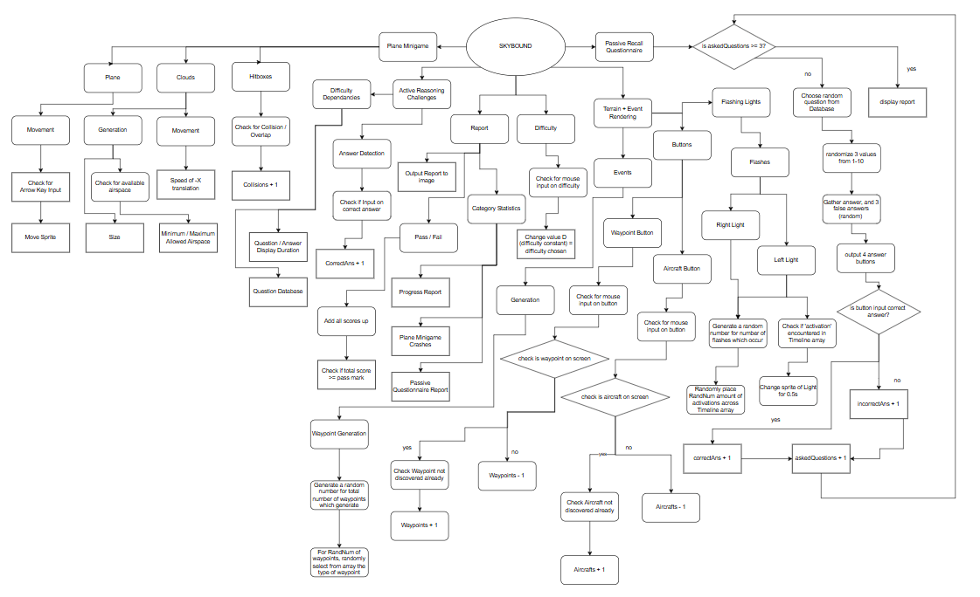

### Overall – Decomposition, Explanation and Justifications

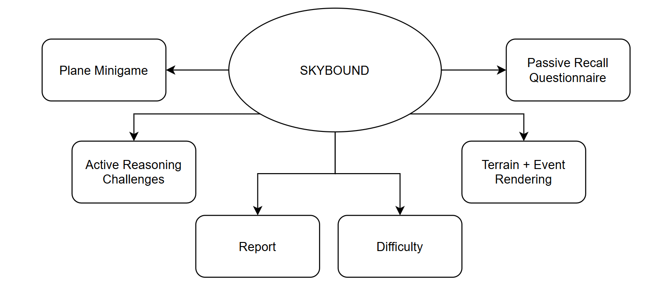

The game is split into 6 components, including the “Plane Minigame”, “Active Reasoning Challenges”, “Report”, “Difficulty”, “Terrain + Event Rendering”, and “Passive Recall Questionnaire”, these components include every part of the test, with all the components on-screen during the test, to the parts of the test which influence the overall scores and variabilities within the test.

Plane Minigame Justification: The small interactive minigame which plays during the test serves as a multi-tasking feature deserves its own model within the game, as it would be programmed separately in its own module, and likely dynamically linked to the test when the program is run. This is due to its role as a fully separate feature within the test, meant to be interacted with individually at the same time as the other features of the test, being the only thing controlled by the arrow keys. This module will be directly linked to the “Difficulty” Module, as variables such as “Minimum / Maximum Allowed Airspace” will change dependent on the Difficulty – with greater difficulty meaning that there is less allowed airspace, and more clouds can be generated.

Active Reasoning Challenges Justification: This is another small interactive feature which occurs during the test, and serves as another challenge to the user in game, by Outputting different reasoning (namely non-verbal and mathematical) questions, which require the user to click one of four answers which replace the question after a variable amount of time. Being isolated with independent controls and outputs regardless of any of the other multi-tasking tests means this feature of the game and justifiably serves as its own module. Some parts of this module are linked to other modules, such as the “Difficulty” setting, which will impact which database of questions is used, and the speed at which the questions disappear from screen and must be answered.

Report Justification: The report is the final document which is Outputted at the complete definite end of the overall test, including both trials of the active multi-tasking assessment and passive recall questionnaire. This is to be an individual model, however dependent on most if not all the other modules, as it will need to pull the variables which declare how many questions achieved correctly, how many planes were crashed etc. for the statistics and final result shown to the user.

Difficulty Justification: the difficulty is a setting which must be toggled before the game start, going from one to five. This serves as its own section in the game as it links to all the other modules of the game, impacting the amount the user must manage overall and just the overall difficulty of the game, increasing the number of clouds that can be generated, the difficulty of answering questions, the passing grade, etc.

Terrain + Event Rendering Justification: during the active test, the program can be split into 3 sections: the plane minigame, the active reasoning challenges, and then the overall terrain and event generation. The terrain + event rendering module encapsulates the entirety of the active test without including the plane minigame or active reasoning challenges, showing that the waypoints and aircraft are directly linked with the buttons which must be clicked to declare these events seen. It also groups the two flashing red lights with the buttons, as the buttons are located directly above the lights, and will likely be embedded into the same interface module.

Passive Recall Questionnaire Justification: at the end of the tests, there will be a form-style questionnaire which will enquire about specific details of the events which occurred during the active test, the questions will be the exact same during both runs, and is deserving of its own branch as it needs its own modules to account for the every event of the active test, randomly decide which (within reason and with account for difficulty) features to ask about, passing details – such as answer validity and which sections of skill they cover – to the final report, acting not only as an active and pivotal feature of the overall test, but also as a mediator for the statistics gathered from the test to the final report.

#### Plane Minigame Decomposition

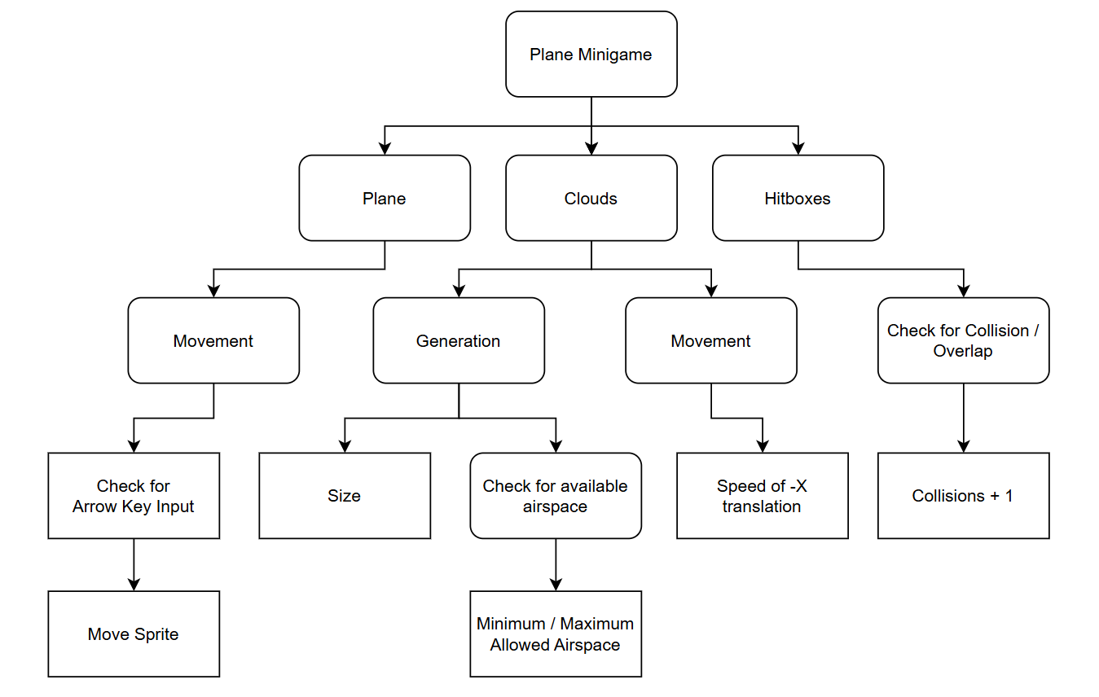

We can split the “Plane Minigame,” which is the arrow-key minigame in the bottom left, into the ‘Plane’ model, the Cloud generation, and the Hitboxes of both, these categories encompass every feature of the plane minigame for it to function as needed, including interaction with other branches of the overall SKYBOUND program.

Plane Justification: the plane entity is the centre and most important feature of the game. It is a model which will be translated up or down depending on the user input, otherwise it will remain in the same x and y value as the last input brought it to, starting in the middle of the small box which encapsulates the game. the ‘camera’ will not follow the plane, aka the plane will not remain centered in the game and will move within the box. It will be modelled very simply as its own module, meant to abstract all but necessary features of the plane as to not overcomplicate this small feature of the overall test.

Clouds Justification: the clouds are another central feature of the minigame, as only 2 entity types will be present in the game, including the plane and cloud entity. Clouds requires its own decomposition, as it will serve separate to the other entity in the minigame. The entire connected will be moved smoothly to the left, and be generated depending on numerous factors with consideration to difficulty, each of these factors requiring their own decomposition modules.

Hitbox Decomposition: whilst hitboxes are a feature of the modelled entity of each of the other categories, we have split it into it’s own category, as the hitbox module under plane and clouds would have to link together, forming a module which isn’t entirely under either yet is still under both, leading to complications with organisation of the modules, so adding it as a separate feature after programming the hitboxes of the other two would be more sustainable.

##### Plane Entity - Decomposition

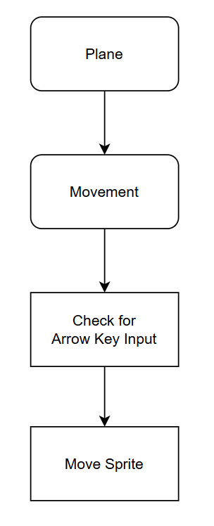

The Plane Entity decomposes simply into the movement of the plane, we would usually have the hitbox included in the plane, however for reasons mentioned in the plane mini-game decomposition we have separated them.

Movement Justification: movement is the only function that the plane will occur for the plane and is the most essential feature of the plane, therefore making it deserving of its own category , it will be checked when the entity is updated (runs forever), and is in charge of translating the model’s y co-ordinate whenever the respective arrow key is pressed.

We can decompose the movement of the plane model into two atomic decompositions, or two modules that need to be made, both “Check for Arrow Key Input” and “Move Sprite” are direct decompositions of “Movement”, however they must be executed sequentially, so they are in that given order, instead of both being branches of movement.

Check for Arrow Key Input Justification: under movement, the event which is constantly checked when the model is updated is whether the user has given the system any inputs, without inputs the mini-game would not know whether to move the model or not, and therefore it is the only, and highest priority decomposition of the Movement section.

Move Sprite Justification: if, and only if an input from a targeted arrow key is input, then we can move the sprite, translating it by a positive y value (up) if the up arrow is clicked, and a negative y value (down) if the down arrow is clicked. This is its own module, as it will run constant checks for any passed parameters from the “Check for Arrow Key Input” justification, and separately move the entity depending on the parameter passed.

##### Cloud Entity Decomposition

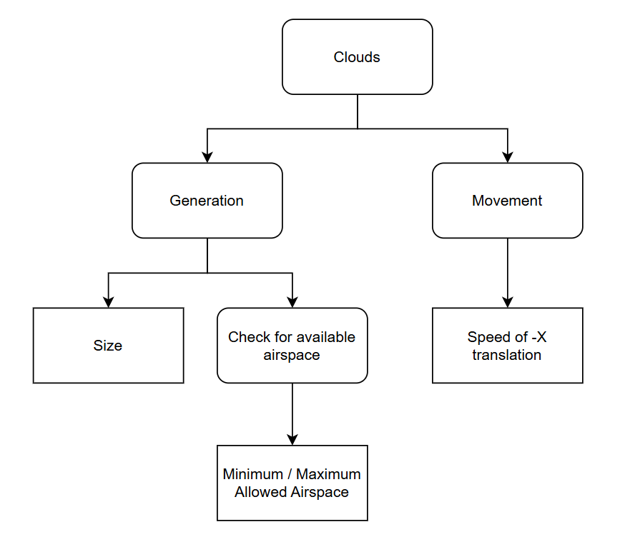

The Clouds can be decomposed into their ‘Generation’ and ‘Movement’, both are the only considerations and actions which the clouds undertake, ignoring hitboxes as we have given it its own module under “plane minigame” due to the sustainability of code.

Generation Justification: the clouds must first be generated into the mini-game to exist as a feature of the game, and it is a repetitive function which occurs, as there will be many clouds passing which the plane must dodge as it moves up and down, the clouds will be generated with their hitboxes encompassing the entire model, the cloud will be made up of many single square boxes joined together to form a single entity, which are roughly 1:5 the size of the plane model/hitbox.

Movement Justification: the whole cloud entities are moving to the left, along with their hitbox, towards the farthest left side of the box, where they will eventually move so far left they will no longer appear on screen and despawn.

Under generation, we have the features of the cloud generation which must be accounted for, with the ‘Size’ of the cloud generated, and the area which the clouds may be able to be generated in, where the system will ‘Check for available airspace’, and decide where to generate. Movement is followed up directly by the exact movement which will occur, the translation by x value.

Size Justification: each cloud is made up of entirely separate squares, which join up to create a singular cloud entity due to their connection. Each cloud square is generated entirely on its own under the whole “Generation” branch, considering the available airspace, and as a result of this we can expect many of these cloud squares to join up vertically with eachother, forming longer rather than taller clouds, due to the characteristics of the available airspace. We consider these connected squares of cloud as one entity with a singular hitbox, even though they are actually many cloud squares with individual hitboxes connected, as there is no difference for the user.

Check for available airspace Justification: when generating clouds, it is imperative we do not end up with a situation where the plane has no possible ways of avoiding the clouds, and is forced into hitting a cloud due to there being no gaps large enough. We can stop this from occurring by constantly checking the “available airspace”, where the system checks there are gaps within the clouds large enough for the plane to fit through, with variable amounts of leeway – this ensures that even if there is a gap large enough for the plane to pass through, these gaps are possible to enter and get to, as the system could flag a false positive for a ‘large enough’ gap, however there is no possible way to pilot the plane into that gap as it is blocked off by clouds around it which are not included in the scan (which will be done in large squares in the minigame). We use variables from the next decomposition to determine the available airspace given, to not only ensure that it is possible for the plane to physically make it through, but also to ensure that the difficulty of piloting the plane through clouds is variable depending on the difficulty.

Minimum / Maximum allowed airspace Justification: under the “available airspace”, there will be variables which decide the minimum allowed airspace that the game can give to the user, which essentially means that the minimum gaps / space given for planes to pass in between clouds can be changed determined by variables, which are set by the difficulty. This is a necessary addition, as multi-tasking the many programs at once is already a challenge, and users that select the easiest mode to warm should not be given tiny gaps to pass through the clouds, as it would significantly overwhelm them and lead to a lack in confidence which may affect their ability to pass the actual FAST test, and other natural aptitude tests.

Speed of -X translation Justification: while it is a given that the movement of the clouds will be a -X translation, we can add this module to give more difference and create a bigger difference between the difficulty settings, making easier difficulties have slower clouds / slower translation of the clouds, allowing them more time to process each multi-tasking feature slower, and help them passively build skill and confidence. The displacement of the clouds will be given by the basic formula x(t)=x0​−v(D)⋅t, where x(t) is the displacement of the clouds dependent on time elapsed, x0 is the original displacement of the cloud, which will be the furthest left area of the box, v(D) is the velocity of the clouds dependent on the variable D, which is the difficulty selected, and will change values depending on the difficulty chosen, and t is the elapsed time. The velocity or rate of displacement of the clouds is given by the formula v(D)=v0​+k⋅D, where v0 is the base / minimum velocity for all difficulties, k is a constant of scaling that adjusts the increase in speed dependent on variable D. This enables the easy adjustment of the speed of clouds from a single variable D, given basic constant values.

##### Hitboxes of Plane and Cloud Decomposition

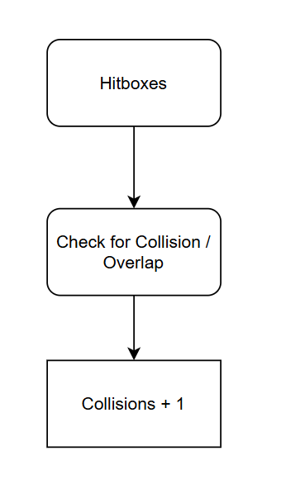

The hitboxes is a separated branch from the overall Plane Mini-game, as joining the hitboxes of the plane and clouds would result in messy, unsustainable decomposition and programming. We decompose the Hitboxes into “Check for Collision / Overlap” as it is the only purpose of having Hitboxes for both, where upon collision of hitboxes we add 1 to a variable to mark this down.

Check for Collision / Overlap Justification: a decomposition of Hitboxes leaves a single module which constantly checks if the plane hitbox overlaps / collides with a cloud hitbox. This check will include many rules, such as after a collision is detected, no collisions will be registered for the next 3 seconds, to ensure that once an overlap occurs, it doesn’t update the next module thousands of times within a second even though the collision only occurs once.

Collisions + 1 Justification: this module is a part of the previous module, but I believe it to be important enough to be decomposed from it, as the entire point of checking for a collision is to take down information about the collision and consider it for the overall test score. Once a collision is detected from the previous module, variables will be added, which include overall collisions detected, which will +1. There will be a separate collisions variable depending on whether they are on their second round of the test or first, these variables will be compared at the final report in the end too.

#### Active Reasoning Challenges Decomposition

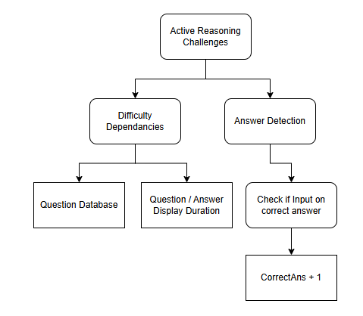

##### Active Reasoning Challenges – First Decomposition

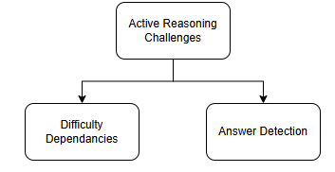

We can decompose the Active Reasoning Challenges into only 2 main parts – the features of the program which vary depending on the difficulty set, and the detection of the users answer from inputs based on questions randomly output from a given question database.

Difficulty Dependencies Justification: many general attributes of the Reasoning Challenges given to the user will be entirely dependent on the difficulty level selected, making features which fall under this category a key decomposition for the overall section. There is only one true interactable feature of the minigame, so this section details all the other static, program-controlled factors, within a feature of the overall game which is very simple and constant.

Answer Detection Justification: once a random reasoning question is output onto the screen, and after a variable amount of time 4 answers will appear on the screen. This “Answer Detection” module focuses on the events after the answers appear on the screen to the user, and is a key decomposition as it is really the only controllable and varied feature within the game, outlining the behaviours for the only possible interaction the user has with this feature.

##### Difficulty Dependencies – Decomposition and Justification

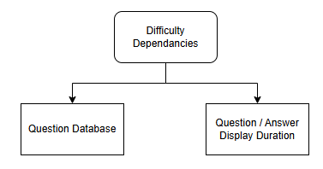

There are two variables which will be altered by difficulty, the database of questions which is used for the active challenges, and the amount of time that the question and answers will be Outputted.

Question Database Justification: this branch refers to the database where the questions that will be output during the test will be grabbed from. There will be 5 different databases for each difficulty level, containing likely the least number of questions possible to still ensure a test can be run without running out or repeating any questions to preserve time when programming. Databases for difficulty levels 1-2 (easiest) will start very simplistic, containing the simplest possible reasoning questions designed to allow the user to adapt to the format of the test and not have to worry specifically, and then difficulty will significantly increase for levels 4-5, where the difference in difficulty between 4 and 5 is low, but the jump from sub3 to 3+ is great. This deserves its own decomposition as it will likely serve as its own module, changing the databases used depending on the difficulty selected at the beginning of the test.

Question / Answer Output Duration Justification: this decomposition shows that the amount of time that the questions, and consequently the amount of time the answers will also be Outputted on screen awaiting input will be Outputted on the screen. The difference in Output time between different levels will be minimal between difficulties, logarithmically decreasing as difficulty increases to ensure the user doesn’t practise for the actual test using harder difficulties, therefore believing that the actual question Output time isn’t lower than the actual value, and potentially prioritising the questions in the actual test and sacrificing other features as they believe they have less time than they do. This may negatively impact the score of the user, so from difficulties 3+, we will have no change in output duration, whereas in levels 1-2, we will have significant differences in duration to ensure the easier levels are very useful for building confidence for the user.

##### Answer Detection – Decomposition

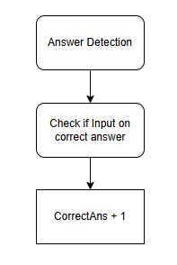

Under Answer Detection, we must check if the detected input from the user is correct, and if so we must store this information in variables, such as the given variable CorrectAns, which is just a placeholder name to portray the basic understanding of this concept. While this branch overall is heavy abstracted from each variable which is essential in the programming of it, I feel as if only the ‘CorrectAns’ variable is imperative to list, as it suits under the ‘if’ statement of the next branch, whereas others can be described within the decompositions of the if statement.

Check if Input on correct answer Justification: the only answer detection we will need for this section of the program is checking if the correct answer is the one which is clicked on, we will not need to take any inputs and add any variables for incorrect answers as we will take a variable for the number of questions asked, and compare it to the ‘CorrectAns’ variable at the end, taking the difference as the number of incorrect questions. This also allows us to ignore the questions where no input is taken, as it will be defaulted to an incorrect answer.

CorrectAns + 1 Justification: as explained previously, when a correct answer is clicked and that input is detected, this variable will be added. I believe this is a key branch that must be represented on the decomposition diagram (even ignoring other key variables) as it shows that only if a correct input is detected will a variable have their value changed, also showing there is selection, and only a different result if an input on a correct answer is detected.

#### Report Decomposition

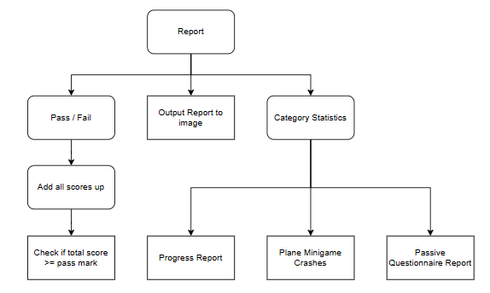

##### Report – First Decomposition

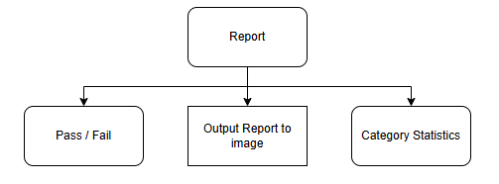

For the report, we must output and show the user their behaviours and statistics of their different results throughout the test, shown in this diagram the two types information shown, including the overall pass or fail mark, the statistics given from the different sectors under “Category Statistics”, and then we have a module to convert this report to some sort of image which can actually Output the information found to the user.

Pass / Fail Justification: the main feature people will look for in the test will be whether they had passed or failed, so this will be incorporated into a large and independently calculated section of the report compared to the other category statistics. This section of the report will feature a overall large score showing the user whether they had passed or failed the test, giving their overall score compared to the pass mark.

Output Report to image Justification: we will need a way to make the report look as if it were an official report, similar to the one exported as a PDF by Symbiotics, which Outputs all the information outlined in this module gained from the users attempt at the test. This has been separated as a different module as it will need to be programmed separately compared to the decompositions which simply outline what should be put on the report.

Category Statistics Justification: along with the overall pass/fail mark, the user should be given more specific information about the different sections in the test, how the user performed in those sections and a comparison between the user’s first and second attempt at those sections.

##### Pass / Fail – Decomposition

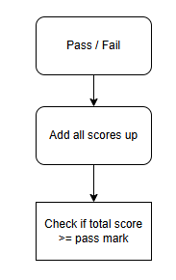

This section outlines how the score for the pass or fail mark will be calculated, showing the abstracted steps of just adding the scores up and checking if the total score is enough to pass.

Add all scores up Justification: the value we use to determine whether the user passes or fails with their test is a sum of all the scores they had achieved throughout the different sections, where scores are taken from. This will include scores from the Collisions variable, the CorrectAns variable, and other variables which were abstracted from the program which are unmentioned within the decomposition diagram. These values will all be taken into equal consideration, but variables such as CorrectAns will be compared to other variables such as (placeholder) TotalAns, as to make sure just spamming answers will go unpunished, as it would not go unpunished in actual FAST and aptitude tests. This module will also take various constant dampeners into account to ensure one single feature of the test has more influence over the final mark compared to the others.

Check is total score >= pass mark Justification: this decomposition is simply to show how we use the sum of all the scores to find the pass mark, where we simply have a value for the pass mark for different difficulties, which scales exponentially until level 3, where it remains constant for levels 4 and 5 also. This is to help allow newer users to gain familiarity with the test style, however making sure that in the accurate difficulty + levels the pass mark is relatively harder than the actual FAST and actual Aptitude tests to ensure that if a pass mark is consistently received on the program, a pass should be achieved easier in the actual test.

The decomposition of the Category Statistics outlines just the categories that will be shown in the report with the users’ statistics for their own personal analysis.

Plane Minigame Crashes Justification: the information about the collisions the user had will be Outputted on two collision-section graphs, where the first graph will show the stats of the user for the first part of the test, and the second graph for the second part. The ‘sections’ on the x-axis of the graph will be split into 3 equally timed portions, where number of collisions which occurred during the respective section will be Outputted on as a dot and line graph. This section is meant to ideally show the change in number of crashes over time for the first portion, likely starting high and going down as the user gets used to multitasking the games, and then compare the first graph with the section, hopefully showing significant improvement from the two.

Progress Report Justification: the progress section is inspired by the “Learning” section in Symbiotic’s FAST Aptitude test, which gives the user rankings based on their improvement from the first test to the second. We will encapsulate this idea and create my own progress report section, which compares the variables and statistics gathered from the user over the two attempts and compare them using an algorithm. As in actual aptitude exams, this progress is expected to be high and significant from the first attempt to the second, as problem solving and familiarity are key skills needed for pilots. This section will output a float from 1-10, and a short explanation of what this means.

Passive Questionnaire Report Justification: this section will mark down the answers the user had input from the “Passive Recall Questionnaire”, Outputting on a graph which categories of questions the user had gotten right, and which question the user had gotten wrong, on two different graphs for the two attempts, so that the user could compare their results. The categories will be named similarly to phrases such as “Auditory Questions” or “Muscle Memory Recall”.

#### Difficulty Decomposition

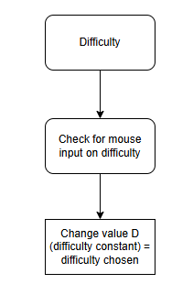

The difficulty module is a very small but impactful topic of the overall game, it alters just about every feature of the game, from each multi-tasking minigame, this simple module is potentially the most important of the software. In this module, we have abstracted process to select whether a difficulty has been chosen out of this diagram as it would be a small part of the single module which will encompass the entire Difficulty section of the program, but a difficulty will need to be chosen to start the program, which will be governed by a selection process.

Check for mouse input on difficulty Justification: the main part of the difficulty module will be detecting where the user clicks on screen which correlates to setting the difficulty a certain level. Without the user clicking on a set difficulty, we will set the default to 3 just in case the user manages to bypass the selection sequence which determines if the user has input a level, which elsewise would result in the program crashing. This section is also a requirement for the game to start, as the user must click or somehow select a difficulty level before the test is allowed to start.

Changing value D Justification: when the user selects a difficulty, a global variable will be altered, D, into the value equal to the difficulty chosen. This value will be passed into all changeable variables, all with their own unique, local dampeners to ensure that the difficulty changes their values exactly as required. Doing this ensures that there is a simple global method of altering settings for difficulty proportional to the one selected as they are intended to be altered, and not complicating the difficulty feature of the game too drastically, allowing a very simple way to help users of all skill levels adapt to the software and use it to better suit their needs.

#### Terrain + Event Rendering Decomposition

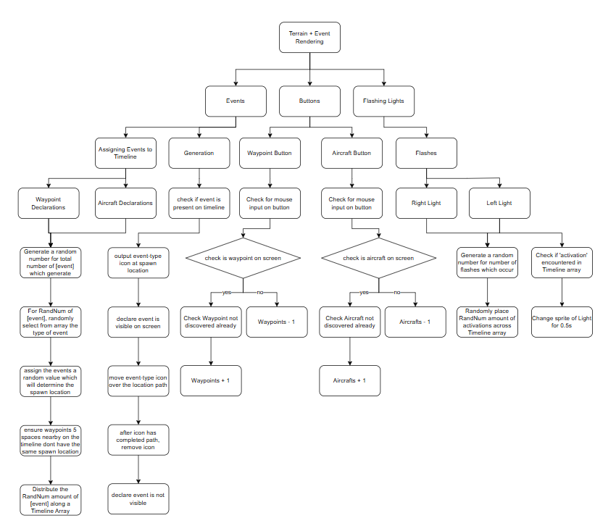

##### Terrain + Event Rendering – First Decomposition

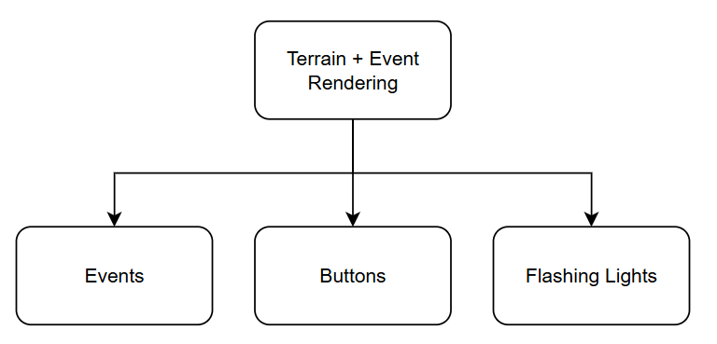

We can decompose the Terrain + Event Rendering into the modules we have encompassed into this module in the first overall decomposition, where we include the two flashing red lights above the terminal, the buttons to declare when you have seen a waypoint/aircraft, and the actual aircraft/waypoint programming itself.

Events Justification: events is the umbrella term used for the waypoints and aircraft, they are considered this because they appear to spontaneously appear in the game, and must be reacted to by the user. This branch will encompass the coding behind the waypoints, and the aircraft, including how they are generated, how they are spawned etc.

Buttons Justification: the buttons referenced are the buttons which are used to declare when an event appears on screen. We have separated this module from the events, as although they are dependent on eachother, they will only borrow a few mutual parameters from the ‘Events’ tab to work, and will be stored separately, which justifies the decomposition.

Flashing Lights Justification: the flashing lights were also included in this umbrella as they are attached in the UI to the button interface, and it would be largely wasteful and too unimpactful to give it its own module under the initial decompositions. This has been explained in the overall decomposition too.

##### Events - Decomposition

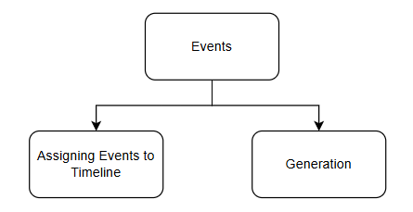

Under the events branch, we decompose them into how we decide when to spawn an event, and then the processes which occur when actually spawning the event.

Assigning Events to Timeline Justification: this module will detail how we decide when to spawn an event, and the detail of each generation of an event. This should be separate to the generation, as even though generation comes after this branch has been complete, and can only occur after this branch’s processes occur, they are distinctly separate, one setting up the preconditions and attributes of events, and the other simply creating them for the user.

Generation Justification: this section puts the events onto the screen for the user to see and interact with, by clicking the buttons. This section also links the buttons and events together. This section is standalone as it has unique processes to declare the output of the events which do not make sense to add together with the generation, which will only occur once at the start of the game, whilst the generation will have modules which are constantly run and checked.

##### Assigning Events to Timeline – Decomposition

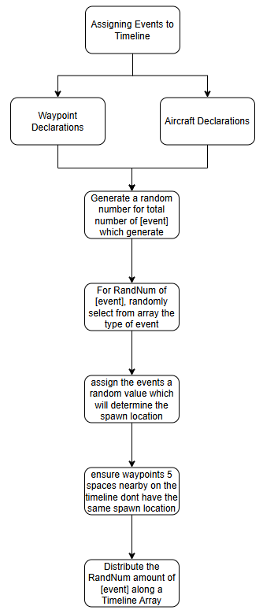

This is a very long decomposition, only as it details the processes which occur under this branch in a flowchart-like fashion, stating what will happen, procedurally. We first split it up into the generation for the ‘waypoints’, and then the generation for ‘airplanes’, however we then connect the branches together again as the two events will have near identical processes, which would be a waste to decompose and recode, so we can reuse the code from the other, changing only constant details but using the same processes. This creates more sustainable code and less work for the developer for an ideal result.

Waypoint Declaration / Aircraft Declaration split Justification: we split the declarations for the aircrafts and waypoints because we need to ensure that it is understood that all events below are repeated completely separately. The decompositions will not be comprised into single modules for both waypoints and aircraft, but will be repeated, with aircraft having their own timeline separate from the waypoint timeline.

Generate a Random Number for total number of events Justification: we need to declare that there is a limit to the number of waypoints/aircraft which can be generated, if there was no limit, we could simply run a random selection sequence every second deciding whether to spawn an event. This is imperative as generally the more events that appear the harder the test is to maintain all the skills at once, so we have an upper and lower limit to make control the random number which are dependent on the difficulty selected. We require the number of events to be random, as questions which may appear in the report asking for the total number of flashes, so this cannot be a constant that the user subconsciously memorises after repeating the test.

For RandNum of [event], randomly select from array the type of event Justification: this branch has a long name which essentially explains the entire idea. We will have different types of each event, e.g. a waypoint might be an “Air Traffic Control Tower”, or an “Airport”, these types will be stored as numbers in an array, and then linked to constants to declare which is which. The program will declare using a for loop (for RandNum – which is a placeholder name for the random number generated from the previous module) to randomly select the different event types that will be fed into the next modules.

Assign the events a random value which will determine spawn location Justification: we will assign each event a random value, likely 1-3, which will determine where we will spawn the event. This means that instead of creating a complex algorithm, we will use a heuristic method to generate how the events will be rendered and moved in relation to the user. To add create the imitation of the user POV moving forward, like they’re in a moving cockpit, we could generate a terrain and spawn in the events into this terrain, and slowly move the user POV through this terrain, generating it, however this will take too long, and instead we can create the same concept by not rendering the terrain, and simply moving the event icons across the screen in a manner which appears that the user is moving, instead of the events. To do this, we could create a module which contains an advanced formula for constant translation of objects relative to the point-perspective the terrain caves towards and the random location the event has spawned, however again, this may be too complicated, and we can create an effect that looks identical to the user but much simpler to program by simply creating 3~ preset spawn locations and paths, where we just create a set path and simple translation algorithm, this will save significant effort, time, and memory for an essentially same effect.

Ensure waypoints 5 spaces nearby on the timeline don’t have the same spawn location Justification: this describes a module which will check if the (same) events occur within 5 spaces in the timeline of eachother, they will not spawn in the same spawn location. This creates a more realistic feel to the terrain, as you would likely not encounter, for example, 2 airports meters away from each other. If events were rendered in shortly next to after one another, in the same spawn location, it may also be difficult to see the icon for the details of the event, which would hinder the test and the users score if a question on the passive recall questionnaire came up asking for it.

Distribute the RandNum amount of [event] along a Timeline Array Justification: the timeline array is an array which will consist of a few hundred empty spaces, and then the events will be randomly distributed into the spaces. The software will check the array every short set amount of time, and process an event when the array data at a location is not empty, and specifies which event, which type of event, and where to spawn it. They must be randomly distributed so that the user doesn’t subconsciously learn when to look for events, and should be constantly checking.

##### Generation – Decomposition

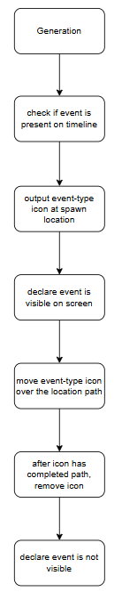

This branch of the ‘Event’ decomposition details the events of actually spawning the icons on screen, and the influences that has on other branches, namely the “Buttons” branch, which directly relies on this.

Check if event is present on timeline Justification: this is a key step in determining whether an event should actually be generated. This decomposition will result in a module which constantly checks the separate Timeline arrays for each event, checking if the array is empty, or features an event and its details’, if an item is detected, the following decompositions will be executed, else it will just run the check again until an item is detected.

Output event-type icon at spawn location Justification: once an item is detected in a Timeline array, this item will check for the event-type and spawn location values assigned to it previously, and output an icon exclusive to specific event-types at the path associated with the value given for spawn location. This will put the events on the screen for the user to view, so is an imperative step which must be undertaken.

Declare event is visible on screen Justification: this module will simply declare that the event is present, and therefore the user can interact with the buttons accordingly, whilst this would likely be build within the same module as “output event-type icon at spawn location,” I believe it is an imperative step to ensure a link between the buttons and the spawn, so that viewers can tell when it is declared.

Move event-type icon over location path Justification: this is the module which describes the heuristic method of simply moving the icon over a path to simulate movement, this is a key module as without it would appear the user isn’t moving across a landscape, with events passing by. This would result in major inaccuracies between my software and actual aptitude tests, so we must create the same sense to help users’ best chances of succeeding actual exams.

After icon has completed path, remove icon Justification: once an event has completed its path across the screen, and is at the end, appearing off-screen, we should remove the icon from the rendered terrain entirely to save space and increase processing speeds, as the computers would not need to render unseen, useless icons.

Declare event is not visible on screen Justification: this declares that a that specific event is no longer available on screen, and therefore cannot be captured by the user clicking the button.

##### Buttons – Decomposition

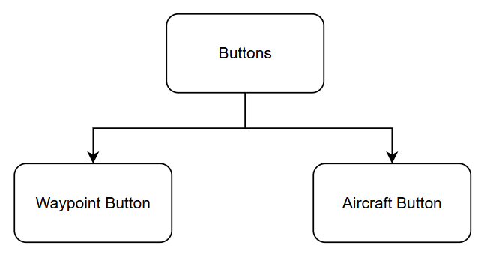

This is the original decomposition of the “Buttons” section under “Events.” The separation of the buttons is justified as we will have separate modules for the two buttons, which check for different variables and parameters. Since we have split up the waypoint and aircraft sections, giving them their own personal timelines and variables, and especially since we declare their events separately, we will need the respective buttons to check for different variables. Even though the code will likely be near identical, this separation is necessary to maintain clarity and accuracy.

This approach ensures that if, for example, the user misidentifies a waypoint as an aircraft and clicks differently to reflect this, the system will correctly handle the error. Since the variables declaring a waypoint or aircraft are distinct, the user would face consequences for such an error. Without this modular split, an incorrect action might inadvertently be rewarded, fostering bad habits. Over time, such habits could undermine the user’s performance during real aptitude tests, potentially leading to failure due to misunderstandings we unintentionally reinforced.

##### Waypoint / Aircraft Button – Joint Decomposition

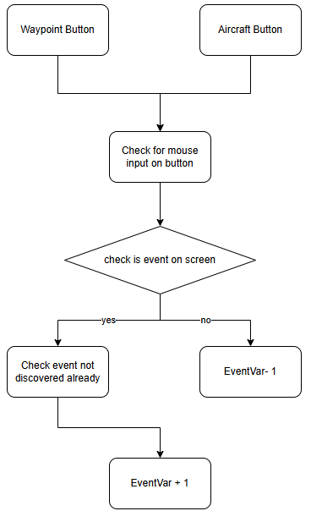

Although in the actual decomposition diagram they are split, and the division was justified in the previous decomposition, I have linked them together here to explain them at the same time, as even though variables and parameters checked are distinctly different, they contain the same code, so I believe it is justified to link them together only for this explanation.

Check for mouse input on button Justification: we first need to actually check if the user has clicked on the buttons, which is what this does. This is a surface level interaction between the user and the UI, with two labels being detected whether they detect an input.

Check is event on screen Justification: the objective of pressing the buttons is so that the user gains or loses points depending on whether the event clicked is on screen, which is exactly what this section represents, this section is needed to demonstrate that the user will lose points for an incorrect assessment of the terrain, unlike other sections where they just don’t gain points. The total amount of individual events which occur will also be stored in a variable and compared against the EventVar’s score. The next branches just demonstrate the results of this decision block.

##### Flashing Lights – Decomposition

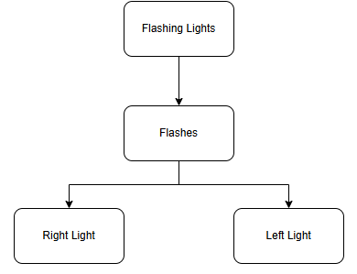

The Flashing Lights branch is a section of the events/terrain rendering which occur as the fundamental code of creating a flash is very similar to creating a waypoint or aircraft, utilising the same methods and processes on a slightly smaller scale.

Flashes Justification: whilst flashes is the only decomposition of the Flashing Lights, I believe it is necessary to outline that the following modules described are about making the lights flash, and the lack of other decompositions could portray that there are no other necessary functions of the lights, other than to flash and be observed by the user, as the lights’ usage in the test is simply to add as another distractor and feature the user must observe as a question mentioning them may come in the passive recall questionnaire.

Right / Left light split Justification: there are two flashing lights next to eachother on the ‘dashboard’ in the exam, and realistically we could keep the two lights joined together, however this would make the next modules messy, and unable to perform separate tasks together, such as flash at the same time, which is a feature of the actual FAST which I believe important enough to add slightly more modules to ensure is a possibility.

##### Right / Left Light – Decomposition

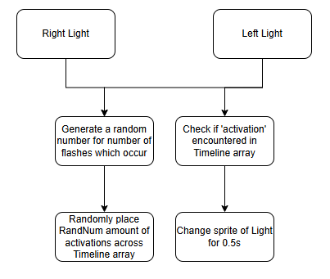

We join the right / left light modules again simply because their processes, while separate, will remain the exact same, and joining the modules together shows the utilisation of code reuse and sustainable programming.

Generate a random number branch Justification: this module, similar to the waypoint / aircraft random number module, will generate a random number between an upper and lower limit, which will decide the total number of times that the light will flash. This is important as a common question which occurs is how many times a certain light had flashed in total, so we need the number to be random to ensure this question changes between tests. We also require an upper and lower limit to the number, to ensure that there aren’t an uncontrollable amount of flashes the user must manage, or too little flashes it is an inconsequential feature the user feels they can ignore. We can also adjust the upper and lower limits depending on difficulty, which gives the user more control over their practise. The next branch is a module which distributes each flash and when they occur over the individual timeline arrays of each light.

Check if ‘activation’ encountered branch Justification: this branch is also shared between the two lights, and separated from the other branch as these modules will be constantly activated and checked for validity. This is a necessary module as without it, the timeline array and the entire module would be useless, as nothing would occur, and the lights would not flash. Once an activation is encountered on the array, then we simply change the sprite of the light to an identical, but clearly alight sprite to imitate a flash.

#### Passive Recall Questionnaire Decomposition

Since this is just essentially a single-file line, I will explain it all in a single block, as there are no decompositions within, only a process-by-process procedure.

We will start by having selected if more than 3 questions have been asked, if less than three have been asked, we gather start the passive recall challenges sequence, else we will Output the final end report.

When the passive recall challenges sequence is selected, we will select a random question from a mini database of set questions that could be asked, such as “How many times did the left light flash?” We will then generate 3 random values from 1-10 to act as decoy answers, and we will put those answers with the actual relevant variable store which holds the answer. We will then randomise the order of these values and generate 4 buttons to hold and represent each onto the screen underneath the question.

Once the UI is set up with the randomly selected question and randomly distributed false and true answer(s), we will check if the mouse has input a click within the hitbox bounds of a button rect every update, and if the button rect is associated with the correct answer or incorrect answer, the respective variables will be updated to match this.

The store of number of questions asked will then be incremented, and the program will repeat until 3 or more questions have been asked.

## Pseudocode Algorithms

### Plane Minigame

*Initialize game*

*Load difficulty settings*

*Adjust cloud spawn rate and chance*

*Create plane object*

*Create cloud list*

*Initialize collision tracking*

*WHILE game is running:*

*Move plane based on arrow key input*

*IF time to spawn cloud:*

*Find available airspace*

*Spawn clouds based on difficulty*

*Reset spawn timer*

*Move clouds*

*Remove off-screen clouds*

*Check for collisions*

*IF collision occurs:*

*Increase collision count*

*Notify player*

*Draw plane and clouds on screen*

The game will start by loading the difficulty settings defined, adjusting how often the clouds spawn and their chance of appearing. The plane moves up and down based on player arrow-key input, and clouds are spawned at regular intervals, with the number and frequency depending on the difficulty. As clouds move from right to left, the game checks for collisions between the cloud and aircraft hitboxes, which if this occurs, there will be a flicker or notification to let the user know they have collided, and the collision count is increased.

### Active Reasoning Challenges

*Initialize game settings*

*Set up question parameters*

*Load difficulty settings*

*Load question database of difficulty loaded*

*Set up button and answer tracking*

*WHILE game is running:*

*IF it's time to ask a new question:*

*Select a new random question from question database*

*Shuffle answers and assign buttons*

*Reset answer tracking*

*Increase question timer*

*IF timer is less than question_cooldown:*

*Output question and options*

*ELSE IF waiting for answer (timer less than double question_cooldown, giving question some time to be asked):*

*Output buttons for answers and highlight selected one*

*ELSE (answer received):*

*Check if the selected answer is correct*

*Update correct/incorrect counters*

*Load a new question and reset timer*

*Draw ARC minigame surface onto the main game screen*

The ARC minigame starts by setting up the game and question parameters, including selecting a random question and shuffling the answer choices. The game then waits for the player to select an answer using buttons, Outputting the question and answers while tracking the timer. After the player selects an answer, it waits a set time and then checks if the answer is correct, updates the score and then loads a new question.

### Report

*Initialize accuracy and score variables:*

*- waypoint_accuracy*

*- aircraft_accuracy*

*- arc_score*

*- quiz_score*

*- collisions*

*IF report is True:*

*Clear screen*

*Output message with the following statistics:*

*- Number of cloud collisions*

*- waypoint_accuracy*

*- aircraft_accuracy*

*- arc_score*

*- collisions*

*- final_score = (weighted sum of accuracies and penalty)*

*IF final_score >= pass_score:*

*Output “PASS”*

*ELSE:*

*Output “FAIL”*

*Output Image of Report*

This algorithm gathers all the statistics from the users attempt at the test, displays the users individual scores, and also calculates a pass or fail mark depending on a threshold value.

### Difficulty

*Initialise User Interface*

*Output Start button*

*Output Difficulty buttons*

*IF mouse input on a button:*

*Set Difficulty = selected button difficulty*

This algorithm simply displays a user interface for the game to start to the user, and upon user clicking a difficulty button with their mouse, the Difficulty variable is changed to that value as a result, which hence changes the difficulty value program wide.

### Terrain + Event Rendering

*START GAME*

*INITIALIZE game window and variables*

*LOAD difficulty setting from file*

*SETUP:*

*- Create surfaces for minigames*

*- Initialize aircraft, clouds, waypoints, and lights*

*- Initialize buttons and scores*

*GAME LOOP:*

*WHILE game is running:*

*HANDLE player input:*

*- Quit if close button is clicked*

*- Handle quiz input*

*UPDATE timers and events:*

*- If time runs out and quiz is not active, start quiz*

*- If quiz is active, display questions and check answers*

*IF quiz is complete:*

*- Display performance report*

*- Show next/previous report pages on button clicks*

*ELSE:*

*SPAWN waypoints if encountered on Timeline:*

*- Choose random position and type*

*- Rotate screen slightly*

*- Add waypoint to list*

*SPAWN aircraft if encountered on Timeline:*

*- Choose random position and type*

*- Add aircraft to list*

*SPAWN clouds randomly*

*UPDATE movement:*

*- Move aircraft, waypoints, and clouds*

*- Adjust positions based on screen rotation*

*CHECK button clicks:*

*- If waypoint button clicked:*

*- Check if waypoint was active*

*- Update score accordingly*

*- If aircraft button clicked:*

*- Mark clicked aircraft*

*- Update score accordingly*

*UPDATE lights and plane minigame*

*DRAW everything on screen:*

*- Background (rotated if needed)*

*- Waypoints, aircraft, clouds*

*- Buttons and UI*

*- Lights and minigames*

*UPDATE screen and limit frame rate*

*END GAME*

This section starts by setting up the screen, loading the difficulty settings previously declared, and then creating objects such as waypoints, aircraft, clouds and buttons. The game constantly checks for player input (like clicking buttons and answering questions) while updating timers for the timeline array, checking for waypoint, aircraft and cloud spawn intervals. If a player clicks the right object when the equivalent event is active then they gain points, if they make a mistake they lose points. The screen rotates slightly to mimic changing bearings at a waypoint. At a certain time limit, the quiz (referenced in a different algorithm) will display questions which require user input, and after this, the performance report is shown, which will keep running until the player quits.

### Passive Recall Questionnaire

*SET asked_questions = EMPTY SET*

*REPEAT:*

*PICK a random unused question from:*

*- "How many aircraft appeared?"*

*- "How many waypoints appeared?"*

*- "Total flashes?"*

*- "Left flashes?"*

*- "Right flashes?"*

*- (If waypoints exist) "What was waypoint at position X?"*

*STORE correct_answer as actual game value*

*ADD question to asked_questions*

*CREATE multiple-choice options (1 correct, 3 random between 1-10)*

*SHUFFLE options*

*DISPLAY question and options*

*WAIT for user click*

*IF user clicked correct answer: INCREMENT correct_answers*

*ELSE: INCREMENT incorrect_answers*

This section is the quiz that will be asked at the end. It chooses a random question from the short list given, outputs the question and stores the correct answer referred from the main terrain + event rendering, and outputting the question. The question is then followed by 4 answer buttons, one of which being the stored correct answer, and the other 3 being random numbers generated from 1-10. If the user selects the correct answer button, then the correct answers store is incremented by 1, else the incorrect store is increased, and then it adds the question to the completed questions, asks another question which has not yet been asked (assuming the asked questions is below a limit).

### How these algorithms form a complete solution:

My solution effectively replicates the FAST test by integrating multiple simultaneous cognitive tasks, allowing users to practise essential skills required for integrated flight school applications. The program includes a structured start menu with difficulty selection, followed by a multitasking test that simulates real exam conditions. When these algorithms are linked together, they will feature aircraft and waypoint identification, a cloud-avoidance minigame, problem solving, and tracking of randomly flashing lights, all of which are concurrently running to assess both the user’s ability to manage multiple tasks at once, and how they would fare in actual natural aptitude tests. After the simulation, a recall questionnaire evaluates the user’s observation and memory skills, reinforcing the importance of attention to detail. The system then generates a performance report with a pass/fail outcome and skill breakdowns. By accurately simulating the same tasks utilised in the FAST, we recreate challenges of real aviation aptitude tests, and my solution provides a structured and accessible way for applicants to prepare, filling a critical gap where there are no free practise tools.

## Analysis of Object-Oriented Design, Key Variables and Data Structures

### Class Diagrams

#### Plane Minigame

|  |
| --- |
| Plane |
| Plane.Image : Surface  Plane.X : int  Plane.Y : int  Plane.Hitbox : Surface |
| Movement()  Draw(Surface[])  Notify()  Hitbox() |

|  |
| --- |
| Cloud |
| Cloud.Width : int  Cloud.Height : int  Cloud.X : int  Cloud.Y : int  Cloud.Hitbox : Tuple |
| Move()  isOffScreen()  Draw(Surface[])  Hitbox() |

|  |
| --- |
| Hitbox |
| Hitbox.Cloud : Cloud / Instance  Hitbox.Plane : Plane / Instance |
| isColliding(Plane, Cloud) |

#### Active Reasoning Challenges

|  |
| --- |
| AnswerButton |
| AnswerButton.Text : string  AnswerButton.Font : pygame.font.Font  AnswerButton.Width : int  AnswerButton.Height : int  AnswerButton.Positions : Tuple  AnswerButton.X : int  AnswerButton.Y : int |
| Draw(Surface[], Font, isSelected[])  isClicked(pos[]) |

|  |
| --- |
| ActiveReasoningChallenges |
| ARC.QuestionCount : int  ARC.Width : int  ARC.Height : int  ARC.QuestionCooldown : int  ARC.CompletedQuestions : Array  ARC.Question : Compound Array/String  ARC.Buttons : Compound Array/Surface  ARC.CorrectAns : int  ARC.IncorrectAns : int |
| newQuestion()  drawQuestion(Surface[], int[])  Update(Surface[]) |

#### Report

|  |
| --- |
| Report |
| Report.CorrectAns : int  Report.IncorrectAns : int  Report.isActive : Bool  Report.QuestionAsked : string  Report.CorrectAns : Compound Array/string  Report.QuestionNum : int |
| GenerateQuestion()  Draw()  Update(Event[]) |

#### Difficulty

|  |
| --- |
| DifficultyButtons |
| DifficultyButton.Width : int  DifficultyButton.Height : int  DifficultyButton.Image : Surface  DifficultyButton.isClicked : bool |
| Draw(Surface[]) |

#### Terrain + Event Rendering

|  |
| --- |
| Clouds |
| Cloud.Image : Surface  Cloud.X : int  Cloud.Y : int  Cloud.XSize : int  Cloud.YSize : int |
| Draw(Surface[])  Move() |

|  |
| --- |
| Aircraft |
| Aircraft.Type : int  Aircraft.X : int  Aircraft.Y : int  Aircraft.Speed : int  Aircraft.Image : Surface  Aircraft.XSize : int  Aircraft.YSize : int |
| Draw(Surface[])  Move() |

|  |
| --- |
| Waypoint |
| Waypoint.Type : int  Waypoint.X : int  Waypoint.Y : int  Waypoint.Speed : int  Waypoint.Image : Surface  Waypoint.XSize : int  Waypoint.YSize : int |
| Draw(Surface[])  Move() |

|  |
| --- |
| Lights |
| Lights.inactiveSprite : Surface  Lights.activeSprite : Surface  Lights.X : int  Lights.Y : int  Lights.isActive : bool  Lights.flashCount : int  Lights.MaxFlashes : int |
| Update()  Flash()  Draw(Surface[]) |

|  |
| --- |
| EventButtons |
| EventButtons.Type : bool  EventButtons.X : int  EventButtons.Y : int  EventButtons.Image : Surface  EventButtons.isClicked : bool |
| Draw(Surface[]) |

#### Passive Recall Questionnaire

|  |
| --- |
| Quiz |
| Quiz.CorrectAnswers : int  Quiz.IncorrectAnswers : int  Quiz.isActive : bool  Quiz.Button : Surface  Quiz.CorrectAns : Compound Array/String  Quiz.QuestionsAsked : int |
| Draw()  GenerateQuestion()  Update(Event()) |

### Data Structures

|  |  |  |  |
| --- | --- | --- | --- |
| **Structure** | **Module** | **Type** | **Description** |
| ARC_Questions | Active Reasoning Challenges | 2D Array | I will likely have multiple different arrays for the different difficulty levels selected, this array will consist of a string for a question in the first position for each row, and then the correct answer in position 2, and then 3 incorrect answers in positions 3 through to 5. |
| PRC_Questions | Passive Reasoning Questions | List | This list will feature a couple of questions about features of the practise test which aren’t directly interactable within the duration of the test, such as the number of flashes for each light, number of events etc. Memory recall questions |
| PlaneMinigame_Clouds | Plane Minigame | Array | This will store all the instances of cloud objects that spawn in the plane minigame and remove them once they are no longer on screen. |
| TER_Clouds | Terrain + Event Rendering | Array | This will store the instances of the clouds in the background of the Terrain + Event Rendering module, and remove them once they are no longer on the screen |
| TER_Waypoints | Terrain + Event Rendering | Array | This will store the instances of the waypoints in the Terrain + Event Rendering module, and remove them once they are no longer on the screen |
| TER_Aircraft | Terrain + Event Rendering | Array | This will store the instances of the waypoints in the Terrain + Event Rendering module, and remove them once they are no longer on the screen |
| Timeline | Terrain + Event Rendering | Array | This will be an array which stores randomly placed values which represent events which can occur, such as a flashing light, a waypoint generated, an aircraft generated, and all the specifics, it should be iterated every number of ticks and the next value will be checked for encounter |

### Key Variables

|  |  |  |  |
| --- | --- | --- | --- |
| **Name** | **Module** | **Data Type** | **Description** |
| Difficulty | Difficulty, Terrain + Event Rendering, Plane Minigame, Active Reasoning Challenges | Int | This variable will be declared within the top Difficulty module, which will be determined by users clicking buttons, setting the Difficulty value as such. This value will be written to a text document, and then gathered by other modules, such as Terrain + Event Rendering, by reading the text file, and then storing the value within the text document as a variable to be manipulated and used. |
| SCREEN_WIDTH | Difficulty, Terrain + Event Rendering, Plane Minigame, Active Reasoning Challenges | Int | This variable is declared in each individual module used and will have different values depending on the program and its attributes and will declare the values that pygame Surface will use to create the window width of the module. |
| SCREEN_HEIGHT | Difficulty, Terrain + Event Rendering, Plane Minigame, Active Reasoning Challenges | Int | This variable is also declared in each individual module used and will also have different values depending on the program and its attributes and will declare the values that pygame Surface will use to create the window height of the module. |
| Tick_Rate | Terrain + Event Rendering, Plane Minigame, Active Reasoning Challenges | Pygame Clock | This variable will also be utilised in each module requiring the screen to change, as it will embody the pygame’s clock, which sets the refresh rate for the module |
| Tick | Terrain + Event Rendering, Plane Minigame, Active Reasoning Challenges | Int | This variable will track the current tick of the program, so that events can happen on a timer, utilising the Tick_Rate |
| Game_Length | Terrain + Event Rendering, Plane Minigame, Active Reasoning Challenges | Int | These variables will likely be named something different in each program, as they will serve slightly different processes, but generally they will be a constant that will set the cooldown for ticks for a process, such as the end of the game, to occur. |
| Background_Image | Terrain + Event Rendering | Pygame Surface | A Surface variable which includes the image for the background of the Terrain + Event Rendering |
| SCREEN | Terrain + Event Rendering, Plane Minigame, Active Reasoning Challenges | Pygame Surface | This is the variable which stores the surface window of the module |
| GAME | Terrain + Event Rendering, Plane Minigame, Active Reasoning Challenges | Boolean | This variable is the condition for the main GAME, a Boolean for |

## Product Design

##### **Opening Screen**

This is the design for the screen which appears when you initialise the program, before the test is started. It allows the user to customise their window for the program, learn how to use the program, select the difficulty and start the test. .

###### **Info Button**

The “i“ button in the top left corner of the screen is clickable and hopefully subtle but notable. It allows uncertain or first-time users to go through a basic run-through of the entire practise test and how each function works, from start to finish.

Success criteria this embodies:

* Guide to show users how the program works
* Easy to navigate reports

###### **Start Button**

Located below the logo of the game, and covering the majority of the centre of the screen, is a large “start” button which will start the test once a difficulty setting is selected.

Success criteria this embodies:

* Notable start screen options

###### **Difficulty Settings**

Below the start button are 5 easily identifiable buttons, labelled from 1 to 5 in order of difficulty (harder setting, higher number). The different buttons are separately coloured, using a gradient from green to red – a common gradient used for difficulty settings.

Success criteria this embodies:

* Start screen with customisable difficulty settings
* Notable start screen options

##### **Ongoing-Test Screen**

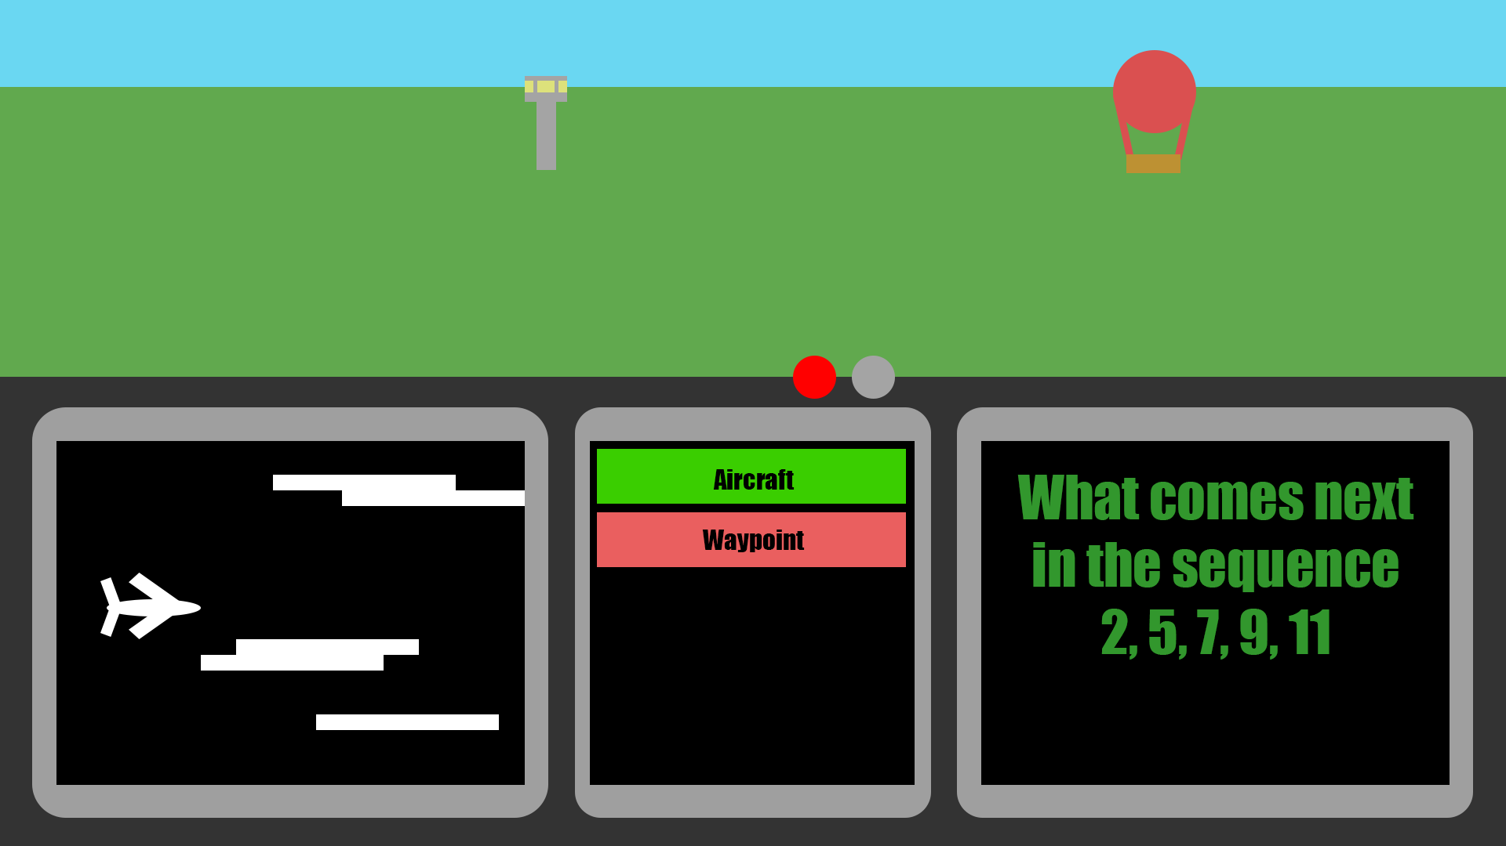When the test is started, the user interface will be similar to this, with the multitasking programs being Outputted in an identical order as shown above.

###### **Rendered Terrain (top half)**

In the top half of the screen, we have a basic solid “terrain” being rendered, shown with the green block, meant to resemble the ground in a grassland. In this grassland, we can see a hot air balloon, which would be randomly generated in (starting from the horizon) and phase out within 20~ seconds as we pass it by. Further down, we can see an air traffic control tower, which would count as a “waypoint”, and will similarly be generated and de-spawned as the balloon. When the aircraft or waypoints appear on screen, the user should click the designated button for the nearest one, doing so when one is visible will award one point, and ignoring an event will be recorded.

Success criteria this embodies:

* Similar UI to the actual FAST
* At least 1 rendered terrain
* Randomly generated waypoints
* Identifiable Waypoints
* Randomly generated aircraft

###### **Top of dashboard lights**

The lights located slightly right to the centre of the screen as shown will flash at random times, in the demonstration image, the light to the left is flashing currently and the light to the right is not alight. The user must be able to count the flashes over the test, and which lights flash at which points.

Success criteria this embodies:

* Similar UI to the actual FAST
* Understandable graphics for the lights on the dash
* Noticeable when the lights on the dash light up
* Both lights can light up randomly
* Reasonable number of flashes from lights dependant on difficulty

###### **Plane Minigame (Bottom Left)**

On the bottom left of the screen, you control a plane moving forward using your scroll wheel or arrow keys and must move up and down to avoid the generated clouds, if a cloud is hit, text at the bottom of the screen declaring “hit” will be shown for 3~ seconds, and it will also be recorded. The clouds will be generated so that it is always possible for the plane to fit through the gaps, and as difficulty increases, the speed of the plane and the number of clouds generated will become greater.

Success criteria this embodies:

* Similar UI to the actual FAST
* Controllable airplane in bottom left minigame
* Randomly generated cloud obstacles in the bottom left minigame
* Ensuring the randomly generated cloud obstacles do not provide obstacles which are impossible to dodge (in bottom left minigame)
* Variable which counts the number of collisions in the bottom left minigame per section of test, per attempt

###### **Reasoning Questions (Bottom Right)**

On the bottom right of the screen, verbal and non-verbal reasoning questions will appear for 4-10 seconds depending on the difficulty, upon which the question will then disappear, followed by 4 potential answers that must be answered within a similar 4-10 second timeframe, which the user answers by clicking on the correct option. The difficulty setting will also adjust the databases for which questions will be asked. Correct answers will be noted, and incorrect and truant answers will both be counted the same.

Success criteria this embodies:

* Similar UI to the actual FAST
* Sensible non-verbal reasoning questions in bottom right minigame
* Adjustable reasoning questions according to difficulty level
* Variables for incorrect/correct maths questions in bottom right minigame

###### **Waypoints/Aircraft Buttons**

As mentioned previously, these buttons are easily identifiable from each-other by using opposite colours, and when a waypoint or an aircraft respectively are Outputted on screen, clicking the respective button will award one point, whereas failing to click a button, or clicking the wrong button will be counted for the final report.

Success criteria this embodies:

* Similar UI to the actual FAST
* Separate and easily identifiable buttons for the waypoints and airplanes
* Variables for when the buttons are clicked when an event is render, and when event is not rendered

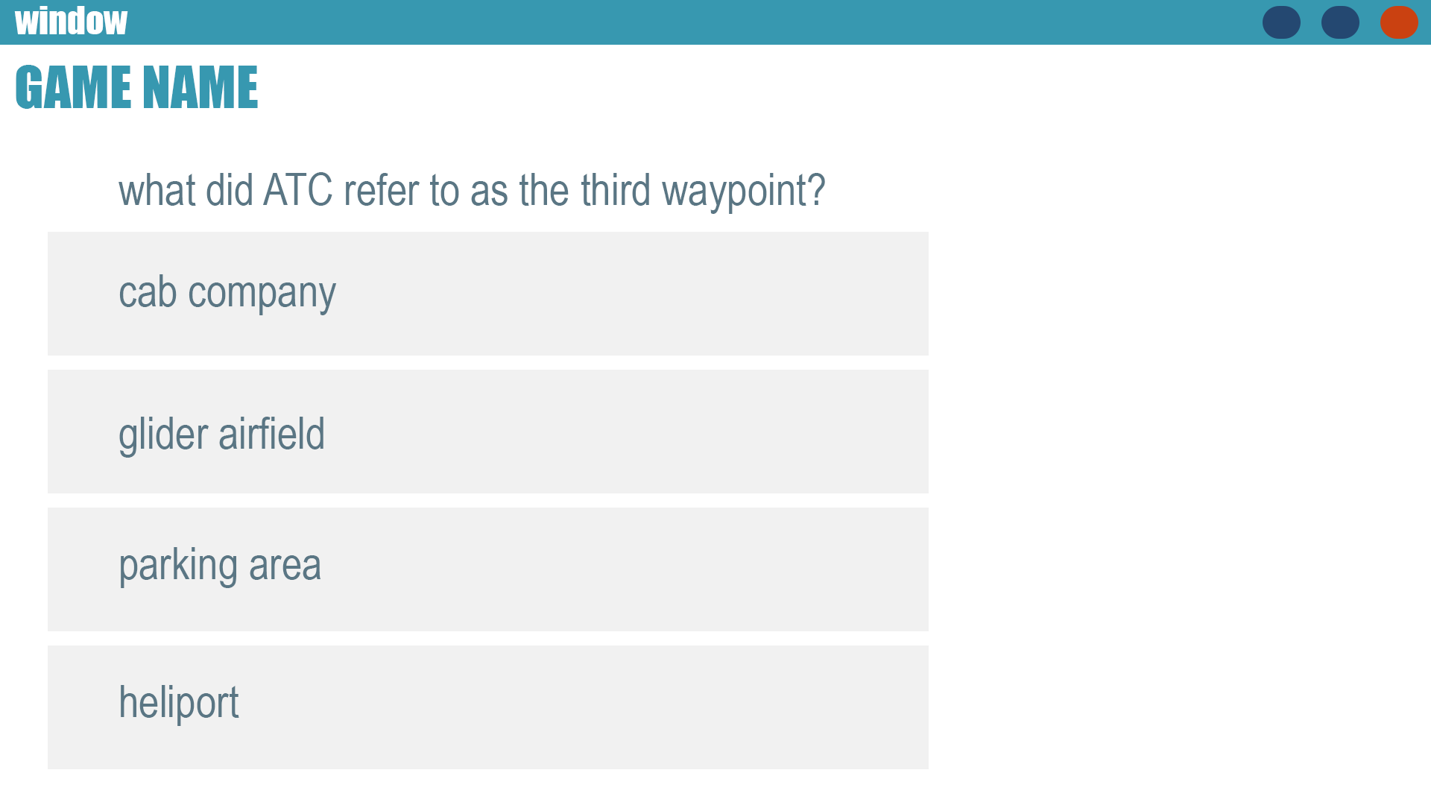**Questionnaire**

After one cycle of a test has been completed, a questionnaire designed like the above will be Outputted, asking a variety of questions based on the test just performed. The number and depth of questions will vary dependant on the difficulty selected.

###### **Question Asked**

The questions will be randomised based on a sum of details of the users flight, such as the generation of waypoints, the number of randomly flashed lights (and which), the details of an aircraft passed, and in this example, an auditory ‘air traffic controller’ talking to the pilot. This will not be a feature of my solution, instead this question was taken straight from the question database of the actual FAST.

Success criteria this embodies:

* Similar UI to the actual FAST
* Reasonable questions asked in the testing phase

##### **Report**

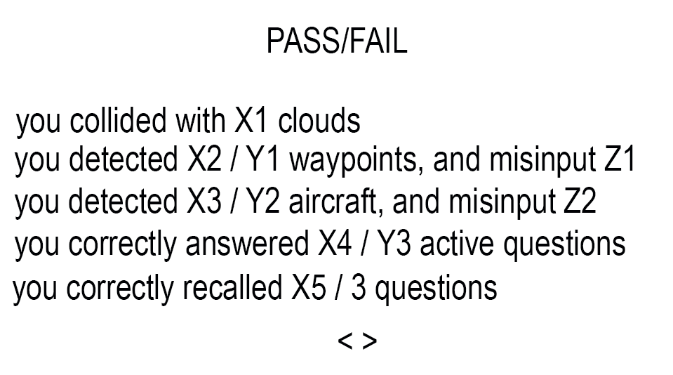

This section will be loaded up after the time limit for the game is up / the user has completed the passive recall questionnaire. Page 1 (pictured above) will show the stats in a simplistic manner for concise feedback to the user

###### **Pass / Fail Mark**

This section will be in text larger than the other text, and will be notable at the head of the page. It will utilise a basic formulae which encapsulates all of the users statistics I created to tell the user if their performance was equivalent to a pass / fail if they were to have taken the FAST or equivalent.

Success Criteria this embodies:

* Easy to navigate reports
* Final report which answers if you would pass or fail

###### **Statistics**

This is the part where the user learns of their actual statistics from their performance in the practise test. It will show the user precisely a stat for each interactable part of the game, including how many Plane Minigame clouds they had collided with, how many waypoints / aircraft they detected out of a total number which actually appeared, and how many times they clicked the waypoint / aircraft button when they shouldn’t have.

It also groups together the two questionnaire statistics, with the upper stat relating to the Active Recall Questionnaire, shown by the “active section”, and then how many final questions they got correct out of the three randomly asked.

Success Criteria this embodies:

* Easy to navigate reports
* Improvement Metrics

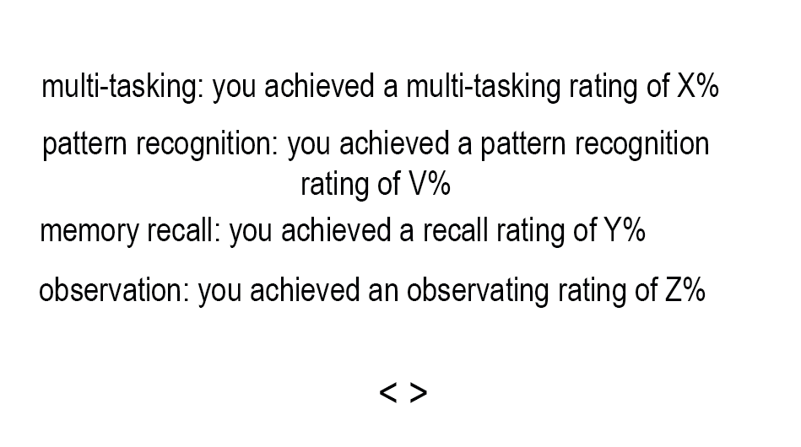

This is page 2 of the report, which will show the abstract ratings of the different categories of skills tested within the test, with a score above 85% being a reasonable level, and the ideal score being >95%.

###### **Sectional Statistics**

The multi-tasking rating takes into account your scores on both the active recall questionnaire and the plane minigame, as those are the main constant tasks which must be performed at the same time. It weighs plane collisions very heavily and correct/incorrect active recall answers less so, as occasionally the user may simply fail to recognise the patterns given, which will be accounted for separately.

The pattern recognition score ranks the aforementioned active recall questions and the user’s ability to detect the patterns given in this challenge. A user with strong pattern recognition skills should be able to achieve near perfect marks, so this score will weigh each incorrect input harshly, giving leeway for one or two incorrect marks at most before a large drop off in score occurs.

Memory recall refers to the passive recall questionnaire which scores the user out of 100%. This score is the direct % of questions they got correct, and so the user must aim to achieve this, as essential parts of the test, such as number of lights which flashed, can only be accessed and tested in this section.

The observation rating looks at the number of correct/incorrect inputs for observation that the user inputs, it gives significant weight to incorrect inputs, which drastically affect the score, as incorrect inputs usually mean the user did not keep track of the events on screen, or was misidentifying events, both of which are heavily disagreeable statistics. It will therefore give slightly less weight to correctly/missed events, although missed events will impact the score exponential to their amount.

Success Criteria this embodies:

* Improvement Metrics

### Branding Designs



The logo has been designed in photoshop, using basic functions such as perspective warp, text and shapes. This invokes a simplistic ideology within the design, as the software is meant to get straight into the point – providing a useful and simplistic practise software to the user, in which the user is given a set of rules and is meant to follow the flow of their practise runs using methods they have been provided with, without deviating. This is a heavy theme in aviation, where pilots are meant to stick to the books, performing the same rigorous and high-pressure tasks multiple times a day, being given set rules they must perfectly abide by without fail.

The elliptical shape is a common sight in commercial aviation, meant for aerodynamics and efficiency over all else, inspired by the body of a commercial aircraft and aircraft fuselages. The typography is stretched and distorted in such a way which suggest speed, airflow, or the view through a curved canopy, referencing the perspective from inside the cockpit, and further influencing the idea of aerodynamics.

### Colour Scheme

The colour scheme used throughout the program consists of different shades of blue, which is fitting for aviation themes, as it is associated with the sky, trust, and professionalism, all of which align with the values of such a practise aptitude practise test. The colours seen are slightly darker than colours used by other similar companies such as SkyTest, as to portray a sense of confidence, a trait which is essential for a pilot. The gradient effect within the letters adds depth, giving the impression of a heads-up Output, a common feature in military fastjets and newer commercial aircraft, such as the B787-10 Dreamliner, or the A220-300.

### Accessibility and Usability

Difficulty:

Difficulty is a fundamental accessibility feature designed to empower a wider range of cadets. Piloting is a skill that isn’t one-size-fits-all; as cognitive processing speeds, reaction times and familiarity with aviation principles vary widely between individuals. By integrating an adaptive difficulty system, Skybound ensures that every player can engage with the assessment in a way that aligns with their personal capabilities. Rather than throwing users in the deep end, and creating artificial barriers, I allow users to fine-tune their experience, removing unnecessary frustration whilst still assessing core competencies.

The Difficulty setting will feature 5 different selectable levels the user chooses prior to starting a session. This setting allows users to slowly adapt to the testing style of the FAST, enabling newer users to start on lower difficulties, such as 1, and getting used to the test and building up the specific multi-tasking skills whilst still performing at a moderate level, allowing the user to build confidence while practising. Once users are more confident, they can select higher difficulty levels, challenging themselves to further build skills in harsher environments, enabling complete confidence going into the actual FAST, which should be significantly easier than the harder difficulty levels of the FAST.

On the main menu user interface, the different difficulty settings will be clearly visible under the buttons to start each attempt, labelled clearly with the number of the difficulty selected, with bright colours corresponding to the difficulty level they embody, i.e. the difficulty 1 will feature a bright green box with the text “1” to show that it is easy, whilst the harder difficulty levels will progressively get more and more red, fading from a green to an amber, and then to a bright red.

Information Button:

The Info Button serves as a critical accessibility feature, ensuring that all users, regardless of prior experience or cognitive processing style, can effectively engage with and understand the game’s core mechanics and assessment structure. This feature directly supports principles of universal design.

Individuals process information in different ways, and by including both text-based and visual explanations, we ensure accessibility for neurodivergent users, including those with dyslexia, ADHD, or other cognitive differences which still enable the user to gain their Medical. For example, while some users may struggle with large blocks of text but benefit from visual representations, while others may require textual reinforcements to fully grasp abstract concepts.

Report:

The final report provides users with structured, transparent, and easily interpretable feedback on their performance. This feature ensures that all users can accurately understand their results and identify areas for improvement.

A major challenge in aptitude-based assessments is the opacity of scoring mechanisms. Without clear feedback, many users may struggle to interpret their performance, leading to frustration and an inability to self-correct. By breaking down scores into distinct skill sections, the report eliminates all uncertainty, ensuring users understand which competencies were tested and therefore which skills they should focus on.

Different users process feedback in different ways. Some individuals, particularly those with dyslexia or ADHD, may struggle with large blocks of text but benefit from well-organised, structured and simplistic statistics, stated with no ambiguity. Others may benefit more from more abstract individual skill targeted performance percentages, which ensures that users are not disadvantaged by inaccessible of ambiguous feedback.

Open source:

The solution is designed to be published as an open source software, available for anyone to view and download the source code and run it for themselves.

One of the primary concerns behind this approach is to provide an accessible alternative to commercial pilot aptitude tests, which can often be prohibitively expensive. Many aspiring pilots may not have the means to afford these high-cost assessments, potentially limiting their opportunities to prepare effectively. By offering a free and open-source alternative, this project helps level the playing field, ensuring that anyone - regardless of their background – has the change to practise, improve their skills, and pursue their aspirations of piloting.

Additionally, making the software open source encourages collaboration within the developer and aviation communities. Enthusiasts, educators and other professionals can modify and expand upon my framework, tailoring it to different testing needs. Over time, this could lead to a more refined and widely adopted tool that has benefits for an even larger audience.

## Test Plan

### Iterative (White box) Testing and Test Data

Each iterative development, I will have a set success criterion I will be required to meet. This means that I will slowly develop different modules outlined in my decomposition diagrams, and at each stage of developing these modules, I will test the following:

Syntax Errors: if any syntax errors occur, I will either perform a regular stage testing, consisting of simple debugging of my code, explaining the existence of a syntax error as a problem in my explanation of my successes and failures, and then explaining what I will change, and the cause, in my next iteration to remove the error. Often for prolonged syntax errors, I will utilise an “Iterative Testing Sequence”, where I will repeatedly attempt to fix the syntax error and then retrial, where if there is another error, I continue debugging until no more errors occur, which then I will perform a formal testing with explanation.

Logical Errors: throughout implementing a new feature, such as cloud generation, or testing to see if clouds are despawned once they go out of view, I will use debugging prints to confirm, such as checking if a cloud instance is still in the cloudList, even after the boundary for despawning has been exceeded. Other examples I will include is the printing the current tick and measuring if visible events such as aircraft / waypoint generation occurs between the randomly generated cooldown. This is mainly a test for the final white box tests, so this will mainly be tested then.

Runtime Errors: to test and combat runtime errors, I will use try and except selection sequences when managing items that may unexpectedly not be present or fail to get recognised. Again, this is mainly a test which should occur during the post-development white box tests.

Example (Formal) Iterative Test Format:

|  |  |
| --- | --- |
| Program | **Explanation of Successes / Failures** |
| A screenshot of the program will be featured here, occasionally with text below explaining a necessary contextual detail. | Here, I will explain exactly what I am executing, and any extra information pertinent to the screenshots of the program provided.  Successes:   * Using bullet-points, I will explain the successes of the previous implementation stage, such as new, working features which were not present before the previous iteration   Problems:   * Here, I will explain the failures of the code I have created, such as syntax errors, logical errors, and basic development errors. |

### Post-development Testing

#### Stakeholder (Black box) Testing

Within this section, I will gather my stakeholders, either virtually or in person, and they will download and trial my solution. They will then be given a series of questions relating to the test, including suggestions and general feedback, which if significant, will be implemented and tested after, with evidenced code, explanations and simple screenshots showing the result.

#### Normal (Valid) Test Data

|  |  |  |  |
| --- | --- | --- | --- |
| **Test Case** | **Test Data** | **Expected Outcome** | **Justification** |
| Clicking on the waypoint button when a waypoint is present | User mouse input on the waypoint button when a waypoint is active | The waypoint button registers the input, and the score is increased by 1. | This ensures the game correctly handles the standard user interaction and updates the score properly |
| Clicking on the aircraft button when an aircraft is present | User mouse input on the aircraft button when an aircraft is active | The aircraft button registers the input, and the score is increased by 1. | This ensures the game correctly handles the standard user interaction and updates the score properly |
| Clicking on the waypoint button when a waypoint is not present | User mouse input on the waypoint button when a waypoint is not active | The waypoint button registers the input, and the incorrect score is increased by 1, and the score is not increased by 1. | This ensures the game correctly handles the standard user interaction and updates the different scores properly |
| Clicking on the aircraft button when an aircraft is not present | User mouse input on the aircraft button when an aircraft is not active | The aircraft button registers the input, and the incorrect is increased by 1, and the score is not increased by 1. | This ensures the game correctly handles the standard user interaction and updates the different scores properly |
| Clicking on a correct answer in the Active Reasoning Challenges | User mouse input on the correct area hitbox of the appropriate answer. | The question area registers the input, and the correct score is increased by 1. | This ensures the game correctly handles the standard user interaction and updates the score properly |
| Clicking on an incorrect answer in the Active Reasoning Challenges | User mouse input on the area hitbox of an incorrect answer. | The question area registers the input, and the incorrect score is increased by 1, while the correct score is not increased. | This ensures the game correctly handles the standard user interaction and updates the different scores properly |
| No input on an Active Reasoning Challenge question | No input on the area of answer hitboxes. | No input is registered in any question area, and the incorrect score is increased by 1. | This will ensure that the game correctly handles no input and standard user interaction |
| Up and Down Arrow key input | Up/Down Arrow Key input. | Input is registered, and the plane within the plane minigame moves in the respective direction | This will ensure that the game correctly handles standard user interaction |
| Plane collision with cloud | A plane and cloud hitbox overlap | Hitbox collision is detected, a method to showcase this is activated, the collision store is increased by 1, and the plane does not register collisions for another 2~ seconds | Ensures the game correctly registers collisions and applies the appropriate penalty |
| Plane avoids collision with cloud | Plane moves around cloud with no overlap | No collision is detected, and no penalty is applied | Ensures normal movement does not cause false collisions |
| User answers a correct question in final quiz | User clicks the button with the correct answer | “Correct Answer!” message printed, correct answers increase by 1 | Ensures correct answers are registered properly |
| User answers an incorrect question in final quiz | User clicks the button with the incorrect answer | “Incorrect Answer!” message printed, incorrect answers increase by 1 | Ensures incorrect answers are registered properly |
| Quiz generates a question when active | Generate question method called | A new question appears with shuffled and random options | Ensures quiz logic correctly selects and Outputs a question |
| Quiz ends after 3 questions | User answers 3 questions | Boolean active variable is false, and no new questions appear | Ensures the quiz stops after the correct number of questions |
| Open info menu | Click the info menu button | Screen loads with the information text | Ensures the information menu and button can handle inputs and output result |
| Change page | Click the page navigation button | Next page is loaded | Ensures regular inputs and page manipulation can occur |
| Select a difficulty level | Click on a difficulty button | Difficulty printed, imported and variables altered in the test | Ensures desired difficulty can be selected and alters difficulty related variables |
| Click the logo / start button | Click on the start button | Game is launched with difficulty selected | Ensures game can be launched with desired difficulty passed through |
| Report active after Quiz | Complete quiz | Quiz is active |  |

#### Boundary Test Data

|  |  |  |  |
| --- | --- | --- | --- |
| **Test Case** | **Test Data** | **Expected Outcome** | **Justification** |
| Plane is just touching a cloud | Planes hitbox is barely inside the cloud’s hitbox | Collision is detected | Tests if collision detection works at the exact overlap point |
| Minimum event count | The count variables for an event = 0 | “How many {event} appeared?” Answer = 0 | Ensures quiz can work with no {event} |
| Quiz asked exactly 3 questions | User reaches 3 questions | Quiz closes, Boolean active variable is false | Ensures stopping condition works properly |
| Rapid clicking during test | Click button multiple times rapidly | All clicks detected | Tests to see if inputs can be overwhelmed |
| Edge of event buttons are clicked | Mouse input is barely inside the button hitbox | Collision is detected | Tests if collision detection works at the exact overlap point |
| Click logo without choosing difficulty | Click logo without selecting difficulty | Test is launched regardless using the last clicked difficulty | Ensures that the game can handle unexpected game start |
| Edge of Quiz answers clicked | Mouse input is barely inside the answer box of quiz answers | Input detected | Ensures collision detection can work at exact button mouse overlap |
| Both page navigation buttons pressed at same time | Press both page navigation buttons at the same time, in the middle | Input to both detected, no page change | Ensures that neither input has priority over the other, resulting in confusing navigation through pages |
| Edge of Difficulty question button clicked | Mouse input barely inside difficulty button | Input detected | Tests if difficulty can be selected confidently regardless of location of input |
| Up arrow input when plane is at limit of border | Press up when plane is at top border | Plane does not move | Tests plane cannot enter invalid location |
| Down arrow input when plane is at limit of border | Press down when plane is at bottom border | Plane does not move | Tests plane cannot enter invalid location |
| Mouse click during movement | Mouse over button while clicking mouse and arrow key | Both inputs registered | Ensures that all inputs are accounted for |

#### Invalid Test Data

|  |  |  |  |
| --- | --- | --- | --- |
| **Test Case** | **Test Data** | **Expected Outcome** | **Justification** |
| Plane moves outside the screen bounds | Plane moves off-screen due to a bug or glitch | Collision detection does not break or cause an error | Tests robustness against movement bugs |
| Event count is negative | Event_count = -5 | Game should run as usual with only a negative start count | Ensures quiz does not accept unrealistic values |
| Clicking outside buttons | Click at (0, 0) | No response | Ensures accidental clicks outside buttons do not cause issues |
| Click info button during game | Try clicking info button when game is launching | No response | Ensures the user cannot accidently activate the info menu during the game |
| Final scores when event statistics are 0 | Event statistic = 0 | Score = 0 | This ensures no division by 0 errors occur |
| Difficulty overflow | Set Difficulty = 50 | Game does not run | Tests if the files are manually altered, it will not run until a valid difficulty is clicked on the menu |
| Close game unexpectedly | Force quit during interaction | Game quits cleanly with no corruption | Ensures that the game is sustainable and will not interrupt the rest of the system |
| Fullscreen toggle | Toggling Fullscreen on the OS | No response | Ensures users with older systems will not encounter accidental errors |
| Click with middle mouse button | Middle-click mouse button | No response | Ensures random inputs will not affect the state of the program |

#### Erroneous Test Data

|  |  |  |  |
| --- | --- | --- | --- |
| **Test Case** | **Test Data** | **Expected Outcome** | **Justification** |
| Plane collides with multiple clouds at once | Two clouds overlap, and the plane hits all of them in one frame | Collision is only counted once | Ensures collision detection is not excessively counting collisions |
| Button click event with no quiz active | User clicks a button when active = False | No response | Ensures clicks do not trigger errors when quiz is inactive |
| No available questions | All available questions have been asked | Boolean Active = False | Ensures quiz handles cases where all questions have been used |
| Try to go beyond the minimum / maximum page | Click the page navigation buttons on the last page | Stays on page 1 | If somehow the navigation buttons are still on screen, ensures the user isn’t soft locked |
| Remove Sprites folder | Change the path location for sprites | Should not load | Ensures the game will not function without all of its constitutional parts |
| Missing UI file | Change path location for that module | Game should run on difficulty last set | Tests if the game module can run independently |
| Missing TER file | Change path location for that module, press start button | UI will close | Ensures that the game will not attempt to run without the main module |

# Implementation and Testing

## Plane Minigame

### Setup, Plane, Movement, and main.

**Success criteria:**

**“**Window with correct proportions created for the Plane Minigame”

**“**Airplane visible in Plane Minigame with accurate proportions”

**“**Controllable airplane in Plane Minigame”

#### 1st Iteration

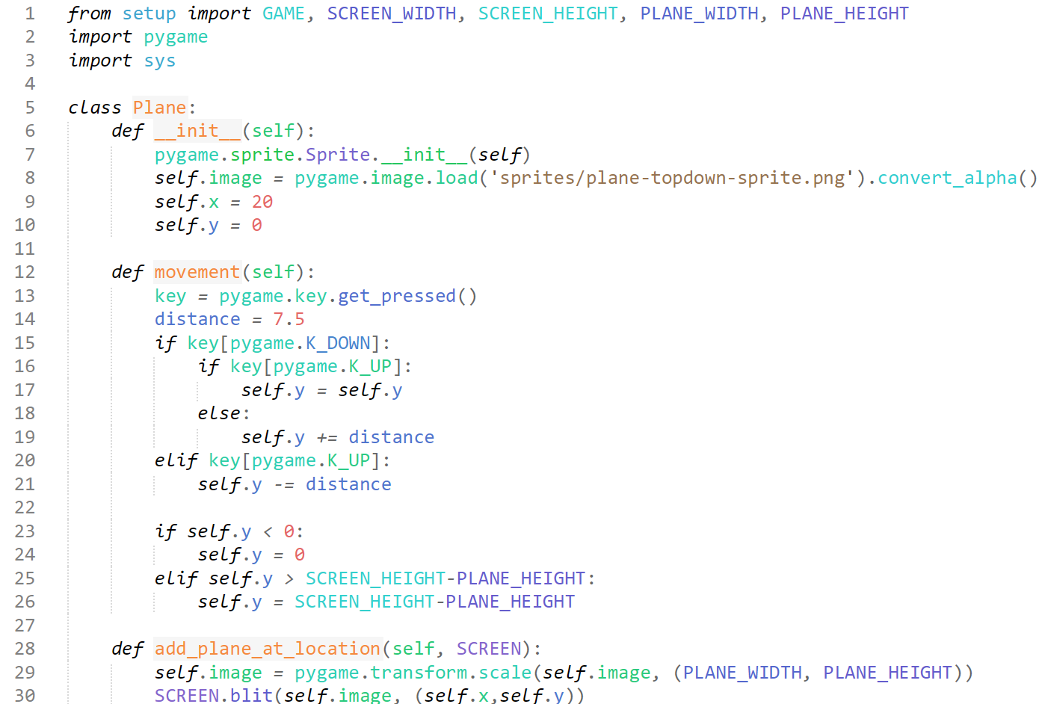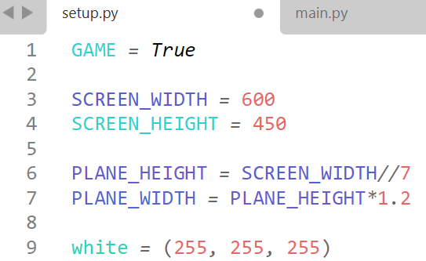titled setup.py, this module is the declarations of constants, such as the window dimensions, and the proportions and size of the “plane” in proportion to this. We also declare some colours for easy access within other modules.

Here is our “Plane” object. It initialises itself with declaring itself as an image along with x and y values. We have a movement method which allows the user to control the vertical movement of the plane, where the distance was chosen as it matches the resolution of the window, and replicates a similar amount of movement compared to the FAST. We also have extra selection statements which check to see if the user is not holding both keys, as this will force the user to move downward, which is not an ideal user experience, so we stop the plane when both keys are pressed, we also ensure they remain in the boundaries of the window by calling the constants declared in “setup”, which therefore can easily be changed with no unresolved issues. We then add a method which simply puts the plane on the screen and resizes the original image to our needs.

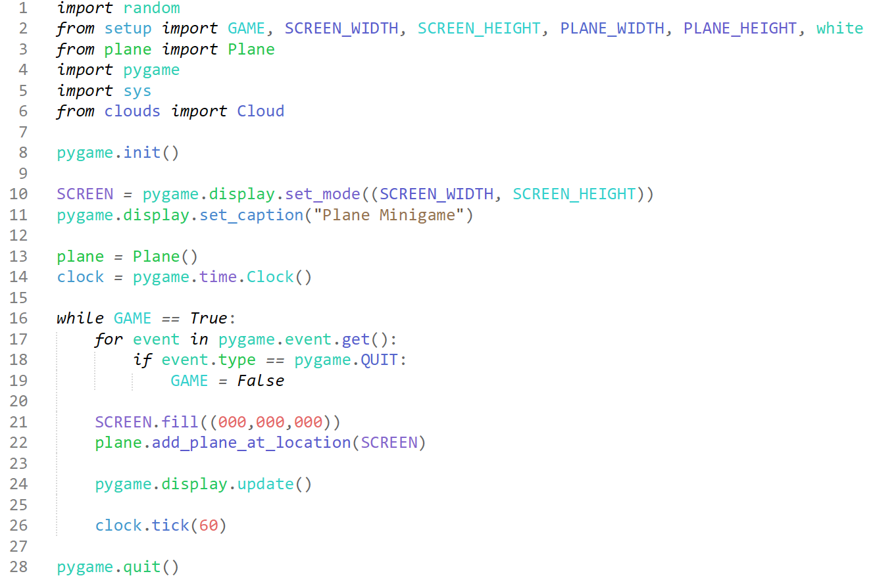

This is our “main” module, which serves as the base of the “Plane Minigame”, here the game is run, and all modules are linked to perform their specific duties within the game, we declare the screen and shorten the plane and clock for easy future use.

Then we get onto the actual running game, we set up an infinite loop for the game to run, and set up the basic pygame event queue. We fill the screen black, just like the FAST, and then we use the Plane’s method “add_plane_at_location” to import it onto the ‘SCREEN’. We then update the Output, so that any changes happening on screen are output, set the clock-tick rate (essentially the FPS the game will run at) to 60, which is a standard value to ensure smoothness however not over-stressing the user’s computer, then we end pygame outside the loop.

#### Testing

|  |  |
| --- | --- |
| **Program** | **Explanation of Successes / Failures** |
|  | When we run the “main” module, this window appears onscreen.  Successes:   * The window opens with correct dimensions and title. * The window background is black * The plane object is output onto the window * The plane object is Outputted as an image * The plane is output at the correct x and y values   Problems:   * The plane object does not move |

#### 2nd Iteration

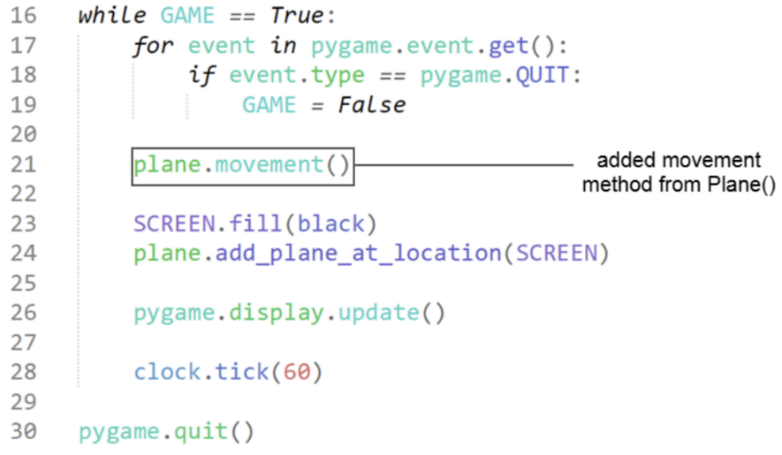 The solution to this is simply to add the movement method to the main GAME loop.

Within the “main” module, I had simply forgotten to call the method which allows the plane to move, movement(). We add this at the top of the module, so that the plane moves before the screen is filled black and other processes are run for the fastest possible access times.

#### Testing

|  |  |
| --- | --- |
| **Program** | **Explanation of Successes / Failures** |
|  | Running the main module again after adding the call for movement method.  Successes:   * Plane now moves up and down depending on the arrow-key input * Plane will not go beyond the borders of the window * When both arrow keys are pressed at the same time, the plane stops * Window runs at 60 frames per second |

### Clouds pt1

**Success Criteria:**

“Randomly generated cloud obstacles in the Plane Minigame”

“Ensuring the randomly generated cloud obstacles do not provide obstacles which are impossible to dodge (in bottom left minigame)”

#### 1st Iteration

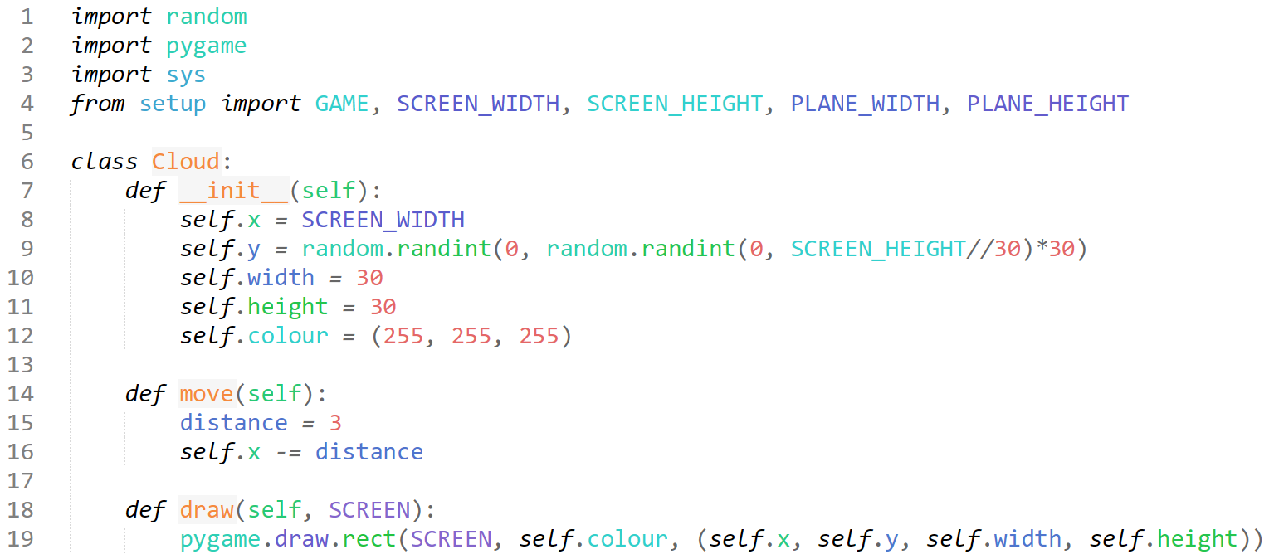

Here I have created a simple object for the cloud which should serve us basic functions to test whether this method of implementing the clouds is viable. We import the basic modules required and setup.py in case we require those statistics.

We declare the class Cloud with no parameters, initialising it with its own spawn x and y co-ordinates, where the x value is set to the width of the screen, so that it spawns at the far right of the screen, just barely not visible, as the default anchor location for pygame is at the top left corner, and for our y value we use 2 random scripts, declaring to choose random a number between 0, and a random number between 0 and the width of the screen / 30 (which in our case would be 15), which this value is then multiplied by 15. I am happy with these random modules as I believe it to be very efficient for the goal, where we essentially draw a ‘grid’ of the y coordinates of the window, where the window is split into 15 ‘grid’ rows, where the self.y coordinates will generate on initialisation. Adding this to the __init__ method works for testing the Cloud and its function, however, will not suffice when we need to spawn multiple clouds.

The move method simply takes the distance constant and constantly updates the x value of the rect, and the draw method creates the rectangle using pygame’s library function ‘rect’.

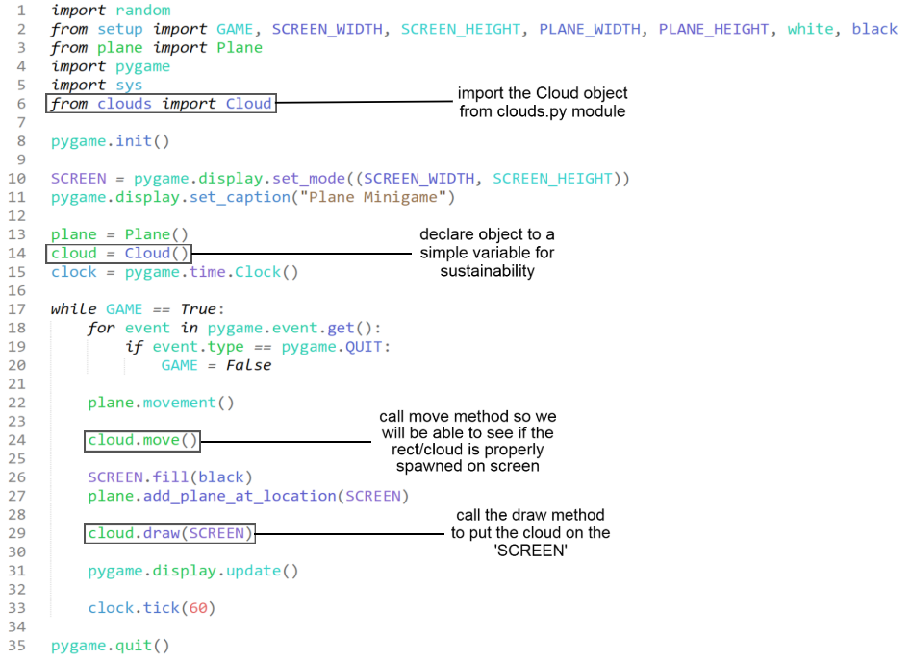

This is the ‘main’ module with labelled added changes which explain the brief edits to test the Cloud object for its fundamentals. We require the movement of the cloud to be at the start, before the screen is filled, and we require the cloud to be drawn after the screen is filled black, as since this is iterated, the cloud would be drawn and then moved as an event.

#### Testing

|  |  |
| --- | --- |
| **Program** | **Explanation of Successes / Failures** |
|  | Running the ‘main.py’ module calling the new imported module with its object and methods.  Successes:   * A ‘cloud’ rect is output on screen * The cloud has the correct dimensions * The cloud spawns correctly from the far right, starting off invisible * The cloud spawns in a random, yet consistent choice from the 15 y values (proven by the two different screenshots) * The cloud moves with the pace specified * The cloud spawns with correct colour desired   Problems:   * Only a singular cloud spawns * Clouds have no detection for one another and do not spawn with eachother * Clouds do not check whether there is a viable gap for the plane |

#### 2nd Iteration

The solution to this problem would be to add a way to spawn clouds over a period of time, and creating a list of clouds to manage and spawn.

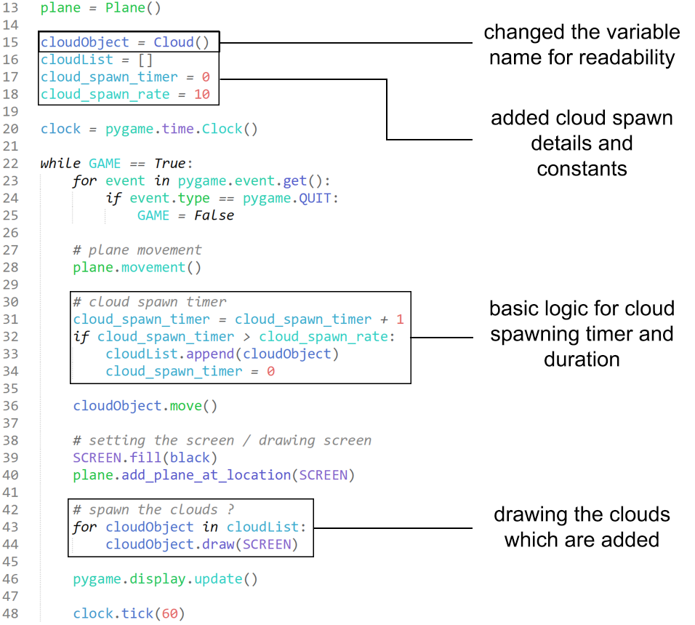

In this next iteration, my main goal is to test the ability to have clouds spawning constantly at a pre-determined rate. We achieve this by creating a list of the clouds, declaring a timer and then declaring a constant to measure when a new cloud is created in comparison to the timer.

In the GAME loop, we add the timer variable by 1 for each tick which occurs, and then every time that variable reaches above the ‘rate’ constant, a cloud object is added into the cloud list, and then the timer is reset to rinse and repeat. Further down, we output the number of clouds on screen as the number of clouds within the list.

This code is not intended to be the finalised version, and not intended to complete the success criteria yet, as I plan to implement small changes such as these to slowly build my way up to that large task, essentially decomposing my workings and iterations modularly.

#### Testing

|  |  |
| --- | --- |
| **Program** | **Explanation of Successes / Failures** |
|  | As usual, running the main.py module with the added changes of cloud logic and adding .  Successes:   * The timer and spawn-rate selection works (tested by adding a print cloudList and print cloud_spawn_timer within main) * Appended Cloud Object into the CloudList   Problems:   * Still, only a singular cloud spawns * The same instance of Cloud is put into the list instead of new instances |

#### 3rd Iteration

The solution may be to rewrite either the method for spawning in the clouds, or even the method for moving them, as there is a chance that the clouds are still being spawned but just aren’t being moved.

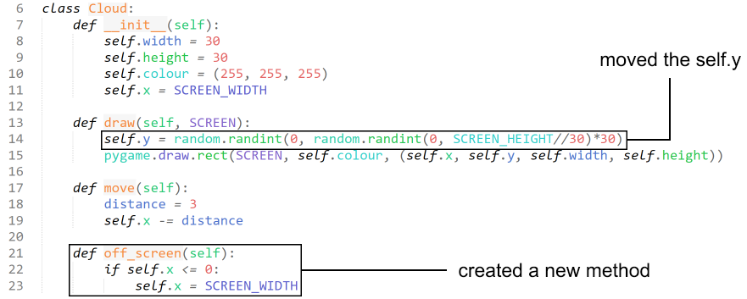

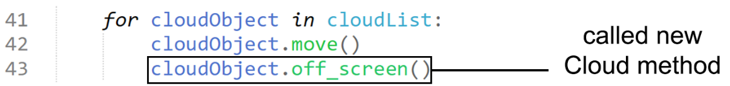

I call the method within the move loop in hopes that it will move each cloudObject within the cloudList, and also check if it has gone off screen each tick.

#### Testing

|  |  |
| --- | --- |
| **Program** | **Explanation of Successes / Failures** |
|  | Running the ‘main.py’ module with the added changes to the cloud object loop.  Successes:   * Method for teleporting the cloud back to the start once off-screen works   Problems:   * Still, while it appears there are multiple clouds, this is only a single cloud object teleporting its y value 60 times a second * The clouds exponentially increase in x speed due to the for loop created * When the cloud is off-screen, it simply teleports back to its original position instead of de-spawning |

#### 4th Iteration

I believe the logic when creating the ‘for’ loop for the movement of clouds and checking whether clouds are off-screen is to blame for the exponential increase in speed, so I will find another way to implement this.

The issue with the cloud spawning can be solved with a different algorithm for determining how clouds are identified and spawned due to CloudList and the iteration spawning algorithm associated. I have identified that since I declare the cloudObject as a set instance of Cloud, every time I append CloudObject to the CloudList, I am just adding the same instance to the list over and over, and therefore each reference to the list simply refers to the same singular object.

The rapid teleportation can be fixed by altering the ‘draw’ method declaring the self.y randomly every tick, and instead declaring back into the initialisation method of the Cloud. This means that each cloud instance will only have a singular, set y value the entire duration of its ‘life’.

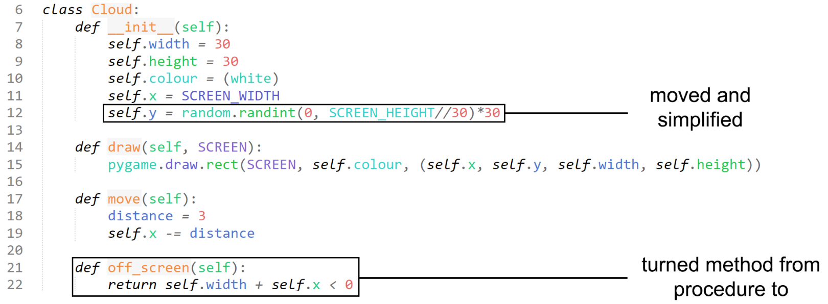

Here I implement the changes mentioned above by taking the self.y declaration from the draw method and put it back into initialisation as a result of changes main to the GAME cloud spawning logic. I have also decided to approach the removal of the clouds differently, instead of detecting when the cloud goes off-screen and just teleporting them back to the original location, I simply return a Boolean value when the entire cloud is invisible (self.x being the top left corner, and then adding the entire width so that all of the cloud must be invisible for a True to be returned) I also imported ‘white’ from the setup module to simplify the self.colour declaration.

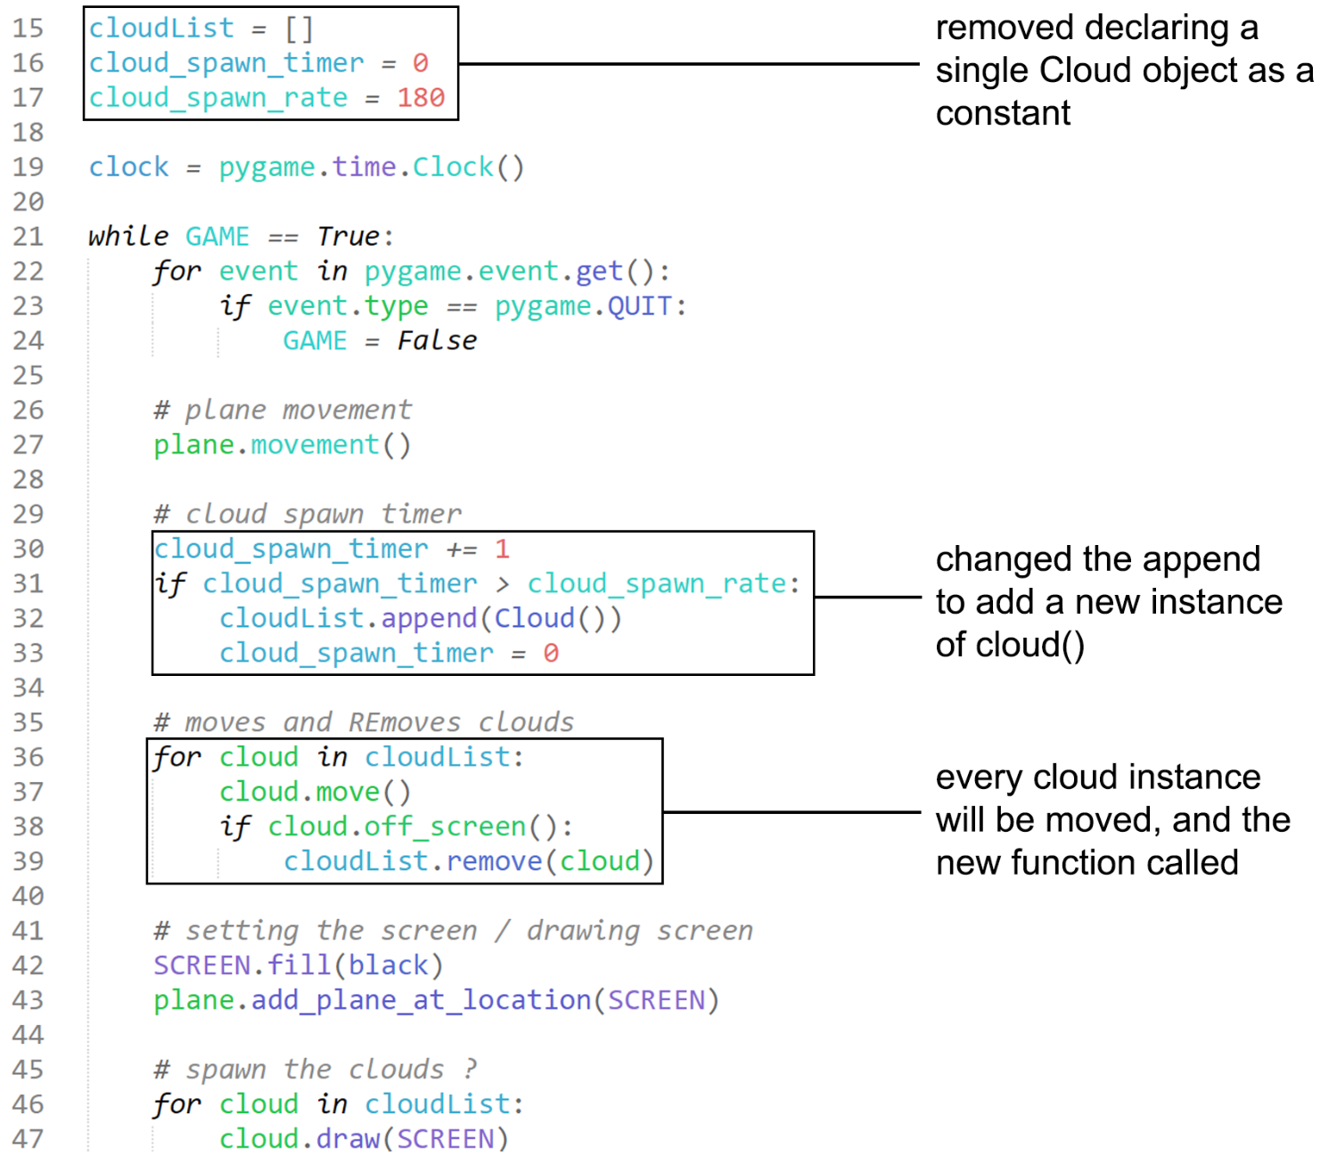

As shown in the diagram, I remove the declaration of ‘cloud’ as a singular instance of cloud to ensure that different instances are created each time I append into the cloudList. I temporarily alter the value for the cloud_spawn_rate so that a cloud spawns every 3 seconds, this however will change to become dependant on the ‘Difficulty’ module which I will implement next.

The logic for the cloud spawn timer is the same, however as this time we append directly ‘Cloud()’, creating a new instance for each item in the list once the timer has been reached.

I alter the process for moving each instance of cloud by creating a for loop, which will iterate over each cloud instance within the loop, and move them separately, I then call the modified ‘off_screen’ function / method, so that if a cloud is fully invisible from the window on the left, it is removed from the list and no longer moved.

#### Testing

|  |  |
| --- | --- |
| **Program** | **Explanation of Successes / Failures** |
|  | Running the main.py module with the added changes to the imported clouds module, and the changes to the cloud logic in the GAME loop.  Successes:   * Multiple instances of the cloud object now spawn * They do not exponentially increase in speed * Off-screen clouds are removed from list * Random y values between the different clouds   Problems:   * Not able to combine the cloud instances together to form larger clouds * Does not check if a viable gap is present for the plane to pass through |

#### 5th Iteration

Now that we have working framework for creating different clouds, we must create processes which will band these instances together, which is what we will target in this iteration.

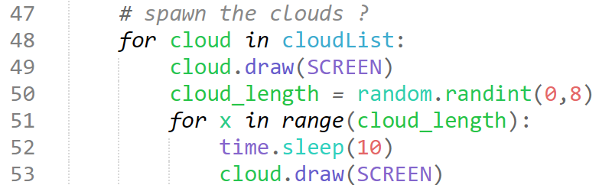I import the time module, and altered the logic slightly in hopes that I could use heuristic methods to achieve the same goal. The thought process behind this was I could generate a random number for the length of the cloud, and then I could use a for loop to spawn the same cloud after waiting 10 ticks, which would mean the x value of the next instance of the cloud would align left perfectly with no gaps between.

#### Testing

|  |  |
| --- | --- |
| **Program** | **Explanation of Successes / Failures** |
|  | Running the main.py module until a cloud is meant to spawn gives the following screen 5/5 tests.  Problems:   * The game crashes upon execution of the new cloud spawn logic |

#### 6th Iteration

This result made it clear to me that I likely cannot create any additions to the process which spawns the clouds in, so I will instead edit the fundamentals of the cloud object and its spawn timer logic to create multiple instances of clouds spawning beside eachother.

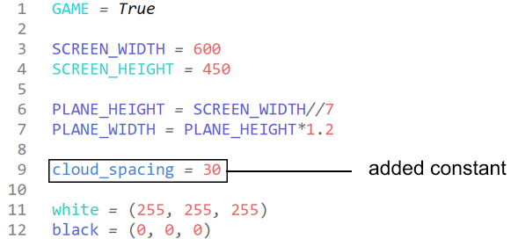in setup.py, I have added a new constant of 30, which is the separation between each cloud instance next to eachother, the same as the width of the cloud so that they completely stick together pixel-perfectly.

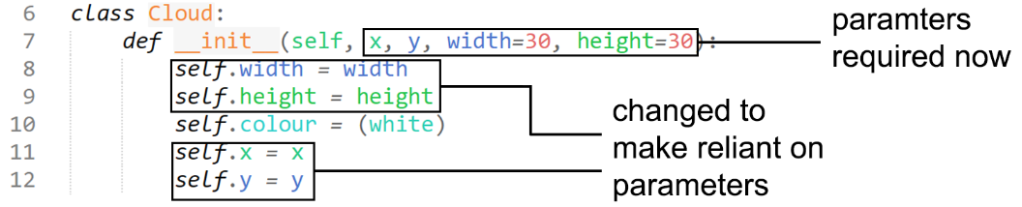

Changing the cloud object to require parameters when being initialised theoretically means when creating instances to spawn in a sequence horizontally, I am able to set each cloud object to follow eachother if I simply take the x and y value of the original cloud instance, and align them by giving the next instance the same y value, and the x value of the original cloud + the cloud_spacing to make them appear to be one singular object. This way I will still be able to use a heuristic method of just joining different cloud instances together without editing the cloud drawing logic, and instead altering the spawns within the spawn timer logic.

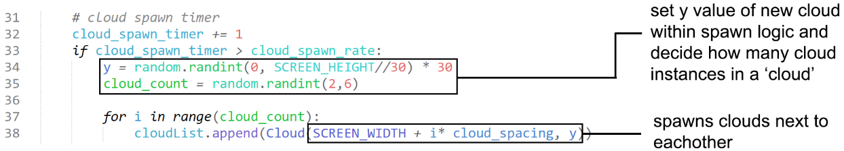

As explained in the annotations, a y value is determined just before the creation of a new cloud instance to ensure each instance is different from eachother, but aligned clouds would have the same y. the cloud_count will likely be altered as iteration continues for accuracy. I am very proud of the logic created for the x values, we take the screen width + the ‘i‘ value and multiply it by the spacing to perfectly create spaced clouds.

#### Testing

|  |  |
| --- | --- |
| **Program** | **Explanation of Successes / Failures** |
|  | Running main.py module with the added changes to setup.py and the edited cloud object.  Successes:   * The game does not crash once built * Several cloud instances can form together to appear as a larger cloud * Clouds have random length between a range   Problems:   * Clouds cannot detect whether there is a possible gap |

I will be pausing development on clouds as implementing the detection of gaps in principle will be significantly more simple once hitboxes and collisions have been created, so I will revisit the ‘Clouds’ section once the hitbox section has been completed.

**Success Criteria not achieved:**

“Ensuring the randomly generated cloud obstacles do not provide obstacles which are impossible to dodge (in bottom left minigame)”

### Hitboxes

**Success Criteria:**

**“**Collision detection system for plane and clouds”

**“**Variable which counts the number of collisions in the bottom left minigame per section of test, per attempt”

#### A screen shot of a computer program Description automatically generated1st Iteration

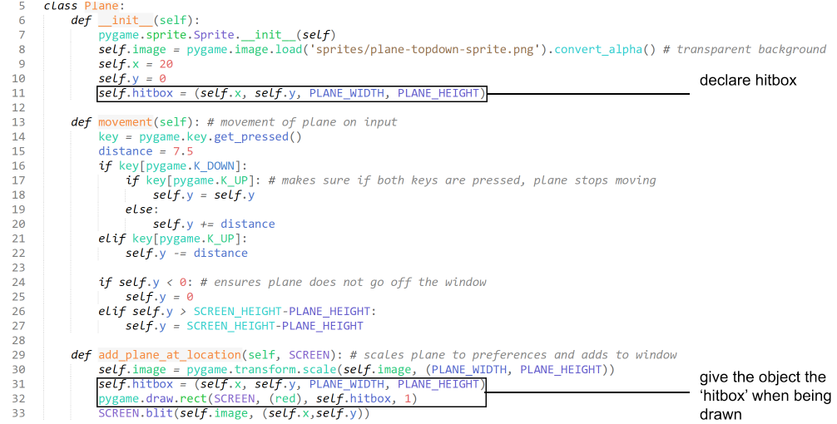I have added a hitbox module to the plane object, which simply draws a box around the plane which will be where we intend to put our hitbox. To do this, I have had to make some slight alterations to the setup and main modules shown in the first image, where I move the declaration of the SCREEN and name to the setup module so that I could import it into the plane.py module without any deadlock imports, and to do this, I must import pygame and sys to the setup module.

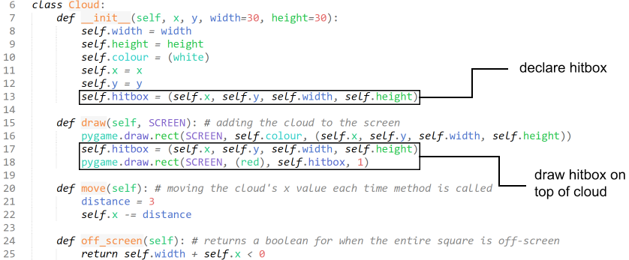We do the exact same thing for the cloud, ensuring that drawing the hitbox rect occurs after the cloud is drawn so it is visible on top. These red rectangles will be a basic outline for where we will make the hitboxes of these objects.

I have sourced the information for creating these boxes from ‘Pygame Tutorial – Part 11 – Hitboxes’ by Max Rohowsky (Max on Tech) on 9/08/20, adapting his programming of his platformer to my object-oriented program, altering details such as the information declared with the hitboxes. (Tech, 2020)

#### Testing

|  |  |
| --- | --- |
| **Program** | **Explanation of Successes / Failures** |
|  | Running the main.py modules with the edits to the plane and cloud object  Successes:   * Red box around plane and cloud * Boxes fit the bounds of the sprites * Boxes move with the sprites   Problems:   * No collision detection |

#### 2nd Iteration

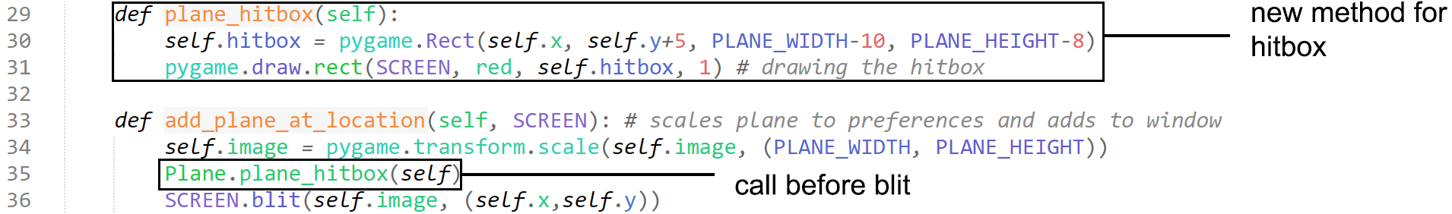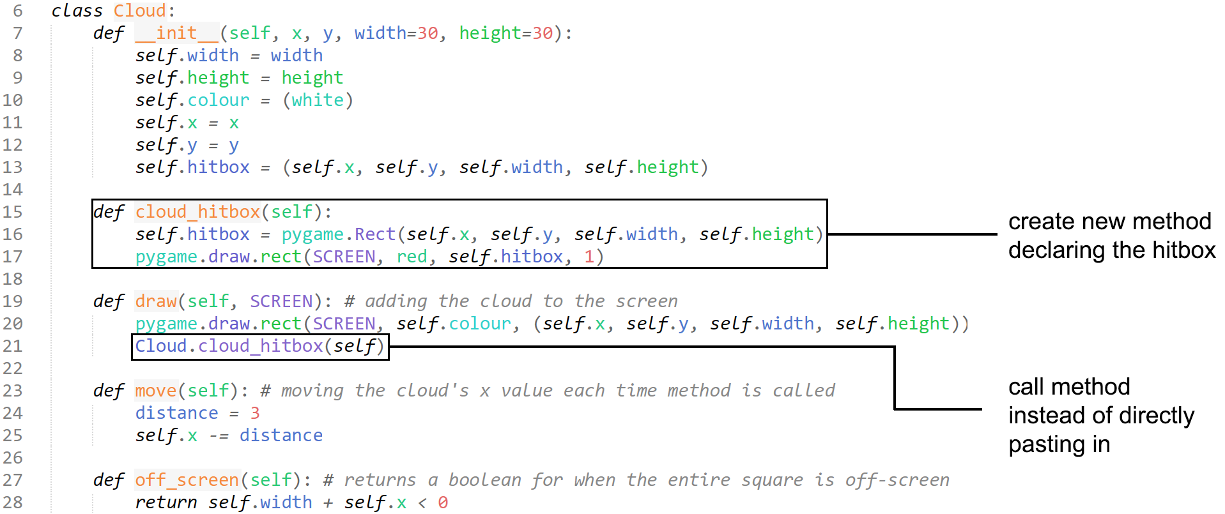to add collisions, I must create a system within the GAME loop which checks each cloud in the minigame for overlap, and to do that I must first define the hitboxes for the main module to access.

Instead of declaring the hitbox and drawing it within the draw method, we can declare a new method with that information and call that method within the draw method. This means that we can interact directly with the cloud_hitbox and plane_hitbox information within the main module for collision detection. There are two screenshots above showing the changes to the cloud object, and then the plane object.

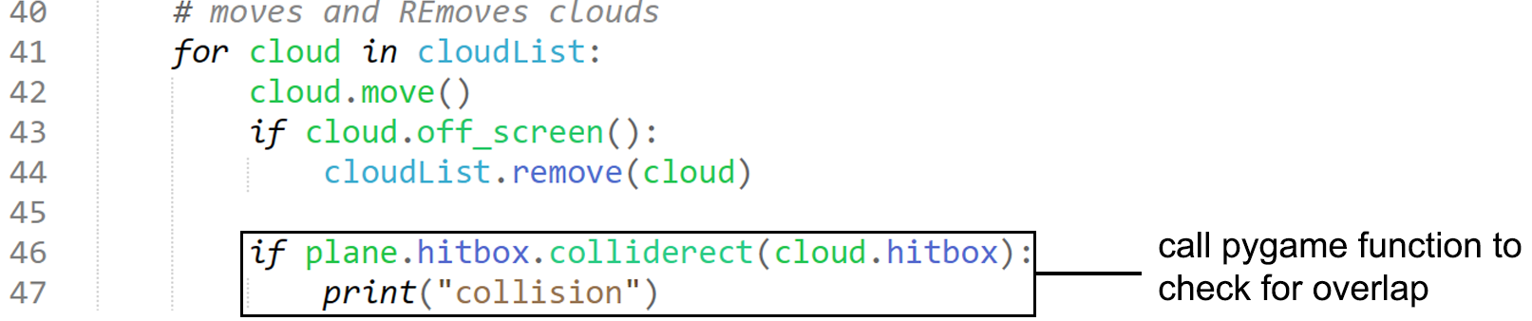We can then simply incorporate the pygame function “colliderect” for the hitboxes of the two objects within the loop which iterates over each cloud, so each cloud has a hitbox interactable with the plane object. I have also adjusted the hitboxes to fit the plane better.

#### Testing

|  |  |
| --- | --- |
| Program | **Explanation of Successes / Failures** |
|  | Running the main module with the new methods and logic added to Cloud and Plane, and then adding the collision detection function within the GAME loop.  Successes:   * Hitbox encompasses only the square where the plane is * When collision boxes overlap, collision is detected which processes the print statement   Problems:   * No variable to store no. of collisions yet * Evident on the screen, the actual plane image isn’t colliding with the cloud, but the hitbox is * Collisions are detected too often |

#### 3rd Iteration

I can simply create a variable to store the number of collisions and add it to the selection statement when collisions are detected, I will also need a way to sleep the collision detection so it only detects one collision even if hitboxes overlap constantly.

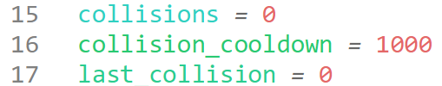First, I declare the variable for the number of collisions, then the cooldown in ticks until the next collision is detected, and then the time (in ticks) the last collision occurred at. I will use the bottom two variables in a maths equation selection to decide whether a collision should be checked for, and once it is, it will be added to the collisions variable, which eventually will be imported to others.

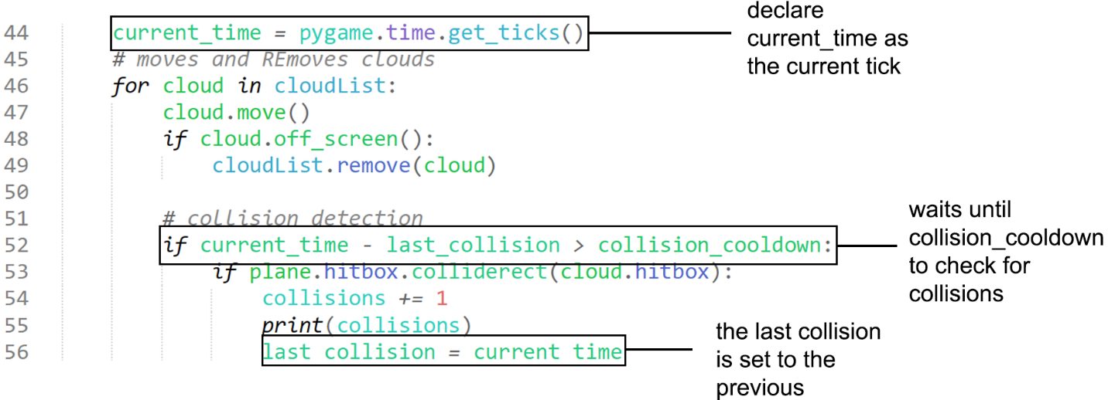This logic sets the current_time as the current tick and then checks if the current tick – the last collision is larger than the cooldown tick, where if it is, it will run the collision detection selection, else it will ignore it and not detect any collisions. When the collision detection code is run, it adds the collisions to the storing variable, prints it for debugging and tracing, and then sets the last collision as the tick which the collision occurred within.

#### Testing

|  |  |
| --- | --- |
| Program | **Explanation of Successes / Failures** |
|  | Running the main.py module with the changes to the requires to check for collisions  Successes:   * The game now waits for 1 second (1000 ticks) between detecting collisions * The collisions variable is not flooded with detections   Problems:   * The box encompasses a large area where the plane sprite does not occupy, giving the user a wrong idea of the hitbox * The user will not know when they have collided |

#### 4th Iteration

This iteration I intend to create a more accurate hitbox for the plane. I believe a heuristic method for creating a more accurate hitbox will be sufficient, as making a pixel-perfect hitbox system would take up a large portion of time, and theoretically adding hitboxes for only the tips of the wings and the body will be triggered anytime a pixel-perfect collision would also be triggered, so I will implement this.

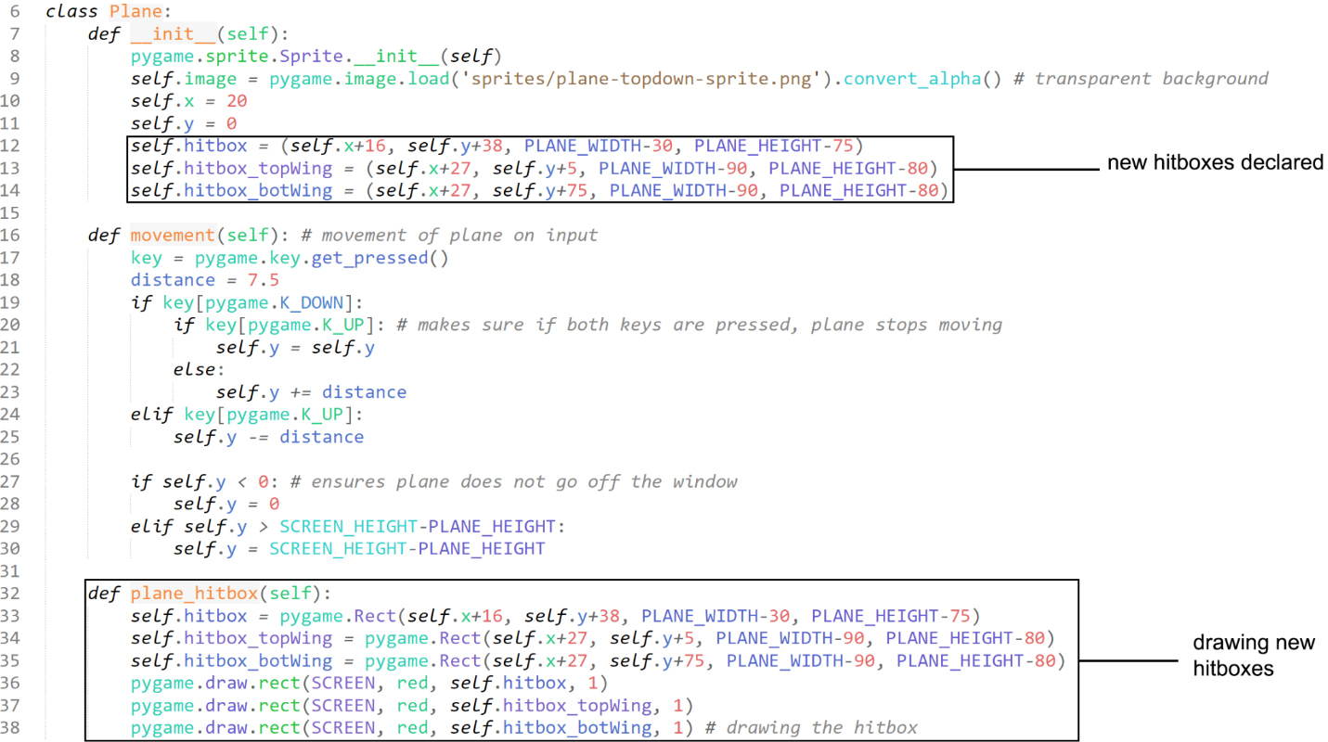I simply just declare new hitboxes. I also edit the previous hitbox to only incorporate the main body of the plane (without wings), and adjust the settings to align them more correctly with the sprite.

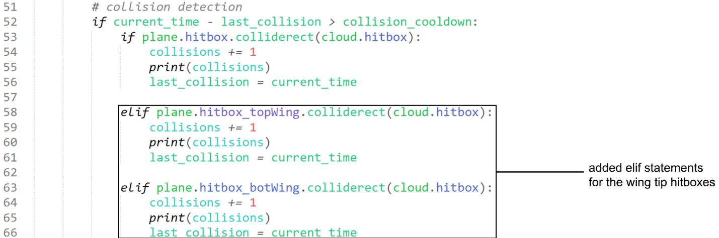added Elif statements to also detect when those hitboxes are triggered within the same loop as the previous box detection.

#### Testing

|  |  |
| --- | --- |
| Program | **Explanation of Successes / Failures** |
|  | Running main with the changes to the Plane object for the hitboxes.  Successes:   * Created accurate hitboxes for the wings without strenuous programming * Both wing tips add to the collisions   Problems:   * The user will not know when the have collided |

#### 5th Iteration

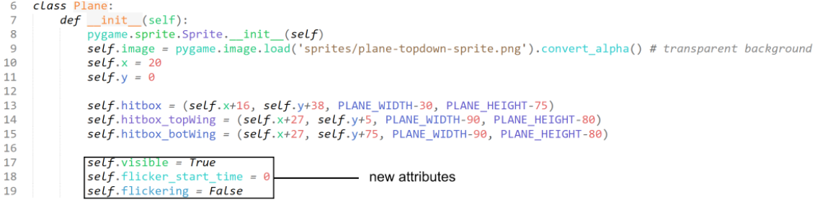I intend to make the plane flicker its visibility on/off 3 times within the second it is ‘invincible’ to show the user that they have collided without distracting them or being too dramatic. This likely requires a few more methods within the plane object to declare when the plane should start flickering, and then constantly updating the plane when flickering for a certain duration of time.

These new attributes will allow me to make selection statements and determine when the plane should flicker.

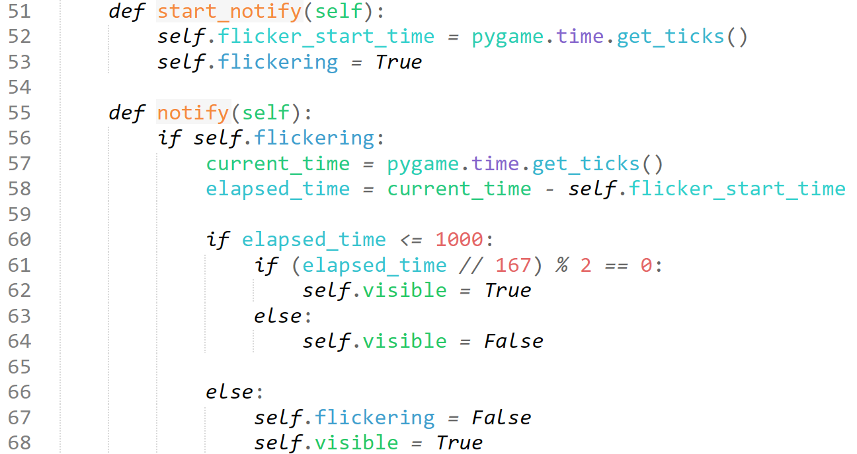We can utilise the self.visible attribute to now determine whether the plane should even be drawn onto the page using a selection statement in the method to add the plane to the screen. I will likely add a class which updates the plane to flicker and put it before calling the draw method to make it flicker.

I have created two new methods within the Plane module + object. The start_notify method will be called when we want the plane to start flickering, and then the update module will be called upon every iteration of the GAME loop to enable this.

Within the start_notify loop, we will take the current tick/time when the program calls to start notifying and will activate the flickering attribute. This attribute is the selection for notify being activated, and if activated will proceed to get the current tick/time, and the elapsed time between the start of the flickering, and the current time of processing. The next selection statement checks to see if the plane has been flickering for just less than a second, where it will check to see if the tick rate can be divided six times, which means that the plane will flicker three times invisible and three times visible, aka 3 flickers. Else, if it has been one second since start_flickering has been called, then it will stop flickering.

We have abridged the logic taken from the cloud generation, utilising ticks and selection statements to decide when events occur.

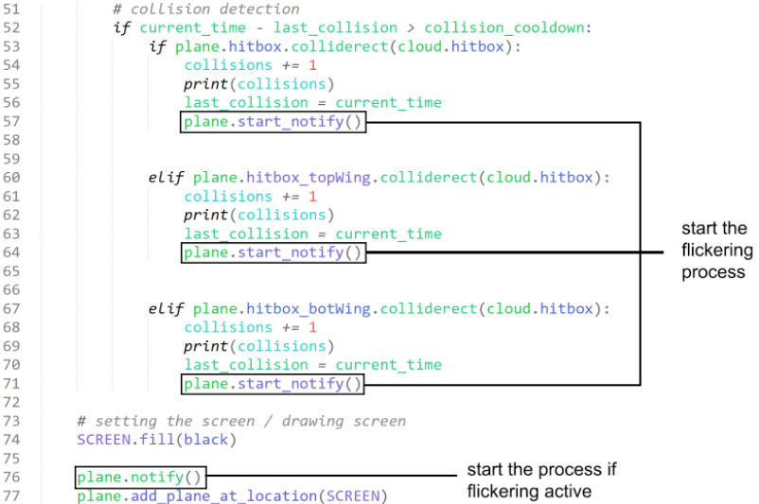

We active the flickering if any hitbox collides with a cloud rect, and then we constantly call the update method before drawing the plane so that it occurs as soon as the flickering is activated.

Now, upon any of the plane hitboxes hitting a cloud, the plane will flicker and the collisions will be added. This should be enough to notify the user that they have collided.

For this iteration, I was heavily influenced by a stack_overflow response about a very similar question, however I have adapted their code heavily to fit into my use of object oriented programming, and my objects.

#### Testing

|  |  |
| --- | --- |
| Program | **Explanation of Successes / Failures** |
|  | Running the main.py module with the new methods and changes to GAME loop. It does flicker 3 times when hitting a cloud, but I can only take an image, so you will have to take my word for it as it is invisible in the screenshot.  Successes:   * Plane flickers 3 times upon contact with a cloud and not invincible. |

I will simply delete the code for drawing the hitboxes for the final iteration, but leave the details of the hitbox, meaning that this module is complete, with all the completed success criteria, soon we can revisit the cloud module to check for sizable gaps.. For now, I will leave the hitboxes visible, and only once the entire project is published will I remove them.

## Difficulty

### Menu

**Success Criteria:**

“Start screen with customisable difficulty settings”

“Similar UI to the actual FAST”

“Notable start screen options”

To take inputs for the difficulty variable, D, I must first create the menu which takes inputs. I am using “**How to Create a Menu in Pygame**” by Coding With Russ, 25/05/22 at link: <https://www.youtube.com/watch?v=2iyx8_elcYg&ab_channel=CodingWithRuss> to help me do this, and whilst he is creating a menu with a different purpose and types of button, I will adapt this to fit my user interface design.

#### 1st Iteration

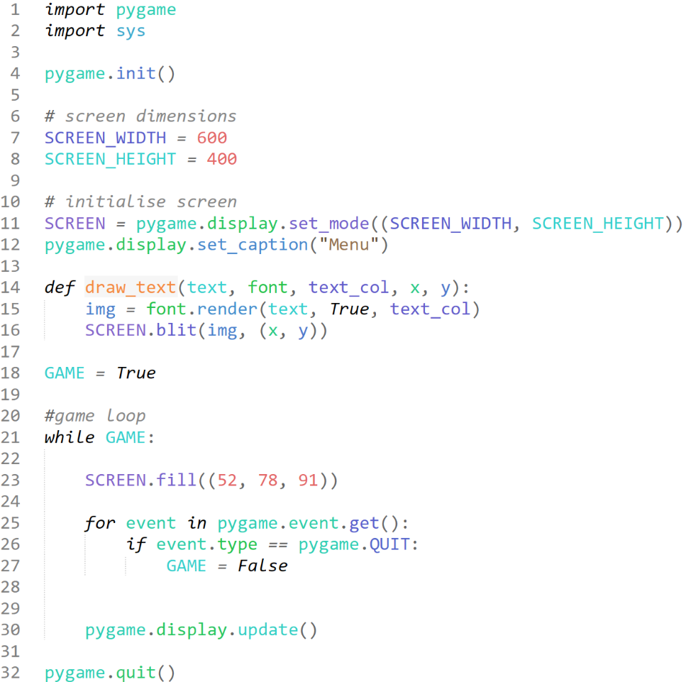I set up the foundations of creating a window here, setting screen dimensions to something small for testing, creating a game loop to run the program, and fill the screen a cool grey. I have copied the method for draw_text, as I know that it will be an important method to use later on when we want to put text onto the screen, as I can see we require the input for the text to put on the screen, the font we will use, and the co-ordinates of where the text should go. (CodingWithRuss, 2022)

#### Testing

|  |  |
| --- | --- |
| Program | **Explanation of Successes / Failures** |
|  | Running this new main.py module saved in a separate file to the Plane Minigame modules.  Successes:   * Window opens * Window titled * Window coloured   Problems:   * No information in menu |

#### 2nd Iteration

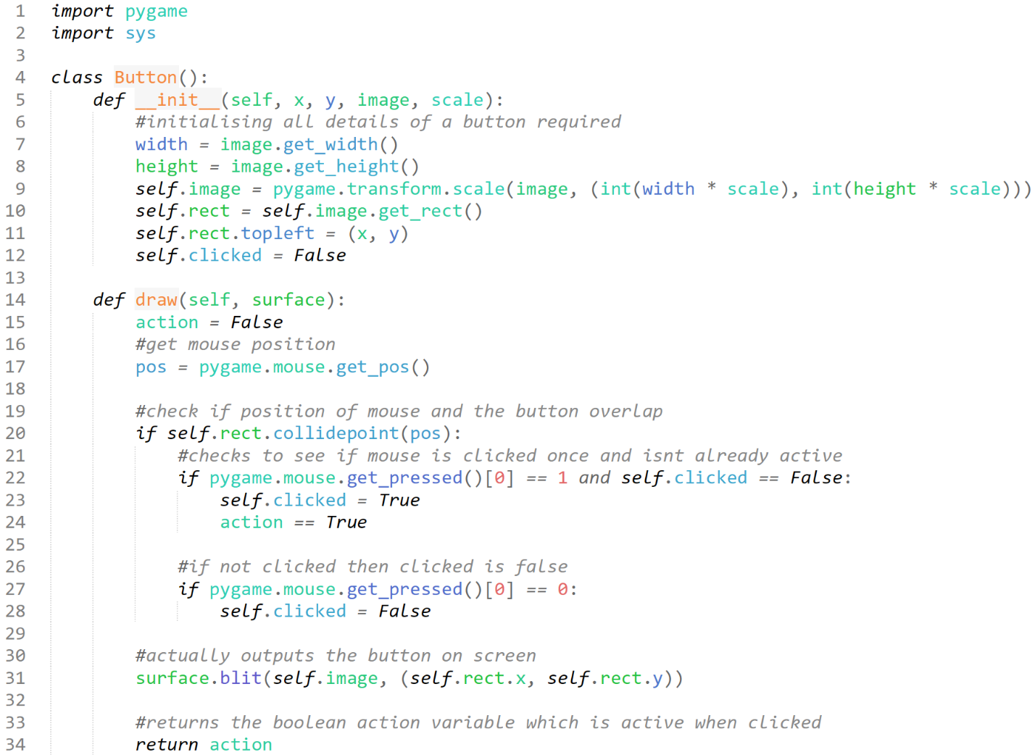I can start by creating a button class which will enable me to create a button using an image, and maybe one by using a rect.

This module is called “button.py”, and will be imported into the main menu script.

Creating a basic object for button and mouse detection, we can reuse many components of previous objects, such as the plane object and the cloud objects, and take inspiration from methods such as spawning, and input detection from the Plane Minigame GAME loop for the declaration of button inputs here.

Essentially, we will pass through the co-ordinates of the button, the image variable and the scale we want the image to be Outputted at as parameters into this object, where it then stores this information as attributes. It contains a draw module, which will get the position of the mouse, and check for any clicks when the mouse is on the button, which it will toggle Boolean attributes depending on the result.



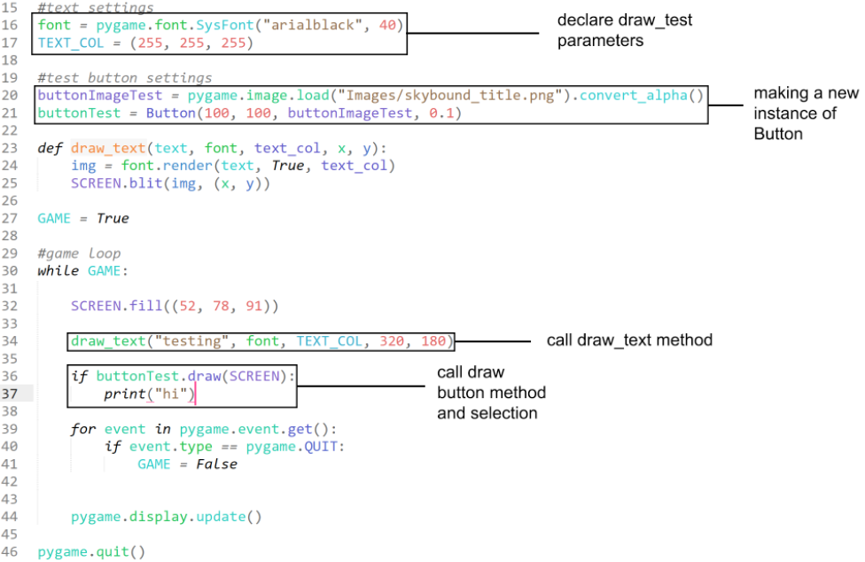As you can see, we declare parameters for draw_text and create a new instance of Button to incorporate into our GAME loop, and then we call the two drawing methods. I create a selection statement for “if buttonTest.draw(SCREEN)” as this would allow me to still call the method and output the button but also check to see if the mouse input works, as the method returns the “action” variable, which is True if mouse input on button.

#### Testing

|  |  |
| --- | --- |
| Program | **Explanation of Successes / Failures** |
|  | As you can see, when we run the main module after the imported button module is created.  Successes:   * Draw_text successfully called and shows an output * Drawing the button is successfully created and called   Problems:   * The button’s mouse input does not work |

#### 3rd Iteration

The mouse input issue is likely something wrong with the draw method, so I will revisit that and check it line by line.

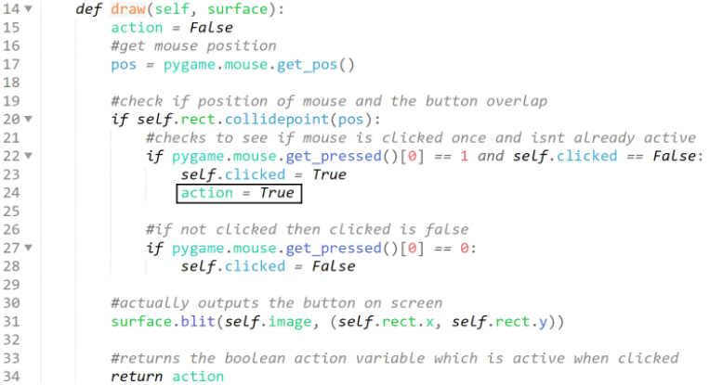 The error simply arose from when I wrote “action == True”, which is a comparison, and not an assignment, which therefore meant action was never declared to be True previously.

#### Testing

|  |  |
| --- | --- |
| Program | **Explanation of Successes / Failures** |
|  | Running the main module after changing the comparison to assignment within the Button object module.  Successes:   * The logo now takes input   Problems:   * Must create multiple instances for the difficulty buttons * Upon selection of difficulty, clicking logo should prompt the start of the game. |

#### 4th Iteration

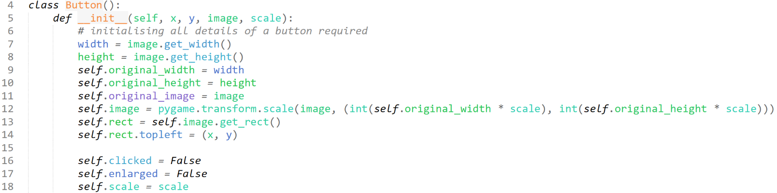For this iteration, I plan to create the button labels for the 5 difficulty buttons and create a neater layout for the menu in general to resemble the mock-up I had made for the design section. I intend to make a method which will show the user which difficulty they have selected.

To create an effect when a button is hovered over (for a more user-friendly experience), I create attributes such as “self.original_width/height/image” and then some Boolean attributes such as “self.clicked” and “self.enlarged”. This enables me to use selection statements for these Boolean variables, where I can enlarge the height and width of the image, and then revert the image back to its original state when the mouse does not hover over the image.

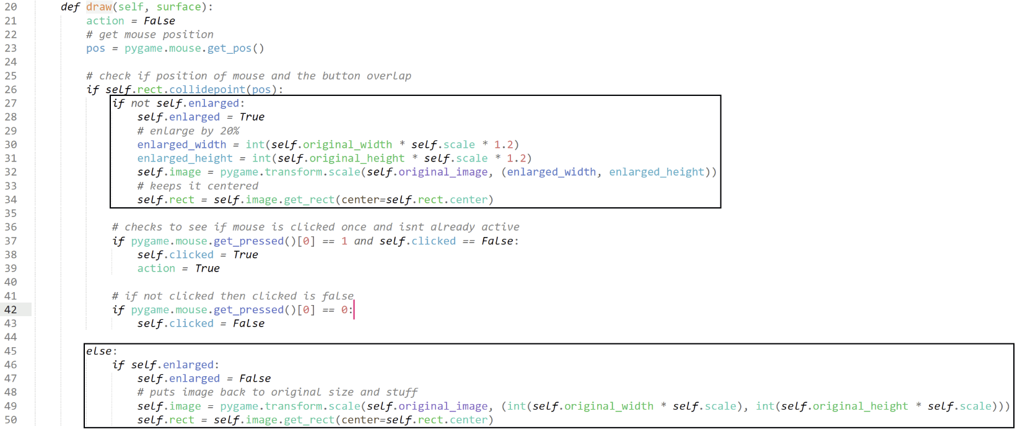I have also made changes to the draw method to facilitate this. When the method detects that the mouse is overlapping an image, it will check if the attribute self.enlarged is False (essentially if the button is not already enlarged), and then will enlarge it by scaling the image from its centre to ensure the image does not move after the mouse stops hovering over it. If the mouse is not hovering over the image, it will declare enlarged as False, and then reset the sizing of the image back to the original (with respect to the centre of the image)

I declare the Difficulty variable after pygame has been initialised. It is defaulted as 3 currently as that will be the standard level.

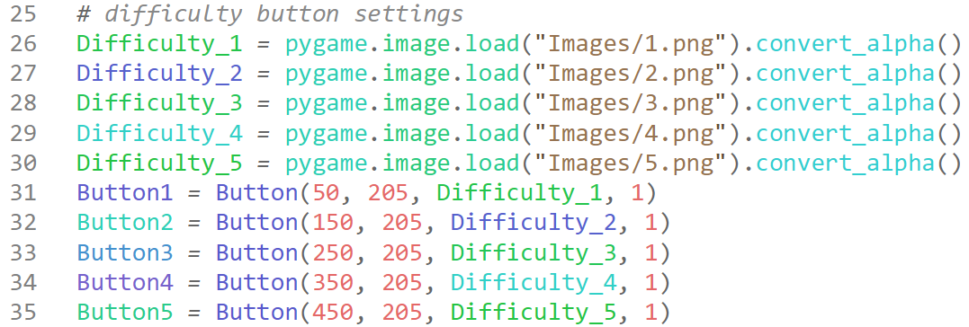I declare all the difficulty buttons by first declaring the image each is associated with, and then creating a Button instance of each, where they are spaced away from eachother (+ the other parameters)

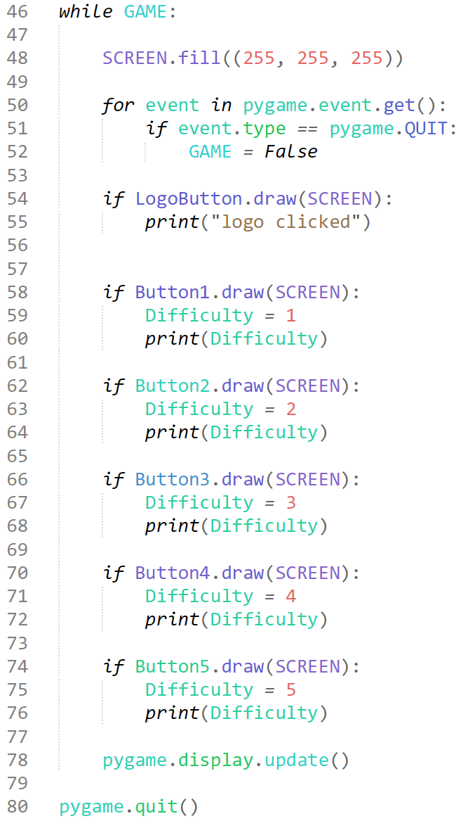Shown to the left is the new GAME loop. I have added the method for each and every button, and due to the sheer length of the code vertically I can only assume there is a more optimised method of doing this, however the only solutions I am able to think of include incredibly pedantic code which may be optimal for space and character count, however would not be worth it, so I have decided to write it simply as this.

As you can see, since the draw method returns a Boolean variable, “action”, we can also use selection statements on them, and upon an “action” (mouse input on the images they represent) we assign Difficulty the value the button represents.

We have print statements under each draw method purely for testing, and they will not remain in the final design of the game.

#### Testing

|  |  |
| --- | --- |
| Program | **Explanation of Successes / Failures** |
| (hovered over the 5 button) | After all these changes to the object, and many logic decisions made, we can run the code in main.py with no issues. When clicking on button 1, 2, logo and 5 respectively, outputs are shown in the terminal below.  Successes:   * Program runs * Each image enlarges upon mouse hover * Input from image / buttons detected * Layout is similar to Design mock-up   Problems:   * Must make Difficulty a global variable, accessible to every module within the entire game. * “are you sure?” start screen * On difficulty select and logo press game should start (run other modules) * No information tab |

#### 5th Iteration

I am going to attempt to get the changeable Difficulty variable accessibly in different modules, using the Plane Minigame as my tester.

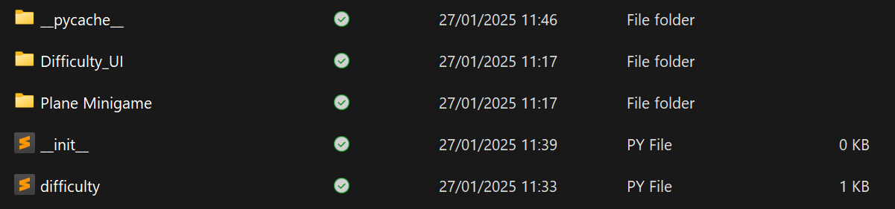Due to the organisation of my project, it is very inconvenient to access a mutual difficulty.



To access the packet within the ‘lower’ modules, such as accessing the difficulty from the Plane Minigame ‘main’ or Difficulty_UI ‘main, we must put this code at the top, which imports os and gathers information about the packet in the ‘higher’ files.

This is incredibly inconvenient, and changing the difficulty within the Difficulty_UI main as a result of an input does not, and will not change the value of difficulty for the plane minigame, so some changes to the organisation must be made.

Previous Organisation:

│ProgramCode/

├── difficulty.py

├── Difficulty_UI/

│ ├── main.py

├── Plane Minigame/

│ ├── main.py

New Organisation:

│ProgramCode

├── DifficultyMain.py

├── difficulty.txt

├── Plane Minigame/

│ ├── main.py

├── (other) /

This new organisation removes the middleman declaring difficulty as 3, and instead just creates and passes the actual changeable difficulty value straight from the UI.

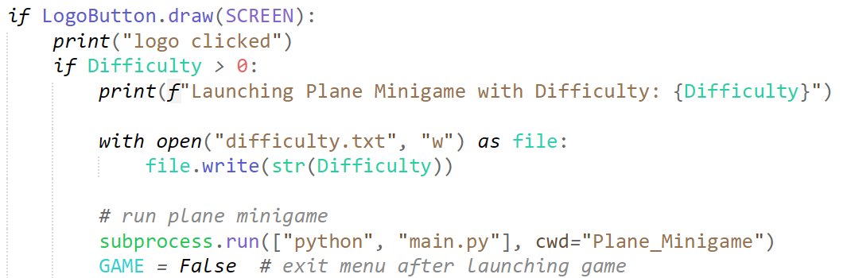

When the logo is pressed, we check to see if the difficulty is greater than 0, because if it is not, then a difficulty has not yet been selected, and the game will not run. We then print the difficulty the user has chosen, and open the text file ‘difficulty.txt’, and write the number which the user clicked on. We finally then run the subprocess ‘main’ for the Plane Minigame, which loads that window, and quits the menu window.

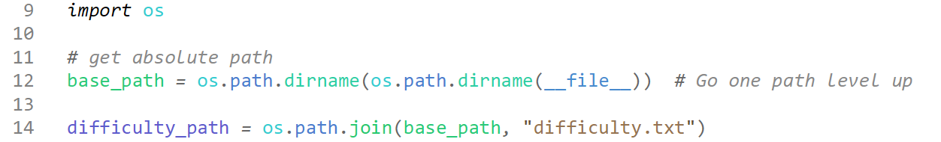

In the main.py of the Plane Minigame, we first import OS to gather the path of the folder one level up, aka the folder which the folder is in, and then assign the address from the difficulty text folder we wrote to previously to ‘difficulty_path’.

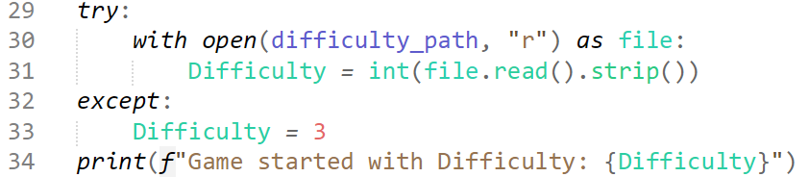Further down, we write this, which tries to gather the difficulty value from the txt file, and assign it to the label ‘Difficulty’, but we will except the Difficulty as 3, so that if the file is unreachable, this is still made to be constant, and the program will not crash.

I will likely implement this section of code in every module / section of the minigame and will reference my explanation here to save time and resources.

#### Testing

|  |  |
| --- | --- |
| Testing | **Explanation of Successes / Failures** |
|  | Running the DifficultyMain.py file.  Successes:   * Reads / writes the difficulty based on input * Plane minigame main.py can read the difficulty * Plane minigame now opens when logo pressed after a difficulty is selected |

### Clouds pt2

**Success Criteria:**

“Ensuring the randomly generated cloud obstacles do not provide obstacles which are impossible to dodge (in bottom left minigame)”

Following up from my previous Cloud development, now that I have hitboxes working, and the difficulty variable in check, I am able to implement the success criteria with a better insight into how the hitboxes of the clouds and plane can be used to measure what is possible vs what is not, streamlining the process of implementing this section.

#### 1st Iteration

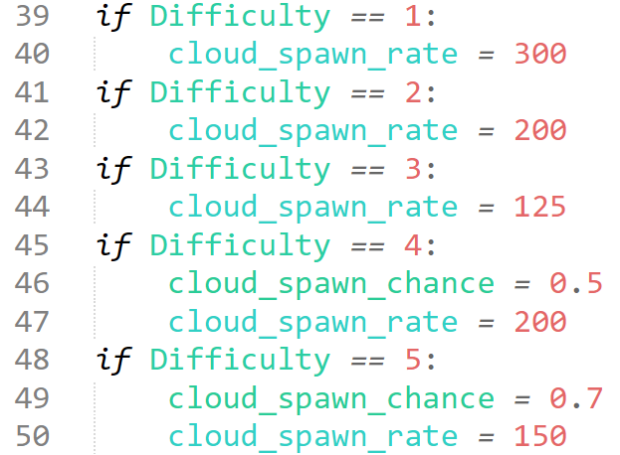First, I set up quite a few IF statements dependant on what difficulty setting was chosen by the user (being read from the txt file).

These numbers have been tested, and feel appropriate for the difficulty levels, proportional to eachother.

You may notice that at Difficulties 4 and 5, we add a new variable, cloud_spawn_chance, which you will see the function for soon.

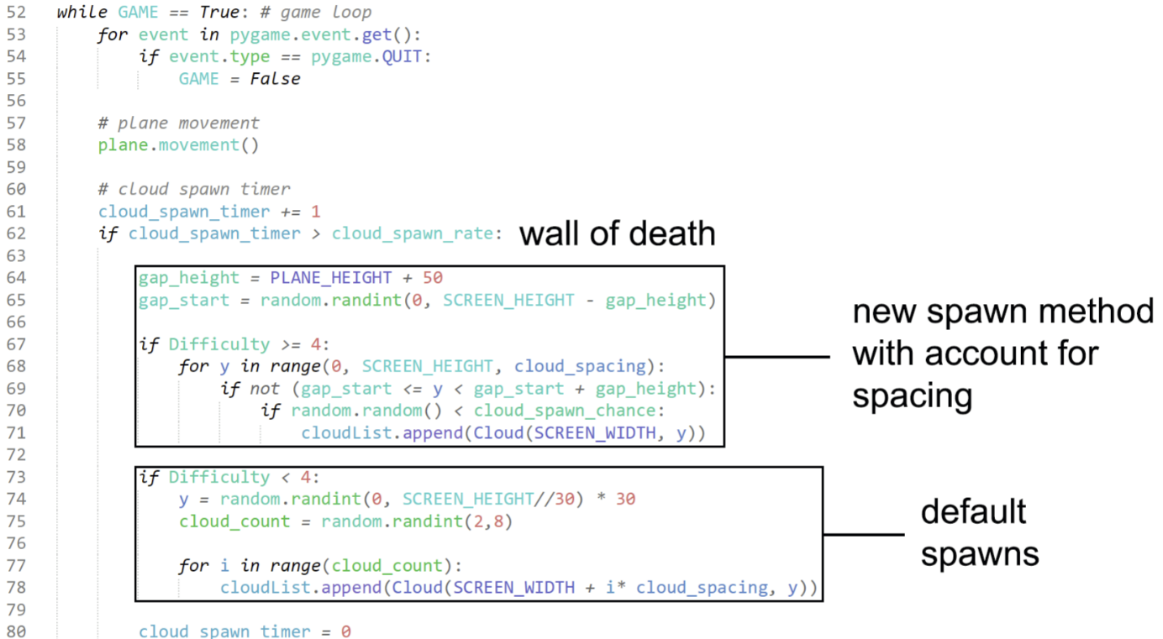

The first box which I labelled ‘wall of death’ for some reason first declares that ‘gap_height’ is the height of the plane + 50 spaces for leeway, and the gap starts at a random position between 0 and this new difference. We then can start writing the code for the ‘wall of death’ for difficulties 4 and 5, which as outlined in my Design, should be relatively harder than 1, 2 and 3. In simplistic terms, I choose a range to put my gap, and then I have a ‘cloud_spawn_chance’ chance of placing a block in any of the other y values. This creates a wall of clouds with at least a gap bigger than the plane for the plane to travel through, hitting the success criteria. I do not implement a feature like this for the <4 difficulty settings, as not enough clouds spawn to make anything impossible. Finally, I remove the hitboxes of the clouds and the plane, and this should conclude our tinkering with the features of Plane Minigame, and this section of Clouds.

#### Testing

|  |  |
| --- | --- |
| Program | **Explanation** **of Successes / Failures** |
|  | Running the DifficultyMain.py module after the features which change parts of the game depending on the difficulty button clicked.  Successes:   * Depending on input, Features of the plane minigame change * Always a viable gap for the plane to fly through, the top proof / screenshot is on difficulty 5, where there are very often spawning ‘wall of deaths’, which will require constant user input. * On bottom image, shows the plane on difficulty 2, with the regular spawning clouds, requiring significantly less input and attention to help build confidence. |

### Information Button

**Success Criteria:**

“Guide to show users how the program works”

“Accessibility Features (Dark Mode, etc)”

#### 1st Iteration

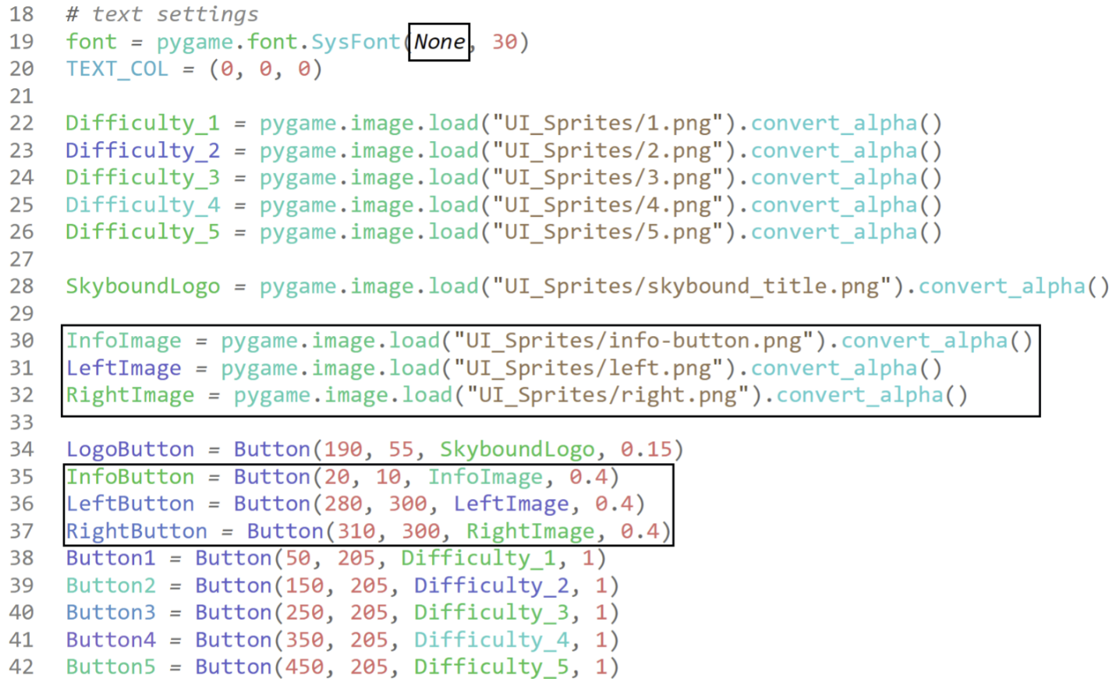In this section, I will essentially just be doing what I have done previously but altering the specifics to add the information screen. In this section I have changed the font to ‘None’, which is the default font which I thought was more professional that the previous ‘arialblack’. I then declare some new images I had added to the directory, and declare them as buttons with the parameters passed through.

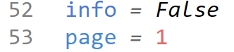

I then declare two new variables, a Boolean for info, and then an integer page variable. The info Boolean will store the state of the menu, where if the user has clicked on an info button, this will be true, and the user will be in the info screen, and if this is false, they will be in the normal screen. The page indicates the page of text the user is on.

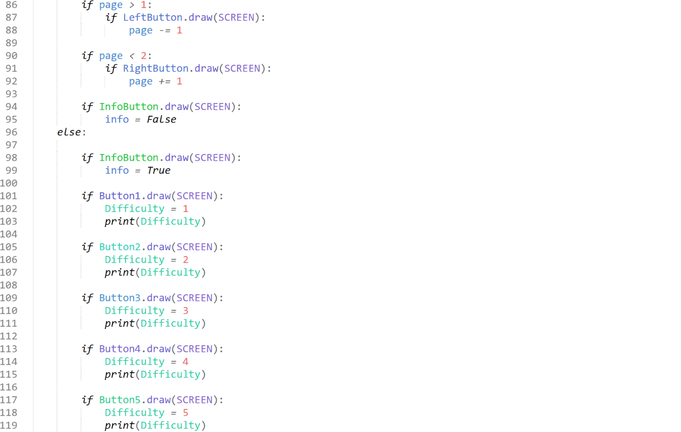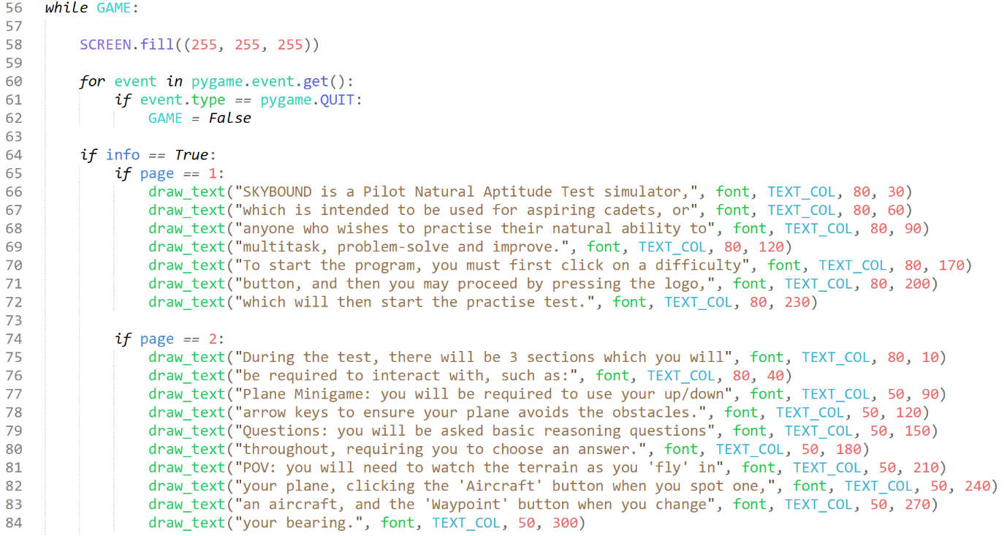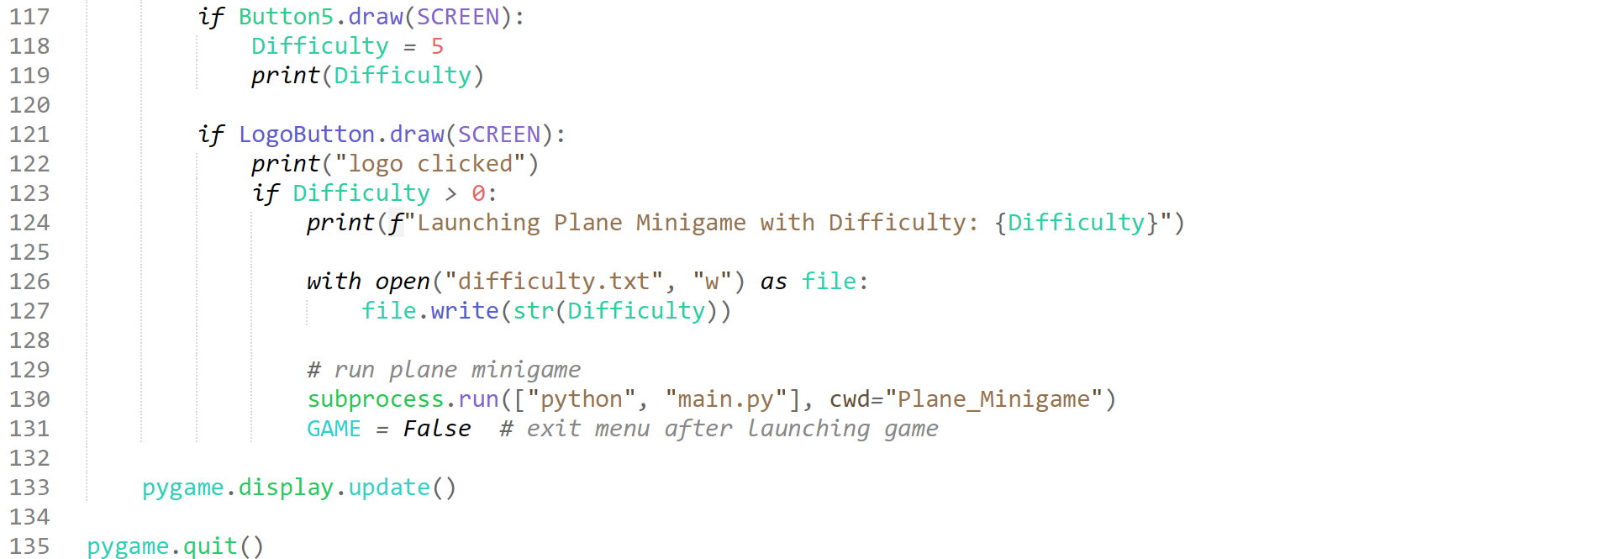

This is my updated GAME loop for the menu of DifficultyMain.py. This could be considered “”death by if statements””, however is it most optimal and simplistic way of meeting the requirements. We essentially check to see if ‘info’ is false, and if it is the menu is Outputted as normal (info is false by default) if not, it will Output the introductory text to Skybound, and if the button to change page is clicked, it will then explain simplistically the features of the game. if the info button is pressed again, info = false and the menu is up again.

#### Testing

|  |  |
| --- | --- |
| Program | **Explanation of Successes / Failures** |
|  | When DifficultyMain.py is built, the first image is what the user will see. Upon pressing the ‘info’ button, the user will be put onto the second image, and when clicking the arrow at the bottom, the user will be brought to the third image.  Successes:   * Working info button * Working left / right page button * If no content on next / previous page, then buttons do not show up. * Double clicking the info button brings back to menu * Explanation is clear * Easy to tell info button is info button * Easy to understand navigation buttons   Problems:   * No dark mode or accessibility features |

## Active Reasoning Challenges

### Databases and Main

**Success Criteria:**

“Sensible non-verbal reasoning questions in bottom right minigame”

**“**Adjustable reasoning questions according to difficulty level”

#### 1st Iteration

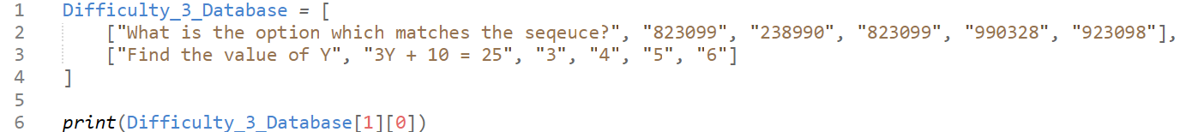

I first start by creating a 2D array, where the format is as follows for the “database”: Question, Question Data, Correct Ans, Incorrect Ans, Incorrect Ans, Incorrect Ans. You can interpret the Question and Question Data as opcode and operand, where the first element is asking what should be done, and the second is the data to apply that question to find the answer. These questions have been pulled straight from the FAST, as they were shown in an example video. I will first add custom, not strictly FAST-pulled questions, and then eventually upon completion of the section, I will add them to the end.

To find reasonable questions to add, I would need to either sit down for a long time to think of ~100s of questions, or I could pull questions across dozens of websites 11+ websites (for simple reasoning questions shown to ~10-year-olds.

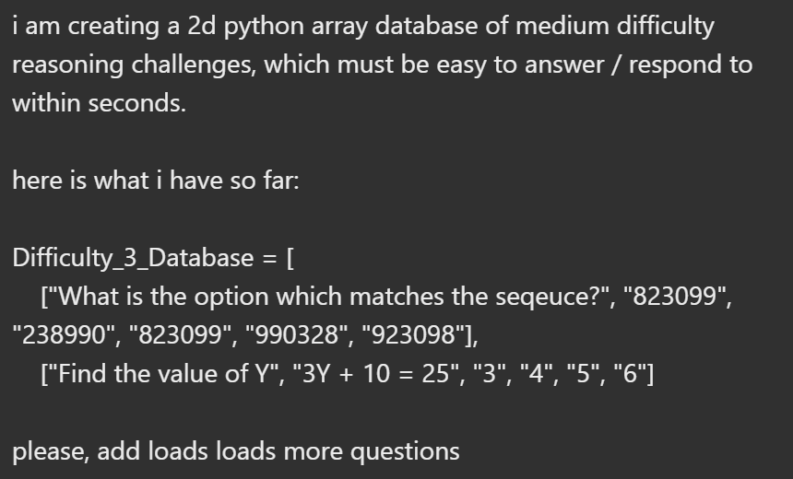Alternatively, I have decided to ask ChatGPT from OpenAI. This decision was made as I could simply paste in my pre-made format, and ask it for relative questions to ask. This would drastically save time, so this is what I have chosen to do. (ChatGPT, 2025)

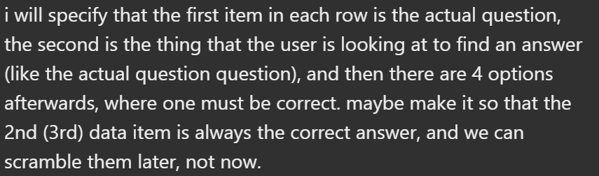These prompts allow ChatGPT to know exactly what to do, and where. It returned the following:

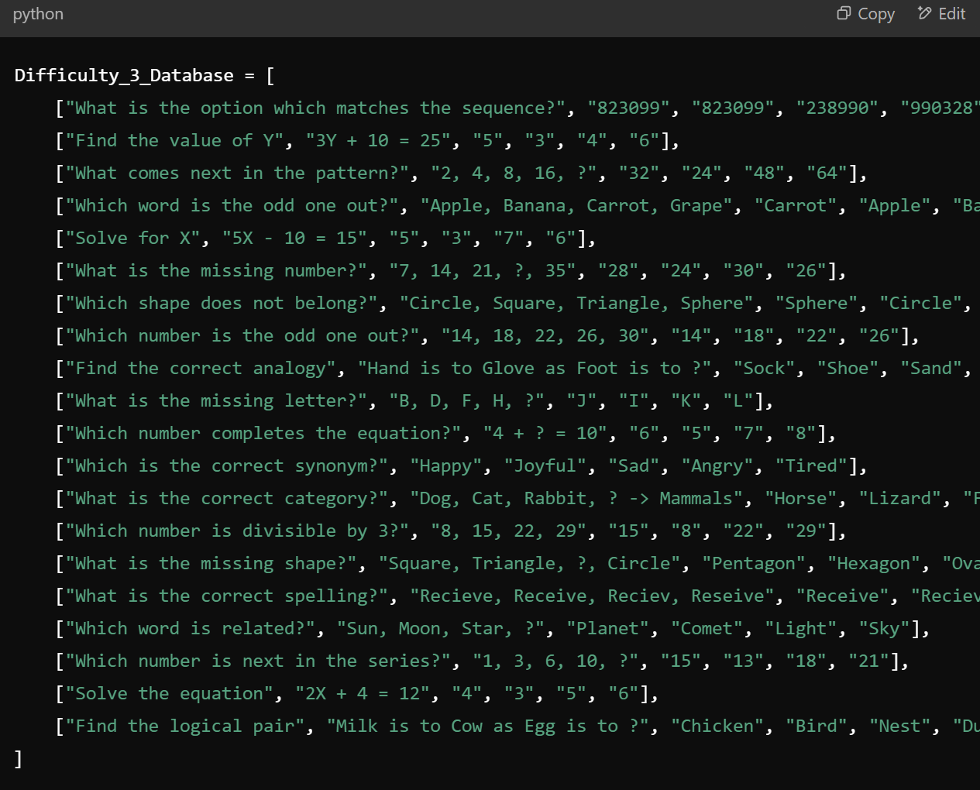

After reading through and moderating the questions, I have concluded that they are all reasonable and at the correct difficulty. I have added this to my code, and I will ask for more, as I aim to have around ~100 questions, so that the user isn’t constantly being asked the same questions.



I have modified, edited and removed hundreds of queries to ensure high quality questions are being asked which make sense and suit the difficulty of the actual FAST. We have ended up with 205, and this is likely to increase further down the line, however for now, this will suffice. I have named this database DB3.py.

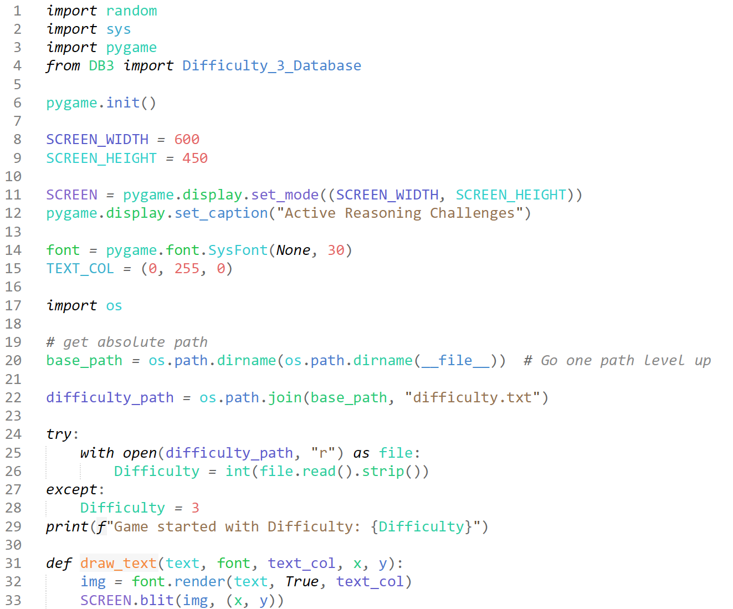

We first start by setting out all these declarations. None of this code is original and it has all been gathered from previous main modules, showing the high level of sustainability that my software currently has, as I have simply adapted different sections of the DifficultyMain and the Plane Minigame main.py.

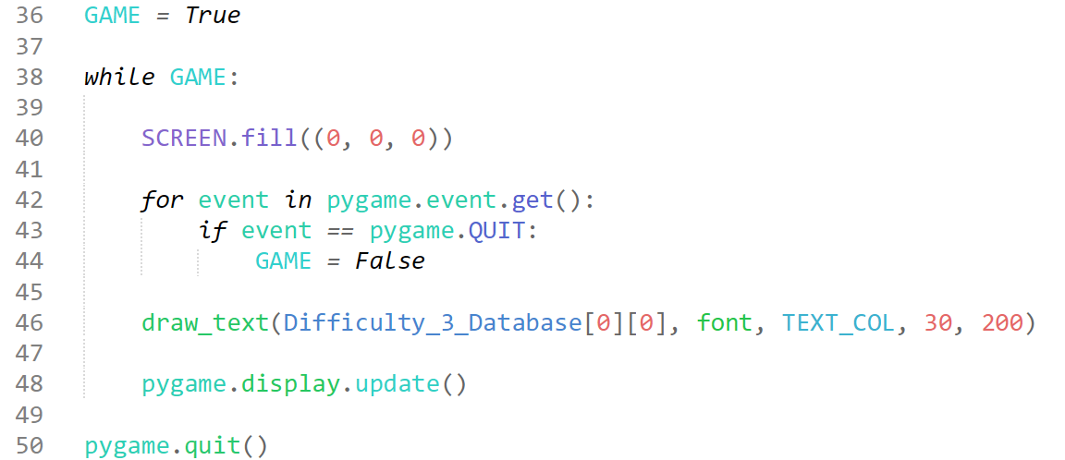

Here, I set up my GAME loop, where I have the standard start of filling the screen black, and then the event queue. I also use the “draw_text” object I had adapted from the Difficulty Main, and used it to call the text from the Difficulty database.

#### Testing

|  |  |
| --- | --- |
| Program | Explanation of Successes / Failures |
| File "C:\...\A Level Project\Program Code\Active Reasoning Challenges  \DB3.py", line 41, in <module>  ["Which is the correct answer?", "40 ÷ 5 = ?", "8", "6", "7", "9"]  ~~~~~~~~~~~~~~~~~~~~~~~~~~~~~~~~~~~~~~~  ["Which number completes the pattern?", "3, 9, 27, 81, ?", "243",  "162", "324", "486"],  ^^^^^^^^^^^^^^^^^^^^^^^^^^^^^^^^^^^^^^^^^^^^^^^^^^^  TypeError: list indices must be integers or slices, not tuple | Essentially, when we run the new main for the active reasoning challenges, we experience this ‘TypeError’ Syntax error.  Problems:   * Syntax Error |

#### 2nd Iteration

Im pretty sure the only reason this error occurs is because I had forgotten to add a comma at the end of some of the array stores, which I promptly fixed





These screenshots look messy, but these are simply the offenders of this syntax error, which as you can see I have now placed commas at the end of.

#### Testing

|  |  |
| --- | --- |
| Program | **Explanation of Successes / Failures** |
|  | When running the ActiveMain.py after fixing the syntax errors, this window appears.  Successes:   * Window now opens * No syntax errors * Text of question at database location shows up on screen * Background is coloured black as specified * Text is coloured green as specified   Problems:   * The window does not close without force * the questions need to be cycled through with answers … (aka next part of this module) |

#### 3rd Iteration

This iteration I aim to create a script which will cycle through random questions, and after a time dependant on the difficulty variable D, it will cycle through 4 answers. I will also try and fix the errors which prevent the program from closing.

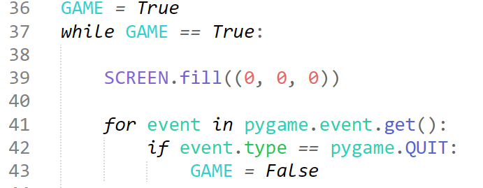

I simply copy and pasted the game quit loop code from my plane minigame, which *does* work, into my new main. There appear to be minimal differences aside from the GAME == True:, but people say “if it aint broke don’t fix it” for a reason, and I clearly tried and failed to fix it.

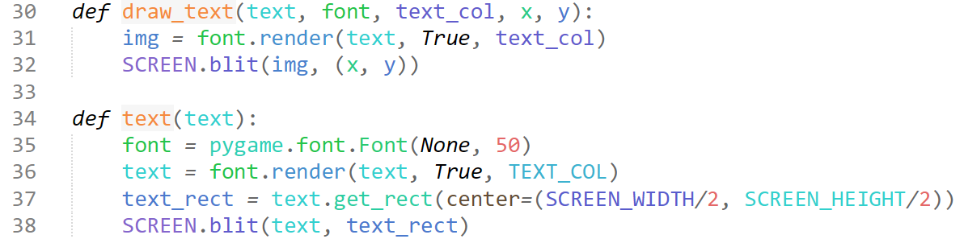

I have decided to alter the draw_text object so that it manages the text with a rect, which will be centered, the previous screenshot shows my original draw_text object, and then under it is my new text object. This new object has been inspired by a stack_overflow answer, linked here: <https://stackoverflow.com/questions/23982907/how-to-center-text-in-pygame> . I have simply mirrored the logic from the answer, converting it to match my needs into an object.

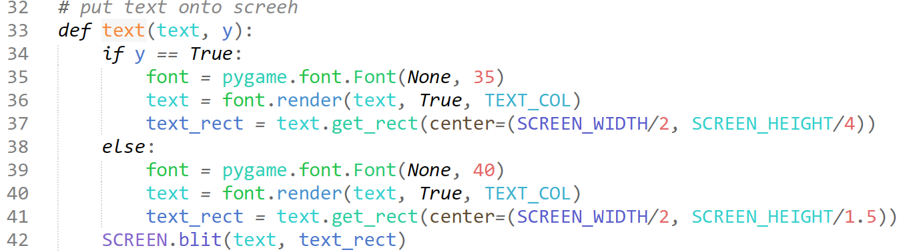

I have added a new parameter for the text object, This enables there to be two types of text on screen, theoretically one for the initial question, and then the data of the question. We can use the new Boolean created to split the text into the two needed sections, where we alter the y value (so they are separated from eachother and evidently portray what they are) and so that we can have the largest font for the user whilst enabling all text to fit.

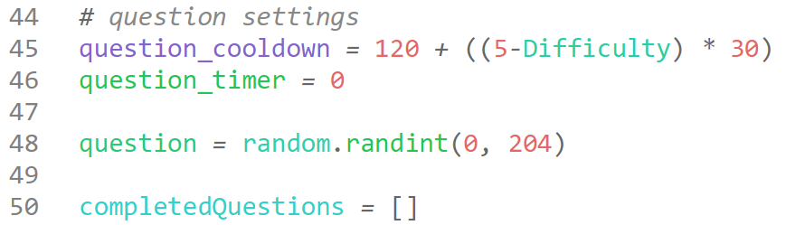

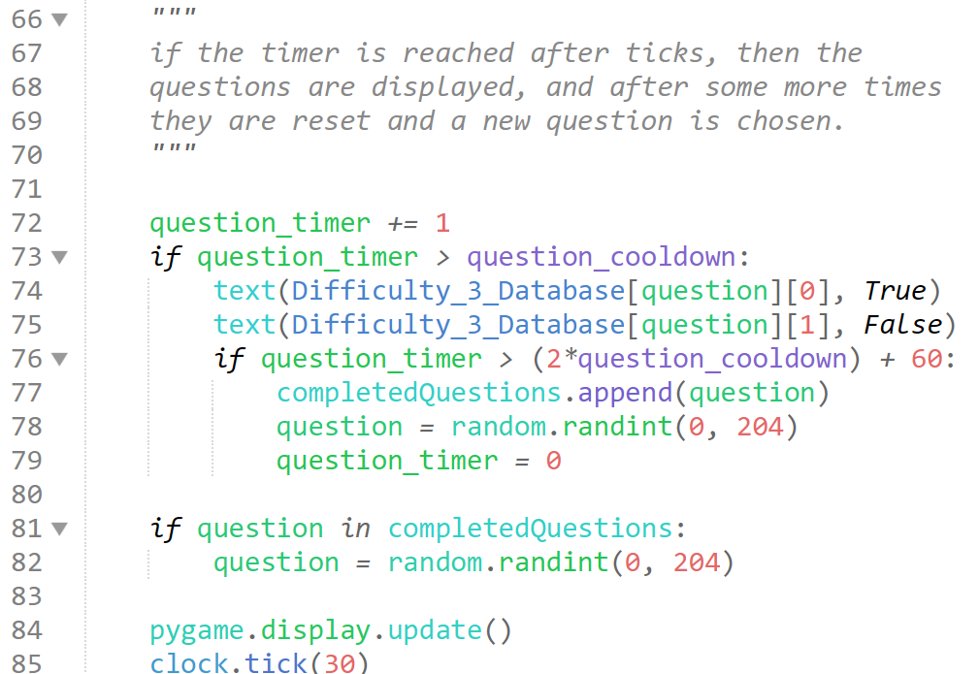

Here we can see the new implemented code for the questions Outputting on screen. We first add the question_timer variable each tick, and it checks if it is greater than the question cooldown timer, which is a constant, and if it is it will Output the random question stored in the question variable, which is a variable stored outside the GAME loop. It then checks if another amount of time has passed, and if so, it will add that question value will be added to the list of questions already asked, a new question is picked and defined, and the question timer is reset back to 0, which will then have a blank screen for another amount of time.

You can see we use the new parameters for the text data gathering from our array. Where we choose the row defined by the question, and then at the top, in larger text output the question stored in column 0, and then the data for the question stored in 1.

The code constantly checks if the question has already been added to the completedQuestions list, and finds a new question if it has been. The clock ticks 30 times a second, so the program will have 30fps, consistently synchronised with the plane minigame, but slightly less fps to save energy on processing, as this isn’t a very high demand high accuracy section.

#### Testing

|  |  |
| --- | --- |
| Program | **Explanation of Successes / Failures** |
|  | We run the ActiveMain.py module, and wait until the cooldown time for a question (120 ticks + 5-3 * 30 ticks == 5 seconds for difficulty 3.)  Successes:   * questions are Outputted * questions are reasonable difficulty * questions spawn and de-spawn on a timer * timer is variable to the difficulty * different text types for the question and question data * window now closes with no issues * questions and text are centered horizontally * completed question value is stored in a list, and never repeated.   Problems:   * no way for user to enter their answers * some questions do not appear to have question data, so a blank store will need to be created. |

#### 4th Iteration

I now want to create a way for the user to choose an answer after the question has been on screen. I will do this by creating a button object, with features such as ‘position’, ‘text’, and ‘is_selected’ so that I can create multiple instances of the same object for the different places on the screen the button may appear.

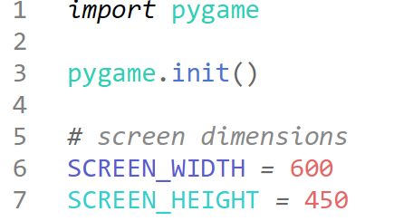

I move the SCREEN_WIDTH and SCREEN_HEIGHT to the new button module so that I can access it first in the button module, and then import it into the ActiveMain module, this means I do not need to add a separate setup file, as the button module can temporarily act as such.

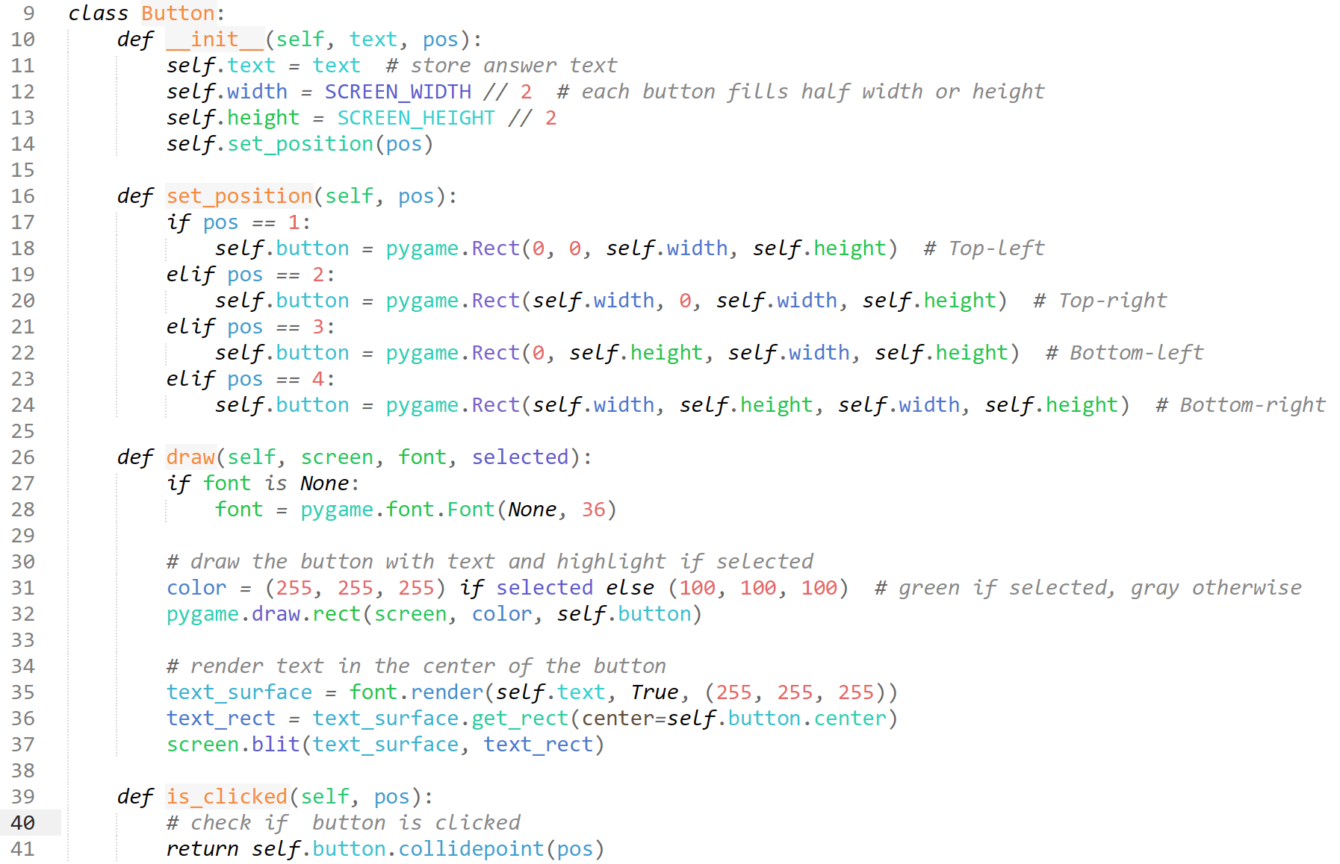

I borrow methods from previous buttons I have created, showing sustainability in my programming.

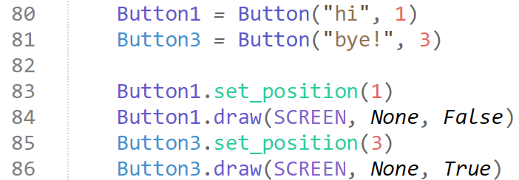

In the game loop, I simply text our new button object by creating two instances and setting the positions to the 1st and 3rd quartile to test. I declare Button1 as clicked and Button3 as not clicked to test if this section works.

#### Testing

|  |  |
| --- | --- |
| Program | **Explanation of Successes / Failures** |
|  | Running the ActiveMain with the new Button object declared and imported, and new instances of the button created.  Successes:   * the ‘buttons’ appear on screen * buttons appear with text specified * buttons appear in the quartile we specify * different visuals for if ‘clicked’ or not   Problems:   * not spawning specifically after the question * need to make them actually clickable |

#### 5th Iteration

I require to somehow randomise the order the answers for the buttons, while retaining that database(question)[2] value is the correct answer to select. Creating a method is likely the best way to go about this, as I can constantly call it during the GAME loop whenever needed.

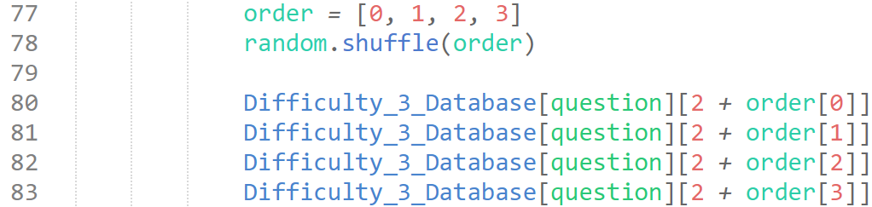

While this isn’t specifically viable code, I am showing this to explain my likely next steps clearly.

The idea is to have an order list and to shuffle this list, I will then use the values of this shuffled order list to add to the values for the answers, which will randomise the order of the database items. I will require a method to retain the fact that originally, there is a correct answer.

I have realised that it would be a lot easier to create a new method for creating new questions entirely, including the new question code that I require, so I will start doing that.

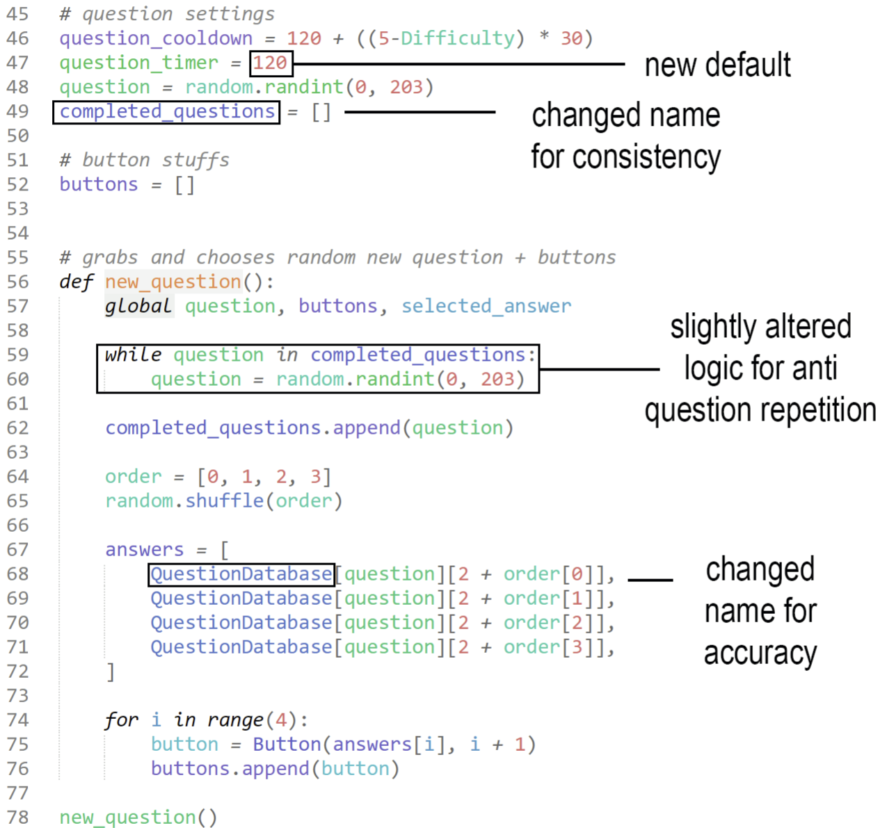

Above shows my new logic for new questions. I no longer need to randomise the next question within game code, as I can simply call this new method. This also allows for simpler button answer sorting.

When I write the last section, ‘for I in range(4)…’, I essentially create a new instance of button.text for each instance of button, which contains the different answers the button instances hold.

The global variable declared ‘selected_answer’ is declared as None everytime the parameter is called. We will put this in the GAME loop to store the answer the user clicks on, and then when a new_question() is called, it will be reset back to none.

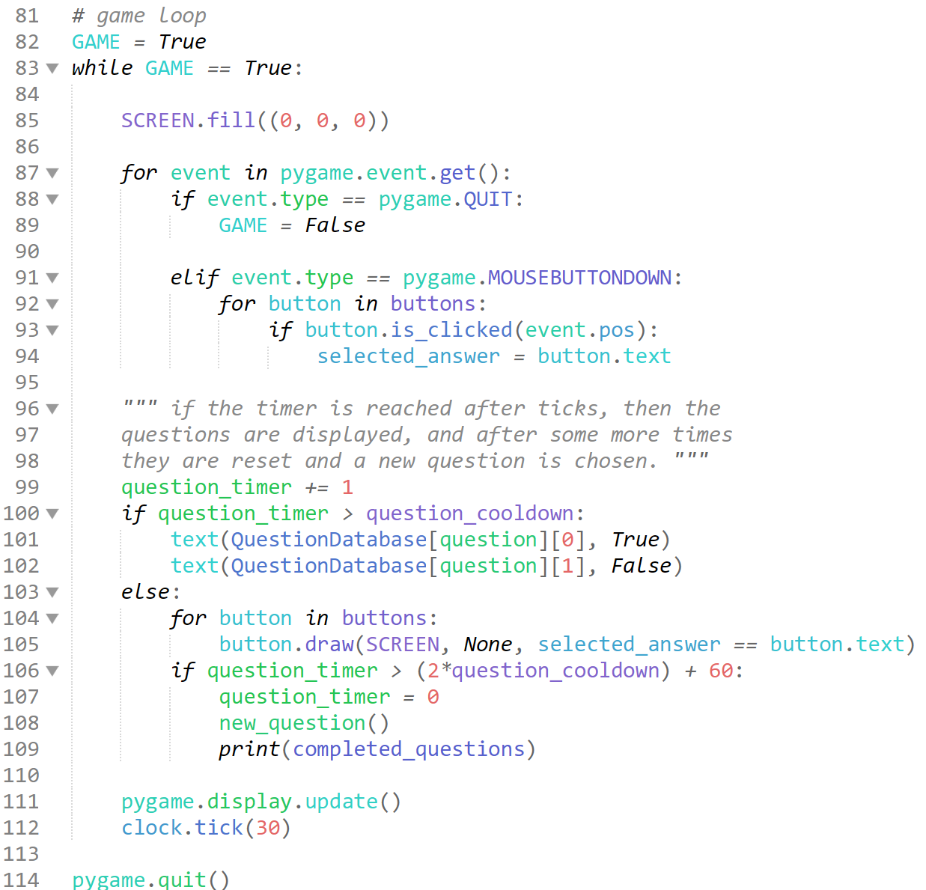

The new and improved GAME loop. We remove the test section after each text method calling the question and question data, and instead put it under a new selection outcome, which finds if the questions are on screen anymore, and if they aren’t, then the buttons for the answers now appear on screen. We then check the timer to check if a the time allotted is up, where we spawn a new question.

#### Testing

|  |  |
| --- | --- |
| Program | **Explanation of Successes / Failures** |
|  | Problems:   * does not recognise selected_answer |

#### 6th Iteration

I assumed that it would automatically declare it as none, but it appears I will have to manually declare this.

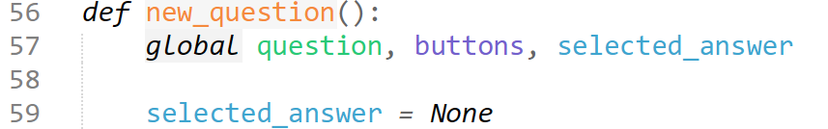

#### Testing

|  |  |
| --- | --- |
| Program | **Explanation of Successes / Failures** |
|  | Running ActiveMain  Successes:   * buttons exist in the 4 quartiles * button text is randomised * buttons are related to the question * buttons can be clicked and interact as such   Problems:   * once a question appears on screen, it never leaves * some database questions only have 5 values, with no question data, resulting in errors when those questions are called |

#### 7th Iteration

I will first attempt to remove the issue of database questions only having 5 values instead of the required 6, which causes the whole module to crash.

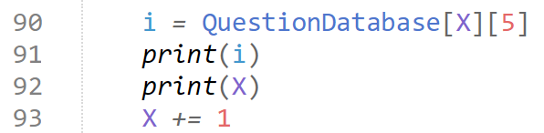

Where we declare X = 0 outside the loop. This code should run through each database question and give me an error when we encounter a question without 6 values, and print what X / item in the database it is, where I will add an empty string as the 2nd value.



There was actually only 1 question which this error could occur on, so it is quite fortunate during the testing stage of that iteration I encountered the issue so frequently. As you can see, I have simply added a blank string to increase the number of values to 6, and make the code still make sense. I have deleted that portion of code.

Now I must find a way to fix the error of questions permanently staying on screen. This issue must have been caused by my new logic for question / button spawning dependant on time, where I moved the logic which changes the question.

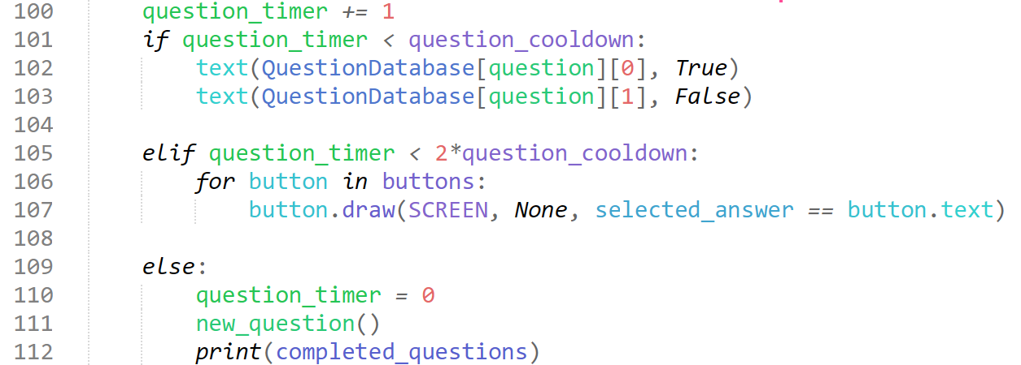

I have reorganised the timing logic for questions, so now at the very start of the program running, the questions are immediately shown, and once the timer exceeds double the question_cooldown, the Elif statement takes priority for selection, and the buttons are shown. Once the question_timer exceeds double the question_cooldown, then it is reset, and a new question is chosen.

#### Testing

|  |  |
| --- | --- |
| Program | **Explanation of Successes / Failures** |
|  | Running ActiveMain New improved logic for the timings of question generation and subsequently button generation, and fixing the potential crashes caused by inconsistencies in the database.  Successes:   * questions now show up without error or fail * after question_cooldown, buttons show up * buttons are on screen for equal time as question * after buttons are on screen for same duration, question_timer reset and then a new question is instantly put on screen * answer buttons come after questions   Problems:   * no store to see if answer clicked is correct or not |

#### 8th Iteration

Adding two simple variables to count if question is wrong or not, and adding to this variable when either or.

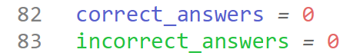

Declared outside of GAME loop, so is reset every time game is run.

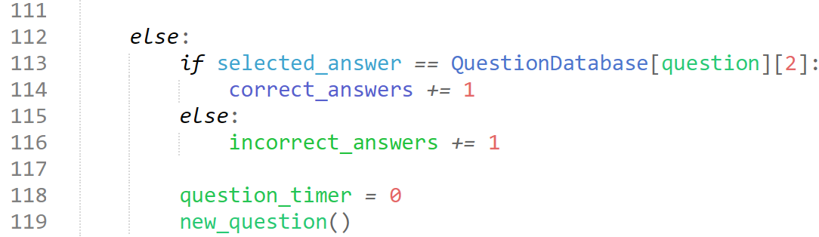

Simply checks if the selected answer clicked at the end is the correct answer in the questionDatabase, and if so, adds the variable, if the correct answer is not clicked, it defaults to an incorrect answer, as that means either a wrong answer is clicked, or no answer is clicked.

#### Testing

|  |  |
| --- | --- |
| Program | Explanation of Successes / Failures |
| *Final print when a correct, incorrect, and no answer button is selected. (shows 1 correct, 2 incorrect)* | We add a quick test print for the correct_answers and incorrect_answers  Successes:   * Correctly adds variables if correct * If wrong answer, adds to incorrect_answers * If no answer, adds to incorrect_answers |

## Terrain + Event Rendering

### Events – Background and Terrain

**Success Criteria:**

“At least 1 rendered terrain”

#### 1st Iteration

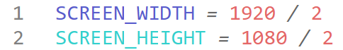

First, I create a module titled “setup.py”, and include the SCREEN_WIDTH and SCREEN_HEIGHT as 1920x1080 / 2, as the final iteration of the game will be full screen (aka the full 1920x1080), but for testing purposes, having it smaller than the screen makes it a lot easier to manage.

I create this setup module first thing as I believe this module will have a lot of foundational settings which should be stored separately.

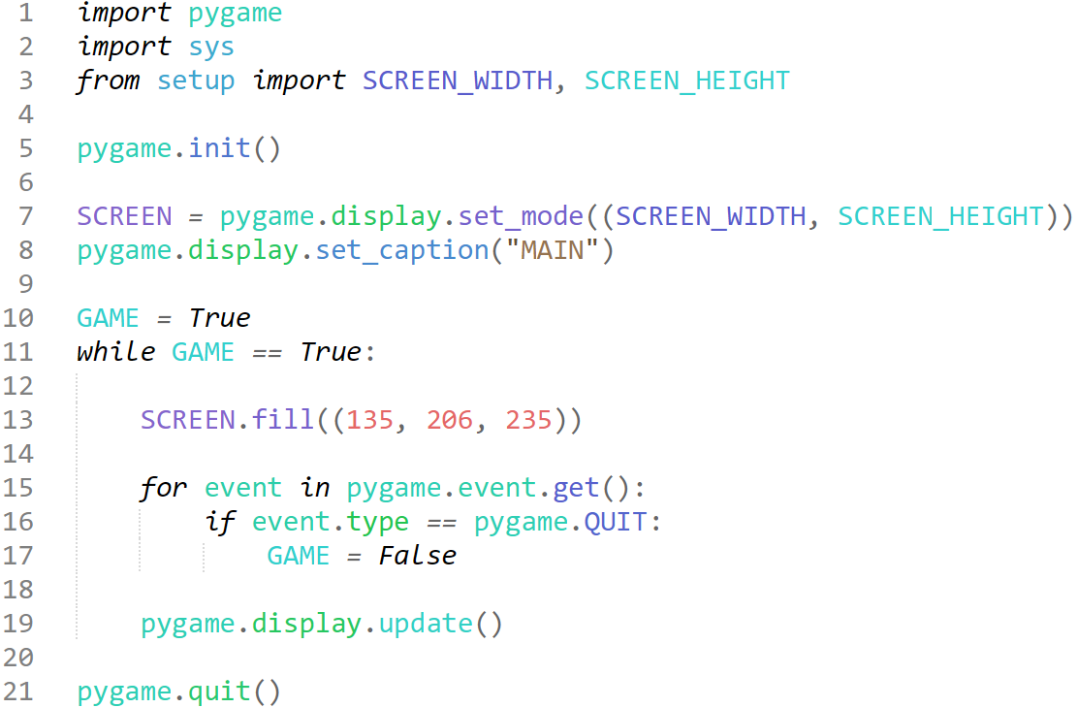

The foundations of another screen, filled with code we have seen a few times before, with the SCREEN.fill being a sky blue for our sky background. This step is only temporary, as I likely want the skies and ground to meet in a dark > light gradient to emulate the feel of terrain and life more.

For this I have decided to just create an image for the backdrop, I have called it “backdrop.png” located in a Sprites folder under EventTerrain_Rendering file.

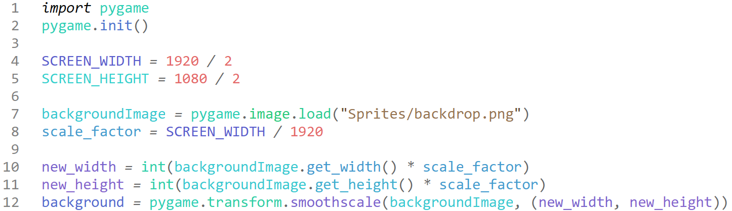

Our new setup, we import pygame and initialise it as there are some pygame required functions which we call when we grab the images and transform them.

We declare the background image, and then declare a scale factor which we will scale the original image by (original image is 1920x1080) reliant on the SCREEN_WIDTH, so that once we revert the width back to 1920 (or any other dimensions), the image will also scale to fit. We then declare the new scaled height and width, and transform this image by these scales.

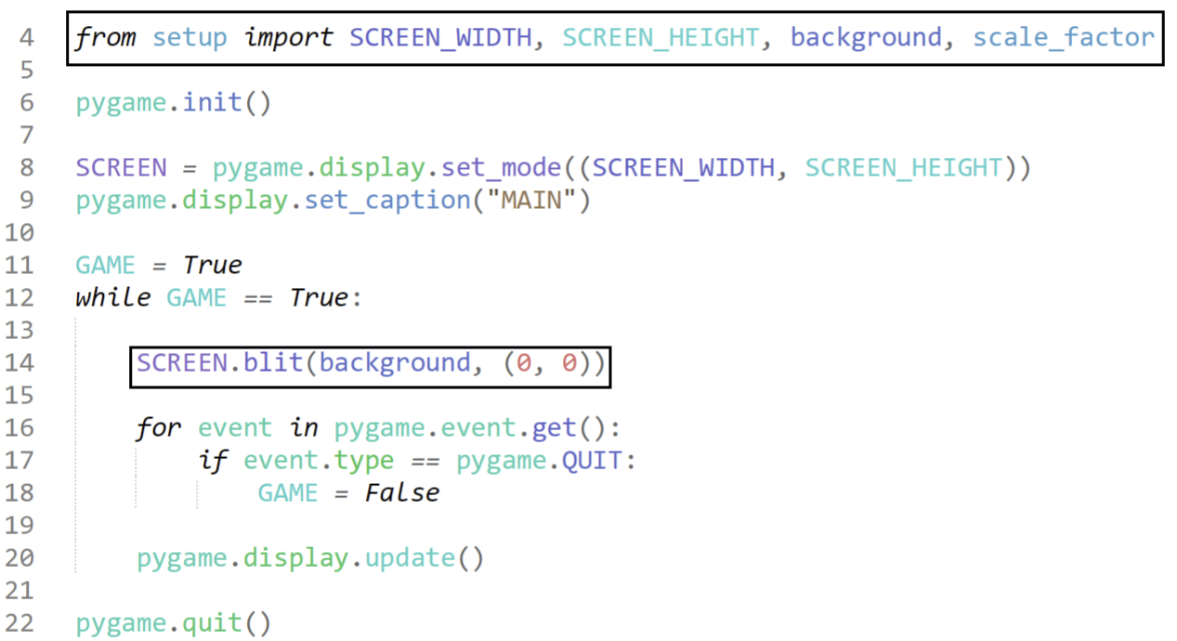

Our new main code, importing the needed setup values and disregarding the irrelevant internal ones, and then blitting the background image instead of the background colour.

#### Testing

|  |  |
| --- | --- |
| Program | **Explanation of Successes / Failures** |
|  | Running main.py  Successes:   * Background image is blitted onto screen * Background image correctly scales to the boundaries of screen   Problems:   * Pretty uninteresting * no sense of scale |

#### 2nd Iteration

I aim to add a cloud image, which progressively gets larger as time moves, so that increases visual interest and recognition that this is indeed the sky and ground, and we are indeed high up (from a cockpit POV). This also gives us a sense of scale, as clouds will be very small at first and slowly grow.

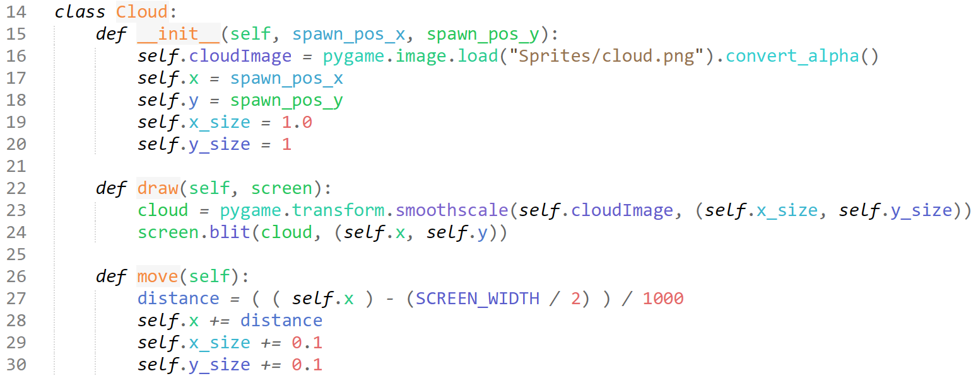

In the setup module, I create a new object for the cloud, as I believed it heavily resembled similar concepts as my other cloud module. I initialise the cloud with an x spawn position, and a y spawn position which will be randomised upon generation. I also initialise the image which I designed in a few seconds in photoshop, and then an x size and y size so that I can slowly increase it to mock the perspective moving forwards.

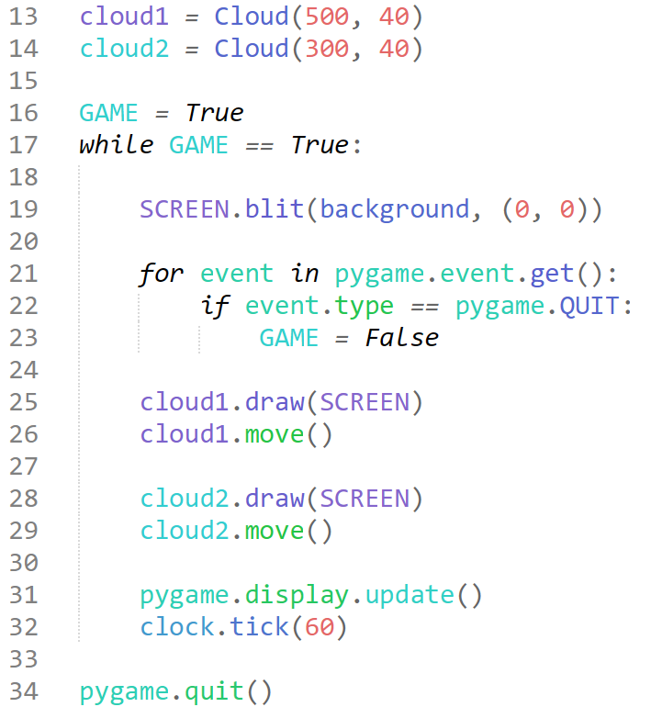

This is my current layout for the GAME loop to test the clouds, I declare two cloud instances, where they are separated by 200 on the horizontal. The idea behind the change in x coordinates is that the cloud2 should slowly shift right, as it is to the left side of the screen, whilst cloud1 appears on the faintly right side of the screen, so it should move right. Within the GAME loop, we then call the methods to blit and move the clouds, and tick at 60fps.

#### Testing

|  |  |
| --- | --- |
| Program | **Explanation of Successes / Failures** |
|  | Running main after importing the new cloud object  Successes:   * they move away with respect to perspective * they grow consistent to perspective movement   Problems:   * they blend into the background too well |

#### 3rd Iteration

This iteration I will start by creating a method to spawning clouds randomly, while ensuring there aren’t too many.

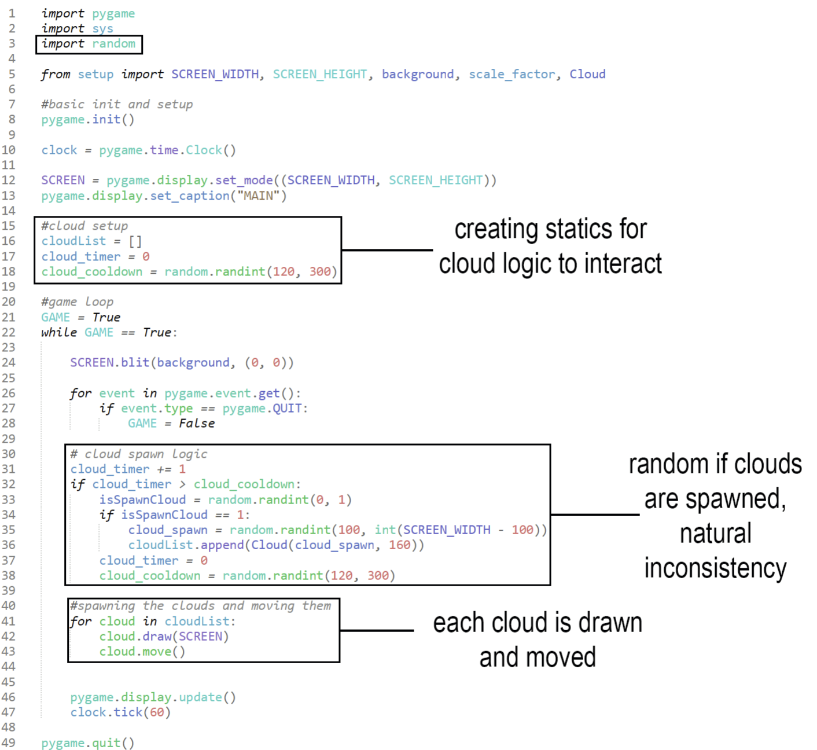

Here I create new cloud spawn logic, it is very similar to previous spawn logic for clouds but edited for different purpose. Here I have a random cooldown which resets upon each cloud spawn, and even when the cloud_timer is greater than the cooldown, there is still a 5050 chance if a cloud is spawned. This helps create greater unpredictability and uncertainty, which mimics nature.

I then use a for loop to move and draw each and every cloud on screen. It currently does not check if the cloud is off screen, and still moves EVERY cloud, so I will likely need to optimise this later.

#### Testing

|  |  |
| --- | --- |
| Program | Explanation of Successes / Failures |
|  | Running the main code with the new cloud spawning logic  Successes:   * clouds spawn randomly * clouds spawn at random horizontals * all clouds move and function   Problems:   * clouds blend into background * clouds are still moved when off screen |

#### 4th Iteration

This iteration will be the simple quality of life features, such as easier visuals for the background vs the clouds, detection and deletion of clouds when they are off screen, **and maybe some minor changes to the scaling for realism.**

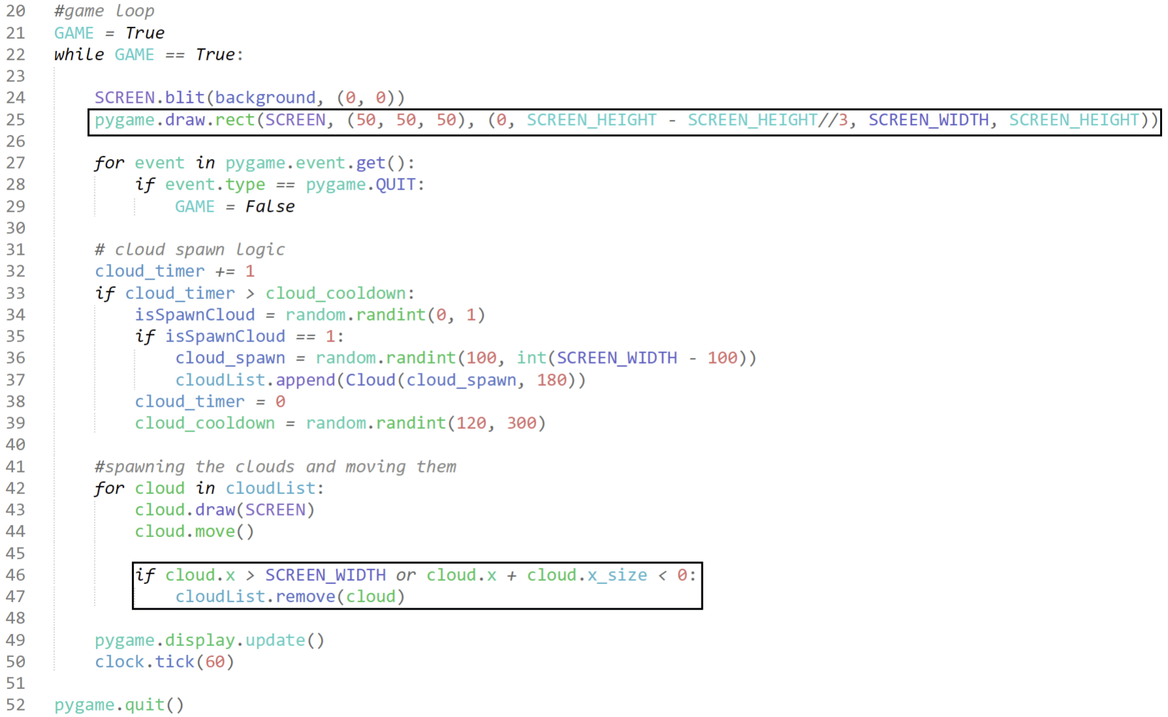

Here, to align with my UI mock-up in the Design section, I add the grey box in the bottom. This box serves so the UI will be less of a distractor the user (when the other modules are all combined into this one).

I also add logic within the CloudList sequence which removes the cloud if the top left of the sprite is either too far right or too far left (i.e., off screen), which is more optimal for long-running games.

#### Testing

|  |  |
| --- | --- |
| Program | Explanation of Successes / Failures |
|  | Running the main  I have reworked the background to contrast with the clouds more.  Successes:   * more visible clouds * grey box for visuals * clouds are removed from cloudList once off screen |

### Events – Aircraft

**Success Criteria:**

“Randomly generated aircraft”

#### 1st Iteration

Creating the aircraft spawns is the next reasonable step, as we will need to program the waypoints and waypoint menu concurrently, as they rely on each other for data, and since the waypoint menu is part of the menu which involves the buttons and flashing lights, so the aircraft must be coded before the buttons to detect aircraft are.

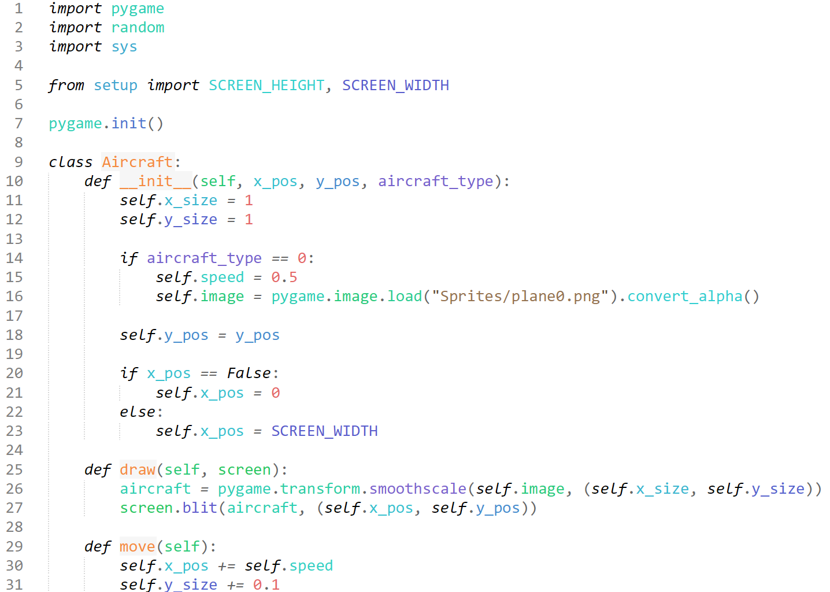

We create a new module, aircraft.py. We can pretty much write almost the exact same things from the background cloud for this, laying out the foundations for a slightly more complicated object.

We import the SCREEN_HEIGHT, SCREEN_WIDTH as we will use them for the positioning of instances.

We take the “aircraft_type”, as different aircraft appear in the actual FAST that need to be reacted to, and they will have slightly different properties, such as altering the visuals and the speed of the aircraft. We also take the x_pos as a Boolean variable, as this will decide if it is flying in from the left or from the right.

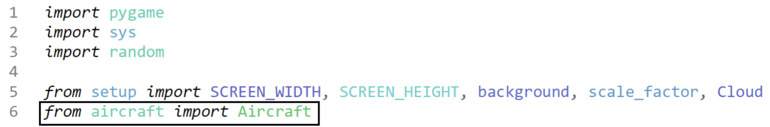

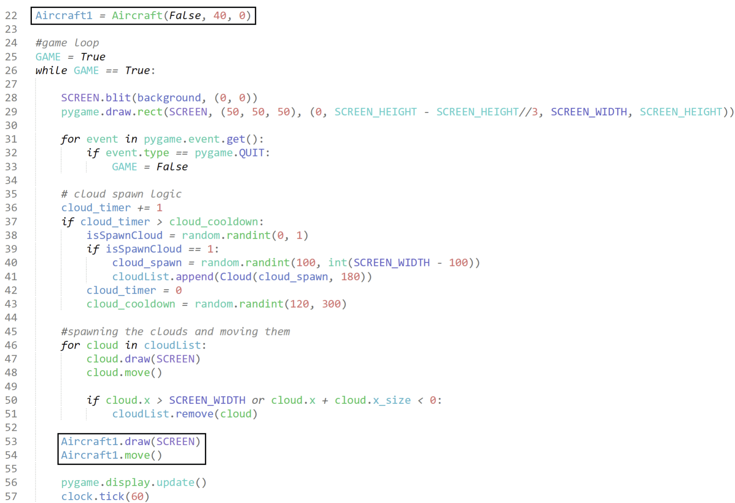

We create a test instance and call the draw and move methods. We use the simple barebones parameters of “False” and “0” as these are the only conditions we have added so far.

#### Testing

|  |  |
| --- | --- |
| Program | **Explanation of Successes / Failures** |
| *Red circle has been added after, is not part of the game* | Running the main after importing new object and module  Successes:   * plane spawns on specified side (False = left) * plane moves across screen with specified speeds in both x and y axis   Problems:   * plane image is wrong |

#### 2nd Iteration

For context about the issues with the plane image, this is what the temporary design should look like:

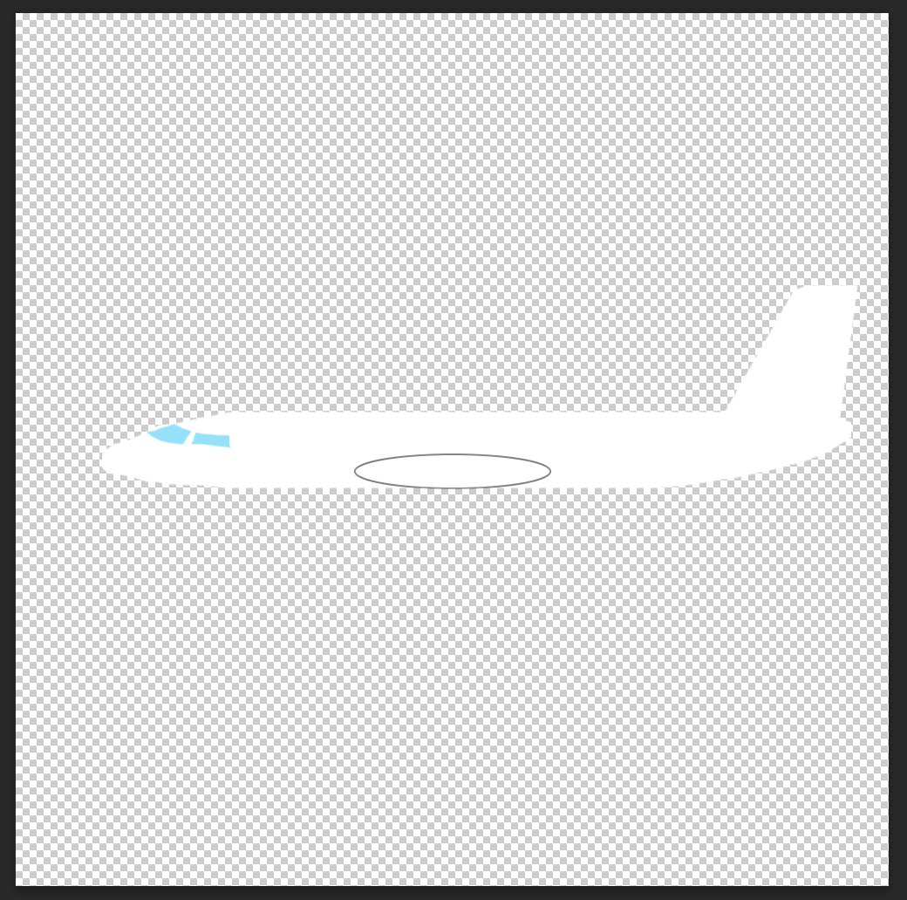 However, as you could see in the image, it appears to be a tiny vertical speck, which obviously is not correct.

I have several theories on why this could be the case, starting with blitting the plane as a smoothscale, which is meant to increase the quality of the image as it enlarges, however it may have misidentified where to enhance, scaling the outlined oval up.

Another idea is that the image is too small the game just processes it in a weird way.

First, I will test out the more likely theory:

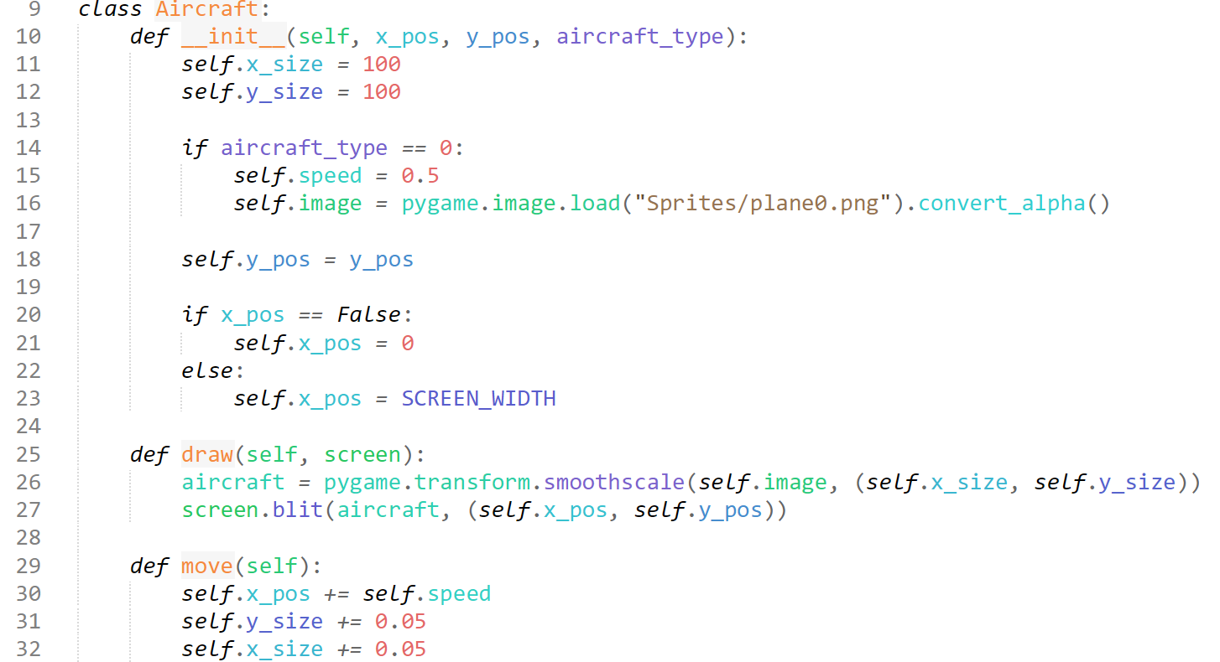

I test to see if it was an issue due to the sizing of the airplane being too small to tell (1x1 pixel) and scale it up 100x. I also decrease the speed at which the size of the plane grows, since it should not seem like it may encounter the POV.

#### Testing

|  |  |
| --- | --- |
| Program | **Explanation of Successes / Failures** |
|  | Running the main while scaling up the sprite:  Successes:   * sprite is now visible * sprite now grows proportionally   Problems:   * sprite is facing the wrong way |

#### 3rd Iteration

We need a way to flip the sprite depending on what way the image is facing.

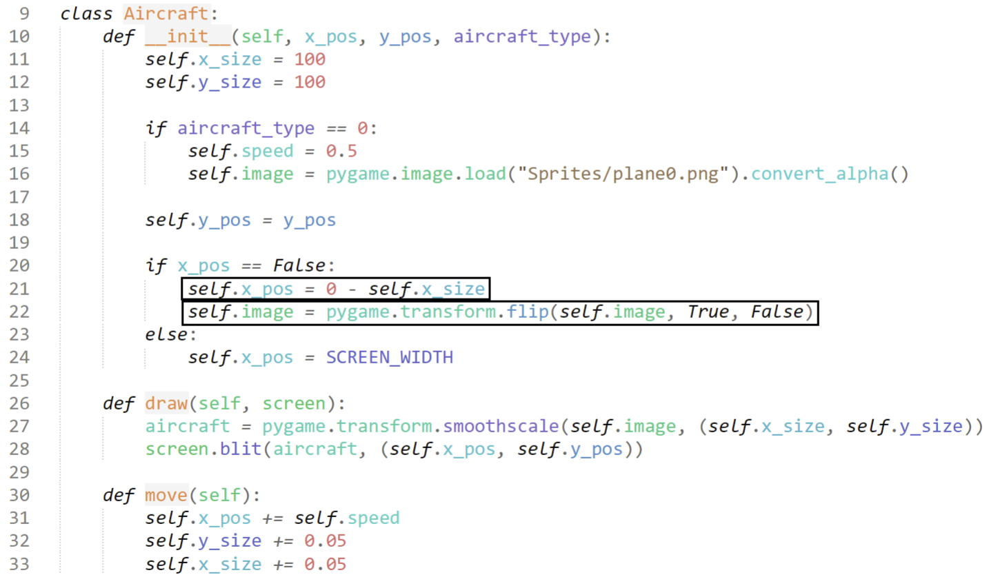

Pygame luckily has its own flip function, which requires parameters for image, horizontal flip, vertical flip. I also change the position, so that if the image comes from the left, it doesn’t spawn the plane already on screen (from the top left, now flipped to top right corner hitbox).

#### Testing

|  |  |
| --- | --- |
| Program | Explanation of Successes / Failures |
|  | Running main  Successes:   * plane is flipped horizontally so now it faces the correct direction (when spawning from left) * plane spawns from off screen on the left   Problems:   * more plane types * plane appears too big/close, traffic detection system would trigger. |

#### 4th Iteration

We just need to create more sprites, and decrease the size of the planes (depending on the type)

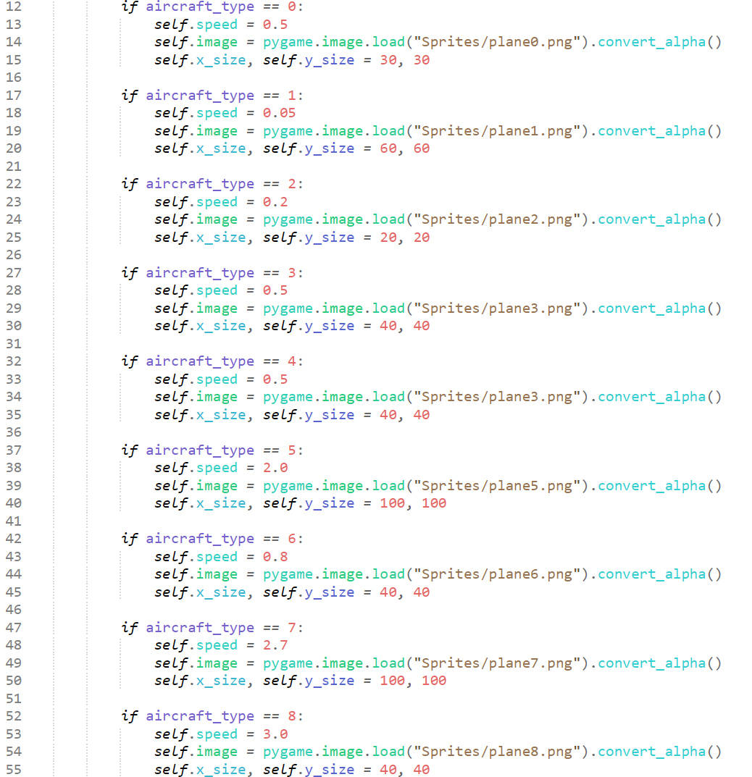

The initial sizes are determined by a few main factors, such as to-scale aircraft dimensions, visibility for player ease, but most importantly, how close would they realistically be allowed to get to the POV aircraft. This design choice is considered due to the fact that, even though the a380 is the largest commercial airliner, and is a huge widebody plane, you wouldn’t realistically see it as that large on the screen, as ATC would not let such a huge aircraft get very near to another air craft.

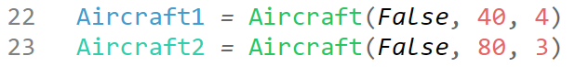

(outside of GAME loop)

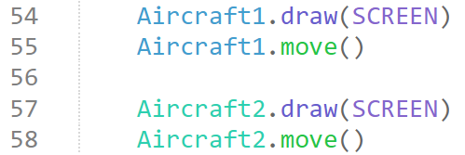

(inside game loop) – this comparison between the multi-role Lockheed F35 (fastjet) compared to an Airbus A380 (commercial airliner) should hopefully show the size and speed differences on screen:

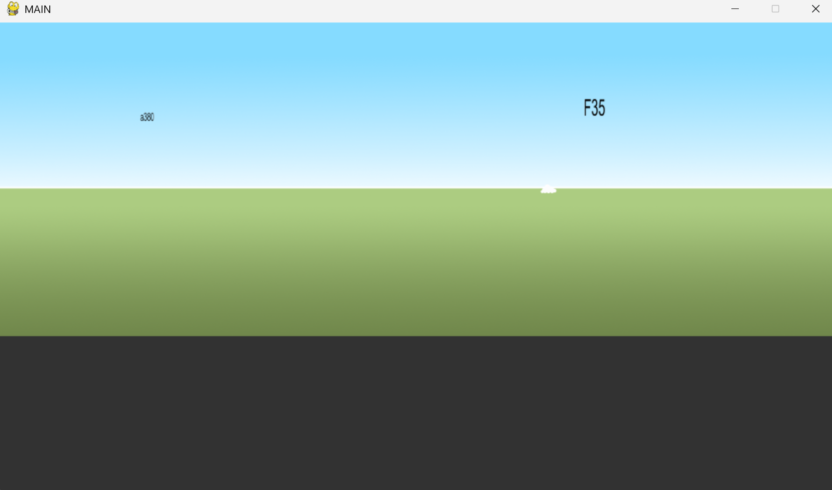

This screenshot is just to show my considerations to realism – whilst the F35 is significantly smaller than the A380, the A380 is much smaller – as it would only be allowed to be far away, whilst the F35 is allowed to approach significantly closer due to its high manoeuvrability and lack of reliance on ATC systems, and the F35 would travel significantly faster (being able to reach Mach 1.6 compared to the A380’s Mach 0.85).

We now need a method to randomly generating these aircraft, and so we can devise a similar system to the clouds.

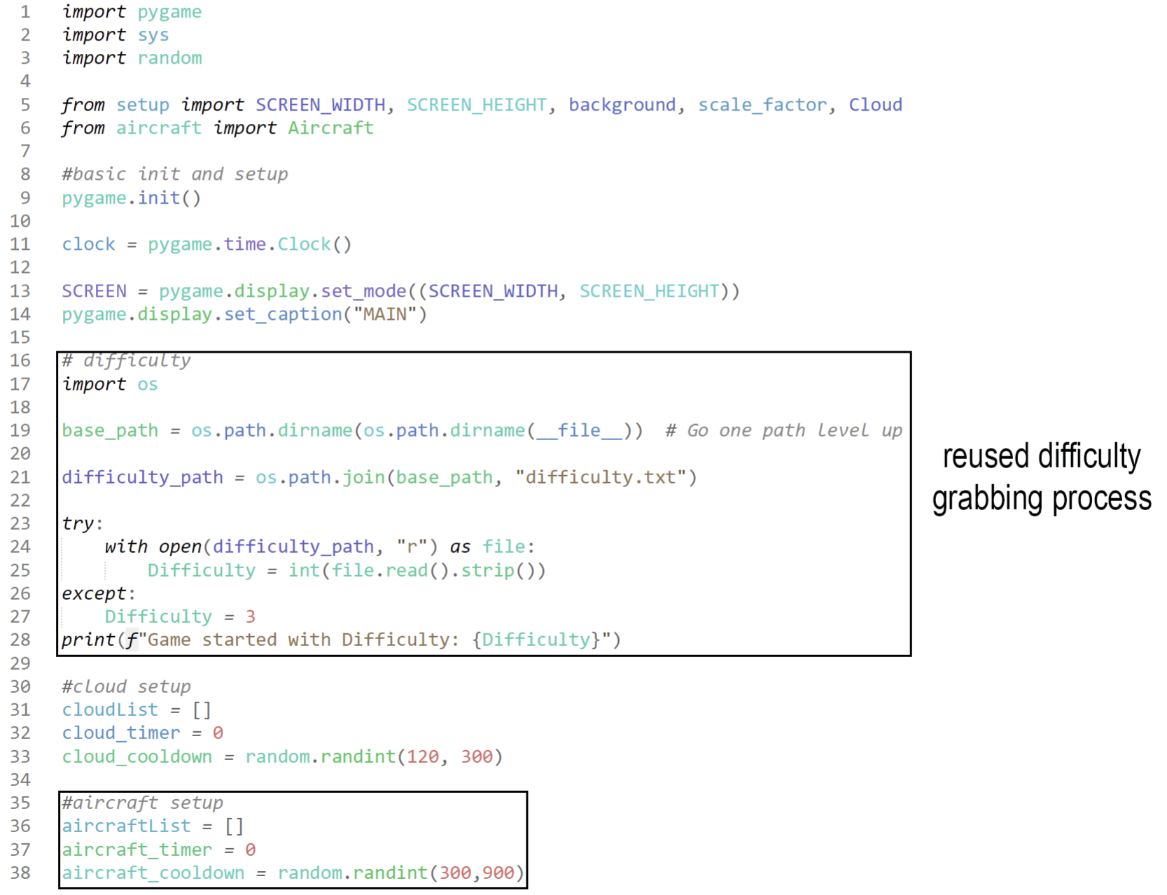

Outside the GAME loop, we add the code to read the difficulty from the file, and then we add the exact same logic used for the clouds to generate aircraft.

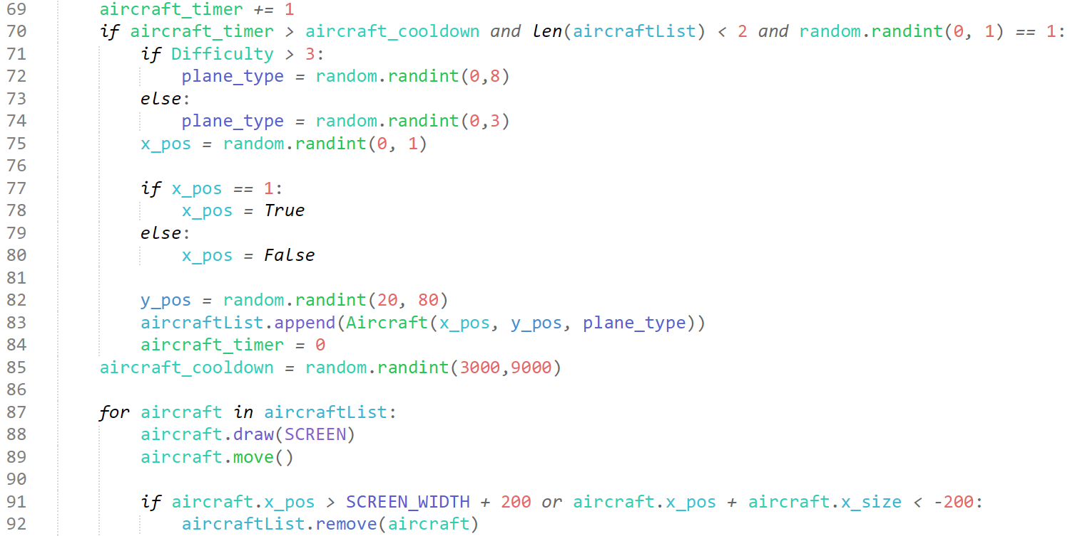

This is our logic for aircraft generation. It should only trigger if the cooldown is met, there are less than 2 aircraft on the screen, and then there is a 5050 chance an aircraft will, or will not spawn.

We then make decisions based on difficulty, as beyond aircraft 3, I have created aircraft types which are military aircraft, and thus have very high speeds. I have limited these aircraft only to difficulty 4 and 5 as in the actual FAST, there are no fastjets, and aircraft travel across the screen relatively slowly, and thus fastjets passing through are very difficult to catch.

#### Testing

|  |  |
| --- | --- |
| Program | **Explanation of Successes / Failures** |
|  | Running main with aircraft spawning logic  Successes:   * planes randomly spawn * only two planes are ever on screen at the same time |

### Events – Waypoints

**Success Criteria:**

“Randomly generated waypoints”

“Identifiable Waypoints”

#### 1st Iteration

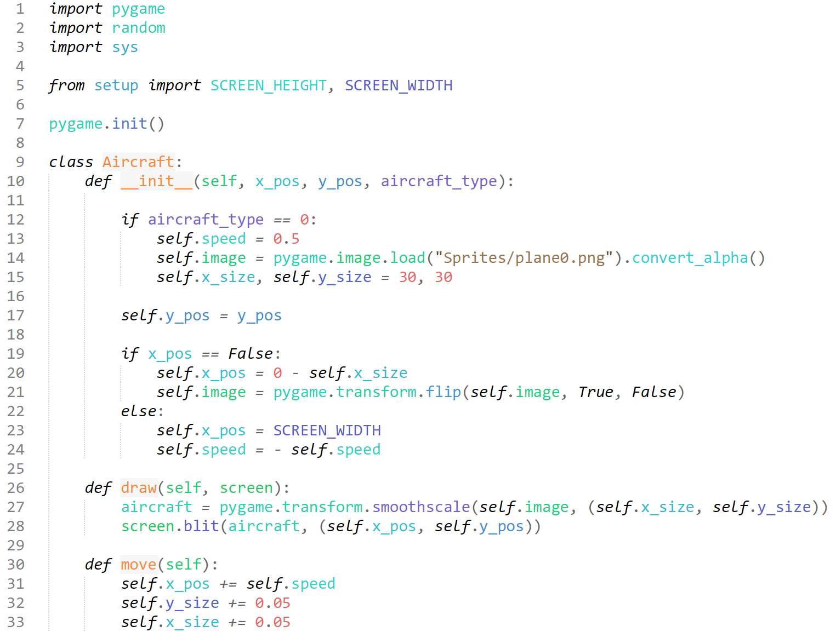

In my design section – we noticed that the waypoints and aircraft behave very similarly, and to save time, I am going to reuse the entirety of the code for the aircraft, for the waypoints. We start of with this foundation, and create a new module called “waypoints.py”.

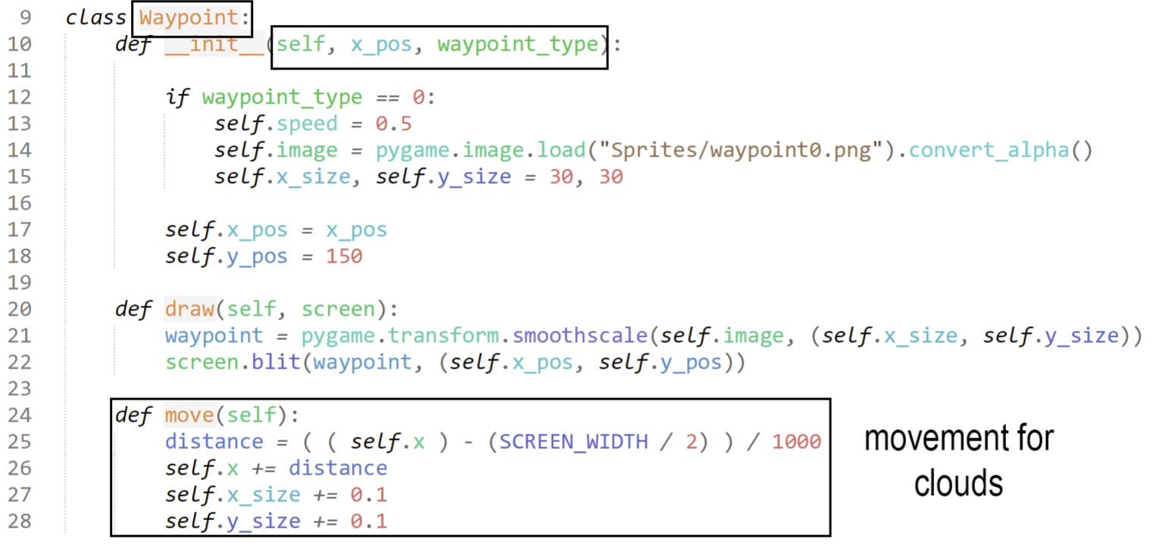

I have edited the code to accommodate for the fact that we are working with the waypoints, such as renaming the class, aircraft_type > waypoint_type, calling a waypoint image etc.

I have altered the parameters of the object, as we will not need to randomise the y coordinate, since they will all spawn from the horizon. Only the x coordinate will be passed through now, and it will be randomised in the GAME loop.

The code for cloud movement replaces the plane movement method as the waypoints will be on a “fixed” point on the horizon, similar to the clouds, and will be moved based on perspective, so the cloud movement is much more suitable, it will be edited later down the line to account for distance from POV, but for now this is how it remains.

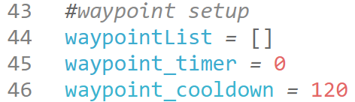

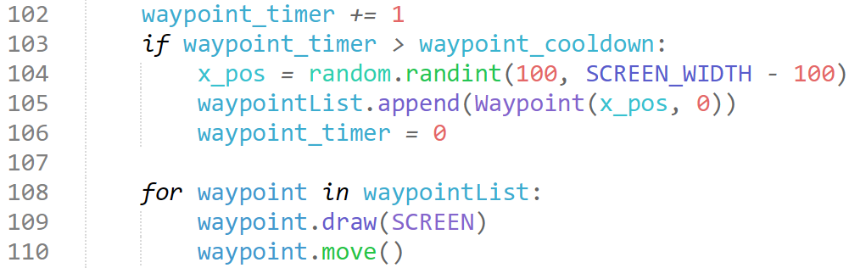

Above are my incorporations of the waypoint into the main.py module, where we import the object, define the list, timer and cooldown exactly the same as we did with the clouds and aircraft, and then we add a similar (albeit simpler) version of the code to test.

#### Iterative Testing Sequence

Our first error is an issue with the move method, and the diagnoses shows the issue:

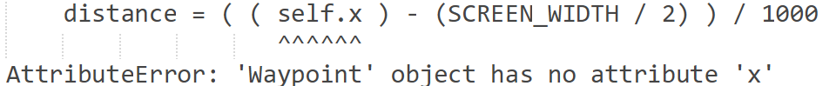

I have forgotten to alter some of the names of the attributes passed into the move method as I was reusing it from the clouds.

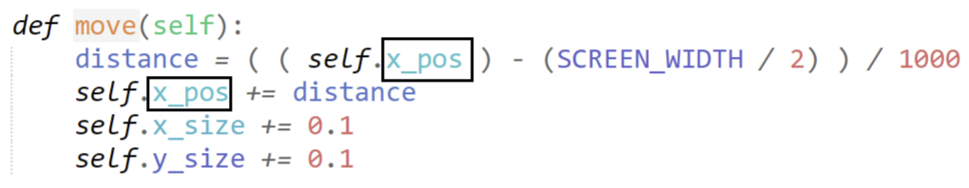

After changing these values, the AttributeErrors no longer existed.

#### Testing

|  |  |
| --- | --- |
| Program | **Explanation of Successes / Failures** |
|  | Running main after fixing the errors from object  Successes:   * waypoints spawn * waypoints move the same as clouds with respect to perspective   Problems:   * they are spawning above the ground * *inaccurate* perspective-based movement |

#### 2nd Iteration

To make it so the waypoints don’t spawn above the ground, I can simply change the self.y_pos to the same value as the clouds, which spawn on the horizon.



I will also create a formula for the perspective based growing.

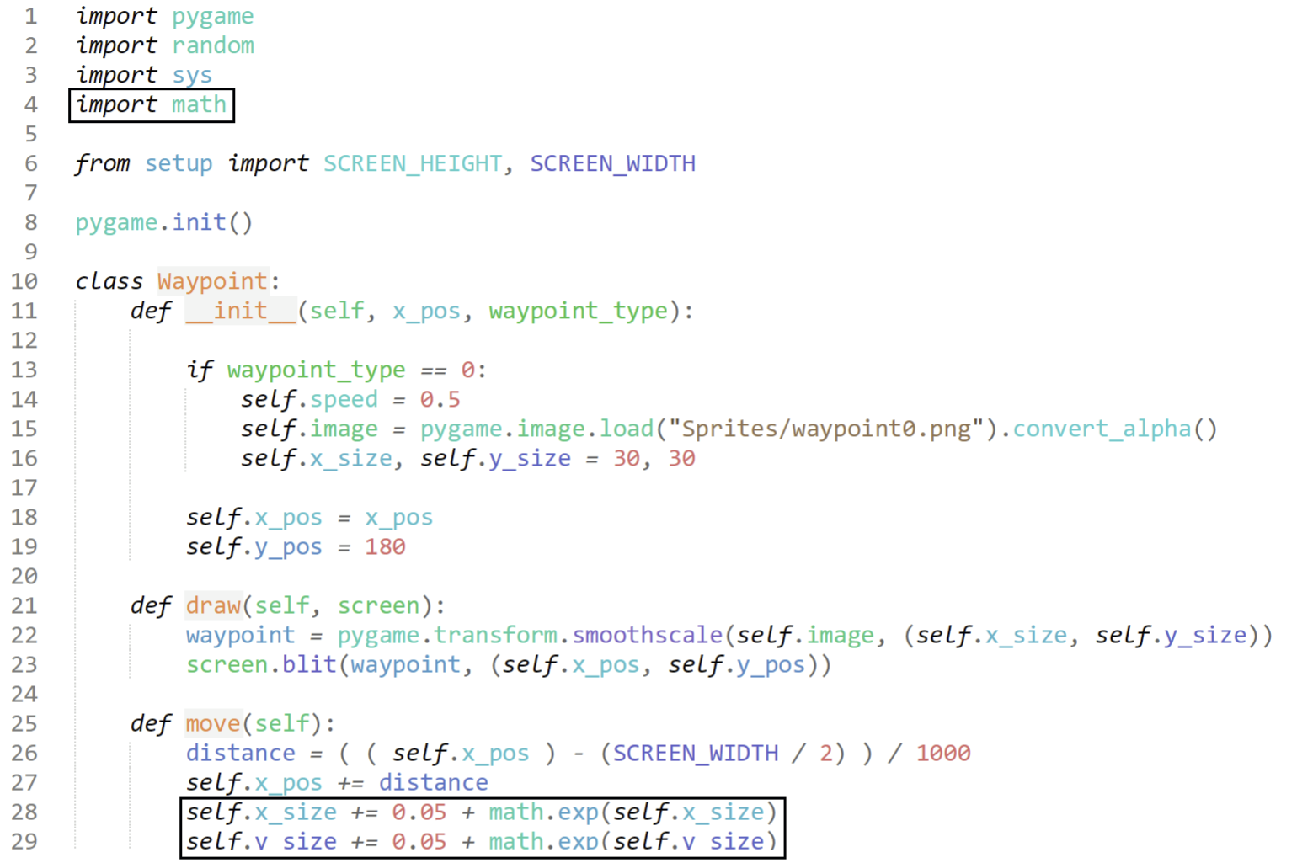

#### Iterative Testing Sequence



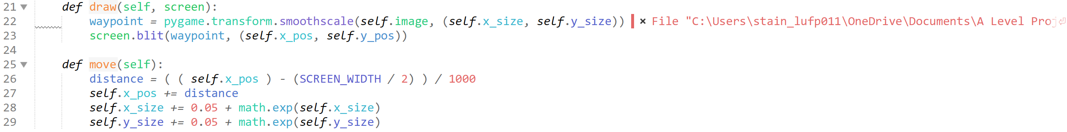

The ValueError occurs on this section of the code, due to my self.x_size adjustments in the move() method. I had made the mistake of using the import exponential function to recurrently call itself within the exponential function as a power, resulting in numbers impossibly huge, potentially leading to an overflow error.

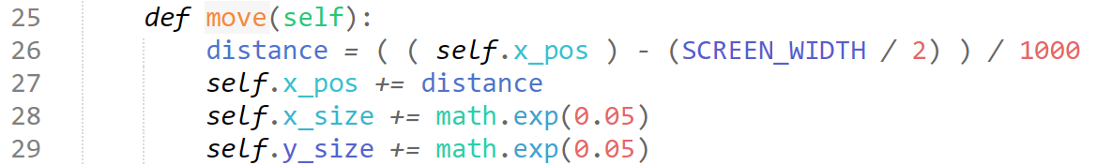

I resolve the issue by turning the function into a O(1) time complex system, placing a constant in the exponential power.

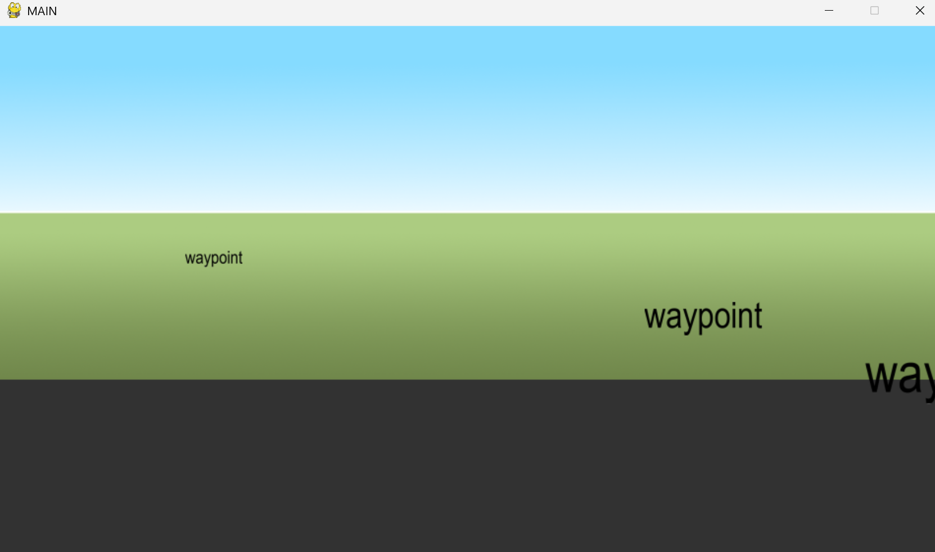

This results in the waypoints being too fast – the waypoint on the left had been spawned for 1 second.

When the object is sized up too fast, it results in the illusion of perspective also vanishing from the y translation perspective, as it horizontally grows right too fast, giving the imitation that the object is still travelling right, even if it is translating right.



I must call my self.x_size within the exponential, otherwise there is no reason for it, as I want my size to exponentially scale. I add a dampener to hopefully combat the ValueError I had before, and add another overall dampener as I believe without it, it would still grow too large.

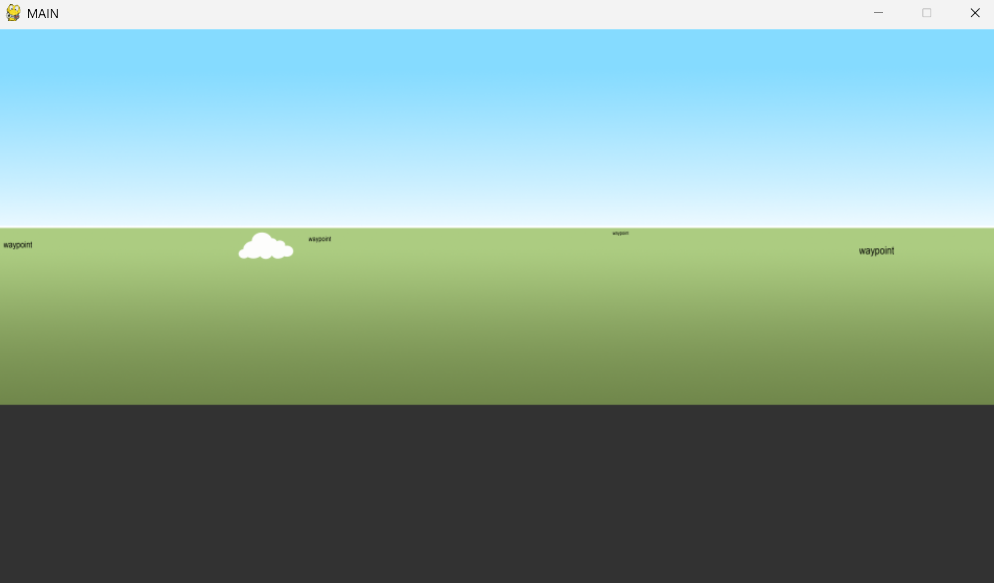

This works well, allowing the translation to still imitate, however it travels too slowly, and does not speed up the closer (bigger) it gets either, so I will aim to adjust some things to fix this.

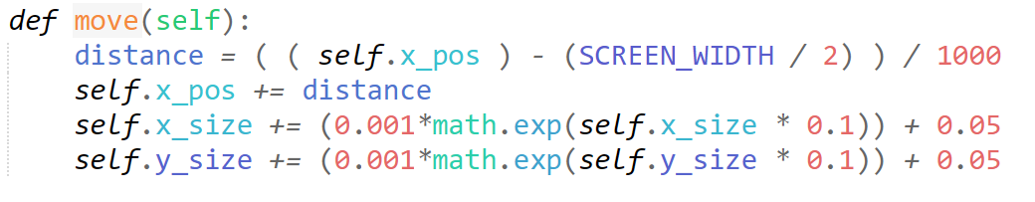

I dampen the self.Z_size less, so that the exponential feature of the equation is more noticeable, and I add a constant to ensure growth.



At the start of the test, the waypoint progresses very nicely and optimally, however, after roughly 2~ seconds on screen, the waypoint grows in size too quickly, and thus scales up the image too significantly, making it so pygame cant even blit it, as it is too large.

I have decided to model my formula before I implement it, this may save time pointlessly iterating through different formulae without knowledge of what is going on.

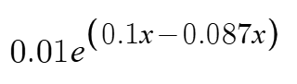

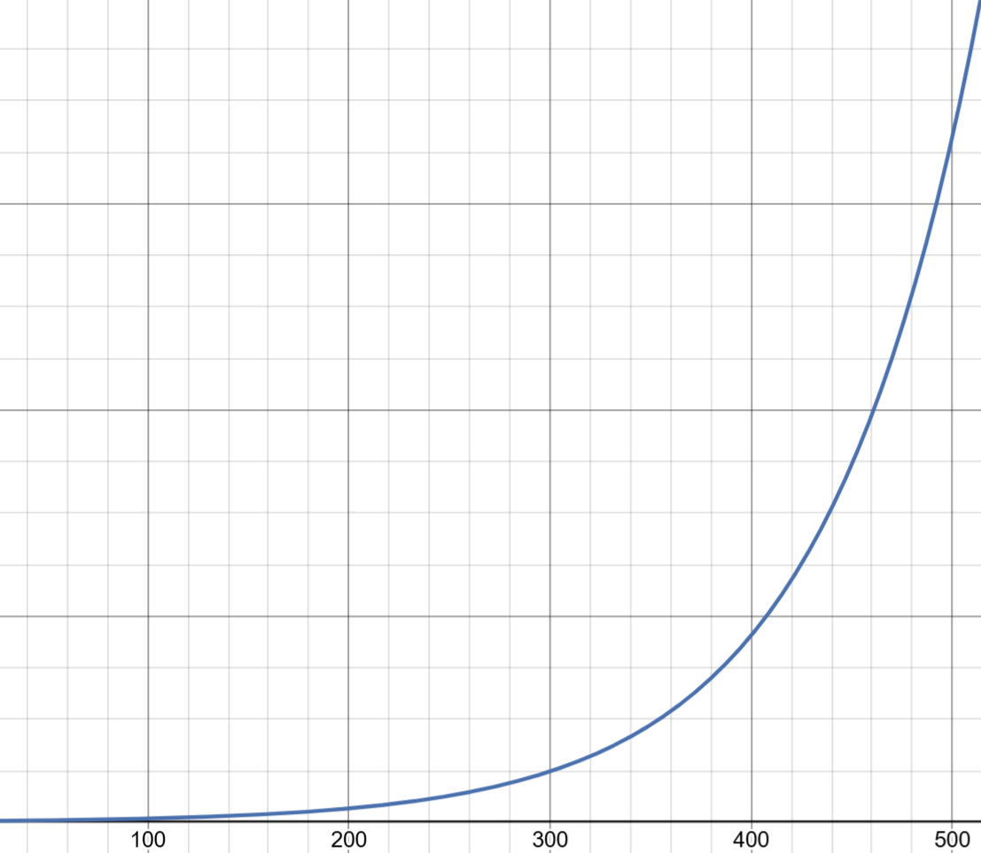

I have decided on this formula, as it has the growth at the rate I am looking for. It has multiple dampening factors. We can substitute the “x” for the self.Z_size value. I have used desmos for this.



I have decided to add a “+0.05” at the end to ensure growth is kickstarted, with a base growth value to speed up progression by a *constant* amount.

#### Testing

|  |  |
| --- | --- |
| Program | Explanation of Successes / Failures |
|  | Happy with an iteratively decided formula, running active main.  Successes:   * waypoints spawn on the ground * logical growth progression with perspective   Problems:   * create waypoint logic for rarer, less consistent spawns * no waypoint types * waypoints show up in front of clouds. |

#### 3rd Iteration

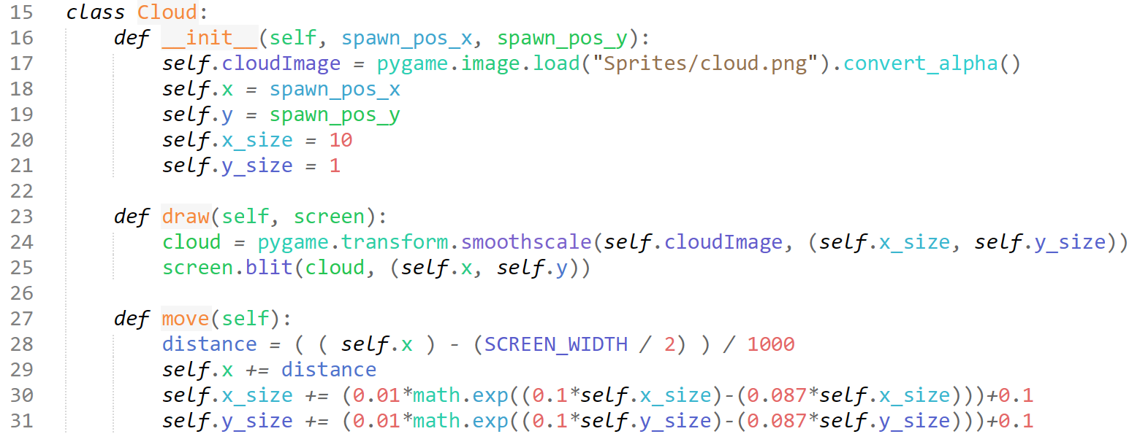

I update the clouds to match the growth type of the waypoints, but with a 0.1 progression as the clouds should grow faster, since they are closer to the POV.

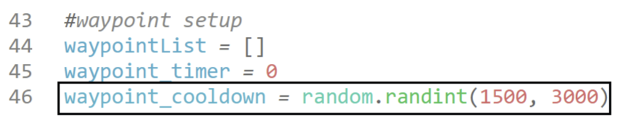

I adjust the cooldown to something high, but random, to create inconsistencies in the spawn timings.

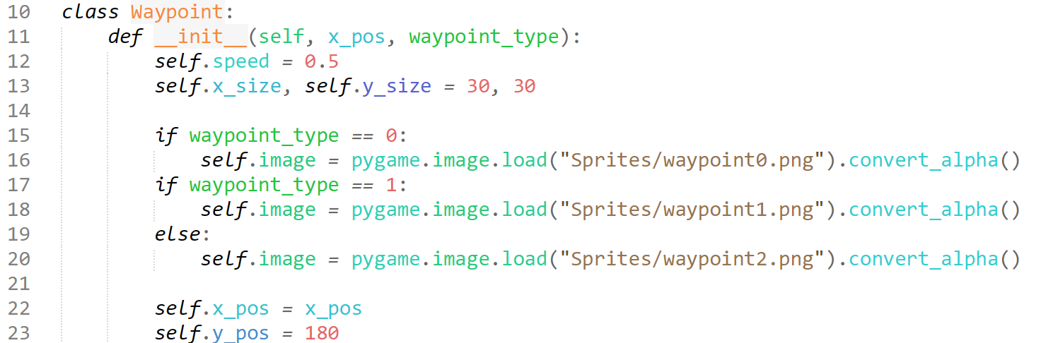

I optimise the code from the reused aircraft, defining speed and size not depending on the type, as they are the same for all. I also add 3 waypoint types: airport, military base, ATC.

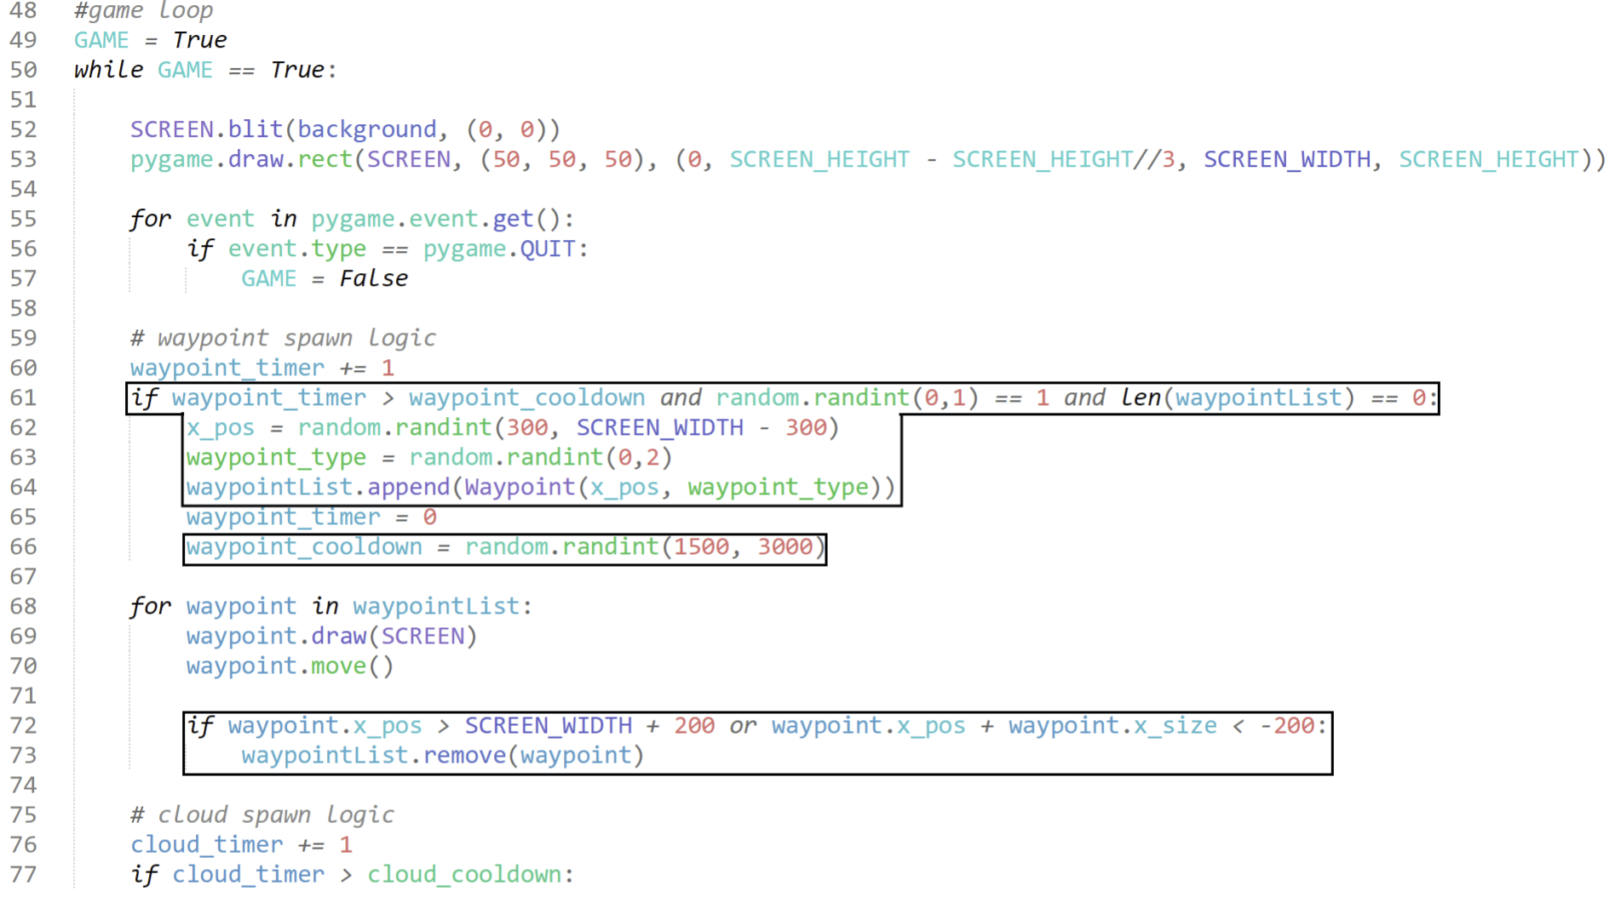

The new GAME loop code. We place the waypoint spawning and moving logic at the start of the GAME loop, before the cloud logic, so that the clouds will always be drawn after the waypoints, and therefore appear behind the clouds, correct to perspective.

I adjust the logic for whether a cloud is decided to spawn as well, mimicking the aircraft spawn logic, but only allowing 1 waypoint to be on screen at a time. This is due to complications with the waypoint/bearing menu if there are multiple waypoints. I adjust the xpos they can spawn at, as if it is too far left or right, they will disappear off the screen too fast for the user to notice, and lose them points unfairly. I have also created simple logic for a random waypoint type, and after a waypoint is spawned, the cooldown is randomised again to create further inconsistencies.

I reuse logic for aircraft deletion for waypoints once they go off screen.

#### Iterative Testing Sequence



When we run it, a cloud that was spawned very centered seemed to stretch horizontally near the end of its ‘lifespan’ and create this error.

Since we just reused the code for the clouds, this will also cause issues with the waypoints when they spawn near the centre.

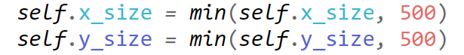

I set max size values to combat this.

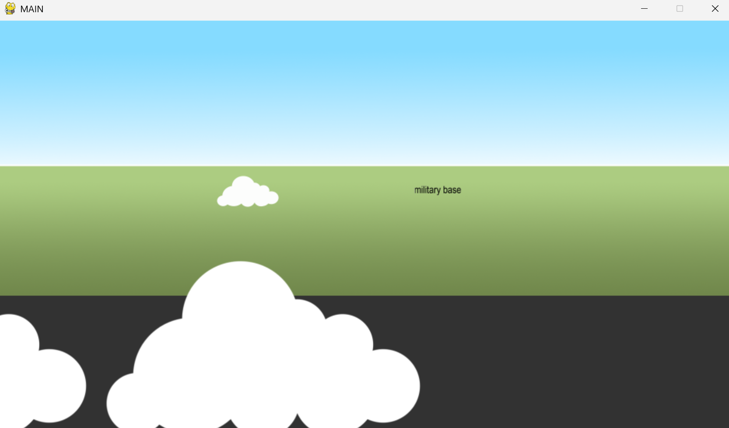

While it does prevent the error, the size increasing is the only thing that mimics it coming closer. This results in the clouds just stopping, and slowly sliding off screen horizontally. The clouds also inconveniently stretch horizontally still just before maxing out.

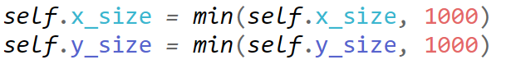

I simply increase the cap to stop this.

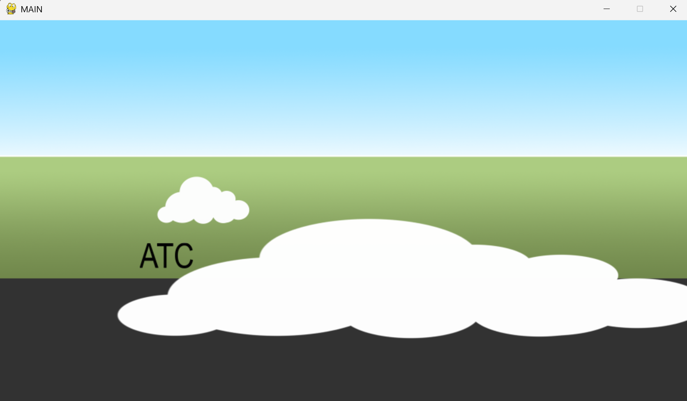

Unfortunately, the clouds still stretch horizontally, and the top of the clouds just get caught on the bottom of the screen, not fixing either of our issues. The issue also affects the waypoints.

I decide to dampen my formula so that growth doesn’t start as early as that.

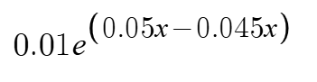

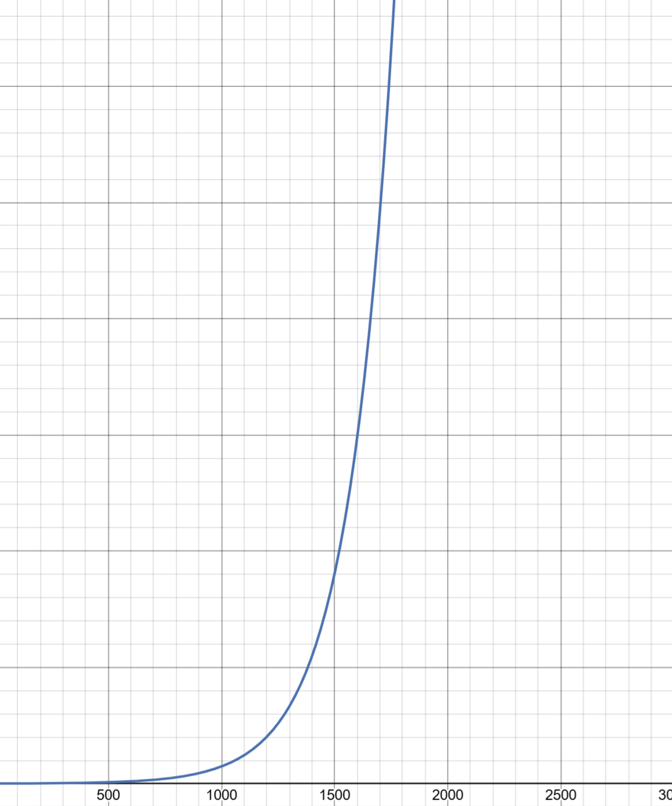

This formula should provide some more relief, having less growth at the start, and then capping at 3000. This also allows the cloud to start growing at around size 500, which is when it starts to appear closer to the POV.

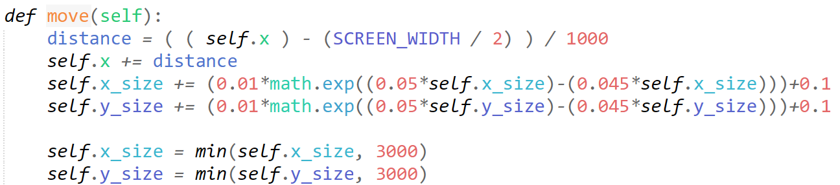

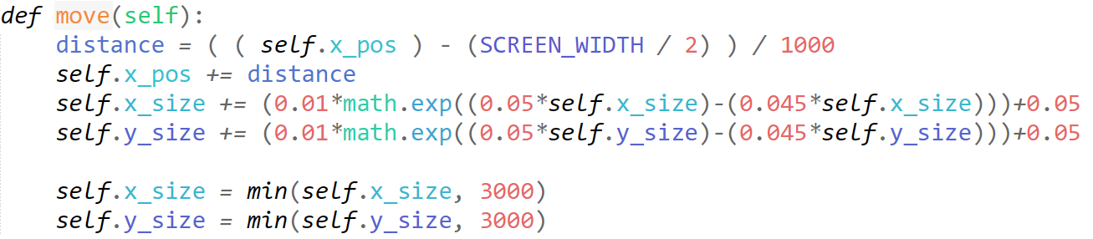

(these edits go for both clouds and waypoints respectively, as they will suffer the same issues, and require the same movement logic. I am concurrently debugging them)

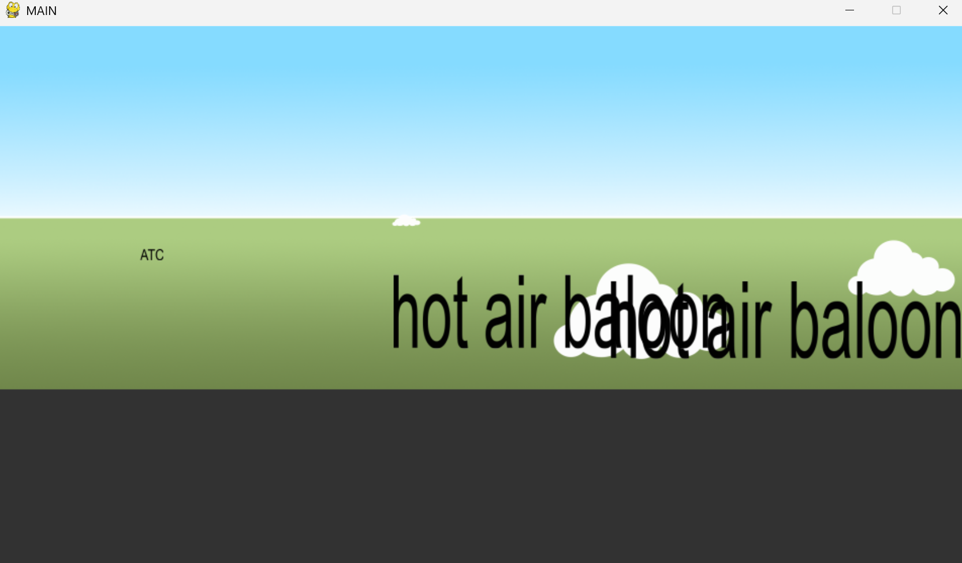

I face no issues with the cloud scaling, and they no longer cause any issues, and work as intended, however I face an issue with the aircraft, as the unique properties of the hot air balloon make a very inconvenient and unrealistic experience.

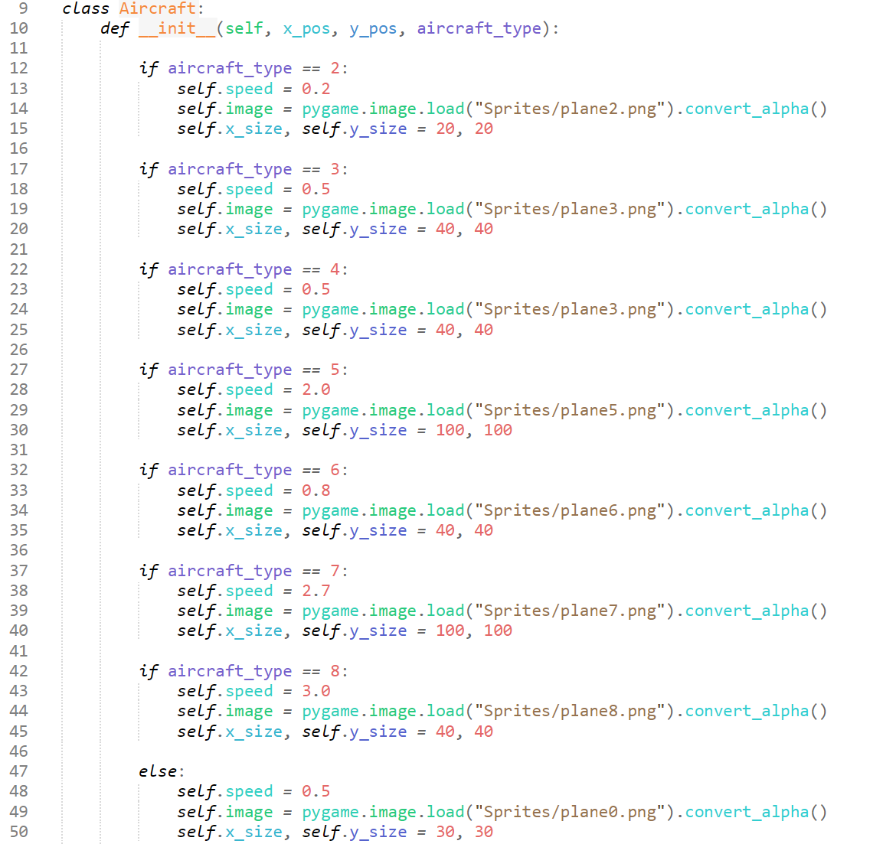

I simply delete the hot air balloon concept, and if that type is selected, it now picks the airliner. It would require logic alike the clouds and waypoints, and it is not worth it for now, as I am approaching my self-set deadline for this section. I may revisit the concept.



I also put the little grey bar (which mimics the interior of the aircraft) at the end, so that clouds appear outside of the POV aircraft.

#### Testing

|  |  |
| --- | --- |
| Program | Explanation of Successes / Failures |
|  | After the recent iterative testing features, fixing many issues across the board with the Terrain + Event Rendering so far.  Successes:   * clouds are behind the POV aircraft * only one waypoint spawns at a time * perspective for waypoints and clouds work, no errors |

### Important Note about the Design vs the Implementation

In my design section, for the waypoint / aircraft generation I mention about distributing the spawns of each into individual timeline arrays, and iterating through these arrays every few seconds. When writing this, I failed to account for the speed of processing that pygame can handle, leading me to believe that separate timeline arrays would be most suitable if I had wanted to simulate planes and waypoints spawning simultaneously.

In my actual implementation, I alter my solution to adapt for the newfound processing “power” that pygame enables me to utilise, so instead of creating two separate timelines for generation, use pygame’s inbuilt timeline / event.get array to store when generation should occur.

For generation, I also no longer utilise a set to distribute it randomly, instead I use a sequence of random statements and cooldowns to decide if an event should be generated, once the randomly generated location within pygame’s timeline array is reached. I also no longer need to create and use two separate arrays, as the tick rate at which I can iterate through my GAME loop can mimic simultaneous action for encounters within the timeline array.

This encapsulates the principles of my Design, whilst utilising new methods to streamline my implementation.

### Buttons

**Success Criteria:**

“Separate and easily identifiable buttons for the waypoints and airplanes”

“Variables for when the buttons are clicked when an event is rendered, and when event is not rendered”

#### 1st Iteration

Here we want to create the middle menu which the lights, waypoint panel, waypoint and aircraft button all sit on. I will create this in a separate module and import everything to the main for cleanliness and sustainability in my code.

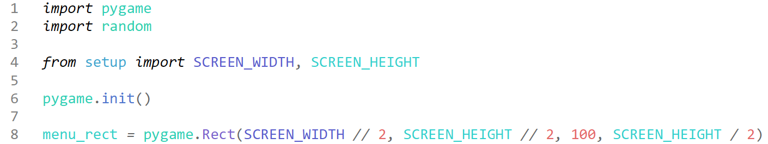

This is the start of our button.py module, where I just put in simple values to gauge where I should move it later.

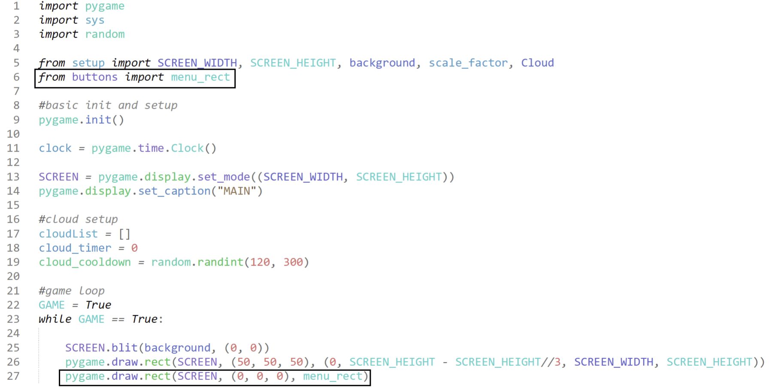

Quick edits to our main to test.

#### Iterative Testing Sequence

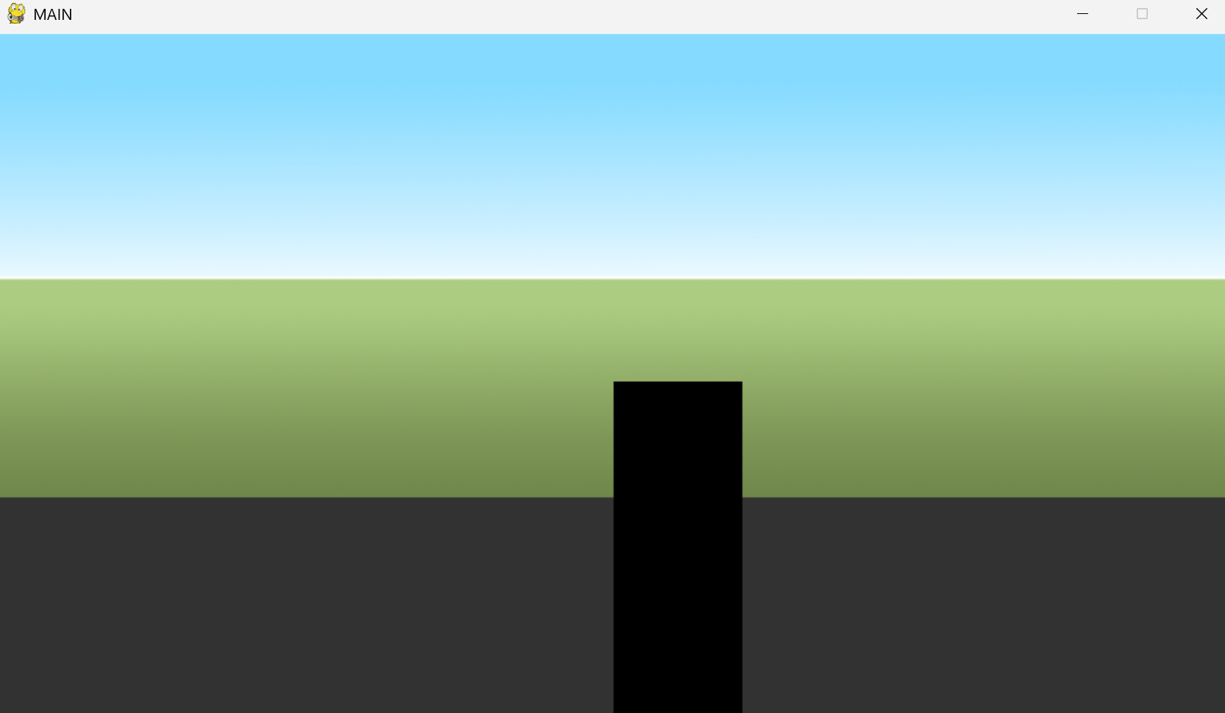

From our quick, I can adjust the x and y values until they line up with centre of the screen to create the box we demonstrated in our Design.

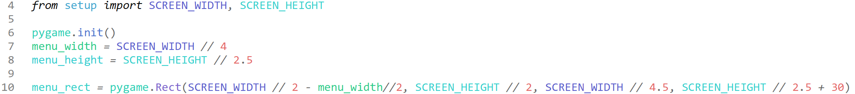

By creating and altering some values in our menu_rect, we can get a perfectly centered menu rect:

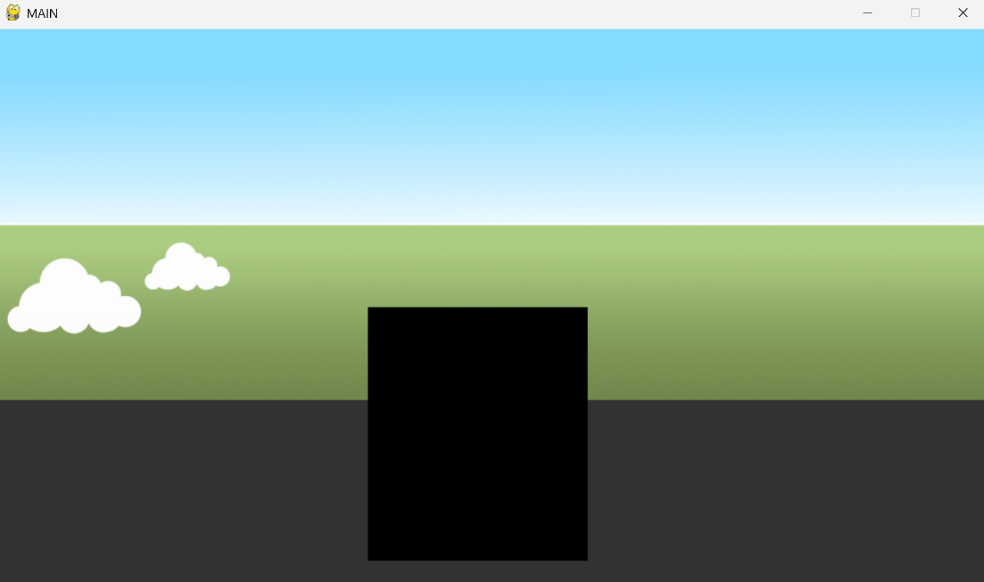

Some slight adjustments to the width: 

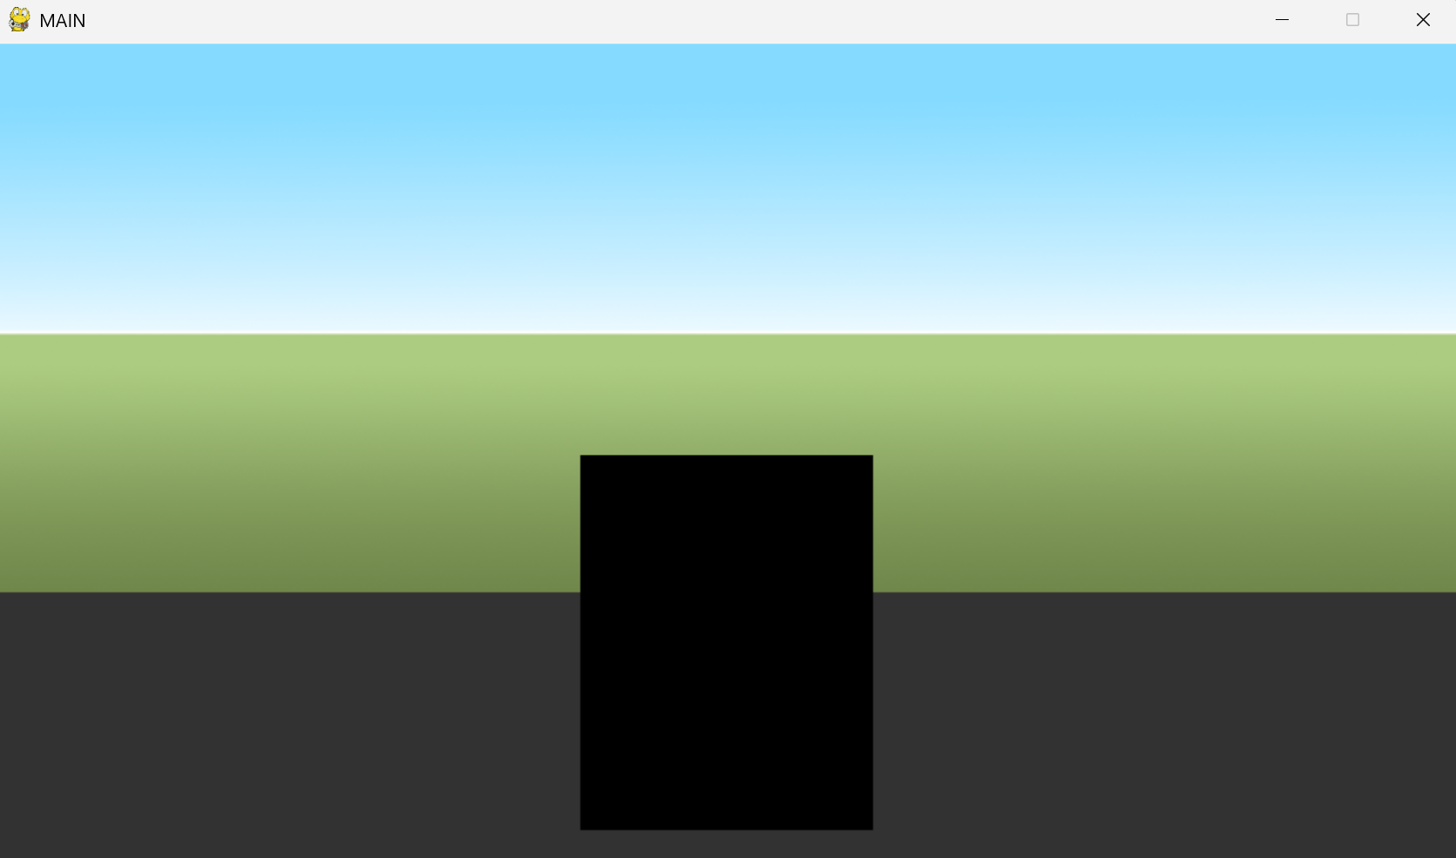

This version is the ideal width and height, and centered, so I will layer a UI interface over it.

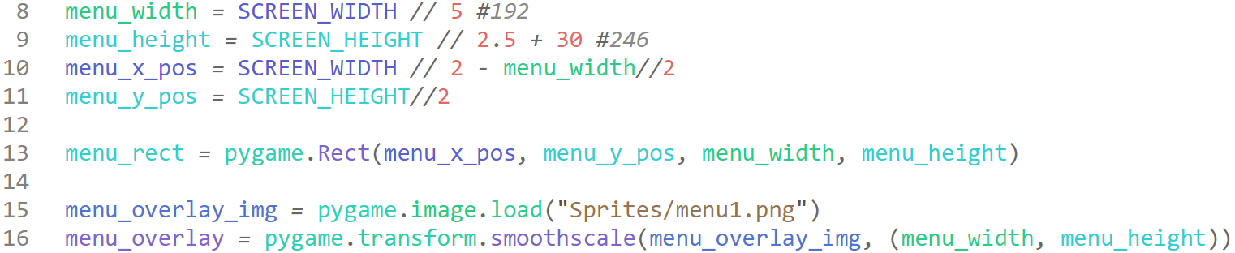

Adjusted for sustainability, we define all the values for the menu in a variable store so we can reference it for the overlay image at the same time.



In the main, we import all the new required variables.



We simply call the menu_overlay and blit it onto the screen at the same position as the square we drew.

We will now ‘officially’ test this section, the reason we had not documented the tests previously is that I would simply be adjusting the positional and translational values of a rect until it felt right, so there was no set goal and extenuating method to performing this, and thus very little test useful data would be created.

#### Testing

|  |  |
| --- | --- |
| Program | **Explanation of Successes / Failures** |
|  | Running main  Successes:   * menu image is overlayed on top of rect * menu image is correctly positioned and sized   Problems:   * colour mixing is an eyesore * no functionality |

#### 2nd Iteration

I would like to make it clear that these images / overlays are all temporary, and once the programming is completed, I will be altering them to be more aesthetically pleasing.



For now, since the aesthetics do not provide any sort of functionality while programming, I have simply neutralised the line declaring the grey background rect. The reason I had added the menu_overlay image is because I needed to gauge the dimensions for the mapped waypoint guide underneath the (unseen) buttons.



Within the buttons.py, I will use these just to align and test, and create objects with click detection after the alignment is correct.



Importing the two new variables into the main

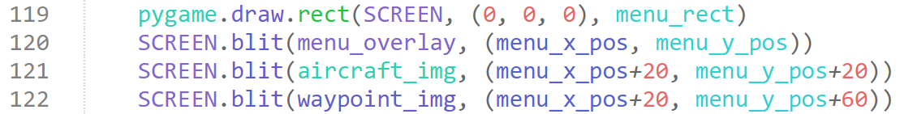

At the bottom, I blit the two new images on top of the menu, with vague coordinates I believe may align, considering the dimensions of the images.

#### Testing

|  |  |
| --- | --- |
| Program | Explanation of Successes / Failures |
|  | Running the main  Successes:   * correctly aligned buttons * layered on top of menu * easily identifiable and obviously separate from eachother   Problems:   * no functionality |

#### 3rd Iteration

I will create an object for the buttons, where the buttons instance can be either the aircraft or the waypoint, based on a bool.

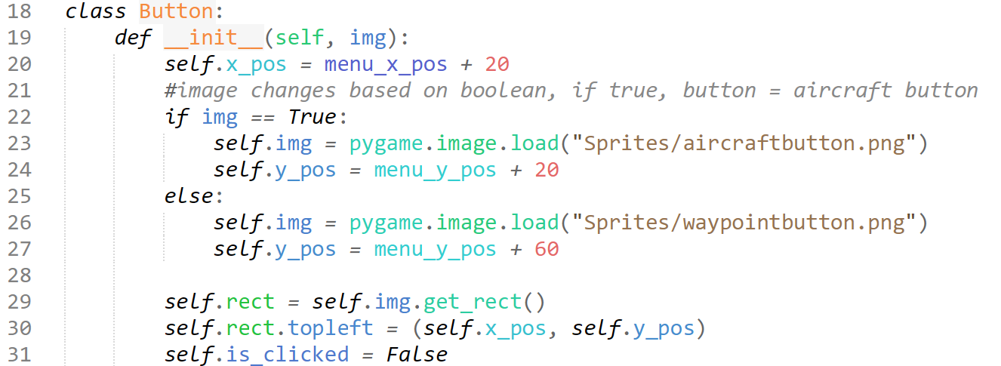

I set out the initiation for the button, where if the bool “img” is declared as True, the instance will be an aircraft button, and if it is false, it will be a waypoint button, changing the coordinates to match.

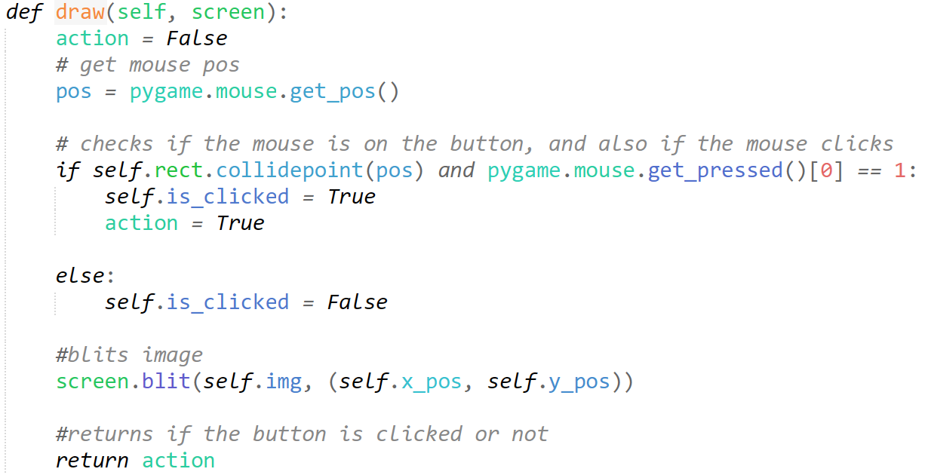

I create this method for drawing the button, and returning if its been clicked or not, it does this by checking if the position of the mouse is colliding with the position of the rect, and then checks if the mouse is clicked, where it then actives the action, which is returned through the function.

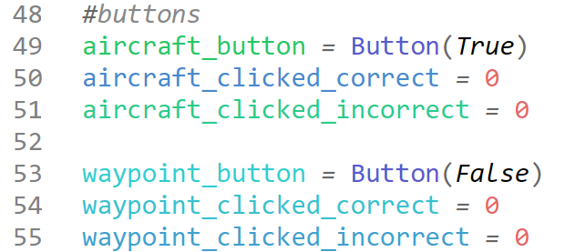

We create an instance of each button, and add new stores for the buttons.

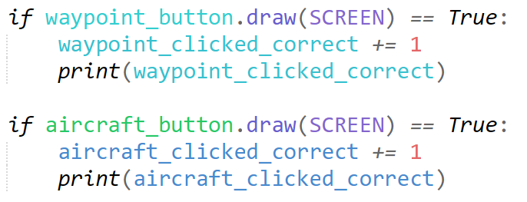

I add this code to the GAME loop, below the menu rect so it appears on top. This should call the draw function, and checks if the ‘action’ returned is True (meaning button is clicked), and will then output our test features.

#### Testing

|  |  |
| --- | --- |
| Program | **Explanation of Successes / Failures** |
| *where I click the aircraft button once, and then click the waypoint button once* | Running the main after the creating and import of the new Button object, and calling the new function in the GAME loop to blit the buttons, and check for inputs  Successes:   * both buttons spawn from the instances * clicking inputs work * both buttons take inputs to their separate conditions   Problems:   * the buttons seem to take the input too much * they don’t check that the waypoint / aircraft is on screen |

#### 4th Iteration

The reason for these issues is to do with the tick speed, as the game code is looped over many times a second, even a fractional second of input will be iterated and checked over multiple times, causing the game to take that input many times.

I will also likely have to make the draw methods in the individual waypoint and aircraft code functions, returning whether something is on screen, and how many and other details to relate.

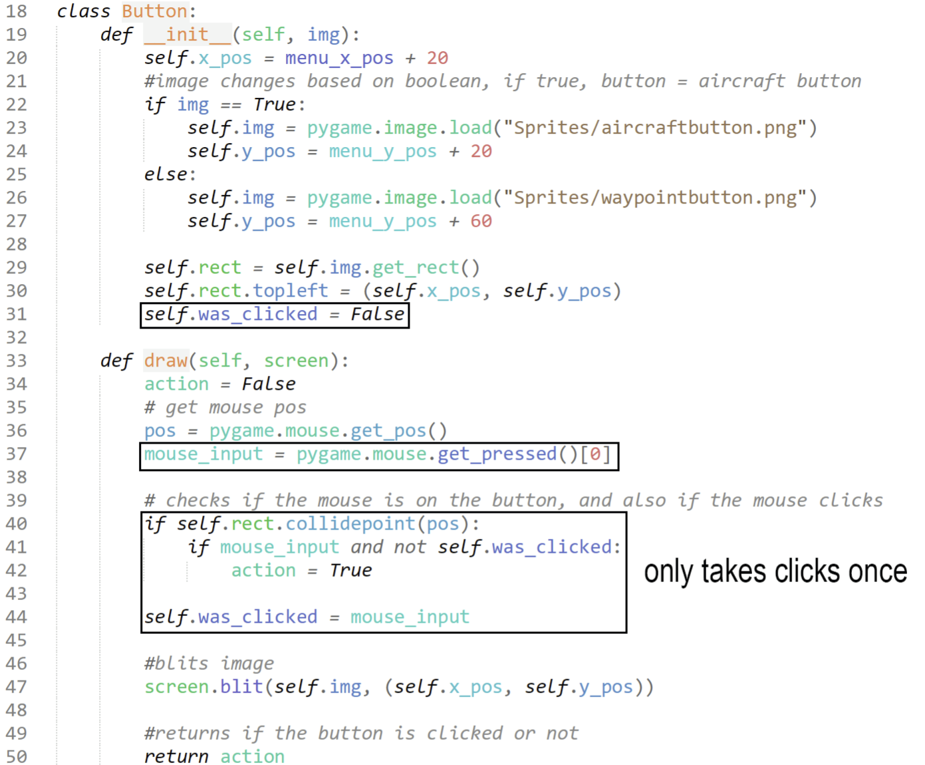

This is my edited code to only take single inputs. It checks if the previous input was a click, and if so, does not allow the program to register further.

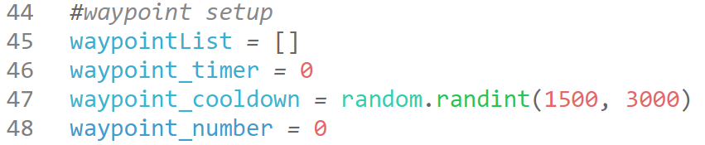

To implement clicking a waypoint and giving you a point per waypoint on screen, I add a static to count the number of waypoints on screen.

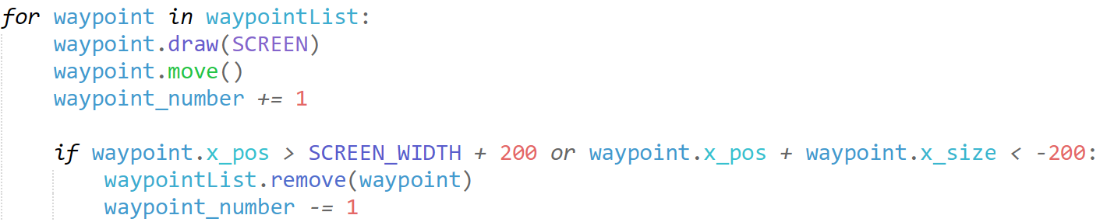

For every number of waypoints, the waypoint number is increased by one, and everytime the waypoint goes off screen, the waypoint number decreases by one.

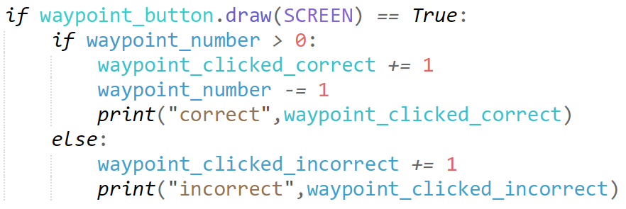

We use this algorithm to check if there are waypoints on screen, and if it is clicked, then the waypoint number is decreased to ensure that the user cannot gain multiple points for the same waypoint, and else it’ll register incorrectly. I have the print statements for testing.

#### Testing

|  |  |
| --- | --- |
| Program | **Explanation of Successes / Failures** |
|  | Running main with changes to GAME loop and draw  Successes:   * only 1 input is counted * when waypoint is not on screen, incorrect points are altered when clicked * when waypoint is on screen, correct points are altered   Problems:   * when a waypoint is on screen, all clicks count as a point, when only one should, and then the rest should be incorrect. |

#### 5th Iteration

I realise it is because I have put in the for loop, which every tick will increase the number by (number of waypoints on screen).

I should instead put it when a waypoint is decided to be generated, and since only 1 waypoint is needed, I can just create a Boolean value for this.

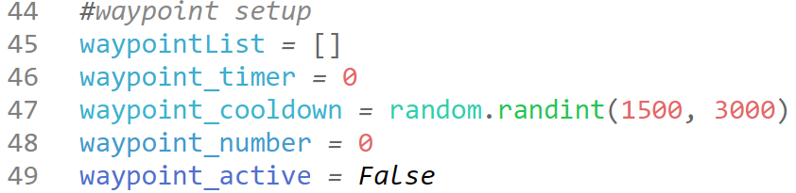

My added Boolean value, waypoint_active.

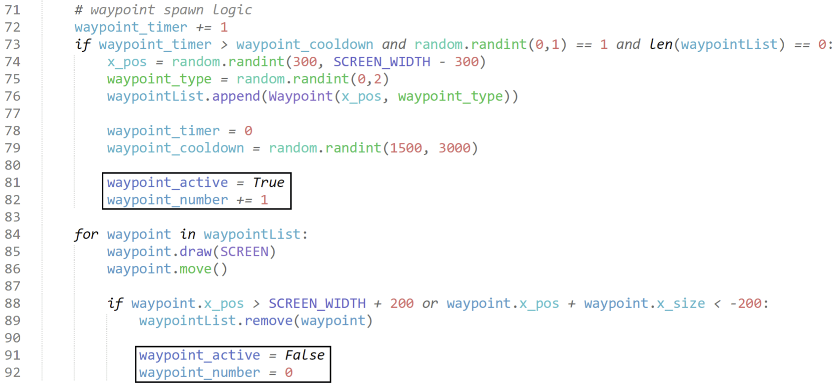

When a waypoint is spawned, it actives the Boolean value and increases the number of waypoints on screen, and when it is removed off screen, it is set to false, and returned back to 0.

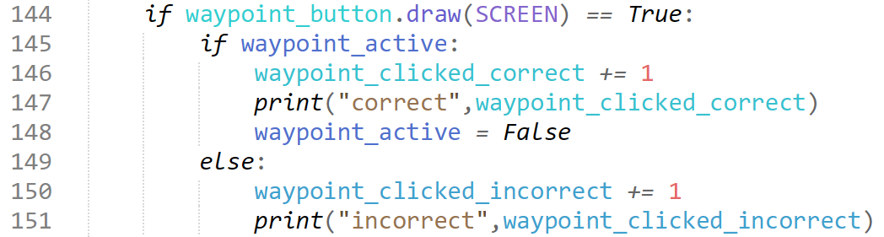

We can finally implement this in our button checking code.

I need to find an alternate way to do this for our aircraft, as there can be multiple on screen, and so a simple Boolean value will not function as intended.

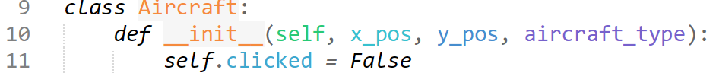

I add a new attribute to the aircraft, clicked, as a Boolean.

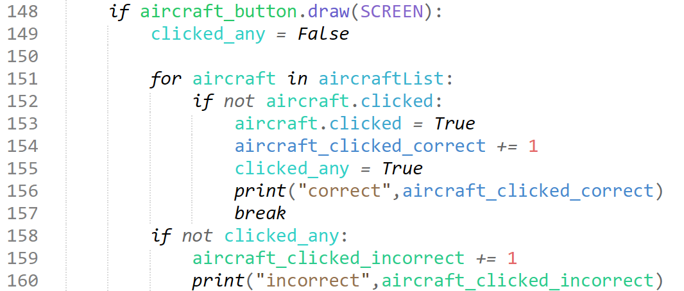

We then check if the aircraft has been clicked, once the aircraft button has been clicked. Each aircraft will track its own ‘state’, and once clicked, it wont be counted again. When a plane is clicked, only award points if clicked is False, and then set it to True.

#### Testing

|  |  |
| --- | --- |
| Program | Explanation of Successes / Failures |
|  | Running main with the changes to logic for clicking waypoints, and aircraft.  Successes:   * individual waypoints + aircraft can only be counted towards one point * if clicked past the number of event on screen, does not count * both buttons work for their respective events. |

### Flashing Lights

**Success Criteria:**

“Understandable graphics for the lights on the dash”

“Noticeable when the lights on the dash light up”

“Both lights can light up randomly”

“Reasonable number of flashes from lights dependant on difficulty”

#### 1st Iteration

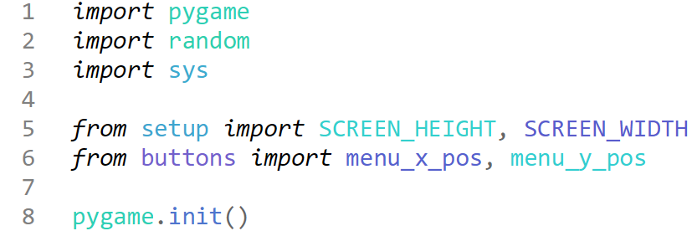

I create a new module, lights.py and write the following setup code.

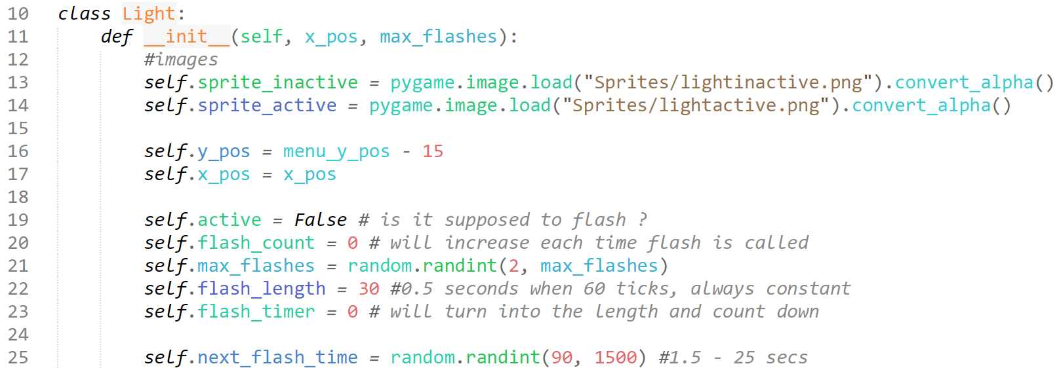

I initialise the Light object, and require the parameters for the x position (which will be different for the two lights) and the maximum amount of flashes (which will be dependent on difficulty)

I create the attributes for the images and positioning, and then start to set up my flashing logic attributes, where I will create methods for creating a flash (altering the images) using the values shown and explained in the comments to do so.

I have temporarily added a next_flash_time attribute to ‘randomise’ the next spawn time, even though this creates unwanted consistencies, but for now I just use it to test.

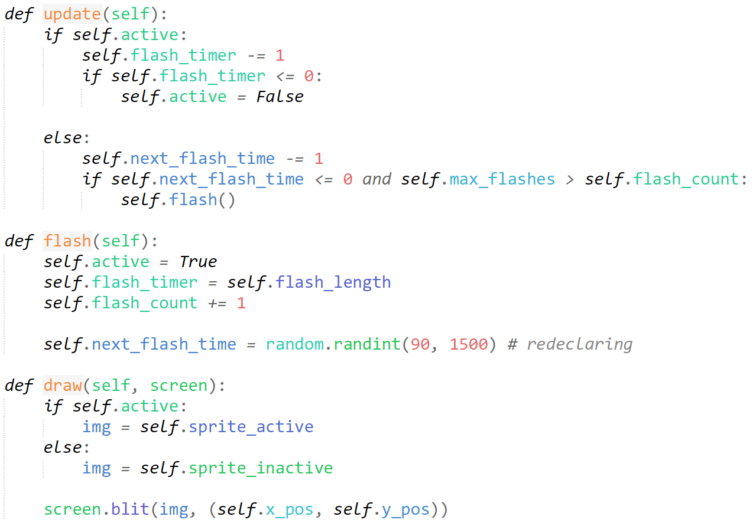

Here I have my methods. The logic is very basic, essentially just waiting for the random timer to go off, then activating the flash which just sets the flash duration timer and activates the active attribute, and rerandomizes the next flash time. Once the active attribute is True, then it will update, pasting the alight image until the flash_timer runs out, which it then stops it, and pastes the dimmed light image.

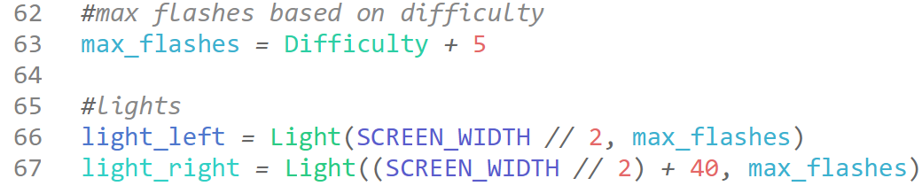

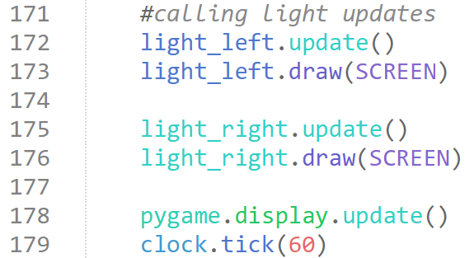

Above is the code I add to the main module. I first declare the max flashes depending on difficulty, which is directly proportional starting from 5, and then just declare two instances for the left and right light.

Within the GAME loop, I constantly call the update, which checks if a flash has been called, and calls it eventually, and then I call the draw method, which blits the image on screen (which changes according to the update + flash attributes changed)

#### Testing

|  |  |
| --- | --- |
| Program | **Explanation of Successes / Failures** |
|  | Running the main after importing the lights object, and creating the two instances  Successes:   * lights are placed well * evident difference when active vs inactive * understandable graphics * both can light up randomly * number of flashes based on difficulty * counts each flash   Problems:   * random flash sequence needs adjusting |

#### 2nd Iteration

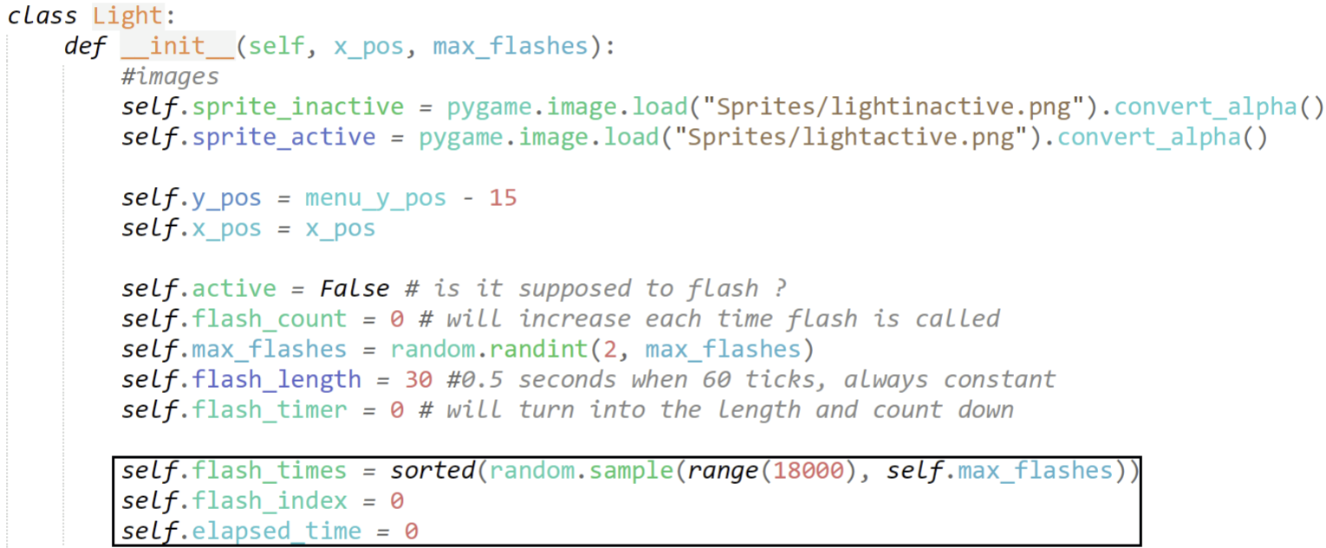

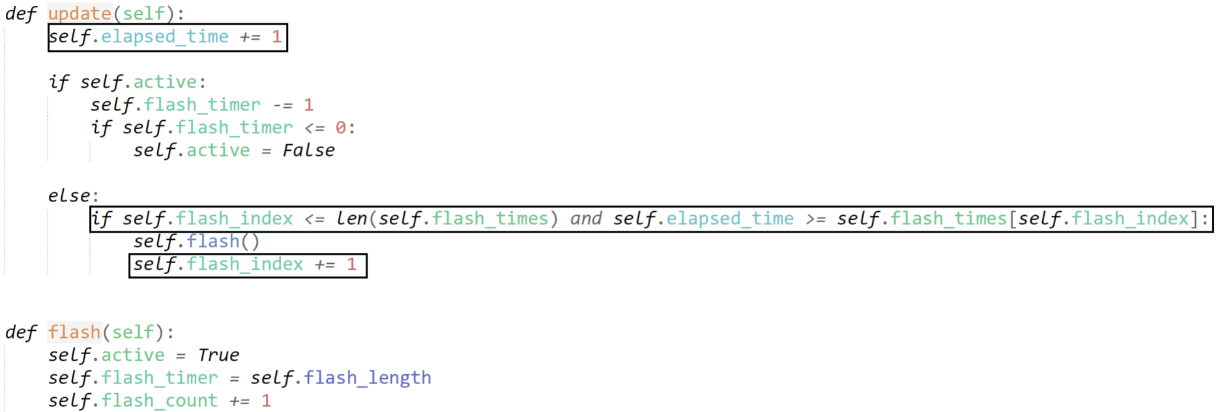

Above is my edited Light object, I essentially replace the random timings and countdown to next flash with a array, which distributes the max_flashes across a timeline of the 5 minutes the program is to run for, and slowly iterates through this list each tick, unless a flash is detected, where the regular methods are called.

#### Testing

|  |  |
| --- | --- |
| Program | **Explanation of Successes / Failures** |
|  | Running the main with changes only to Light object logic  Successes:   * ‘consistently’ irregular distribution of flashes |

It is important to note that in my Design section, I talked about having a “timeline” array, and distributing the flashes for each light randomly along this array. Whilst this is not the exact solution to the dot for the implementation I have used, it is very similar, I simply use a sorted index / list instead of a specific array labelled “timeline”.

### Events – Further Waypoint Interaction

**Success Criteria:**

“When waypoints on screen, POV appears to change direction”

#### 1st Iteration

Currently, we do not have the means to imitate rotation and direction changing as our background image is made to perfectly fit our screen, if we want to be able to freely rotate and transform, we must have a larger image.

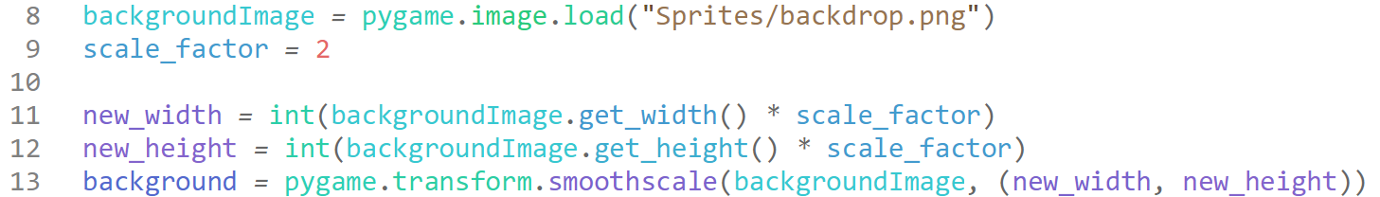

Instead of creating a new image with higher resolution, I just make the scale factor 1, instead of 0.5, doubling the image dimensions, and 4x the overall image area.

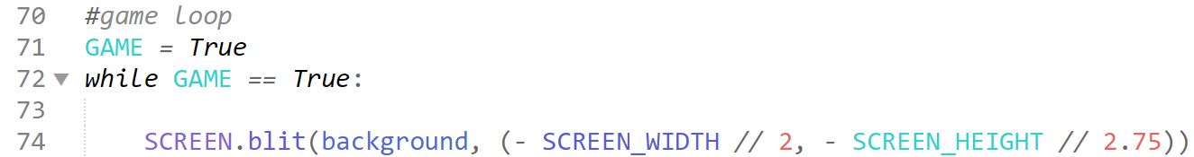

Instead of putting the image at 0, 0, we will need to change this to make there some ‘excess’ of the image on each side, so that rotations still keep the image in mind.

#### Testing

|  |  |
| --- | --- |
| Program | Explanation of Successes / Failures |
|  | Running the main with the subtle changes to background  Successes:   * The image still looks the same, with same proportion of sky : ground * Horizon line is the same   Problems:   * No rotation code |

#### 2nd Iteration

When a waypoint appears on screen, after roughly 2 seconds the POV should seem like it is rotating, and then it’ll flatten out.

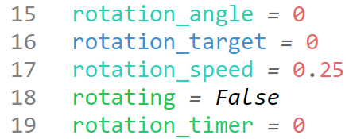

In the setup.py module, I add these values to import to our main to assist in managing the rotation logic.

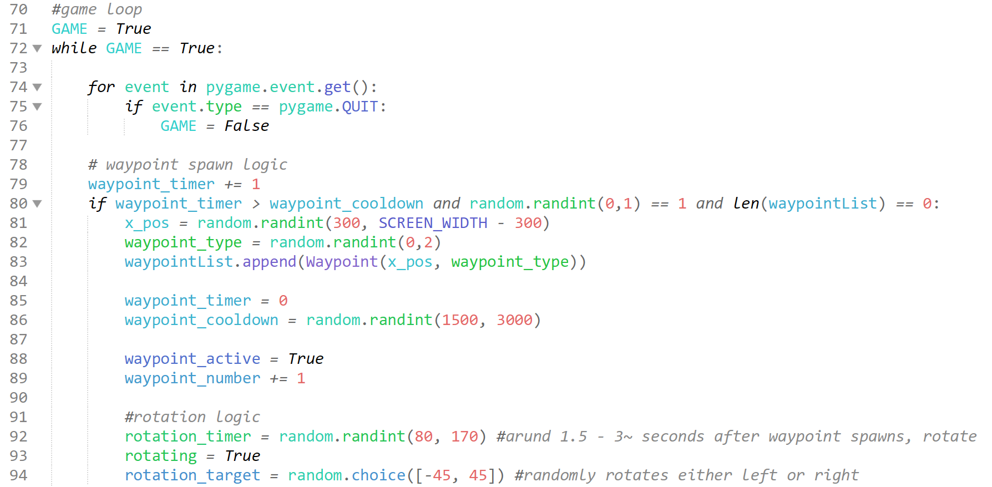

Our edited waypoint logic and GAME loop, notice how we do not blit the background at the very start anymore, as we need the waypoint influence and new rotation logic to edit and blit that. Here, every time the waypoints spawn, we set rotating to true, as every time a waypoint is encountered the POV should rotate.

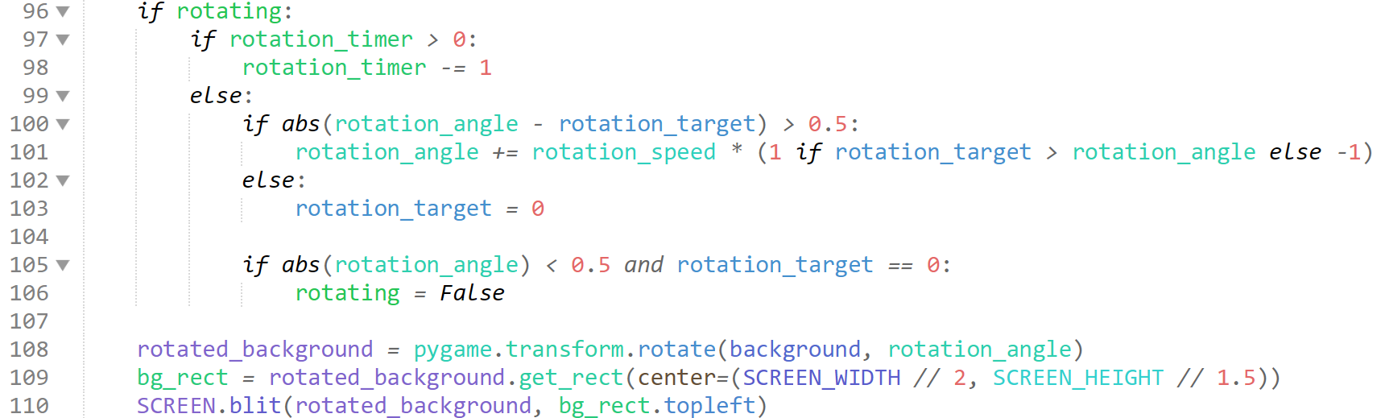

I add logic into the GAME loop which manages the rotations, where if the rotations start, then the angle is slowly iterated, which then directly affects the blit. As you can see, I also learn of a simpler way to do selection statements, which would have been useful if I knew of this optimised method before.

#### Testing

|  |  |
| --- | --- |
| Program | **Explanation of Successes / Failures** |
|  | Changes to main in GAME loop and new setup values  Successes:   * When a waypoint spawns, rotation is triggered * When rotation is triggered, the background slowly rotates * The background slowly rotates back.   Problems:   * Nothing else rotates, only the background |

#### 3rd Iteration

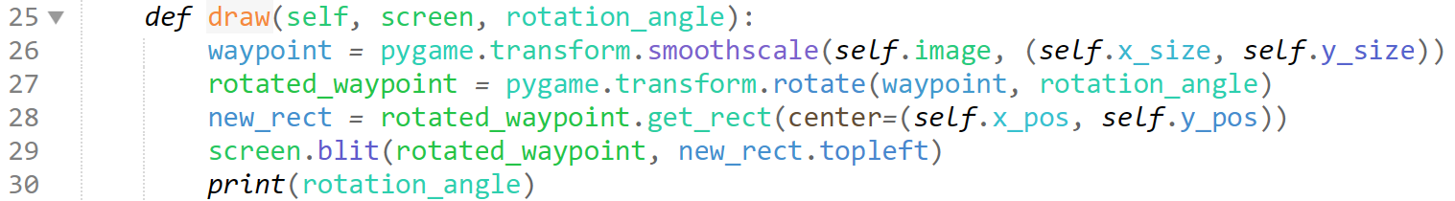

In the waypoint draw method, I add the following code, which replicates the rotational affect given to the terrain.

#### Testing

|  |  |
| --- | --- |
| Program | **Explanation of Successes / Failures** |
|  | Running the main  Successes:   * Waypoint rotates   Problems:   * Perspective only looks right when rotating the opposite direction to waypoint spawn * Does not ‘go with’ terrain |

#### 4th Iteration

These are huge issues which require large amounts of debugging. I am going to resort to the simplest fix: remove all combination of events which do not make sense, and program the rotation for each event / background item.

This solution unfortunately stems from huge calculations which are required to be made. I have created a few simple formulae shown below, however within python they do not perform as they should, potentially due to limitations in the procedural method in which python performs calculations, and the limitations of the math library.

I attempted to design the plane as such;

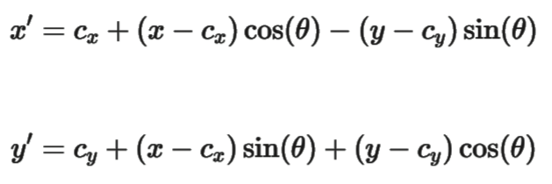

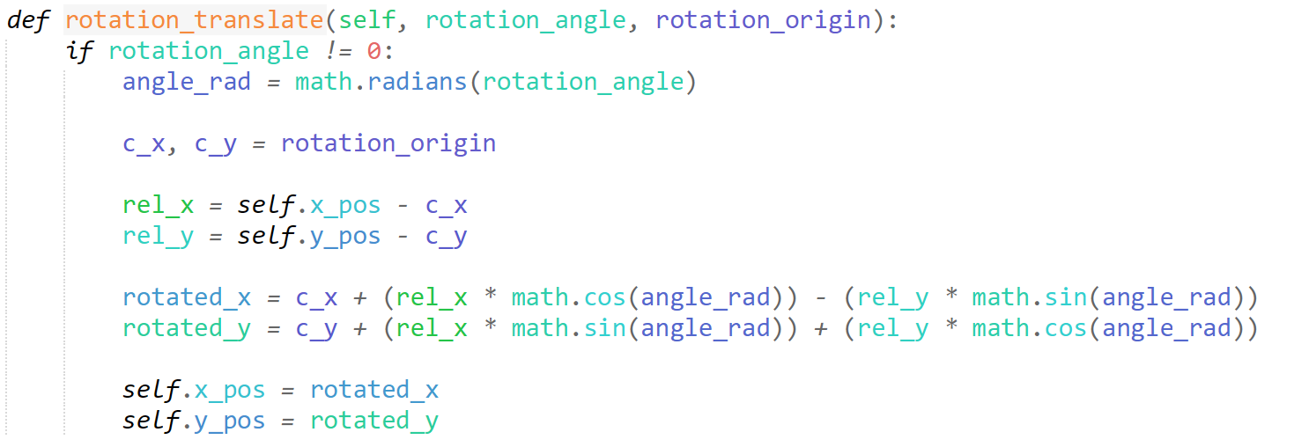

However, instead of rotating it the (rotation_angle / 360)rads, it would force the aircraft to undertake multiple circumferences of translation upon the method being called, so I must abandon this principle, as I see almost no ways of improving and building upon this.

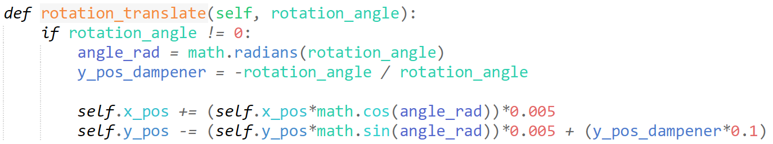

Instead, I use a more simplistic trigonometric pattern to alter the x and y positions to make the place appear as if it has the same horizontal velocity as it did before rotation (while the POV is rotated)

I add a dampener which simply moves the plane in the left or right direct depending on where the POV is supposed to be turning into, and this gives our plane models a real feel.

I simply add method to each the setup (cloud) and waypoint module, and it works fully as intended, albeit slightly rough and imperfect, but significantly better than I had imagined it would.

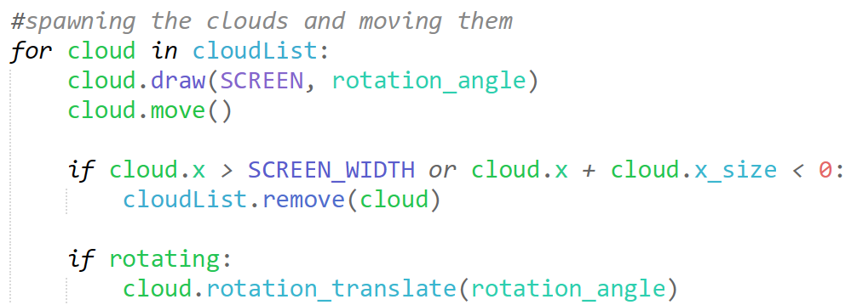

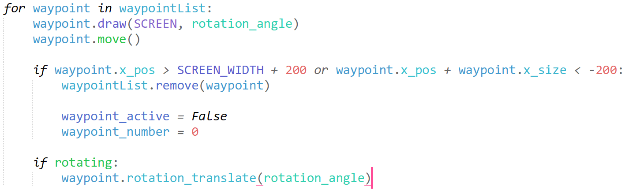

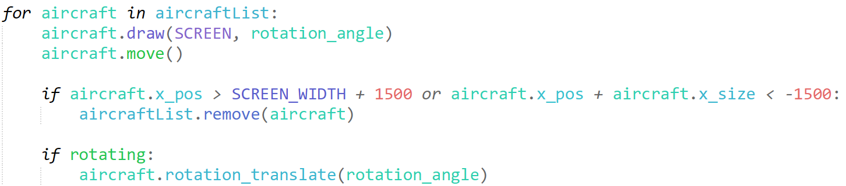

I simple incorporate calling the method for each item in their respective for loops, activating it if “rotating” is true.

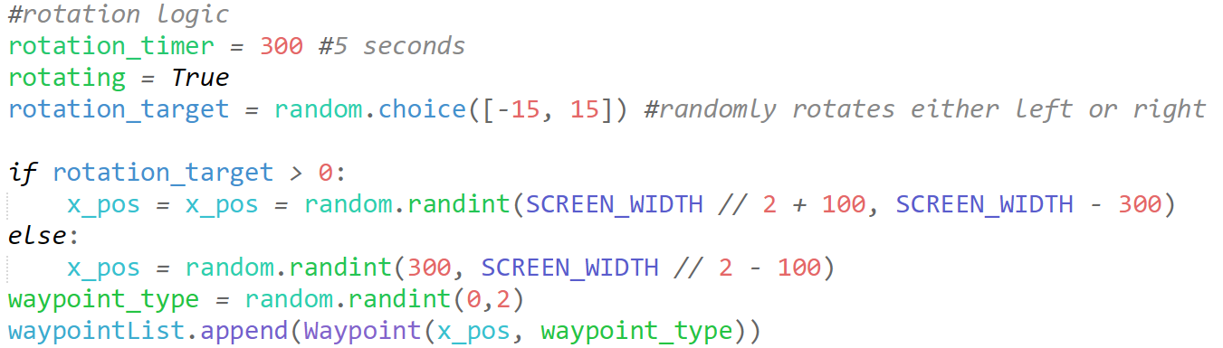

I make the rotation timer 300 ticks, or 5 seconds so the user will have enough time to notice the waypoint before the plane rotates. I also make the x_pos dependant on side of rotation, to ensure it doesn’t rotate off the screen too quickly, and the user can further notice it.

#### Testing

|  |  |
| --- | --- |
| Program | **Explanation of Successes / Failures** |
|   *Just after rotating* | After adding the working method to each of the items from the aircraft code, and embedding programming which actives upon rotation  Successes:   * Waypoints do not float * All items rotate with the landscape at the same rate * Items appear to remain in roughly the same spot with regards to 3D perspective   Problems:   * Waypoint / bearing terminal has no functionality |

### Finishing Event Additions

#### 1st Iteration

Here, I need to merge my active reasoning challenges and plane minigame into the Terrain + Event Rendering

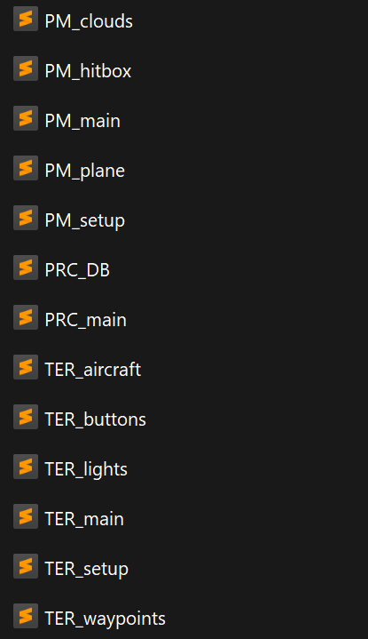First, I need to find a method to call the separate module within the GAME loop. I have decided that creating an object out of the module is the best course of action I can take to implement this.

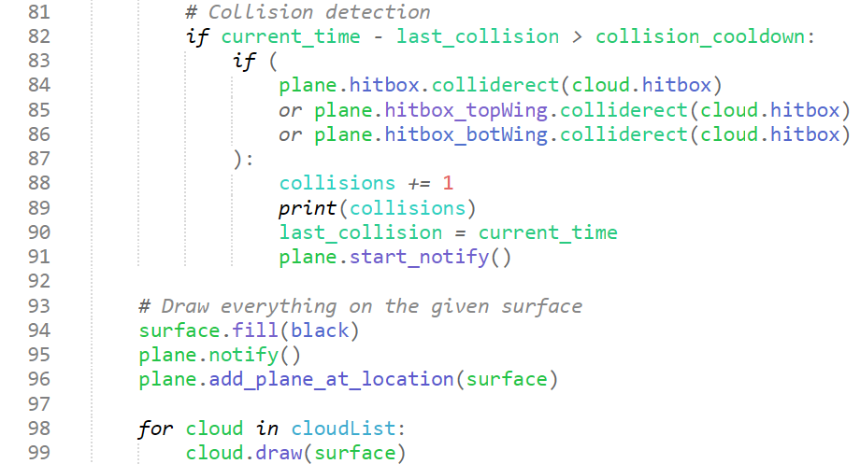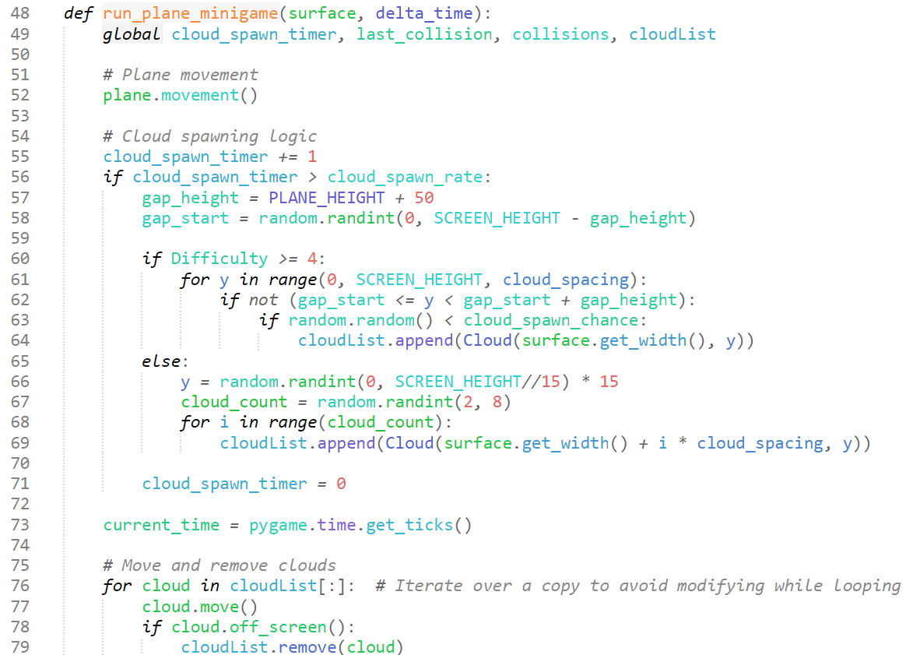

This appears to work, I simply just create a method out of the game in a new file.

Here is my new file organisation, which allows me to access all the dependancies and modules within my Terrain+Event Rendering.

As you can see, I have renamed all my modules from each respective to the title name of their sections, ie TER_main is the Terrain Event Rendering main, and PM_main is the Plane Minigame main.

This organisation allows me to still keep things in easily sorted groups, without having to use complex os code to go out of path levels and back in, removing clutter from my main code.

I have had to change the title of all imports to accommodate.



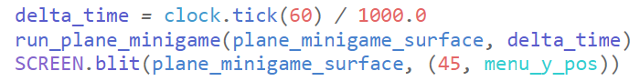

I add this to the GAME loop in the TER main to call the method for the minigame.

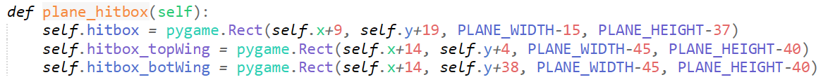

Adjusting the hitboxes to fit the new resized module.

#### Testing

|  |  |
| --- | --- |
| Program | Explanation of Successes / Failures |
|  | After creating the plane minigame method and adding it to the main game loop.  Successes:   * The plane minigame is blitted onto the terrain event rendering main * All features of the plane minigame work |

#### 2nd Iteration

I now need to do the same for the Active Reasoning Challenges

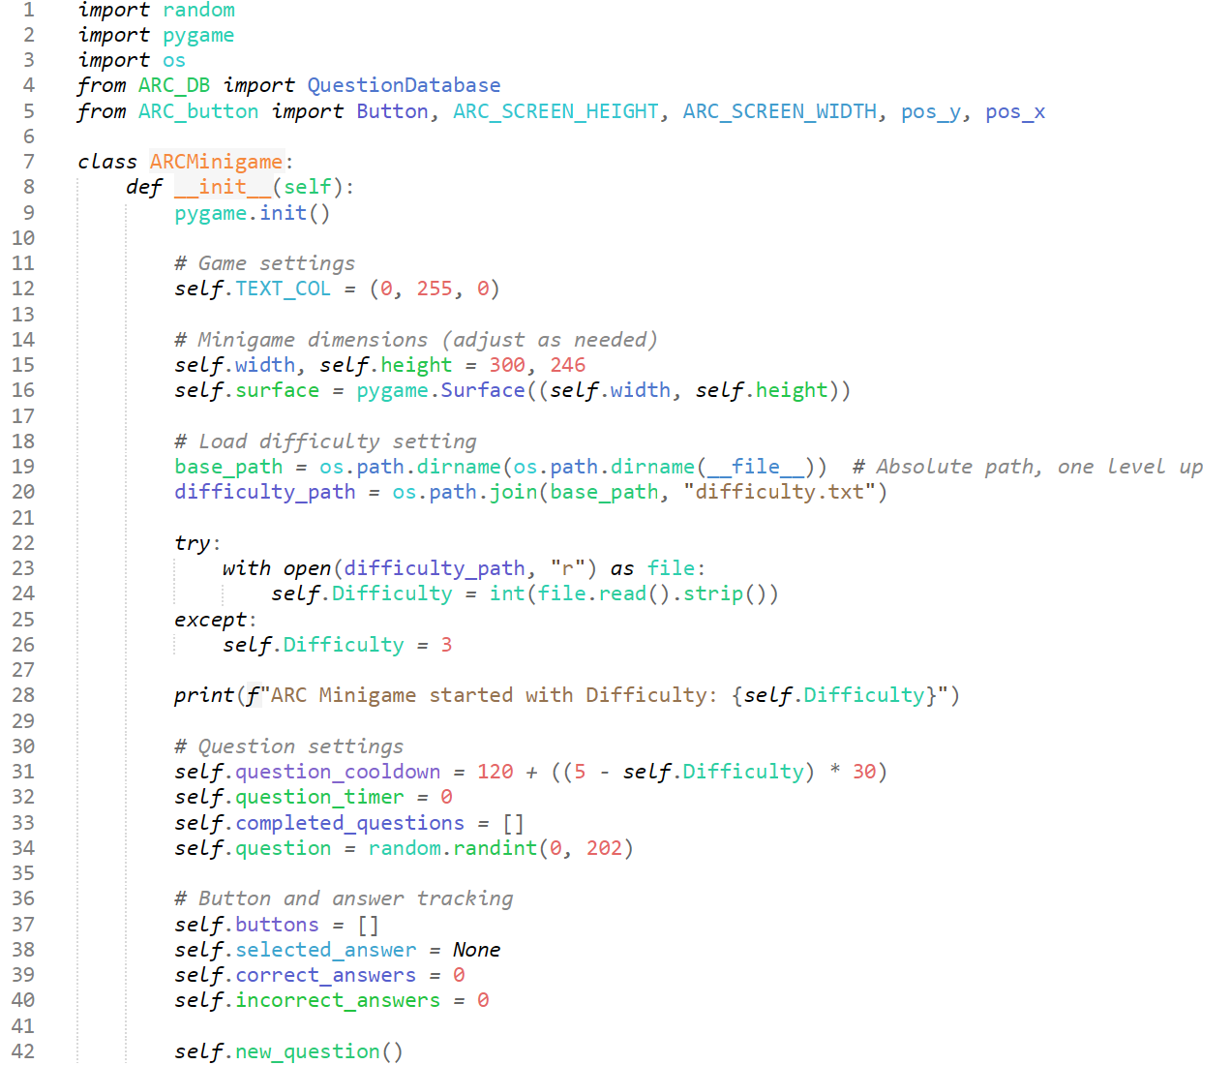

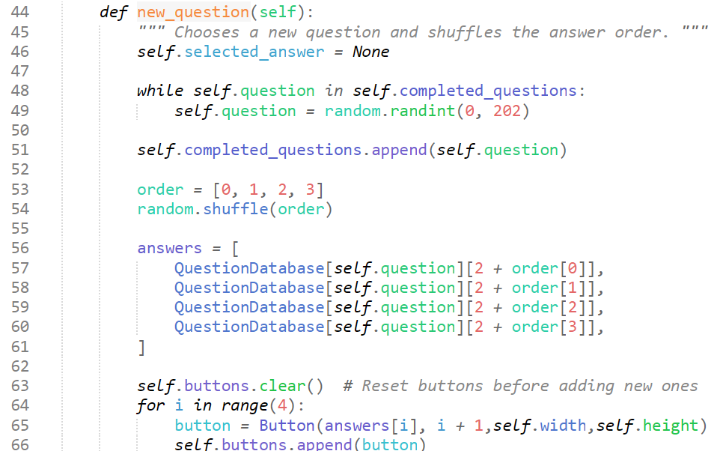

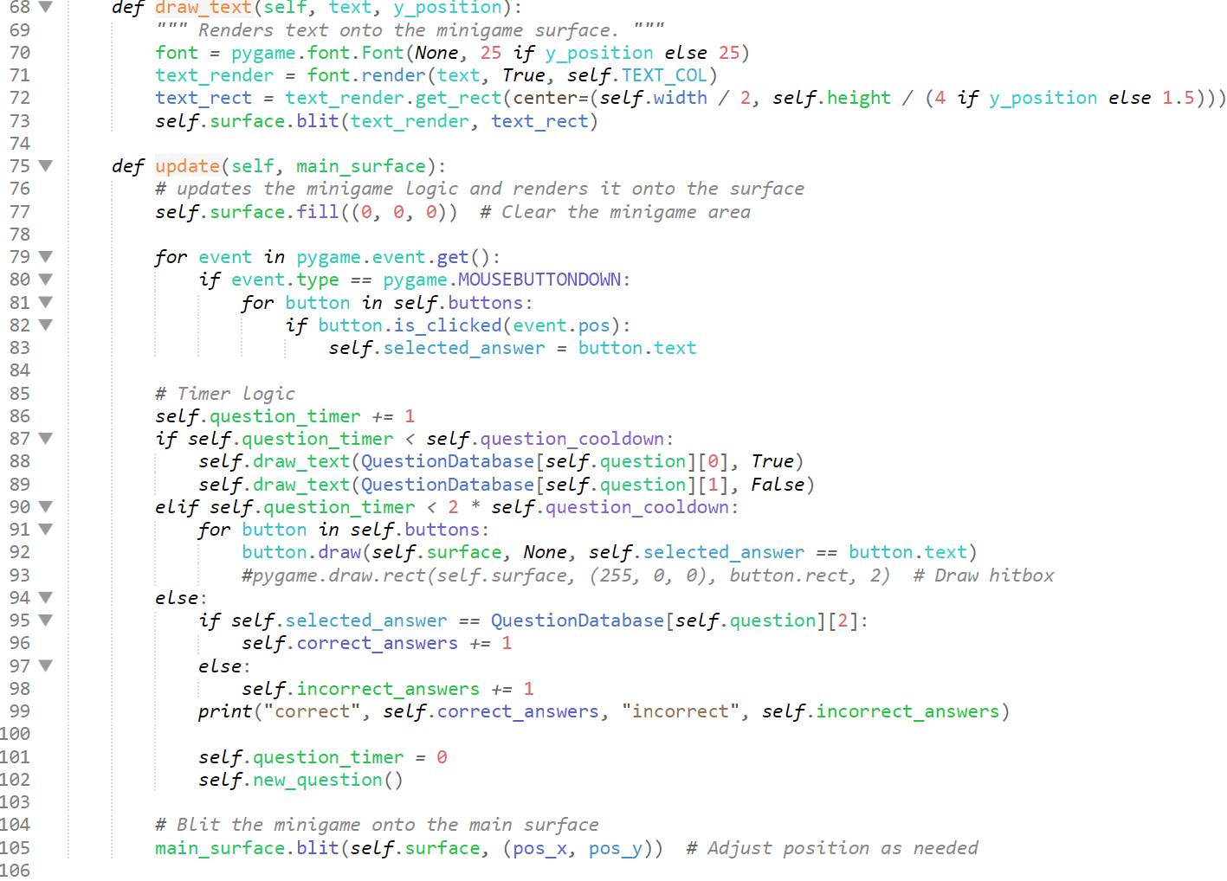

I basically just create each separate identify of the GAME loop for the active reasoning challenges into their own methods under the ARCMinigame object to call.

in the TER_main, I add this code to the bottom of the GAME loop.

#### Iterative Testing Sequence

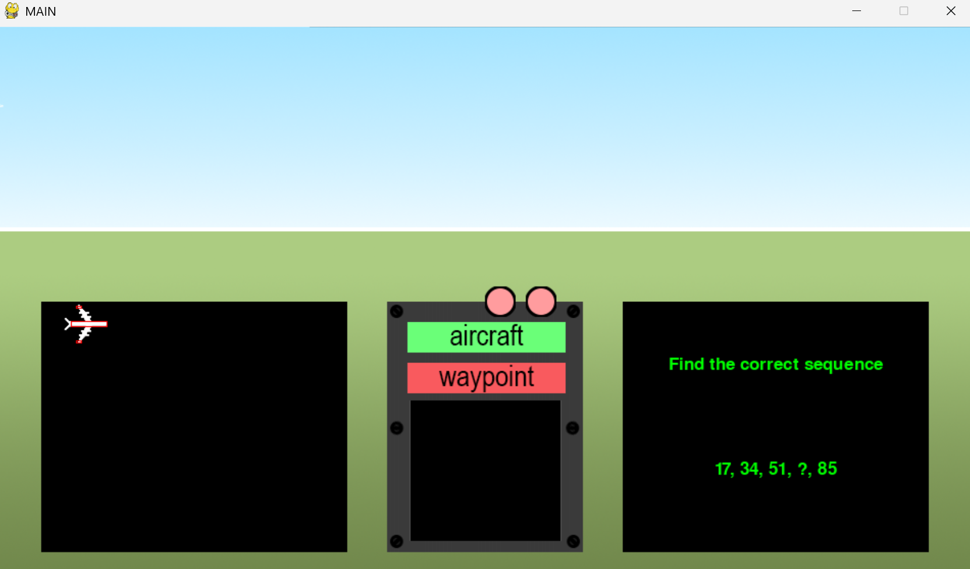

This appears to work, however when options to click the answer show up, they are unable to be selected.

Upon further testing, the buttons can be clicked, however they have a hitbox starting from the top left corner of the screen.

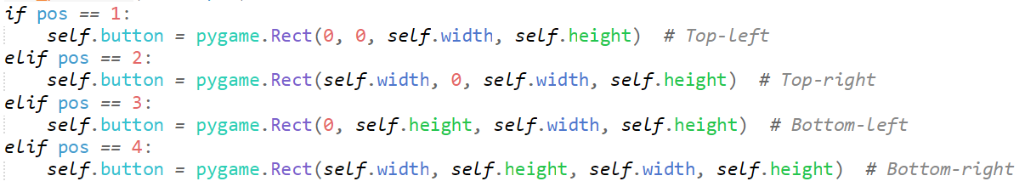

I believe this is due to this section of the code, as when imported into the TER_main, it takes the positional values of the TER_main instead of the ARC_main.

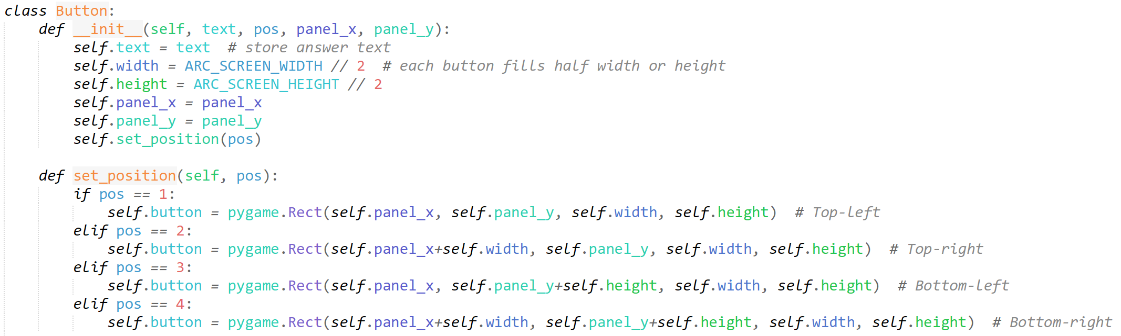

I attempt to fix this by declaring the internal panel x and y position where the panel will be placed, and centre-ing the hitboxes around these.

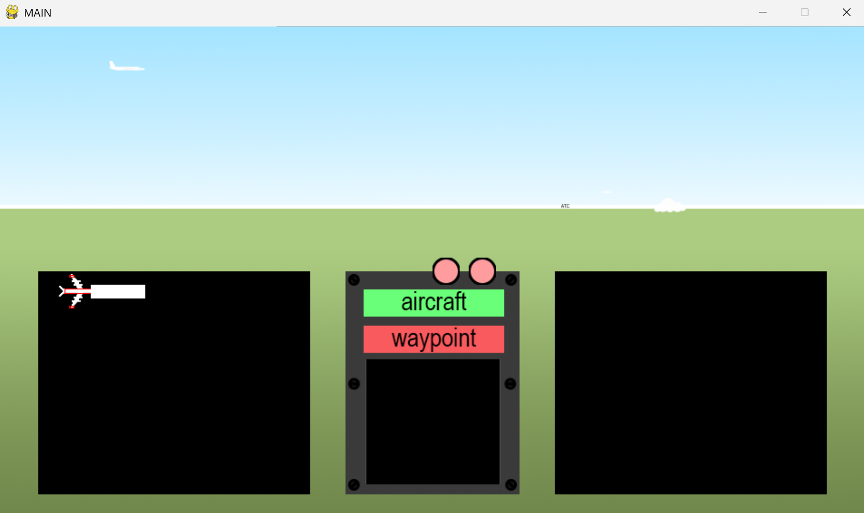

However, this only makes things worse, as now neither the text, nor the hitboxes are in the right spot, furthermore, the hitboxes aren’t even at the top left corner anymore and have disappeared.

I have decided I will just alter the positional value of the mouse specifically for the active reasoning challenges, this will mimic clicking the right position even if the hitboxes are in the wrong location.

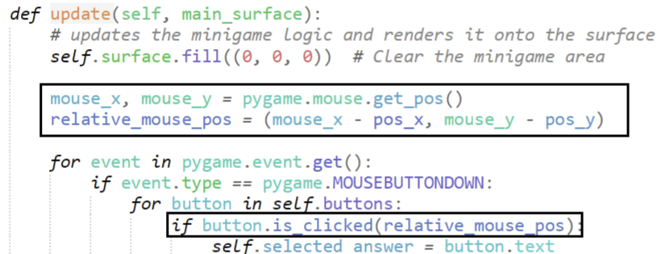

Altering the hitbox of the mouse to match the locational position of the hitboxes

#### Testing

|  |  |
| --- | --- |
| Program | Explanation of Successes / Failures |
|  | After the iterative testing to fix the hitbox detection for the active reasoning challenges  Successes:   * Mouse pos interacts with the question options * Hitboxes appear in correct positions * Active reasoning challenges seems to be in the correct position |

## Passive Recall Questionnaire

### Question Form

**Success Criteria:**

“Reasonable questions asked in the testing phase”

“Several answer buttons with options”

#### 1st Iteration

Originally, I thought about making a database of questions to call within a quiz object, however upon creating this, I realised how little questions I can physically ask without being overly demanding on the user, so I have decided to embed the question database within the object

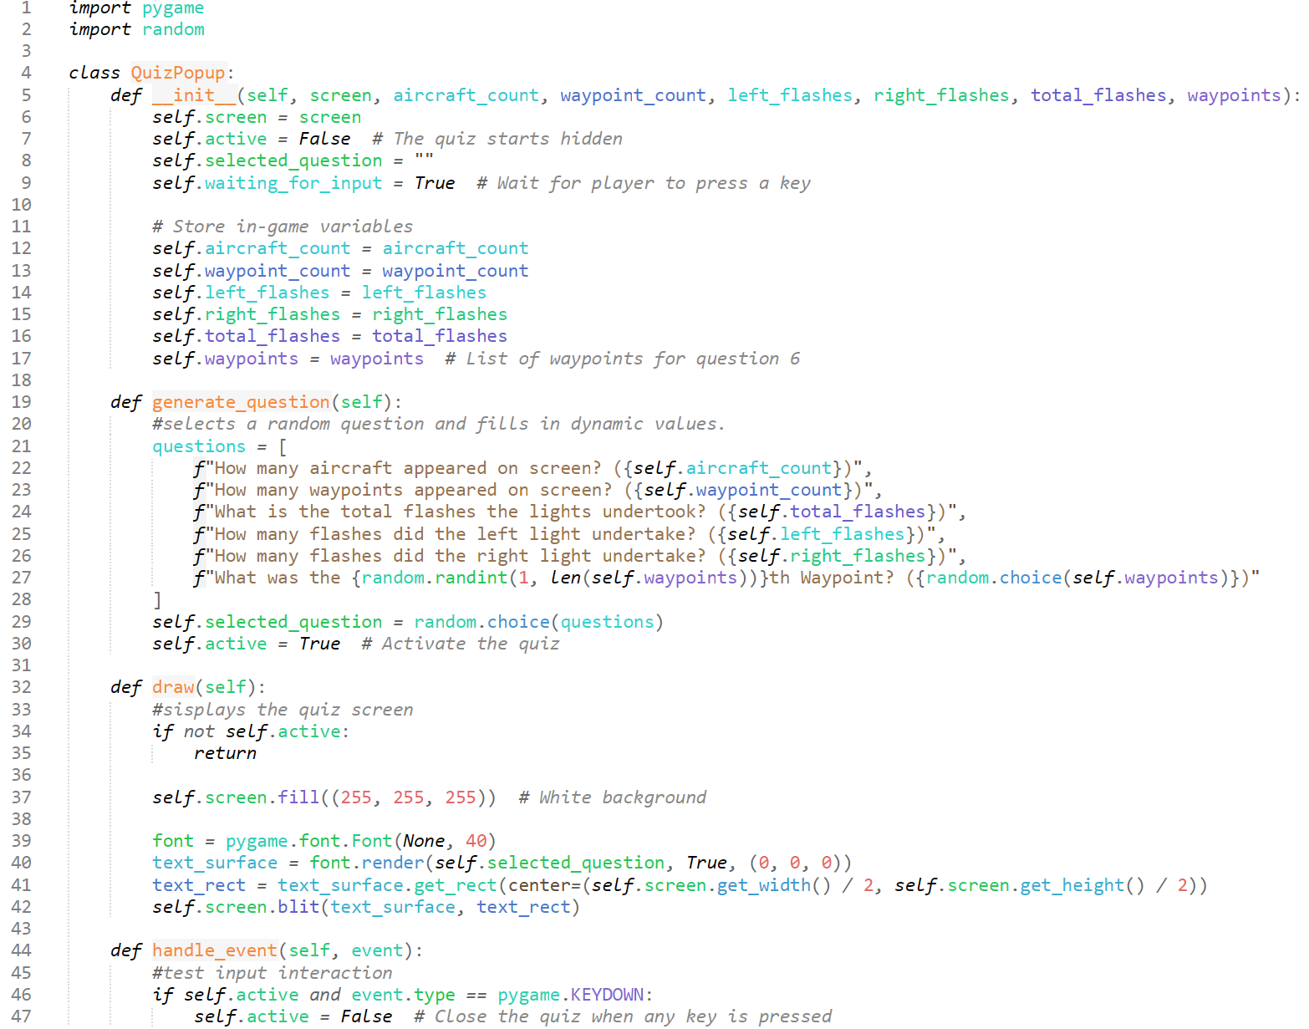

This is a new object I have created in a new module, PRC_main (passive recall challenges), essentially when called it finds out basic variables for interactivity with the quiz itself, and then finds the in-game variables which are the answers for the questions.

Calling the separate methods, such as generate questions, will activate the quiz and choose a question from the embedded list of possible questions. For now, I have embedded the answers within the question for testing.

The draw method is the method to be called when the active is true (after a question has been generated) and the quiz is to take over the main game.

The method handle_event is simply a test interaction method for now, where if any key is pressed, the quiz interacts with such.

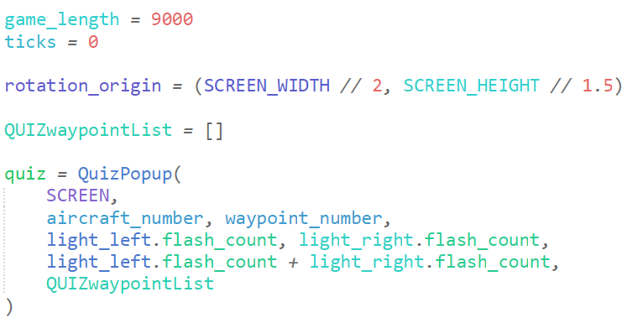

This is the declaration of the quiz instance taking in the parameters from the object specific attributes. I also have a waypoint list which only holds the type that the waypoint is for easy quiz access. This is declared outside the GAME loop.

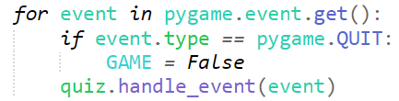

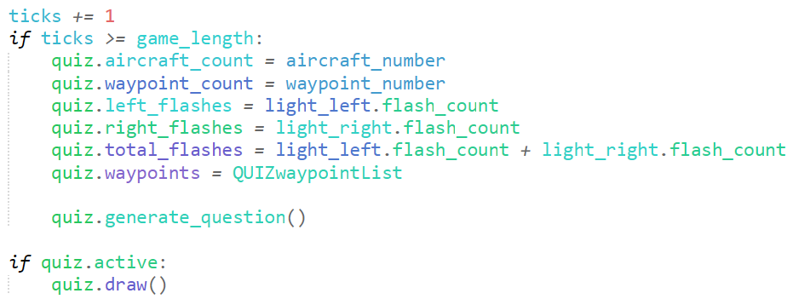

Within the for event loop, I place the handle_event method, which checks if a key is input, and then ends the quiz’s self.active attribute. At the bottom of the GAME loop, I implement the code, which is to activate after a specified time (game_length), it updates all the variables / attributes to be passed into the quiz as the answers, and then calls the quiz if the quiz is active.

#### Testing

|  |  |
| --- | --- |
| Program | Explanation of Successes / Failures |
|  | Running the TER_main after the ticks exceed the game_length  Successes:   * Quiz starts after timer * Questions shows up on screen * Answer shows up after question   Problems:   * Question changes each tick * No way to answer the question * Game does not end upon key input |

#### 2nd Iteration

I believe the reason that the game does not end after a key input like its supposed to is that when a key is input, self.active is declared false, but then if the quiz timer is exceeded, generate_question() is called, declaring the self.active as true, where then the selection asking if self.active is true is called, starting the quiz.

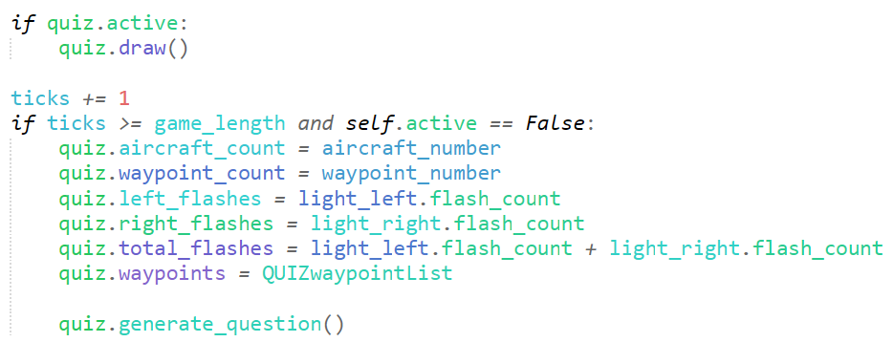

I alter the logic for calling the quiz, so that the generate question method is only called if the self.active is false, else it will repetitive looping sequence will just continue.

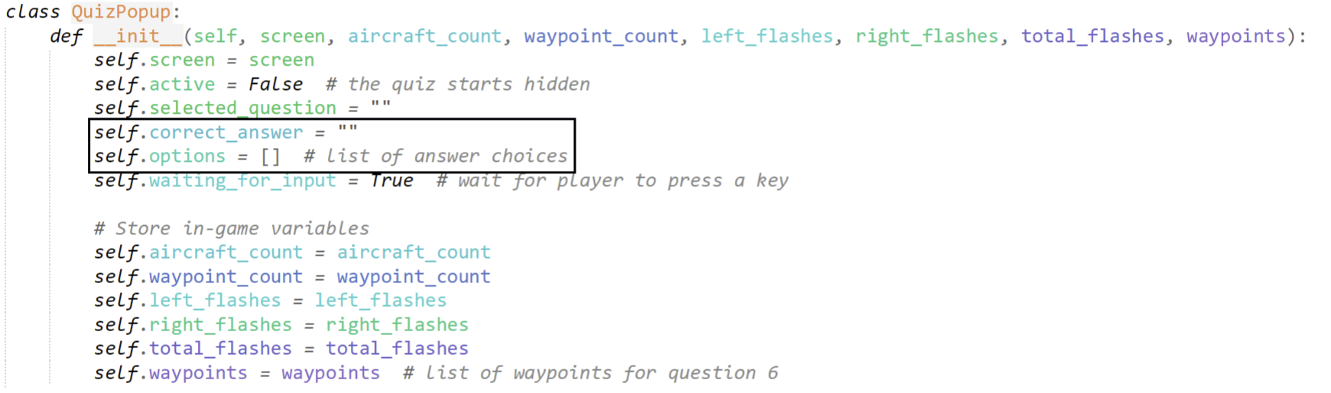

I add two new attributes to the QuizPopup, which store the correct answer to the quiz question and the list of answer choices, which will be randomised.

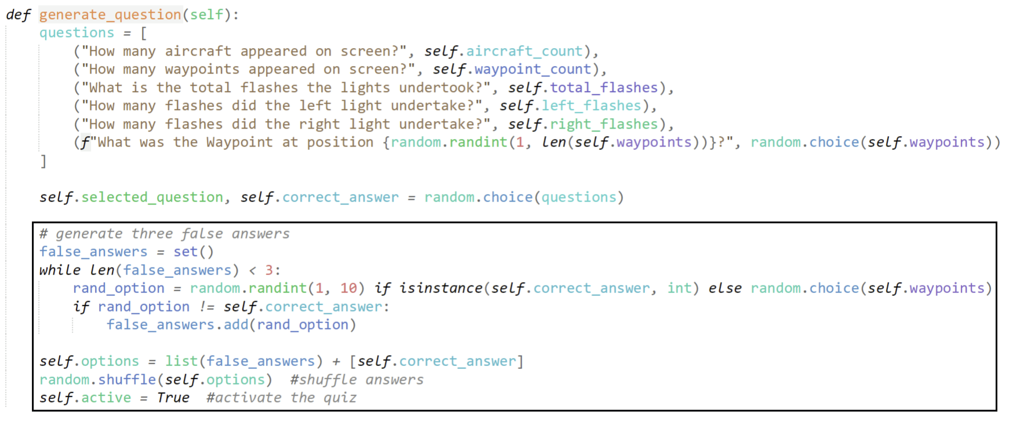

These edits essentially create a set of false_answers to store incorrect answers, which are randomly generated until 3 are created.

If the generated rand_options matches the self.correct_answer, then it is discarded.

The set also ensures that only unique items are stored, and that the options are then shuffled at the end. It then finally activates the quiz.

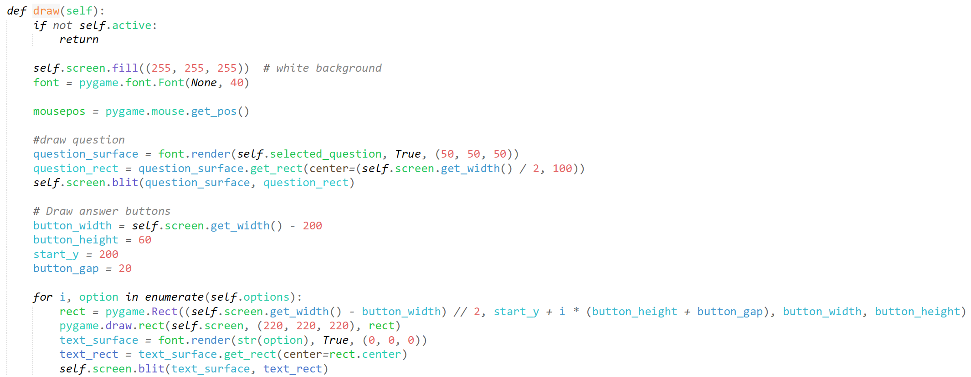

This method aims to render and blit everything onto the screen (when self.active is True), filling the screen in white, drawing the randomised questions onto the screen.

Usually when I create buttons, I create a separate object. However here that seemed pedantic, and using the enumerate built in function, I can convert each of the options into its own button based on what shuffled order it is, adjusting the y co-ordinate for each button and then blitting it onto the screen.

#### Testing

|  |  |
| --- | --- |
| Program | Explanation of Successes / Failures |
|  | Running TER_main with adjustments to the quiz popup object.  Successes:   * 4 buttons sized well blitted on screen * Buttons contain the information from the set() * Buttons have a randomised order   Problems:   * No button functionality * Game plays in the background, invisible |

#### 3rd Iteration

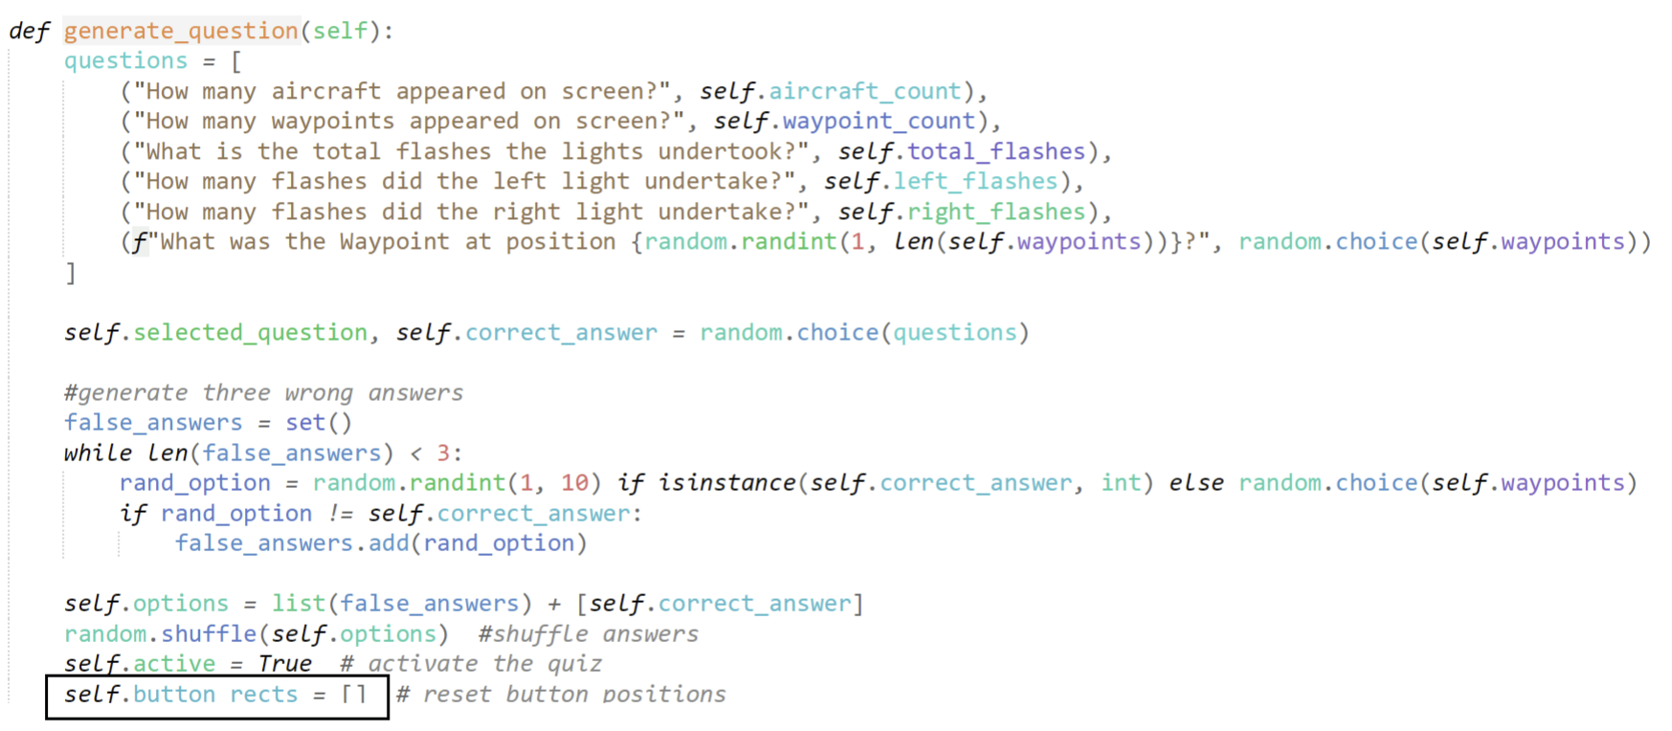

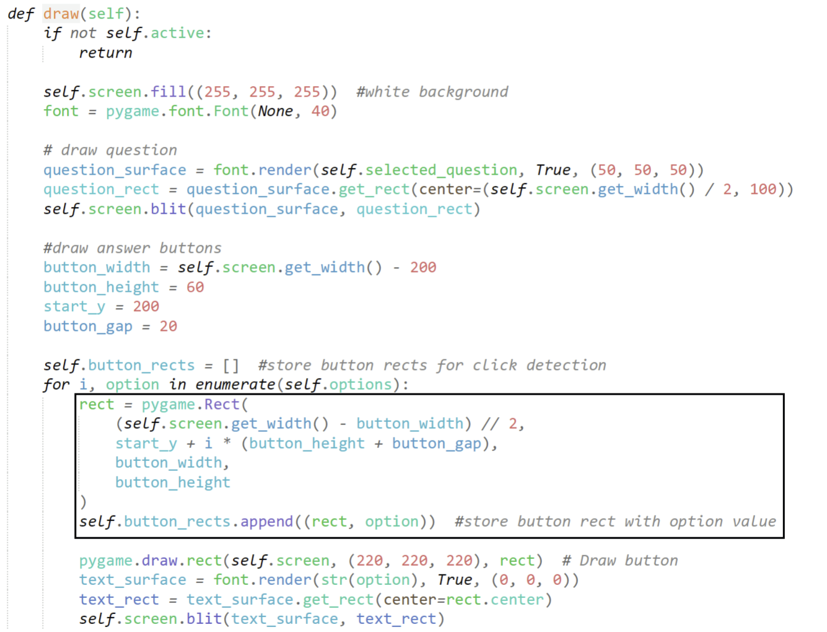

This adds a reset for the buttons each iteration, and also stores each button rect instances with an option.

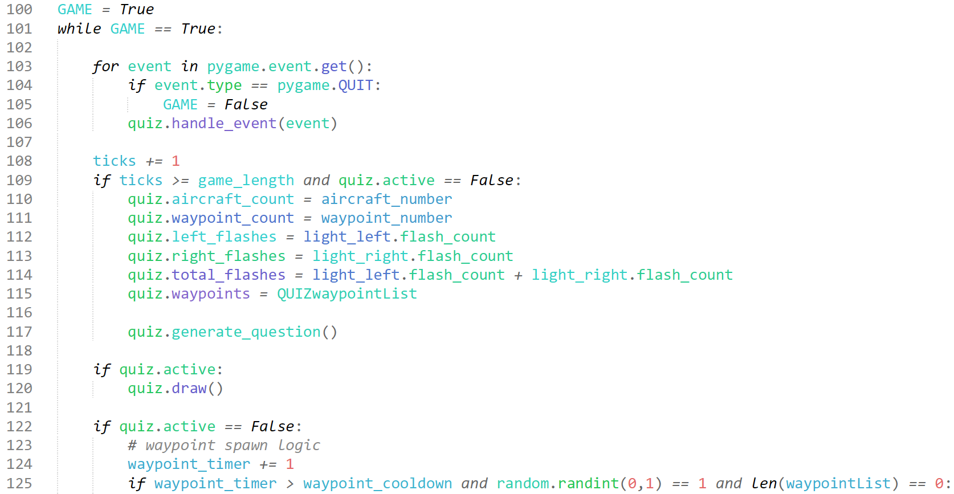

Within the GAME loop in the TER_main, I modify the GAME loop, incrementing ticks each iteration, and checking if the quiz should be enabled. Once the quiz is enabled, the regular game will cease, and only the quiz will be interactable and visible.

#### Testing

|  |  |
| --- | --- |
| Program | **Explanation of Successes / Failures** |
| *After clicking 1, which is the number of waypoints which appeared* | Added changes to the quizpopup object, and the GAME loop.  Successes:   * No background processes occur when the quiz is on screen (no interactivity with the waypoint/aircraft button) * Buttons are interactable   Problems:   * Infinite repeat of questions / no end * Questions repeat |

#### 4th Iteration

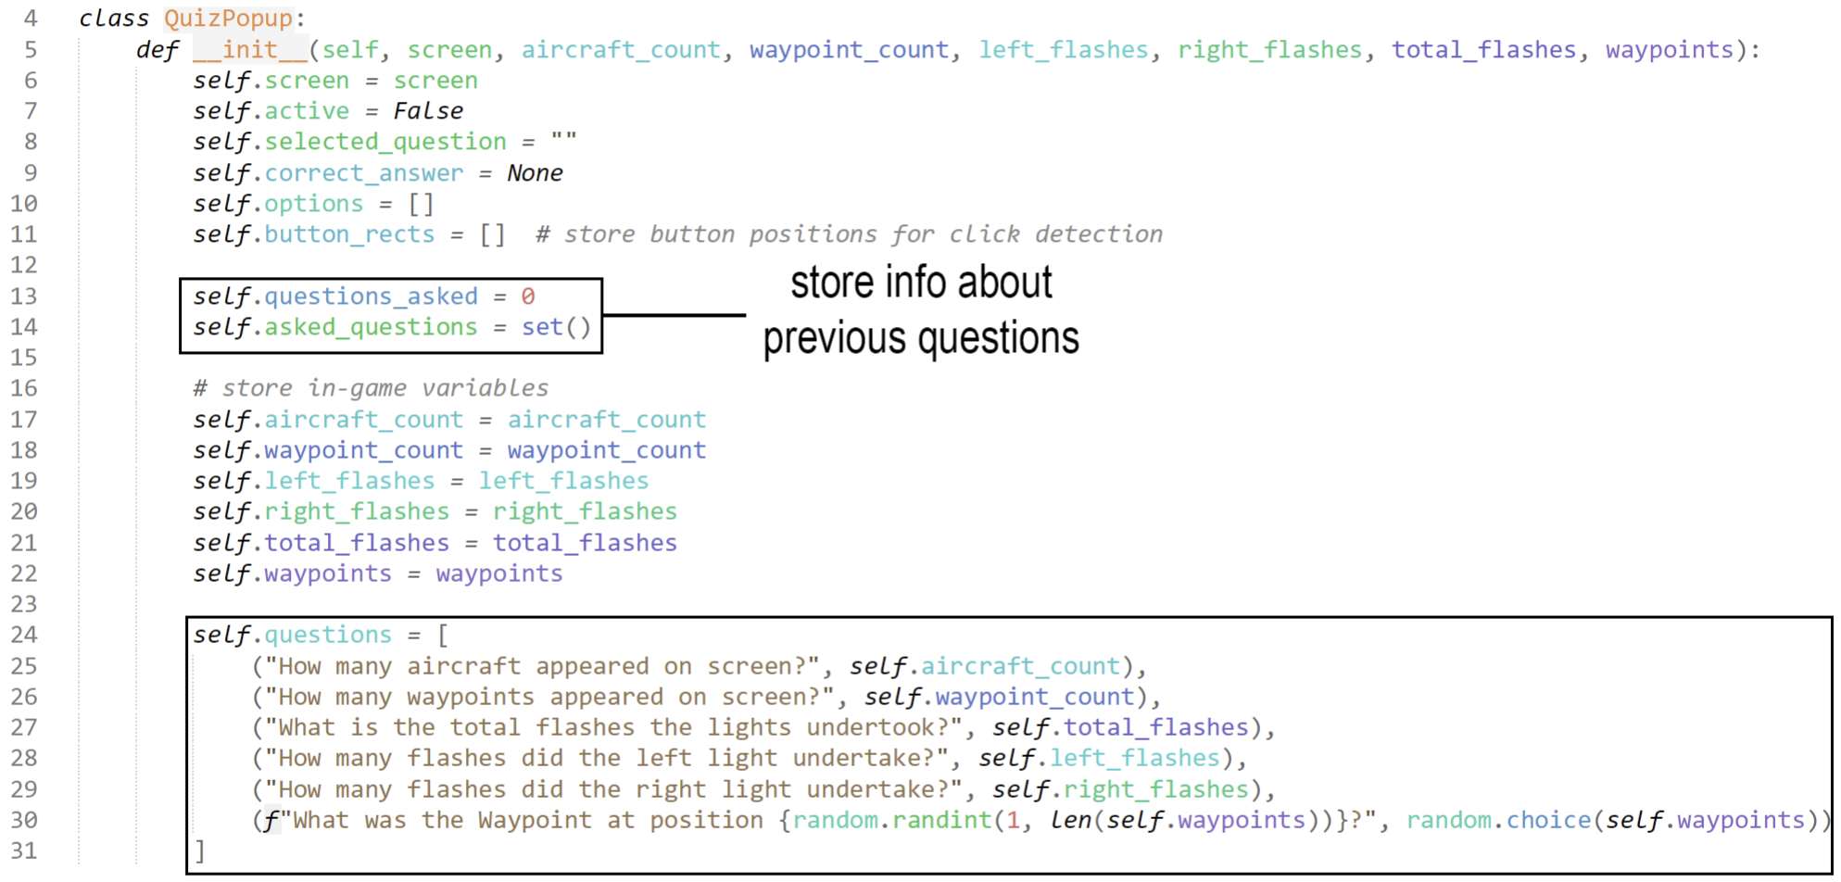

To fix the issue about questions repeating, I am adding a set to store the questions that are currently asked, and I will also remove the infinite question process by creating a value which stores the number of questions asked, and I will add selection processes which will determine if more than 3 questions have been answered.

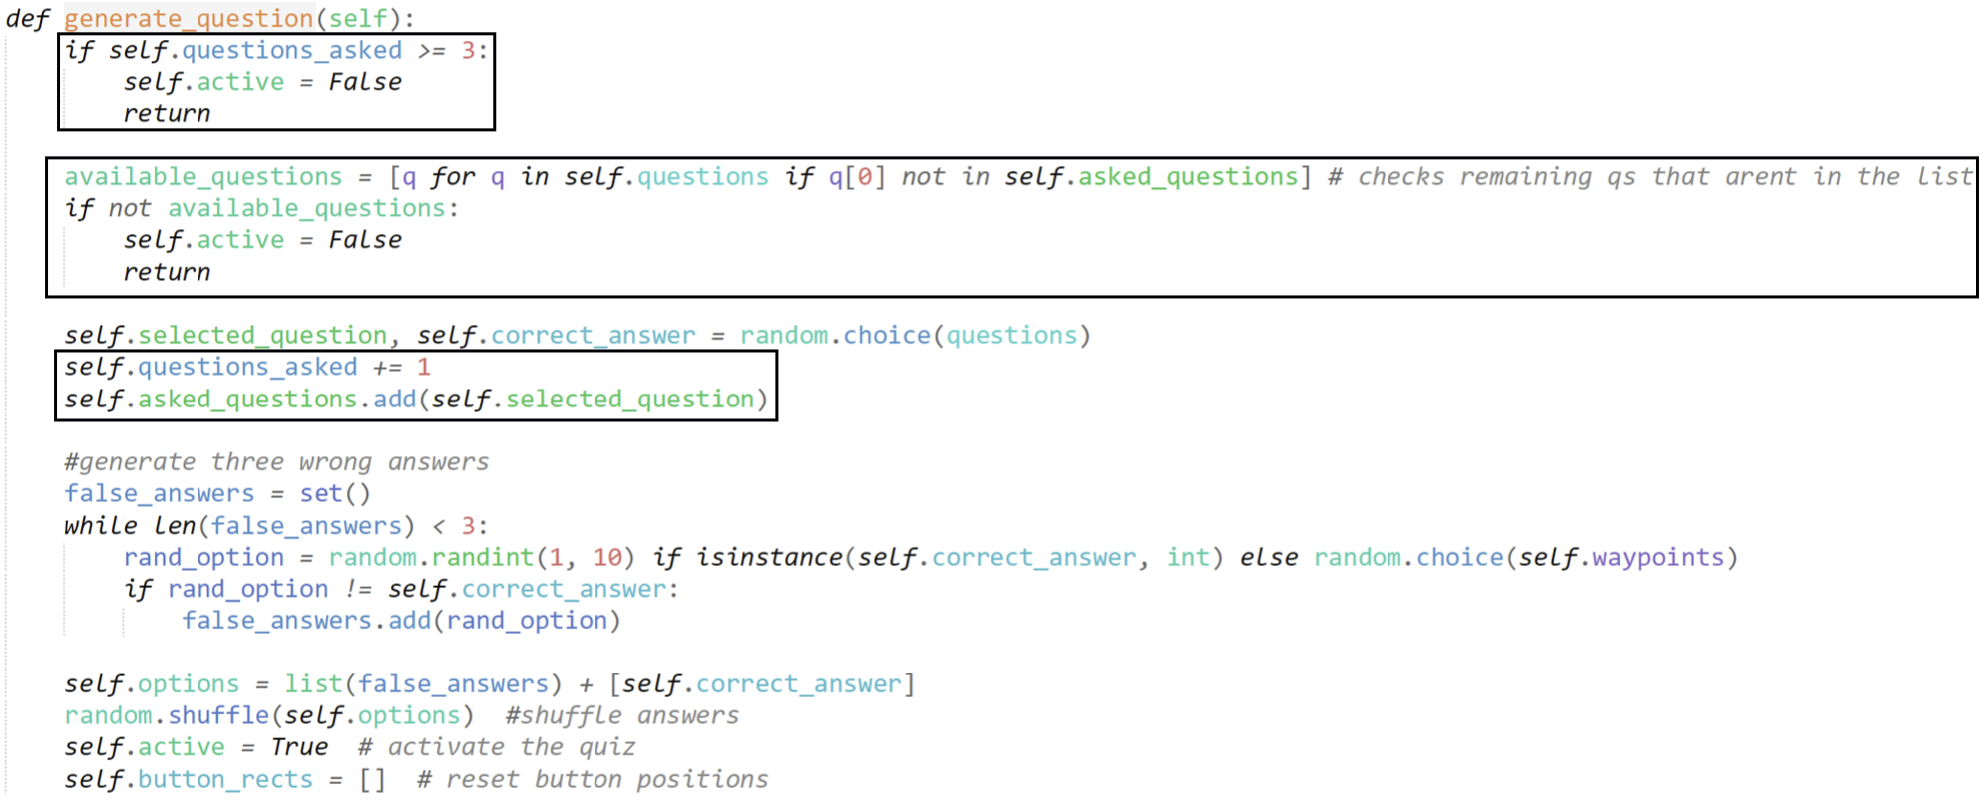

In the generate_question method, I create limits, only activating the quiz if there have been less than (or equal to) 3 questions asked. It also adds the new code which increments the questions_asked value up each question, and adds the question to the set.

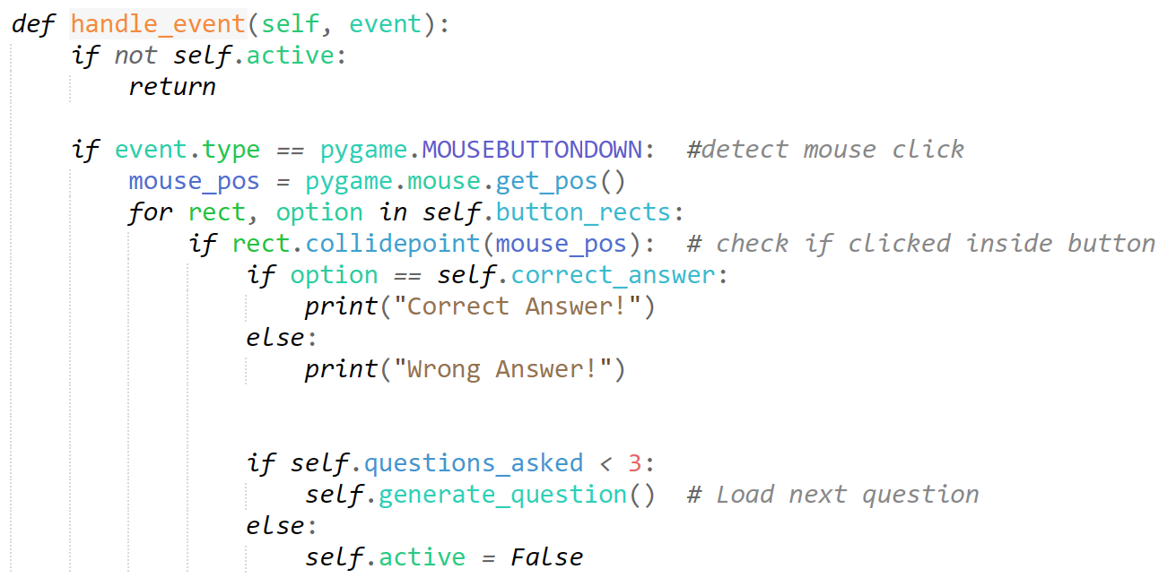

In the handle_event method, I add the section which only loads the next question if less than 3 questions have already been asked, if not, the quiz should end.

#### Iterative Testing Sequence

“Traceback (most recent call last):

File "C:\...\TER_main.py", line 91, in <module>

quiz = QuizPopup(

SCREEN,

...<3 lines>...

QUIZwaypointList

)

File "C:\...\PRC_main1.py", line 30, in __init__

(f"What was the Waypoint at position {random.randint(1, len(self.waypoints))}?", random.choice(self.waypoints))

~~~~~~~~~~~~~~^^^^^^^^^^^^^^^^^^^^^^^^

File "C:\...\Python\Python313\Lib\random.py", line 340, in randint

return self.randrange(a, b+1)

~~~~~~~~~~~~~~^^^^^^^^

File "C:\...\Python\Python313\Lib\random.py", line 323, in randrange

raise ValueError(f"empty range in randrange({start}, {stop})")

ValueError: empty range in randrange(1, 1)”

this is the error which occurs when I attempt to run the TER_main.py module.

Essentially, the error states that self.waypoints is empty, so len(self.waypoints) == 0, which causes random.randint(1, len(self.waypoints)) to fail.

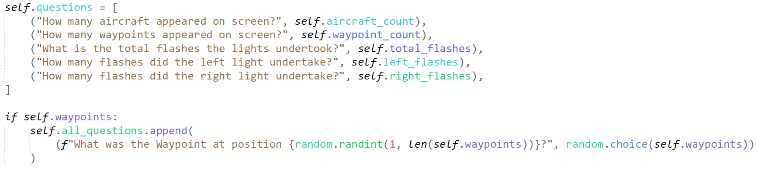

To fix it, I simply do not add that question unless self.waypoints has a value, where if it does; I append the question in.

“Traceback (most recent call last):

File "C:\Users\stain_lufp011\OneDrive\Documents\A Level Project\Program Code\TerrainEvent_Rendering\TER_main.py", line 117, in <module>

quiz.generate_question()

~~~~~~~~~~~~~~~~~~~~~~^^

File "C:\Users\stain_lufp011\OneDrive\Documents\A Level Project\Program Code\TerrainEvent_Rendering\PRC_main1.py", line 47, in generate_question

self.selected_question, self.correct_answer = random.choice(questions)

^^^^^^^^^

NameError: name 'questions' is not defined. Did you mean: 'self.questions'?”

I believe this line is simply a syntax error linking to this line within the generate_question module:



As I attempt to call the old questions list instead of the new self.questions attribute.



#### Testing

|  |  |
| --- | --- |
| Program | Explanation of Successes / Failures |
| *Upon clicked 1, after an aircraft was visible on screen* | Running the program  Successes:   * After 3 questions, the game restarts (the main minigames come on screen) * The questions do not repeat (brute-force testing)   Problems:   * Aircraft count seems to not update within the questions. |

#### 5th Iteration

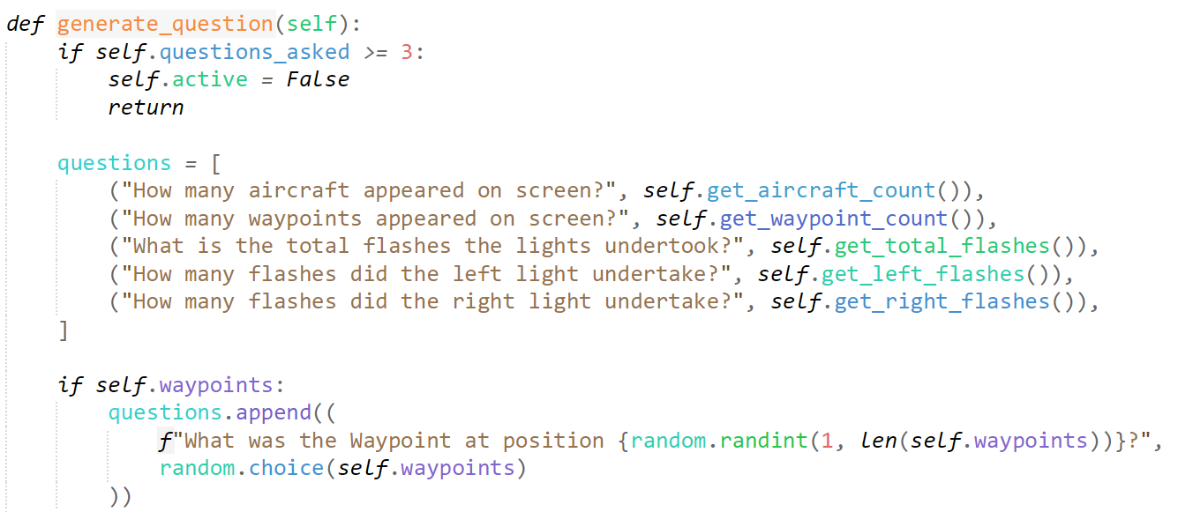

I move the questions back to the generate_question function so that I can update it regularly instead of just once upon initialisation.

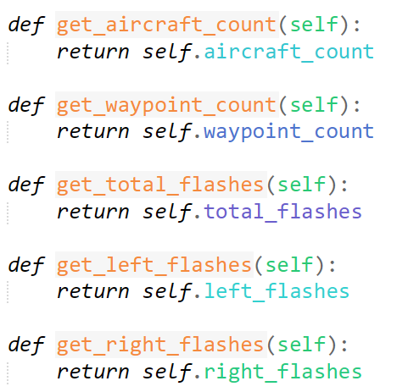

I create several new methods within the quizpopup class, these work with the new questions array, which just means that the values are updated when the question is chosen.

#### Testing

|  |  |
| --- | --- |
| Program | **Explanation of Successes / Failures** |
| *When there is 1 aircraft currently on screen, and no other aircraft appeared (there is no option for 0 – showing that 0 cannot be the correct answer)* | Running the TER_main again  Successes:   * Values are completely updated and accurate |

## Report

### Data Report/Foundations of the Report

**Success Criteria:**

“Final report which answers if you would pass or fail”

“Improvement Metrics”

#### 1st iteration

I have decided to program this directly into the TER_main as a method for simplicity. If I had created an extra module and object to be imported, I would end up repeatedly transferring parameters inefficiently.

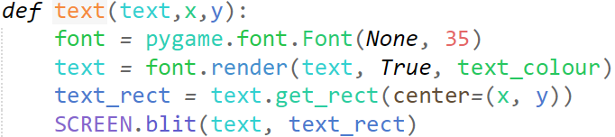

I take my text method from my old ActiveMain from the ARC, reusing it for sustainability.

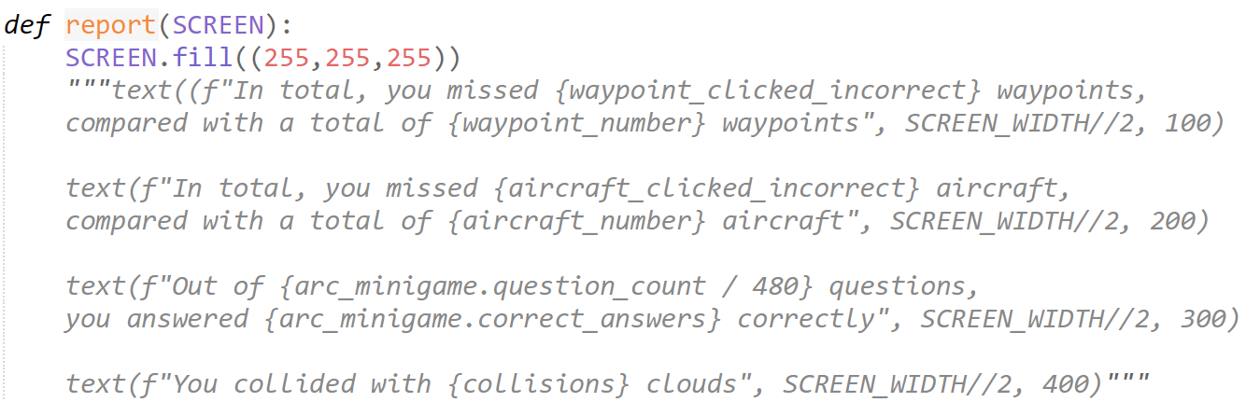

You may notice this screenshot includes comments instead of code, but that is only because I could not fit the screenshot in this page (at an understandable size) without wrapping the text. For all purposes, this code will not be in comments and will be normal, as such.



Some variables were previously inaccessible / non-existent before I created this report, so the following are were I managed to get them from:



Collisions was declared as a global variable for the run_plane_minigame object we created, that I just imported to track in the TER_main.

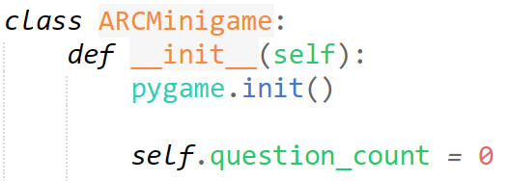

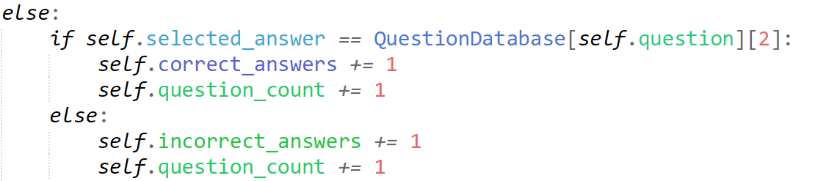

I embed a sneaky “self.question_count” (which I just declare as an attribute into the ARCMinigame object) into the answer logic.



I add another relevant statistic about the number of questions wrong / right in the passive reasoning challenge quiz.



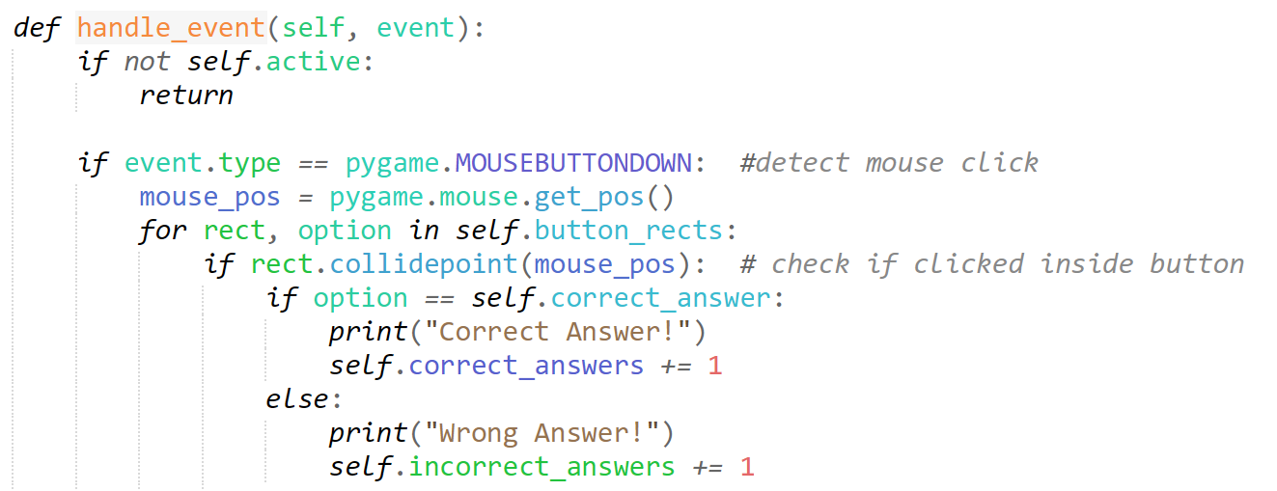

I do this by creating a new set of attributes to track the inputs instead of just printing correct or incorrect.

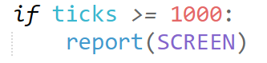

I incorporate this into the GAME loop, as a temporary test, so that actual values can be fed through.

#### Testing

|  |  |
| --- | --- |
| Program | **Explanation of Successes / Failures** |
|  | Running the TER_main  Successes:   * All text output on screen correctly * All stats are correct * Appears on screen after ticks   Problems:   * No pass / fail mark / calculation * Occasionally, the report fails to appear. |

#### 2nd Iteration

I aim to fix the bug of the report failing to appear by making the fail-case scenario of the program to show it.

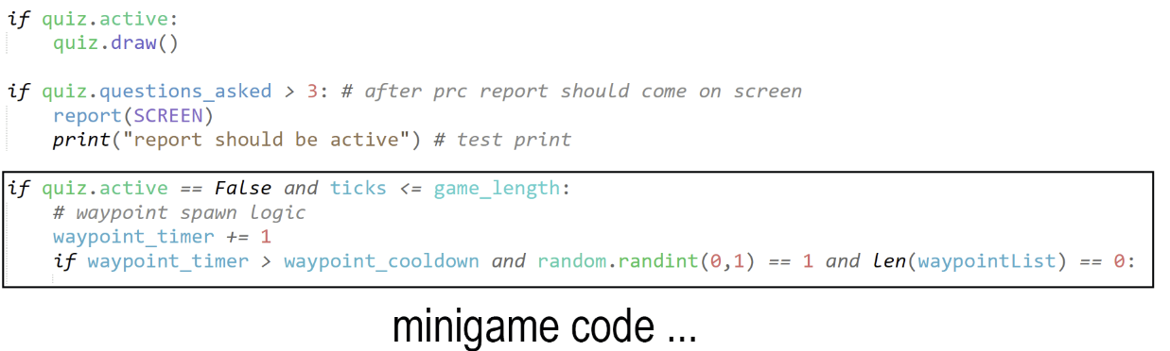

This means that the report activation is not dependant on time, but rather if the passive recall questionnaire is completed or not, ensuring it does not fail to misread ticks and lag by the IDE. It also ensures that the minigame code only activates if the ticks are below the game_length, this stops errors on the IDE’s side from interrupting the questionnaire or the report.

I will create a simple mathematical model to score each component of the test, and give them different weightings depending on their importance.

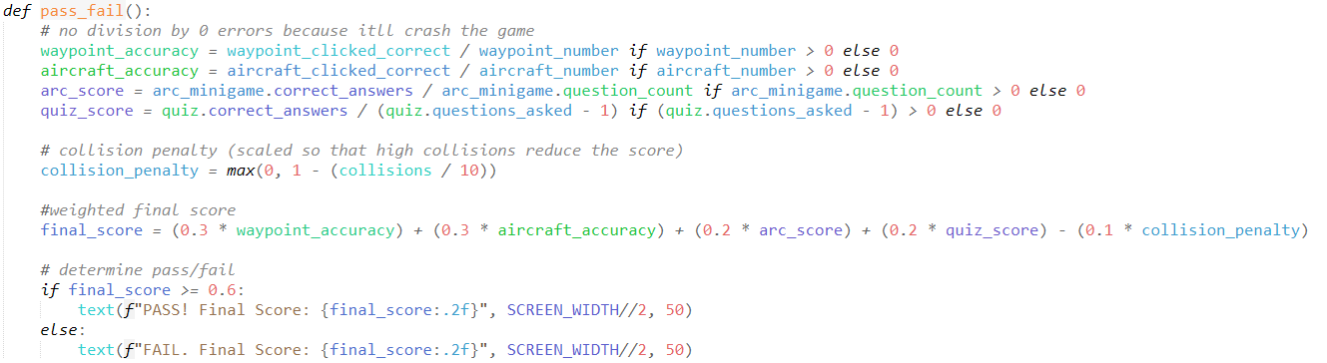

You can see the weightings I put on each accuracy/score created, and ‘exponentially’ increasing the collision penalty so that there is leeway for one or two collisions without drastic effect, whereas it heavily impacts it afterwards.

I give the final score to 2 decimal places for a higher point of precision, and to match the general 100% readability format with integers.

I also ensure no infinity errors can occur by preventing any scores from dividing by 0, this does mean that if there are no waypoints/aircrafts on screen, the user will automatically be given a 0 rating for such, but I have calculated below the odds of this happening as to ensure that this is not unfair for the user, using a ‘1% significance level’, as any higher will impact common attempts.

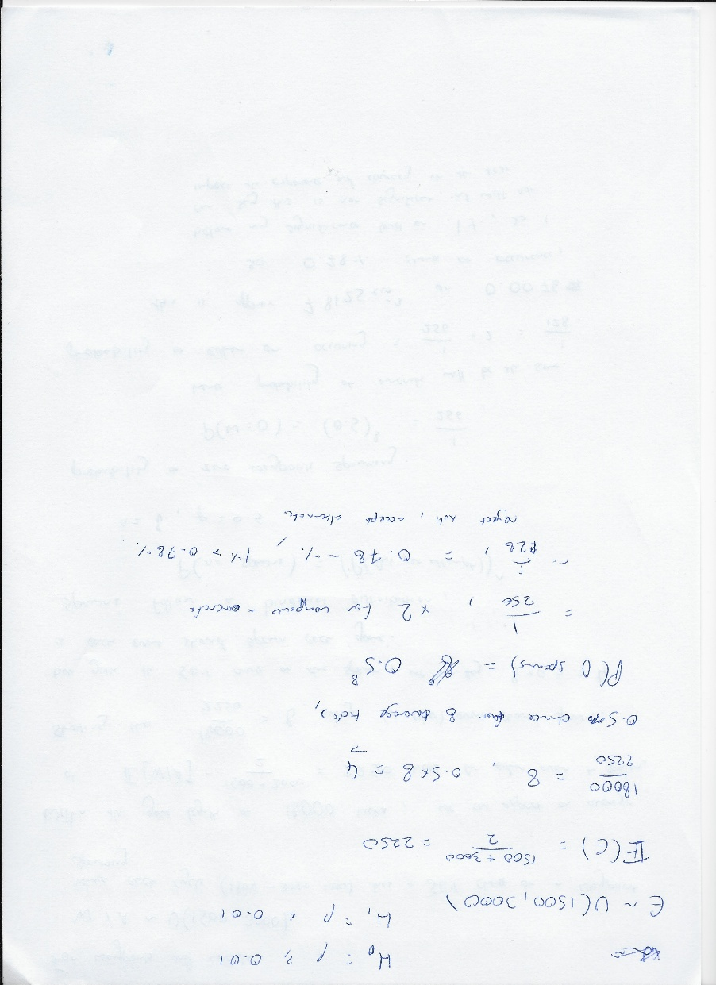

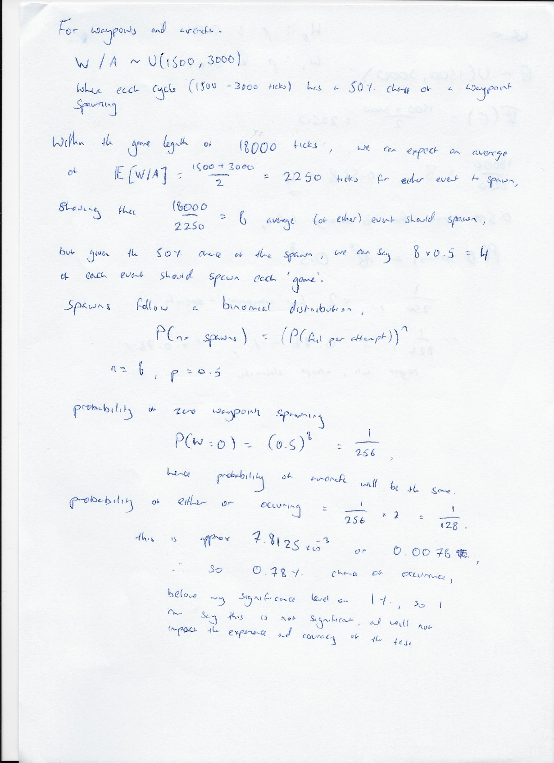

Word explanation of the calculations. I can reject the null hypothesis at the 1% level and accept that this is not a significant and common occurrence enough. It has been peer reviewed by Sacha, shown by his signature below after independently revising it.

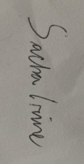

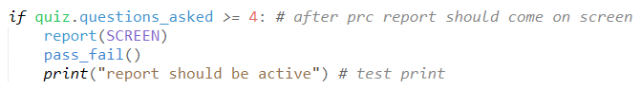

I call the method at the same time the report should be active, and put it at a higher level in the programming, so that the text is output after the screen is filled.

#### Testing

|  |  |
| --- | --- |
| **Program** | **Explanation of Successes / Failures** |
|  | Running the TER_main after calling the pass_fail function after the report is active.  In the first screenshot, within the 600 test ticks, I achieve a max score, however this is limited due to the time limits.  In the second, I do not attempt anything but the end questions, leading to a fail, but showing that acing one score does not impact the final mark enough to be bias exactly.  Successes:   * Pass / fail mark given depending on stats * Text is output on report with score   Failures:   * Small text, hard to read report in general. |

Now that I have the foundations of what I will do, I can fully mould the report to suit the Design proposal I have output, which includes different statistics, and then overall statistics for each individual sections on a different page.

### Report Navigation and Adaptations

**Success Criteria:**

**“**Easy to navigate reports”

#### 1st Iteration

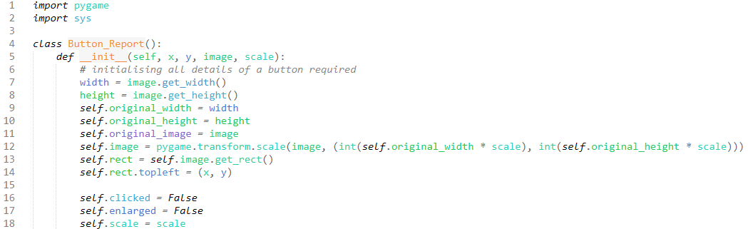

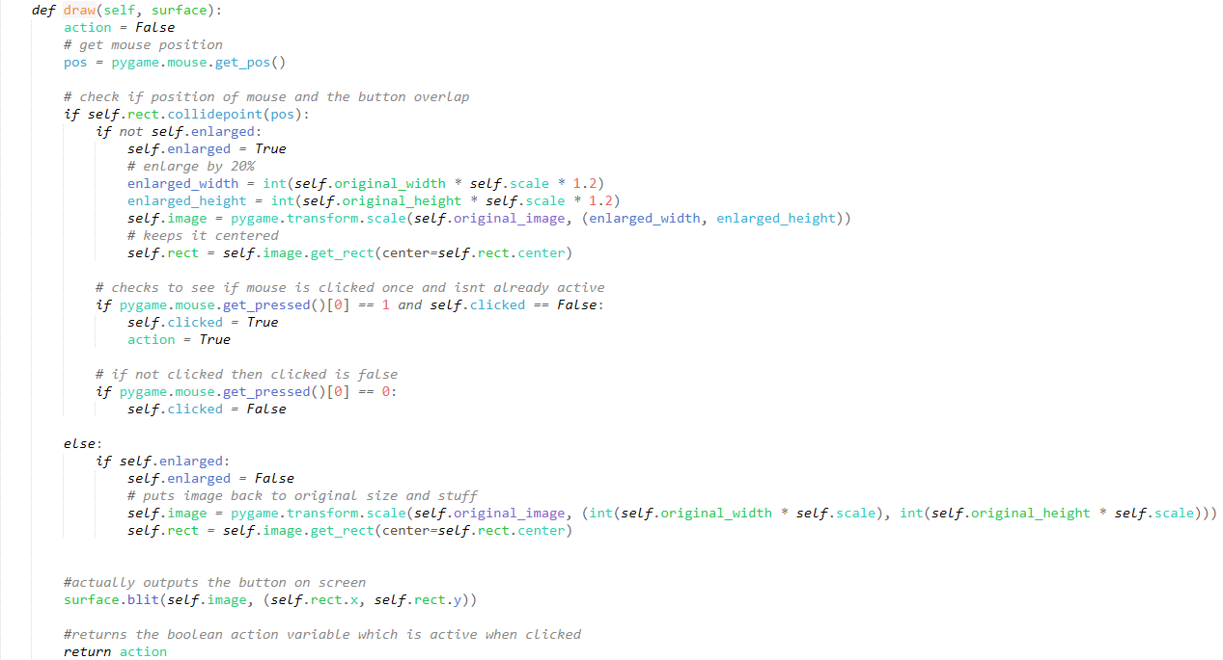

I reuse the button.py module I used for the DifficultyMain to hopefully create the multi page buttons.

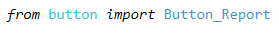

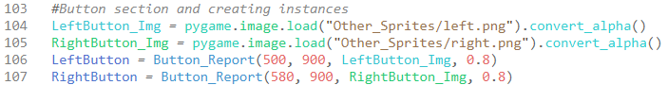

Here I declare the images for the left/right buttons and then declare instances of Button_Report for each button.

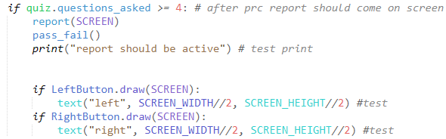

Call it when the report should be active.

#### Testing

|  |  |
| --- | --- |
| Program | Explanation of Successes / Failures |
|  | Running the TER_main  Problems:   * The buttons do not show up on the report |

I believe the issue here is that I have given them co-ordinates which do not exist within the bounds of my window, so I have adjusted them. This is more of an iterative test, but the error is of such where I feel separate tests is ideal as this took me a while to figure out. This will not count as an iteration.



#### Testing

|  |  |
| --- | --- |
| Program | Explanation of Successes / Failures |
|  | Running the TER_main again with the coordinate changes  Successes:   * The buttons now appear on screen * They enlarge with hover * The relative text appears on click   Problems:   * They intrude with the report |

#### 2nd Iteration

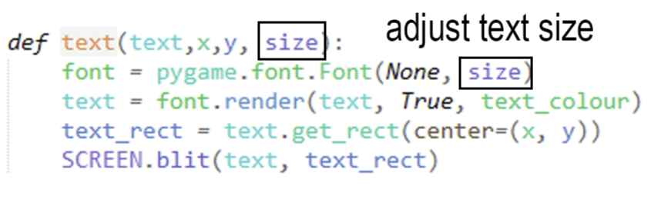

I make some changes to the text, adding another parameter: size. This will allow me to change the size of the text depending on what I want, enabling me more customisability. It will let me change the size of the pass / fail text to add more emphasis.

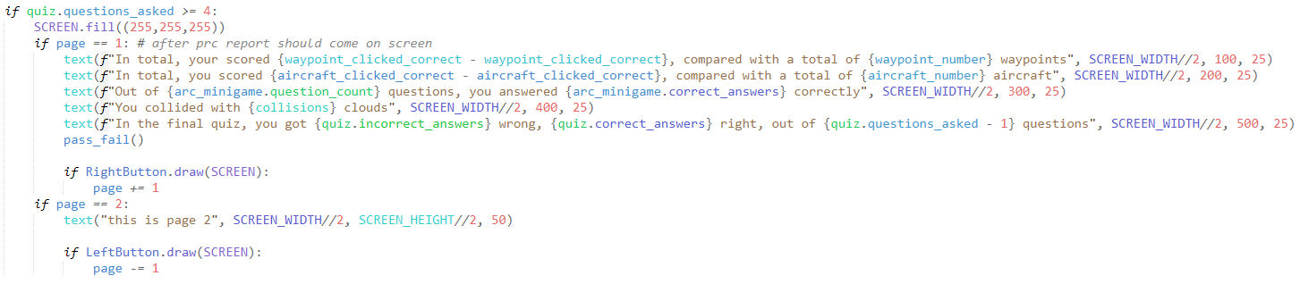

I have removed the function report entirely, as since I would need multiple pages and selections for such, I may as well write out what is required, this also allows me to fill the screen only once. The page label/variable, similar to the DifficultyMain, I manipulate it using the function draw from the button, where different pages Output different info.

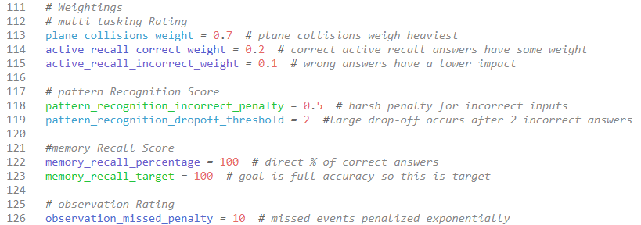

Here are my weightings constants declared outside of the GAME loop. Declaring these as values here allows me to alter them as I see fit, and allows users (who will have access to the code) to alter the weightings as they see fit. This means that users will be able to decide which features to punish more, i.e. if a user is struggling with the active reasoning challenges, then they can alter the weightings to punish it more, to force themselves to get better.

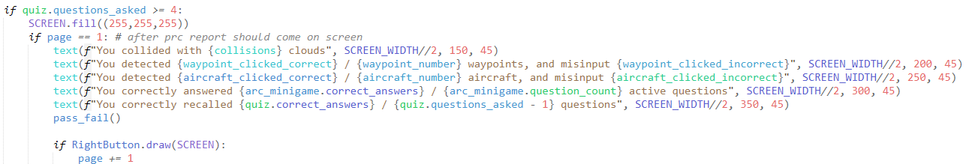

The page 1 text has been updated to match the Design, featuring the statistics and text I mention there, it has also been enlarged and positioned closer together for a more compact and aesthetically pleasing look.



Since I am to calculate the weightings like I mention further down in my design, I must import math so that I can utilise the exponential function exp, as I talk about some features having exponential growth/decay depending on their value.

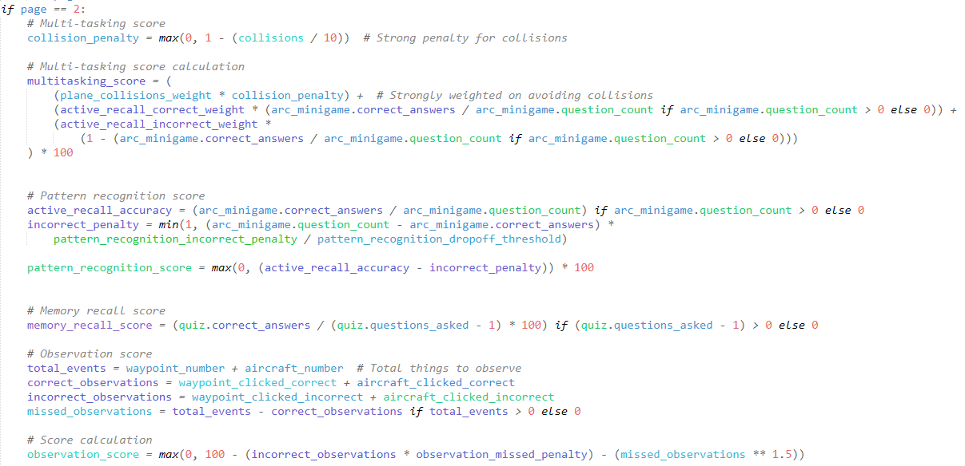

This is the code I have created to generate the scores. The multi-tasking score is heavily weighted on the collisions / 10 penalty, and active recall answers / incorrect answers have a weight of 0.2 and 0.1 respectively. For pattern recognition, correct answers weigh the most, and a harsh penalty of 0.5 for each incorrect answer, and there is a big drop off after 2 incorrect answers. The memory recall score is directly the % of questions you got right, and finally the observation rating increases on each correct input, incorrect observations significantly reduce the score, as these usually occur when the user does not keep track of the event, and missed observations are exponentially penalized.

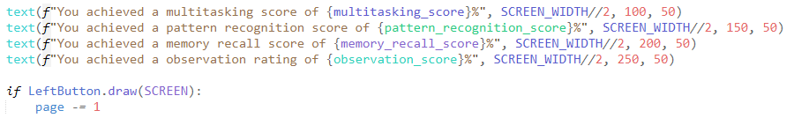

This is the text used for the second page to output the scores, they are slightly larger than the previous page simply because there is enough space for it.



Here is the same block of code however with my capping the scores to 2 decimal places to pre-empt the visually annoying feature of the text going off the screen. The values could also go uncapped with this, so this is a good prevention to maintain legibility.

#### Testing

|  |  |
| --- | --- |
| Program | **Explanation of Successes / Failures** |
|  | Running the game with a length capped at 600 ticks for testing (10 seconds)  The first two screenshots are separate tests from eachother as shown by the varying code, and the second and third screenshots are from the same attempt, the reason that the multi-tasking score is not perfect, even though perfect scores were achieved, is due to the score rating and implementation, as a result this is only an issue for games that run for a short amount of time.  Successes:   * UI matches design * Correct text and variables to track * Routing to different pages with different content works as required * Individual scores are captured and rated based off the basic algorithms I created, utilising different weights |

## Post-Development Testing

### Test Data for Function and Robustness

#### Normal (Valid) Testing

|  |  |  |  |
| --- | --- | --- | --- |
| **Test Case** | **Test Data** | **Expected Outcome** | **Evidence** |
| Clicking on the waypoint button when a waypoint is present | MOUSEDOWN event over Waypoint button when Waypoint in WaypointList | The waypoint button registers the input, and the score is increased by 1. | *print number of waypoints present, and correct/incorrect waypoint input* |
| Clicking on the aircraft button when an aircraft is present | MOUSEDOWN event over Aircraft button when Aircraft in AircraftList | The aircraft button registers the input, and the score is increased by 1. | *print number of aircraft present and correct/incorrect aircraft input* |
| Clicking on the waypoint button when a waypoint is not present | User mouse input on the waypoint button when a waypoint is not active | The waypoint button registers the input, and the incorrect score is increased by 1, and the score is not increased by 1. | *print if input of waypoint button is incorrect. Clicked when no waypoint present* |
| Clicking on the aircraft button when an aircraft is not present | User mouse input on the aircraft button when an aircraft is not active | The aircraft button registers the input, and the incorrect is increased by 1, and the score is not increased by 1. | *print if input of aircraft button is incorrect, clicked when no aircraft is present* |
| Clicking on a correct answer in the Active Reasoning Challenges | User mouse input on the correct area hitbox of the appropriate answer. | The question area registers the input, and the correct score is increased by 1. | *when clicking a correct answer* |
| Clicking on an incorrect answer in the Active Reasoning Challenges | User mouse input on the area hitbox of an incorrect answer. | The question area registers the input, and the incorrect score is increased by 1, while the correct score is not increased. | *when clicking an incorrect answer after duration is up* |
| No input on an Active Reasoning Challenge question | No input on the area of answer hitboxes. | No input is registered in any question area, and the incorrect score is increased by 1. | *Upon no input after timer for questions run out* |
| Up and Down Arrow key input | Up/Down Arrow Key input. | Input is registered, and the plane within the plane minigame moves in the respective direction |  |
| Plane collision with cloud | A plane and cloud hitbox overlap | Hitbox collision is detected, a method to showcase this is activated, the collision store is increased by 1, and the plane does not register collisions for another 2~ seconds | *print statement for number of collisions, whenever there is a collision* |
| Plane avoids collision with cloud | Plane moves around cloud with no overlap | No collision is detected, and no penalty is applied | *No collision detected* |
| User answers a correct question in final quiz | User clicks the button with the correct answer | “Correct Answer!” message printed, correct answers increase by 1 | - correct answer store (previously 0) |
| User answers an incorrect question in final quiz | User clicks the button with the incorrect answer | “Wrong Answer!” message printed, incorrect answers increase by 1 |  |
| Quiz generates a question when active | Generate question method called | A new question appears with shuffled and random options | *After selecting a question the second appears* |
| Quiz ends after 3 questions | User answers 3 questions | Boolean active variable is false, and no new questions appear | *After clicking 3 questions, active variable false and no new questions appear, so report appears* |
| Open info menu | Click the info menu button | Screen loads with the information text |  |
| Change page | Click the page navigation button | Next page is loaded |  |
| Select a difficulty level | Click on a difficulty button | Difficulty printed, imported and variables altered in the test | *clicking the difficulty buttons 1 2 and 3* |
| Click the logo / start button | Click on the start button | Game is launched with difficulty selected | clicks logo, and the GAME module opens |
| Report active after Quiz | Complete quiz | Quiz is active | quiz is active! |

#### Boundary Test Data

|  |  |  |  |
| --- | --- | --- | --- |
| **Test Case** | **Test Data** | **Expected Outcome** | **Evidence** |
| Plane is just touching a cloud | Planes hitbox is barely inside the cloud’s hitbox | Collision is detected | collision detected |
| Minimum event count | The count variables for an event = 0 | “How many {event} appeared?” Answer = 0 |  |
| Quiz asked exactly 3 questions | User reaches 3 questions | Quiz closes, Boolean active variable is false | *report active on input of 3rd question* |
| Rapid clicking during test | Click button multiple times rapidly | All clicks detected | *all clicks detected* |
| Edge of event buttons are clicked | Mouse input is barely inside the button hitbox | Collision is detected | *arrow on corner of waypoint buttonregistered* |
| Click logo without choosing difficulty | Click logo without selecting difficulty | Test is launched regardless using the last clicked difficulty |  |
| Edge of Quiz answers clicked | Mouse input is barely inside the answer box of quiz answers | Input detected |  |
| Both page navigation buttons pressed at same time | Press both page navigation buttons at the same time, in the middle | Input to both detected, no page change | *page number upon a single input, within a tick it changes to a lower, then back to the usual page without any visual changes during this process* |
| Edge of Difficulty question button clicked | Mouse input barely inside difficulty button | Input detected | *clicking where the mock mouse is, on the edge of the enlarged hitbox button* |
| Up arrow input when plane is at limit of border | Press up when plane is at top border | Plane does not move | *plane does not move* |
| Down arrow input when plane is at limit of border | Press down when plane is at bottom border | Plane does not move | *plane does not move* |
| Mouse click during movement | Mouse over button while clicking mouse and arrow key | Both inputs registered | *Colliding with clouds (using arrow keys) and clicking the waypoint button (no waypoint present) and choosing an answer concurrently and simultaneously* |

#### Invalid Test Data

|  |  |  |  |
| --- | --- | --- | --- |
| **Test Case** | **Test Data** | **Expected Outcome** | **Evidence** |
| Plane moves outside the screen bounds | Plane moves off-screen due to a bug or glitch | Collision detection does not break or cause an error | *Plane cannot leave bounds* |
| Event count is negative | Event_count = -5 | Game should run as usual with only a negative start count |  |
| Clicking outside buttons | Click at (0, 0) | No response | *no inputs / blank space after question because no response* |
| Click info button during game | Try clicking info button when game is launching | No response | Not Applicable, button does not even appear, nor does the active variable exist within the game module |
| Final scores when event statistics are 0 | Event statistic = 0 | Score = 0 | *score is 0* |
| Difficulty overflow | Set Difficulty = 50 | Game does not run | *setting Difficulty to 50*  *game will not open until another difficulty is selected* |
| Close game unexpectedly | Force quit during interaction | Game quits cleanly with no corruption | *Simply finishes the program* |
| Fullscreen toggle | Toggling Fullscreen on the OS | No response | *No response – still windowed* |
| Click with middle mouse button | Middle-click mouse button | No response | No response, nothing changes:    *Before middle-mouse click, and after middle mouse click.* |

#### Erroneous Test Data

|  |  |  |  |
| --- | --- | --- | --- |
| **Test Case** | **Test Data** | **Expected Outcome** | **Actual Result** |
| Plane collides with multiple clouds at once | Two clouds overlap, and the plane hits all of them in one frame | Collision is only counted once | As a result of the invincibility, and collision detection, only one collision is counted when clouds overlap, and the plane collides with them.  *collisions variable when this occurs* |
| Button click event with no quiz active | User clicks a button when active = False | No response | Not Applicable, when active = False, buttons cannot appear and no not take input |
| No available questions | All available questions have been asked | Boolean Active = False | *Quiz does not update from the last question* |
| Try to go beyond the minimum / maximum page | Click the page navigation buttons on the last page | Stays on page 1 | Not Applicable, navigation buttons are removed on the boundary pages |
| Remove Sprites folder | Change the path location for sprites | Should not load | *FileNotFoundError, Does not load* |
| Missing UI file | Change path location for that module | Game should run on difficulty last set |  |
| Missing TER file | Change path location for that module, press start button | UI will close |  |

### Final Testing

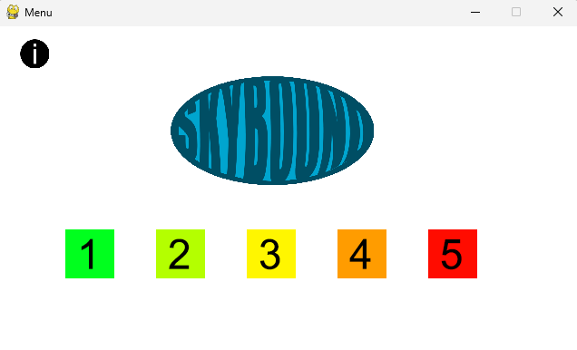The first thing to test is the highest-level user interface to check that there are no usability errors.

The right image shows the first thing the user will see when they load the program from the intended module, DifficultyMain.py.

*Colour corresponding difficulty buttons

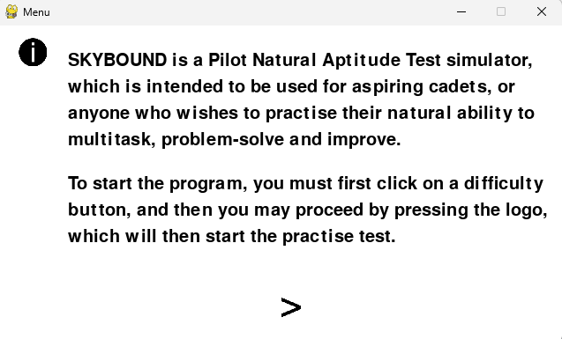

Upon the user clicking the information button, info becomes active and then the screen is cleared to show text and navigation arrows. This text outlines the program and its usability.

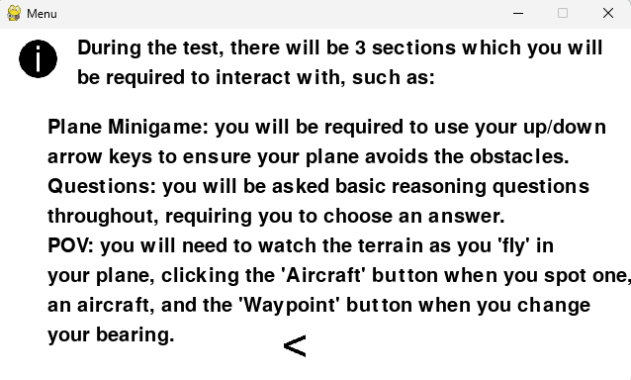

Upon clicking the right arrow navigation button, the page value will change, and the next page’s information will be Outputted.

Clicking the information button will return the user to the original screen, while maintaining the state of the page.

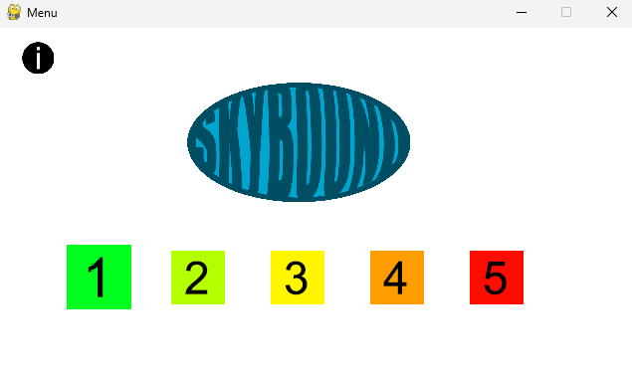Within the menu, whenever the mouse arrow hovers over any button, such as the information button, a difficulty button, or the logo / start button, it will enlarge to provide the user with some feedback. (in this example, the mouse is hovering over the 1st Difficulty button.

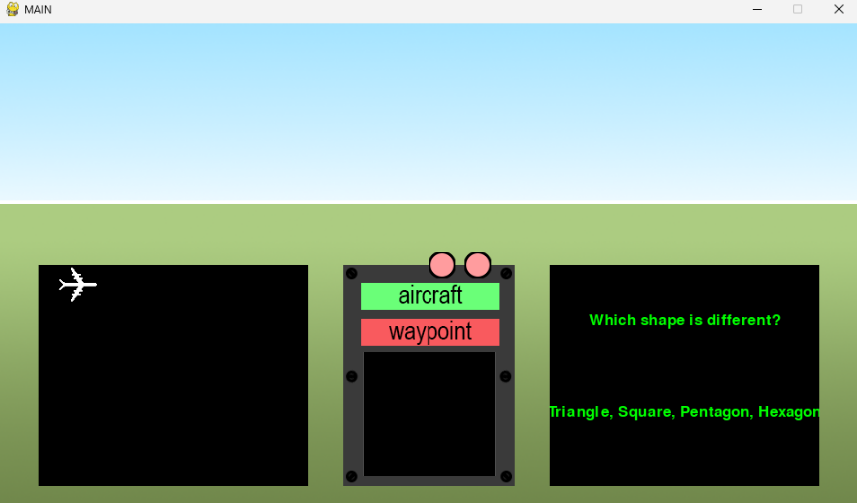

Once a difficulty label has been pressed, and the logo has been pressed, the following window will pop up, starting the game.

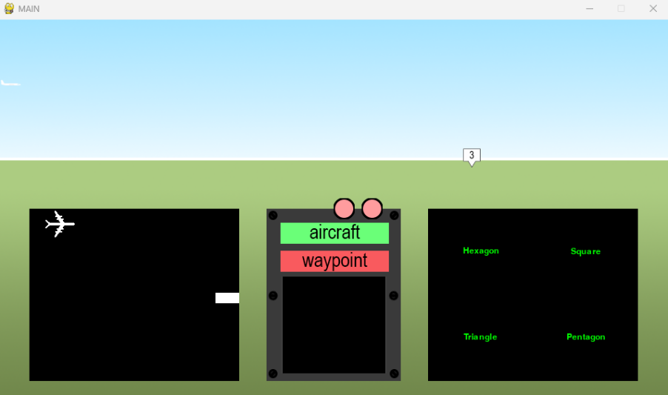

A waypoint of type “3” has spawned

The question is replaced with the potential answers, shuffled

An aircraft has spawned

A cloud has spawned in the plane minigame

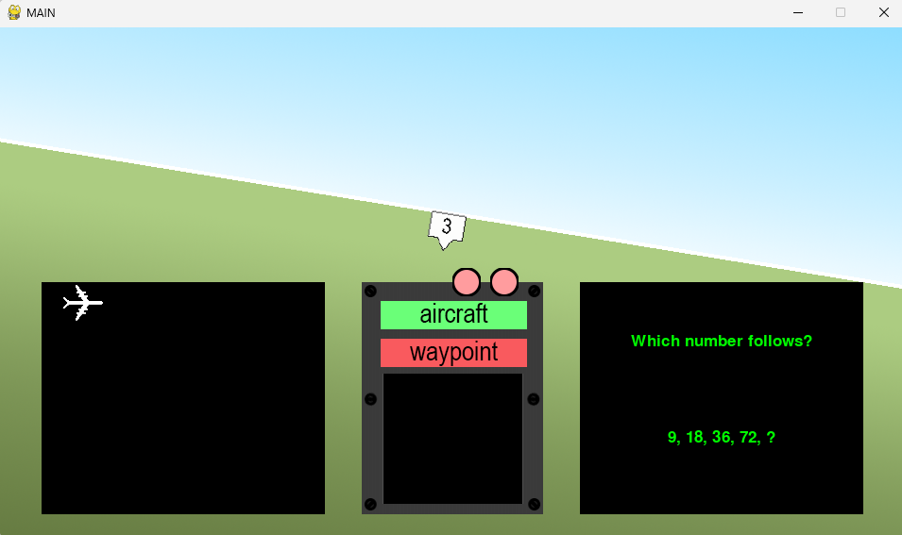The screen rotates / plane changes bearing as a result of encountering the waypoint

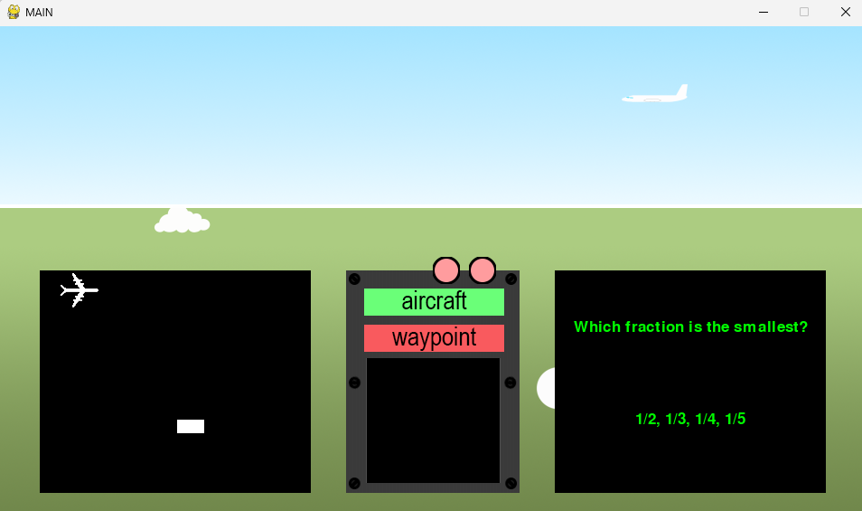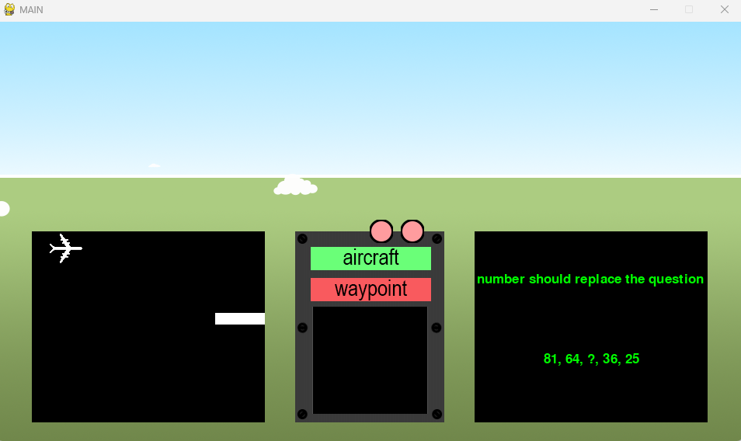

Cloud instances spawn as background information / visuals

Since a plane is on screen, clicking the aircraft button is registered as a correct input (correct 1 is a print statement)

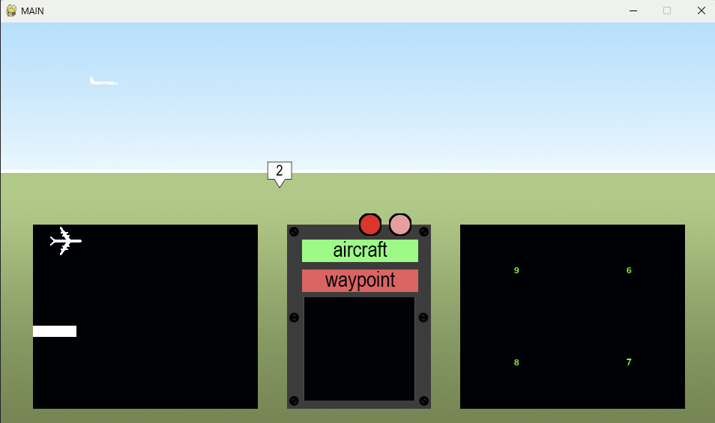

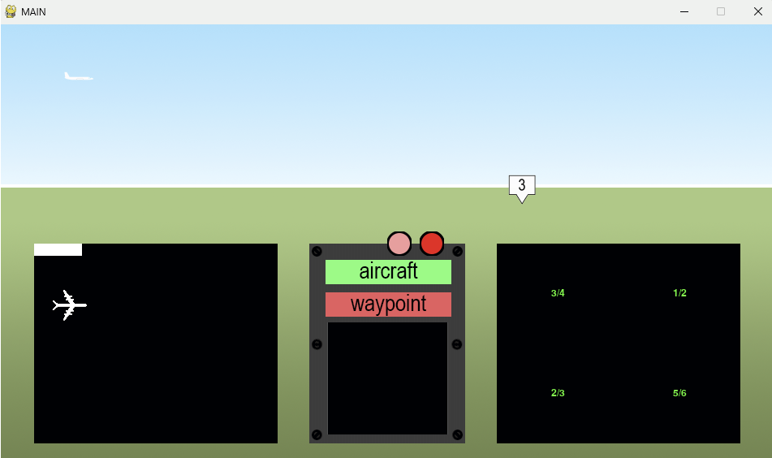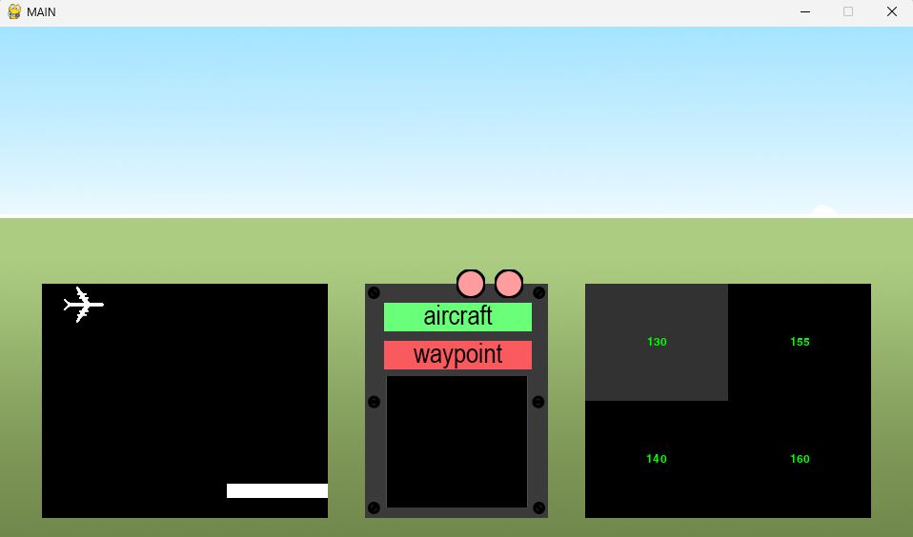

Right Light is now ‘flashing’

When an answer option is selected in the bottom right (the example clicks the top left option) The option turns grey to register this input

Left light is flashing, evidently shown by the significant hue difference, it stays alight for 0.5 seconds

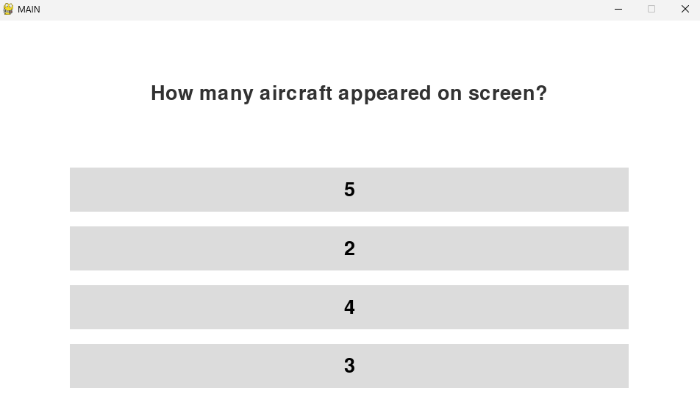

After the game_length number of ticks have been met / exceeded, the quiz will pop up.

Asks random question from the list

Outputs one correct answer and 3 incorrect answers from 1-10, randomises order

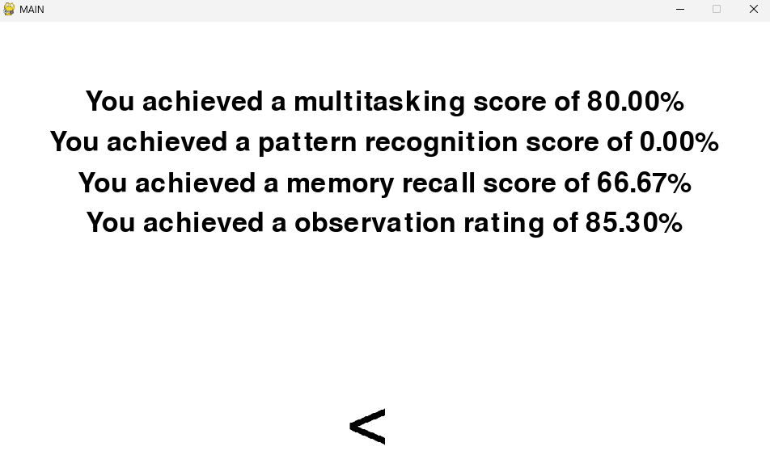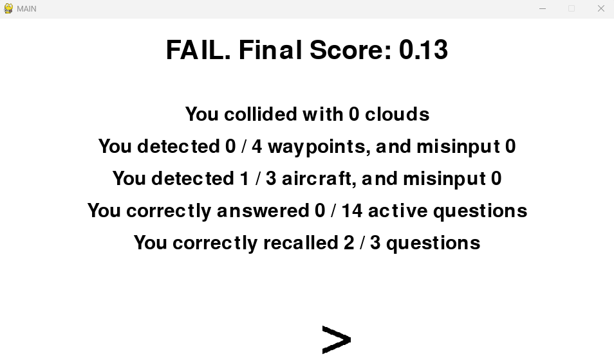

Upon input of the arrow key, the arbitrary percentage scores are Outputted

*Allows users to see which areas they should focus on improving

Once 3 questions have been answered, the report will be Outputted, with a score, and a pass or fail mark decided by a threshold value 0.85

It will Output the individual statistics of the user’s attempt

The user can use the arrow to navigate to the next page of the report

### Stakeholder Testing

I have given each stakeholder a copy of the code and information on how to use it, however for a few stakeholders I found it is easier to give them the experience on my laptop.  
  
Stakeholder Questions ***How did you find the starting user interface?***

***Did you understand the information pages?***

***How did you find the different difficulty settings?***

***Did you experience any issues throughout the practise test?***

***How helpful was the final report and information pages?***

***Do you have any extra suggestions for my solution?***

These questions will provide me with helpful information insight to each section of the test, allowing the stakeholders to provide input for any feature they would like to give feedback on.  
  
I was given the following responses via messages and in person:

#### Zhang (via WhatsApp)

***How did you find the starting user interface?***

“I found it easy to navigate, and especially liked the info button. I liked the different colours for the different difficulty levels, but I misunderstood clicking the logo at first to start the game.”

***Did you understand the information pages?***

“I did like that touch, however I found it slightly hard to read and understand, and I presume it would be hard for a new user to gauge what they must do based on those two pages alone.”

***How did you find the different difficulty settings?***

“I appreciated the colours in the UI, and upon trial of difficulties 2 and 4 I liked the difference in timings and problems”

***Did you experience any issues throughout the practise test?***

“The only issue I faced was occasionally a waypoint would be blocked by a cloud, however I presume that is accurate to real life, and is a feature of the practise test.”

***How helpful was the final report and information pages?***

“I liked the pass/fail score a lot, and I liked that I could view my statistics of my attempt easily.”

***Do you have any extra suggestions for my solution?***

“I would suggest potentially reworking the information pages for user accessibility before the software goes public, thank you for inviting me to be a client for such an ambitious project.”

#### Jack (in person)

***How did you find the starting user interface?***

“It was alright could be better”

***Did you understand the information pages?***

“It was a load of writing and I didn’t really bother with it when I tried ngl”

***How did you find the different difficulty settings?***

“I liked it but difficulty 5 was way too easy for me”

***Did you experience any issues throughout the practise test?***

“honestly I don’t think I did but I cant remember too much of my run”

***How helpful was the final report and information pages?***

“I think there was a bug because it told me I failed”

***Do you have any extra suggestions for my solution?***

“Make it harder for me”

#### Liu (via WhatsApp)

***How did you find the starting user interface?***

“I liked it, very simplistic and minimal, yet all the key information was clearly Outputted”

***Did you understand the information pages?***

“Definitely, but I fear I may only have understood them because of my previous knowledge of the test, I am unsure if a new user would be able to understand before they start”

***How did you find the different difficulty settings?***

“on my attempt I found difficulty 1 and 2 very similar with almost negligible difference, but that is likely because they are hard to compare.”

***Did you experience any issues throughout the practise test?***

“No”

***How helpful was the final report and information pages?***

“I found them very helpful” “I liked the different statistics for my progress tracking”

***Do you have any extra suggestions for my solution?***

“No I think it is really good”

#### Tolupe (via WhatsApp)

***How did you find the starting user interface?***

“It was quite nice, quite easy to use”

***Did you understand the information pages?***

“They were quite hard to read since it was just a wall of text, but the words themselves made sense”

***How did you find the different difficulty settings?***

“I thought they were quite a nice addition and made lots of sense. I tried 5 first but that didn’t work out too well”

***Did you experience any issues throughout the practise test?***

“Not to my knowledge, but it did take a second once I clicked the logo to start the game”

***How helpful was the final report and information pages?***

“Very helpful, I failed on my first attempt and then after I tried again on Difficulty 1 I passed”

***Do you have any extra suggestions for my solution?***

“Maybe try and make the information guide more helpful if you can”

#### Tiffany (in person)

***How did you find the starting user interface?***

“It made a lot of sense with the different colours” “The logo is cool”

***Did you understand the information pages?***

“I skimmed them, but it seemed to make sense”

***How did you find the different difficulty settings?***

“They were quite nice, I started on difficulty 1 and passed, and then tried difficulty 3 and failed so I guess I need more practise”

***Did you experience any issues throughout the practise test?***

“I found it hard to keep track of which light flashed which amount of times while having to count the number of waypoints and aircraft”

***How helpful was the final report and information pages?***

“Pretty good, on my first attempt it told me I passed but I didn’t do as well and failed on my second”

***Do you have any extra suggestions for my solution?***

“That was better than I thought it would be, so no”

#### Isaac (via WhatsApp)

***How did you find the starting user interface?***

“It took me a while to figure out to press the logo” “I had to read all the instructions to find that out”

***Did you understand the information pages?***

“I had to read it a few times and was still unprepared for the actual test when it started”

***How did you find the different difficulty settings?***

“I thought even 1 was pretty hard, I passed but I did not pay attention to any of the questions they asked at the end”

***Did you experience any issues throughout the practise test?***

“Not apart from it being really hard”

***How helpful was the final report and information pages?***

“Pretty helpful but it took a sec for me to figure out which scores meant what”

***Do you have any extra suggestions for my solution?***

“Maybe add a section in the information pages about what scores mean what in the report and also make it easier to understand haha”

#### Conclusion

Stakeholders generally seem content with the final solution, agreeing with my updated design for the UI with bold and colour coded difficulty buttons, and appreciate the report at the end, with the final pass / fail mark, individual statistics covering each section of their practise run, and the scores on the other page. Stakeholders generally seem to utilise the difficulty settings as intended, starting on lower settings to build confidence and then attempting higher difficulty settings, in which they are generally reminded to practise more.

However, users often claim to misunderstand the information page and the % scores on the report. This is likely due to the limited visuals and paragraph blocks, and some claim that it took them a while to realise that they must press the logo to start their practise run, which was clearly outlined in the information page, showing that many of them simply did not read it, even if they knew they should.

# Evaluation

## Criteria

### Success Criteria

|  |  |
| --- | --- |
| **Criteria** | **Met?** |
| Start screen with customisable difficulty settings | Yes |
| Improvement Metrics | Yes |
| Similar UI to the actual FAST | Yes |
| Similar difficulty to the actual exam | Yes |
| **Easy to navigate reports** | **Partial** |
| **Guide to show users how the program works** | **Partial** |
| **Accessibility / Usability Features (Dark Mode, etc)** | **Partial** |
| Notable start screen options | Yes |
| Window with correct proportions created for the Plane Minigame | Yes |
| Airplane visible in Plane Minigame with accurate proportions | Yes |
| Controllable airplane in Plane Minigame | Yes |
| Randomly generated cloud obstacles in the Plane Minigame | Yes |
| Ensuring the randomly generated cloud obstacles do not provide obstacles which are impossible to dodge (in bottom left minigame) | Yes |
| Collision detection system for plane and clouds | Yes |
| Variable which counts the number of collisions in the bottom left minigame per section of test, per attempt | Yes |
| Sensible non-verbal reasoning questions in bottom right minigame | Yes |
| Understandable graphics for the lights on the dash | Yes |
| Noticeable when the lights on the dash light up | Yes |
| Both lights can light up randomly | Yes |
| Reasonable number of flashes from lights dependant on difficulty | Yes |
| At least 1 rendered terrain | Yes |
| Randomly generated waypoints | Yes |
| Identifiable Waypoints | Yes |
| When waypoints on screen, POV appears to change direction (rotate) | Yes |
| Randomly generated aircraft | Yes |
| Separate and easily identifiable buttons for the waypoints and airplanes | Yes |
| Reasonable questions asked in the testing phase | Yes |
| Several answer buttons with options | Yes |
| Variables for when the buttons are clicked when an event is rendered, and when event is not rendered | Yes |
| Final report which answers if you would pass or fail | Yes |

**Evidence

**Success Criteria this embodies:**

“Start screen with customisable difficulty settings” – Screenshot of the start page – This criterion is met fully, shown above by the start page, which contains easy understood and optional difficulty settings.

“Notable start screen options” – Screenshot of UI of start screen – Similarly, the start screen options are evidently notable, consisting of very limited features, each and every button clickable is clearly defined with purpose, each being notable for their own task, this criterion is almost completely met, however the logo being the start button could be more evident.

“Accessibility / Usability Features (Dark Mode, etc)” - Screenshot of the features added and what they change – Easily labelled colour-coded difficulty options – On this page, the presence of different difficulty settings is a usability feature in itself, allowing users of different aptitude and familiarity to progress and utilise the game to its maximum benefit, the information button also helps with this, showing the user there is an explanation available that is usable and accessible. However, it fails to give the user the option of a ‘Dark Mode’ for users whose eyes are more sensitive to light, so this criterion is only partially met.

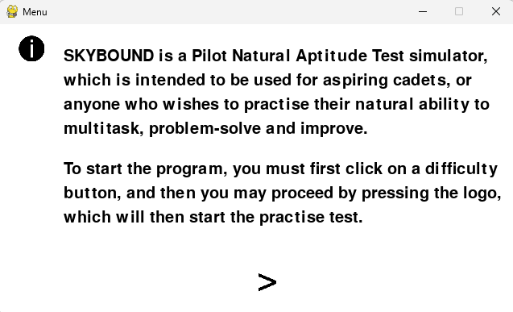

**Success Criteria this embodies:**

“Guide to show users how the program works” – Screenshot of the text shown to explain the program when an info button is pressed – upon clicking the information button the user will be shown text to explain how the game works, although this encompasses the broad aspect of it, our stakeholders brought up the issue of understandability, as the text might not be enough to show the users. While this evidence fully encompasses the criterion, there is still sections that should be improved.

“Accessibility Features (Dark Mode, etc)” - Screenshot of the features added and what they change – information about the test for the user to understand – The information telling the user of the features of the test allows users with less familiarity to gain a basic understand of the program before their attempt, again there is no dark mode, so this criterion is only partially met.

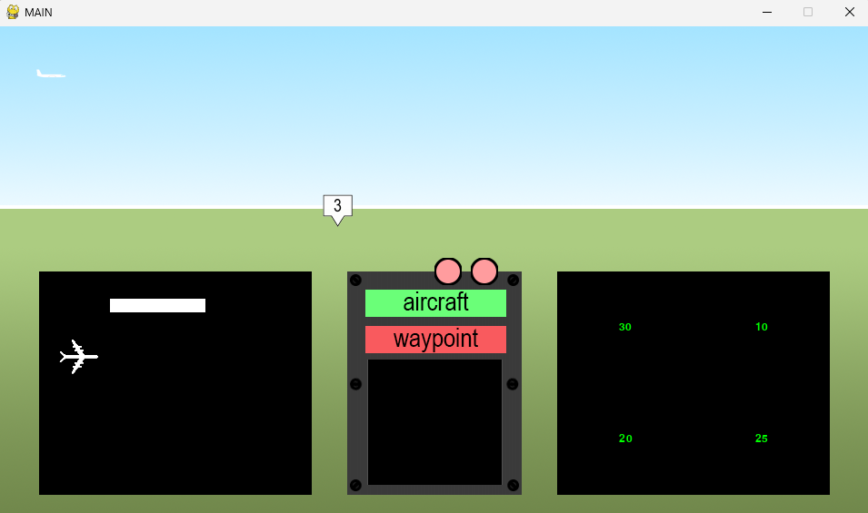

**Success Criteria this embodies:**

“Similar UI to the actual FAST” – Screenshot of the UI in the test – all locations of the different tasks are located in the same relative areas as in the actual fast, with the plane minigame in the bottom-left corner, the waypoint / aircraft button and their respective colours resemble the same patterns as the actual FAST, the lights are located just above these buttons, and the active reasoning challenges are located in the bottom right, with events and terrain spawning in the top half of the screen, with the whole UI giving a feeling of being inside a cockpit with different systems.

“Window with correct proportions created for the Plane Minigame” – Test demos of the minigame – the plane minigame has correct proportions relative to the FAST, being square shaped and in the relative location, whilst the window proportions do not take up to half the screen. This criterion is fully met.

“Airplane visible in Plane Minigame with accurate proportions” – Test demos of the minigame – the plane is visible in the image, and relative to the clouds and window size it is of accurate proportions. This criterion is fully met as a result.

“Controllable airplane in Plane Minigame” – Test demos of the minigame – whilst not directly visible, the airplane is able to be controlled with the up and down arrow keys, evidenced by the fact the airplane has moved out of the way of the cloud and from its original starting location of (20,0) to one of a lower y value.

“Randomly generated cloud obstacles in the Plane Minigame” – Test demos of the minigame – a cloud is generated in the above screenshot, and from difficulties 1-3 generate with a random number of attached clouds (within bounds), meeting the criterion fully, with extra details for higher difficulties.

“At least 1 rendered terrain” – Screenshot of the terrain in development – Whilst not directly obvious, the terrain is the background, consisting of a large green plain and the sky, separated by a white skyline. Whilst I did hope to create more terrains that the plane would travel through, the criterion itself is still fully met.

“Separate and easily identifiable buttons for the waypoints and airplanes” - Screenshot of the design for the buttons – this criterion is achieved evidenced by the waypoint and aircraft buttons being separated, and nearly oppositely coloured.

“Identifiable Waypoints” - Screenshot of the models of the waypoints – waypoints are identifiable with a large number on them, Outputting the number they have been assigned.

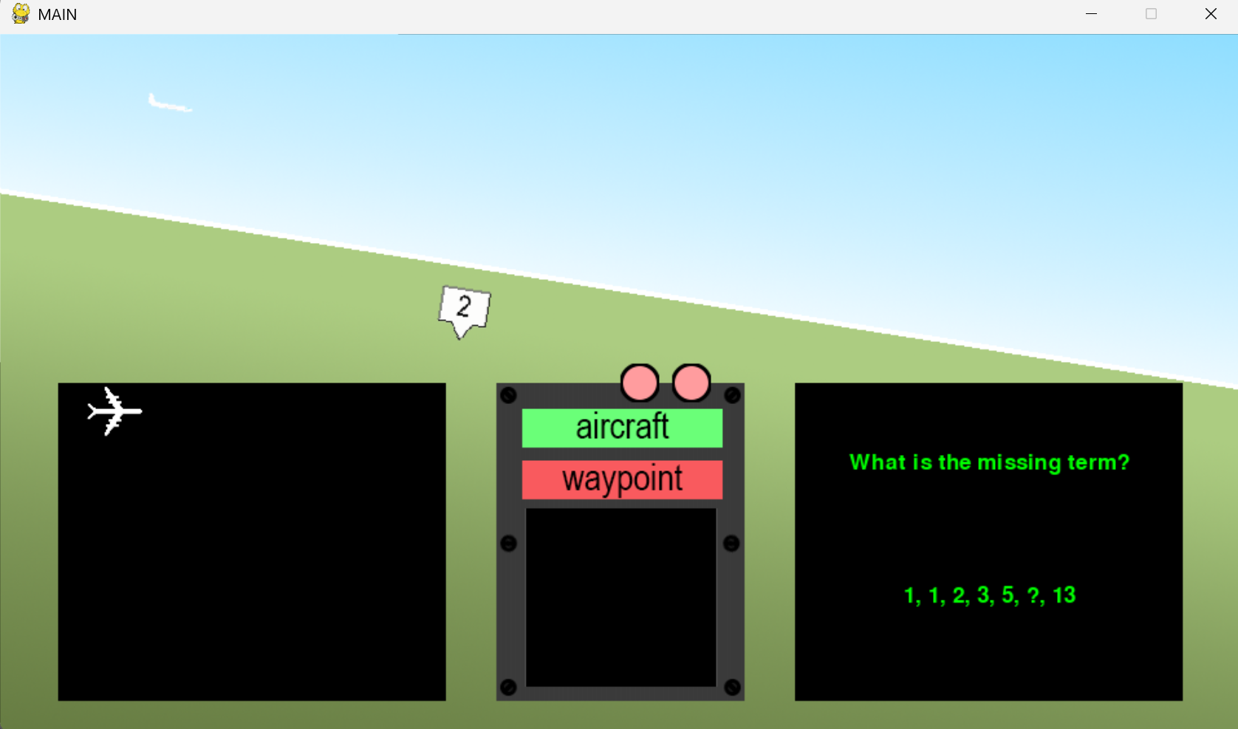

**Success Criteria this embodies:**

“Identifiable Waypoints” - Screenshot of the models of the waypoints – the waypoint is a clear marking on the terrain, clearly Outputting its type (2) with a large letter, it stands out, and is easily identifiable, so this criterion is fully met.

**“**When waypoints on screen, POV appears to change direction (rotate)” - Screenshots of terrain when turning – the terrain is angled, and so are the plane and waypoint, as they move relative to terrain. This criterion is fully met.

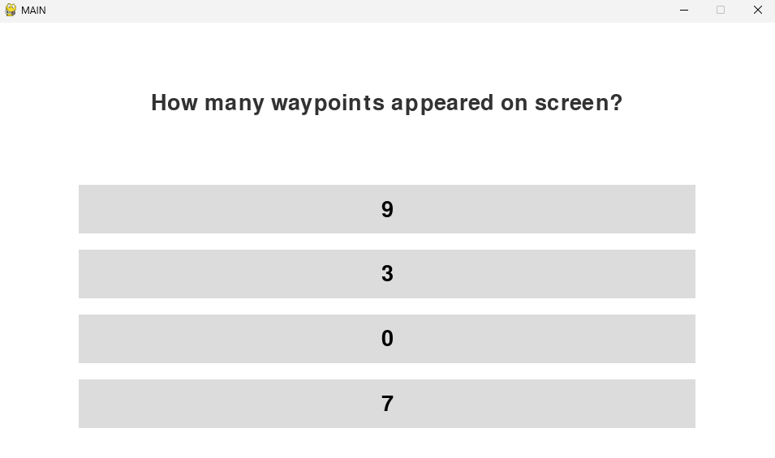

**Success Criteria this embodies:**

“Several answer buttons with options” - Screenshots of the buttons – the buttons are clearly Outputted, and have random options from 1-10, with the real answer value embedded in one of the random buttons, so this criterion is fully met.

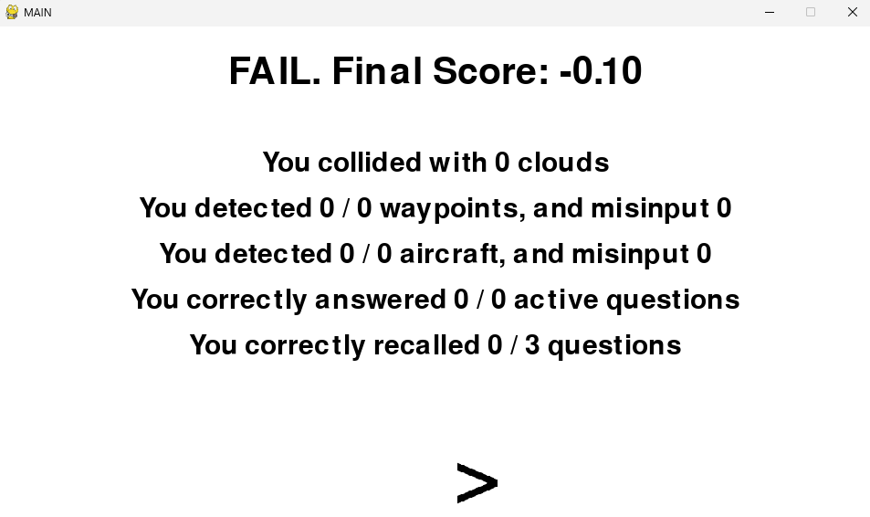

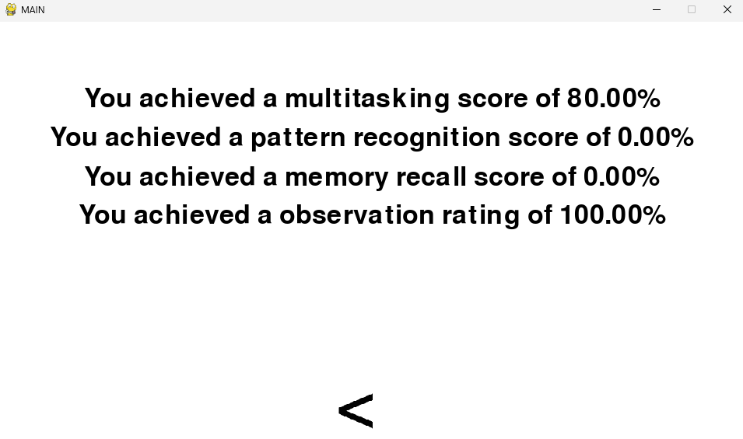

**Success Criteria this embodies:**

“Easy to navigate reports” - Screenshot of a simple report with understandable scoring methods – the report only consists of two simple pages, page 1 will give you actual values and statistics from your attempt, and your pass / fail mark, all being clearly labelled and explained, and page two scores you based on the different skills they test, fully meeting this criterion.

“Accessibility Features (Dark Mode, etc)” - Screenshot of the features added and what they change – Methods to show areas of potential user improvements and current strengths – the report in itself with the skill based scoring meets the criteria, however the feature of dark mode is not available, so the user is stuck with a bright interface which may damage their eyes, this criterion is therefore only partially met.

**Previously Evidenced Success Criteria**

“Improvement Metrics” – Screenshot of the code which compares stats – Page 214

“Similar difficulty to the actual exam” - Screenshots of the different Pass / Fail marks given for different combinations of scores – Page 219

“Ensuring the randomly generated cloud obstacles do not provide obstacles which” - Screenshot of rendering programming for obstacles – Page 118

“Collision detection system for plane and clouds” - Screenshot of minigame and trace variables – Page 99

“Variable which counts the number of collisions in the bottom left minigame per section of test, per attempt” - Test demos of the minigame – Page 103

“Sensible non-verbal reasoning questions in bottom right minigame” - Screenshot of question database – Page 124

“Understandable graphics for the lights on the dash” - Screenshot of the graphics used for the lights – Page 181

“Noticeable when the lights on the dash light up” - Screenshot of the light up graphic – Page 181

“Both lights can light up randomly” - Screenshot of random code showing when they light up – Page 182

“Reasonable number of flashes from lights dependant on difficulty” - Screenshot of limiting code showing that the flashes are adjustable and limited – Page 180

“Randomly generated waypoints” – Screenshot of code to generate them randomly – Page 154

“Randomly generated aircraft” - Screenshot of code to generated them randomly – Page 146

“Reasonable questions asked in the testing phase” - Screenshot of the questions potentially asked, and how they are generated – Page 196

“Variables for when the buttons are clicked when an event is rendered, and when event is not rendered” - Screenshot of the code which designs this – Page 173

“Final report which answers if you would pass or fail” - Screenshot of code and screenshot of report – Page 218

“At least 1 rendered terrain” – Screenshot of the terrain in development – Page 139

## Usability Features

### A blue oval with black text and colorful squares AI-generated content may be incorrect.Difficulty

Different easily understandable buttons to change the difficulty

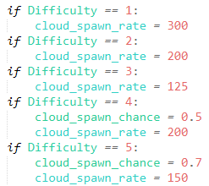

Difficulty changes the rate at which clouds spawn in the Plane minigame

Difficulty alters the chance of a vertical cloud spawning at > 3 difficulty

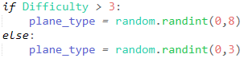

A different variety of aircraft can spawn (with higher speeds) > 3 Difficulty



Less cooldown for active questions on higher difficulty

More potential light flashes with higher difficulty

This usability feature is largely successful as they provide an intuitive and accessible way for users to interact with the system. The colour-coded difficulty buttons ensure that selecting a difficulty level is quick and easy, which scaling difficulty mechanics, such as increased cloud spawn rates, aircraft variety ans speeds, and faster question cooldowns, effectively adjusting the challenge level in a meaningful way. While some features could benefit from additional feedback mechanisms, such as tooltips of brief explanations, the overall system successfully maintains usability by being clear, responsive, and adapting to skill levels.

### Information Button

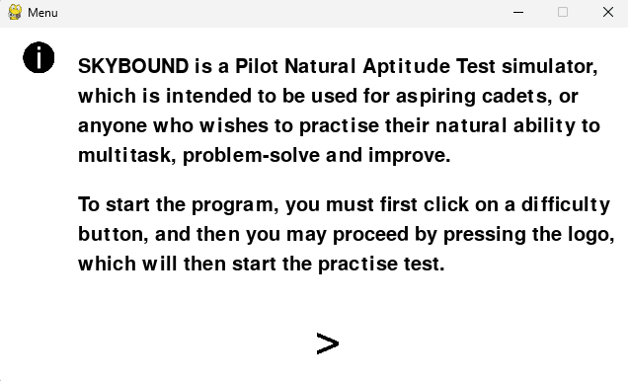

Information button outlying the different features of the game and its overall purpose

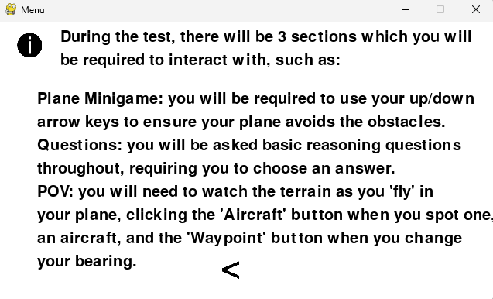

The information button partially meets its usability goal. While it provides key details about the program, many users overlook or misunderstand important instructions, such as needing to press the logo to start. The large text blocks without visuals make it harder to engage with, leading to confusion about navigation and score interpretation. The page also fails to explain report statistics like multi-tasking score. While functional, the feature could be improved with clearer formatting, visuals, or interactive elements.

### Report

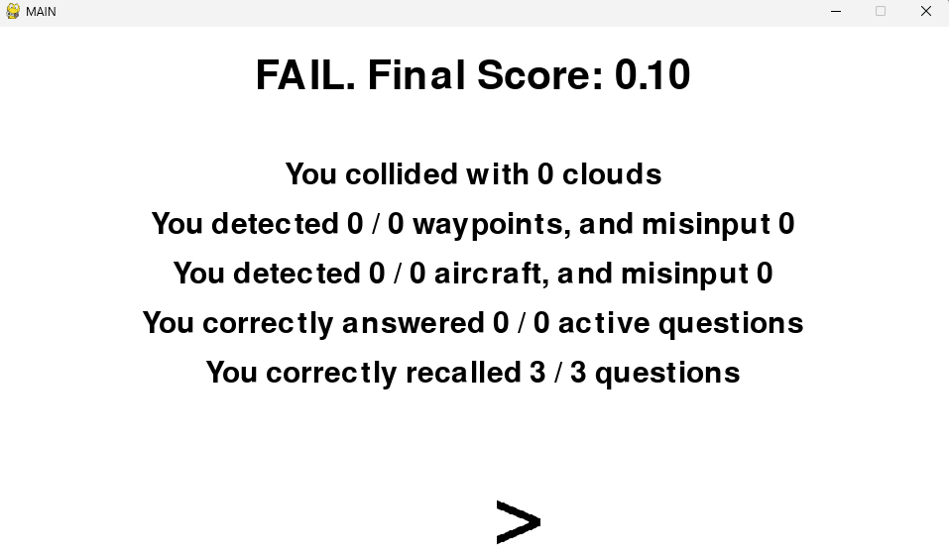

Simple pass / fail in bold text and a clear final score

Foundational statistics presented

Skill scoring

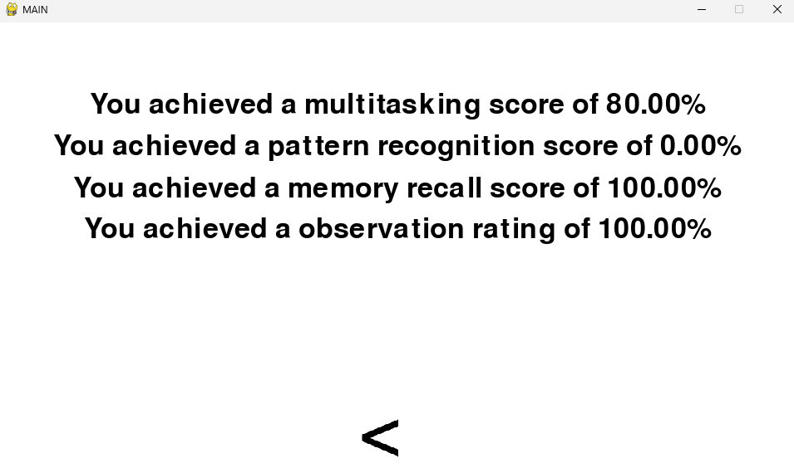

The final report effectively provides structured and transparent feedback, ensuring users can understand their performance and areas for improvement. By breaking scores into clear skill sections, it reduces ambiguity and helps users focus on specific competencies. The bold pass/fail result and percentage-based skill ratings make the feedback accessible to a broad range of users, which may interpret information differently. Some users with learning difficulties may still struggle with text-heavy layouts, so additional visual aids could further enhance clarity. Overall the report successfully conveys results but could be refined for even greater accessibility.

## Limitations

The current main limitations of the solution are the differences between the actual FAST exam and my current solution. Whilst my current solution is made to be adaptable and open for users of all skill levels and situations, the actual FAST may not consider this fact as much and contains slightly different features.

A significant difference and limitation in my solution is the lack of the repeating test. Within the actual FAST, after the user answers the passive reasoning challenges quiz, they will repeat the test, featuring the exact same situations as they previously did. I discussed this with the stakeholders and other potential users on a forum, and they said that whilst not including the repeated attempt was not ideal, it would not make much difference as the users could simply restart the test, taking what they learnt from their previous attempt and improving themselves.

Another of these features is the report at the end, whilst my report can appear simplistic and understandable, it lacks the complete depth that Symbiotic’s FAST offer, giving visualised graphical data of the users attempt in a downloadable document, with data such as direct improvement metrics between attempts. Whilst this enables the user to understand their results and report easier, the actual data presented is not much different to the data presented in my solution, and whilst this may hold true, it still does not help with the user friendliness of the report navigation for a user.

Furthermore, a main criterion that has not been fully met of the program is the hard navigation, difficult understanding of the final scores, and a lack of initial understanding about the test and its contents for the first time, proven by feedback from our stakeholders.

Newer users may be intimidated by the large blocks of text that resemble an information section, and thus not be able to properly understand the processes within the game, nor understand the meanings of the final reports.

This success criteria was attempted to be met, given by the information screen on the main menu, however this does not provide the user with information about how to understand the report and the arbitrary statistics, such as the ‘multi-tasking score’ or other.

Whilst many accessibility features have been included in the final solution, such as an information button, difficulty levels, and different scores for the different skills tested Outputted at the end in the report, I fail to implement a dark mode.

Dark mode would be useful for users who are often on the software outside of usual daytime hours, as it would dim the lights present on the menus to accommodate for their situation, allowing their eyes to be under less strain as the colours would blend in more with the background. To fix this, I have created a simplistic model of how a dark mode could be implemented.

### How I could address partially/unmet criteria and usability features

#### Easy to navigate reports

A solution of this would be to make the information section more navigable and understandable for users as a whole, showing them more information using methods other than just text, and explaining explicitly what is weighted within each scoring of the report.

A solution I have created to demonstrate the path that future updates can use to fulfil this criterion:

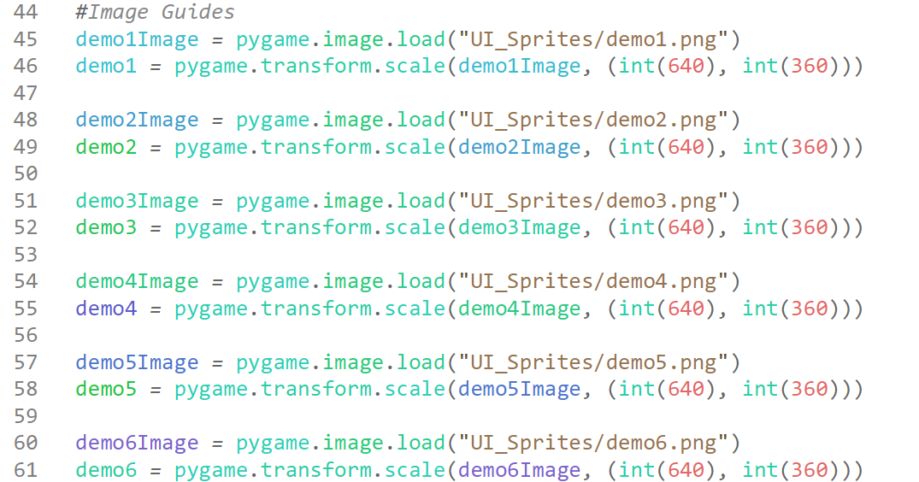

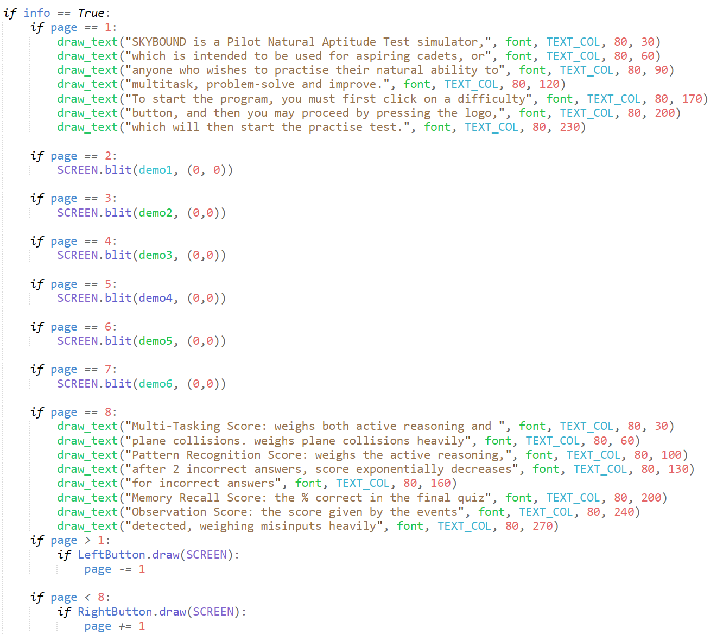

Output:

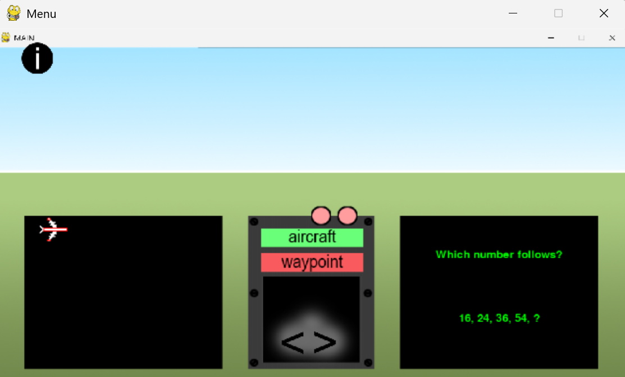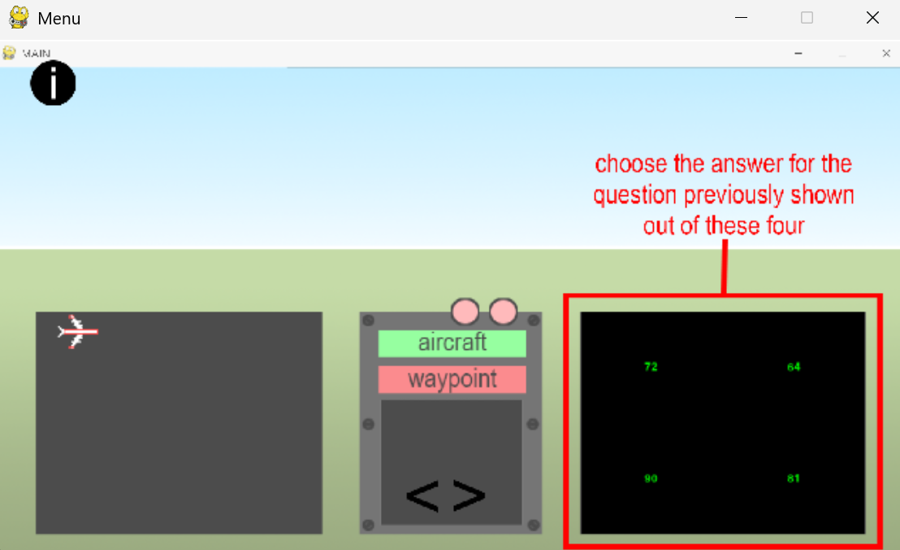

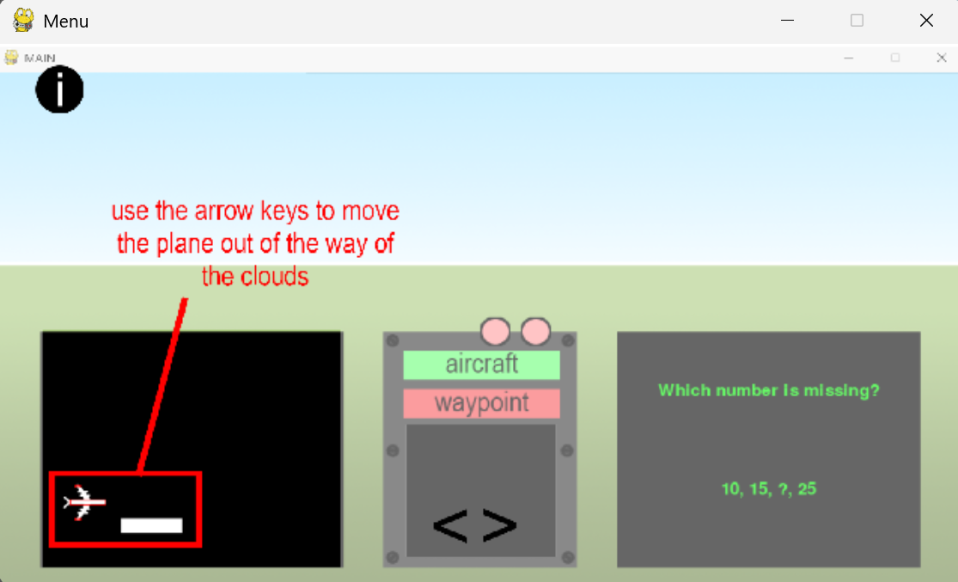

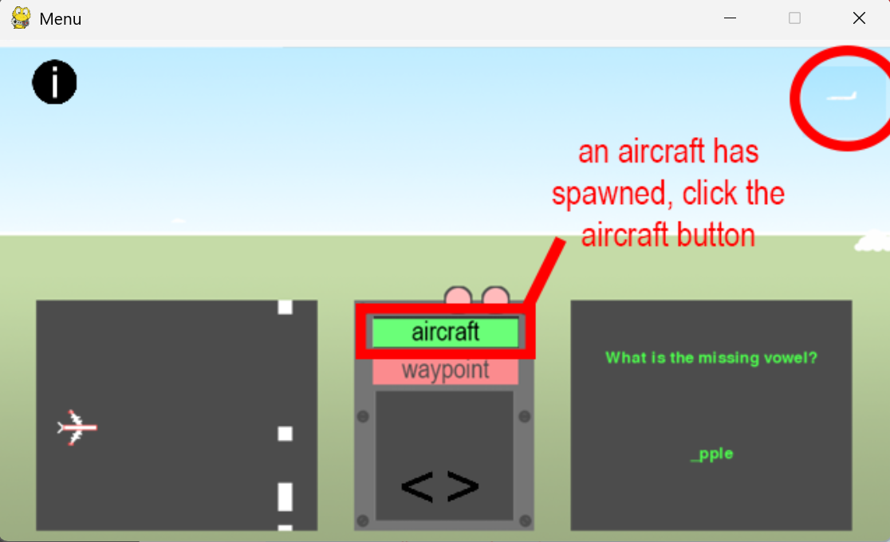

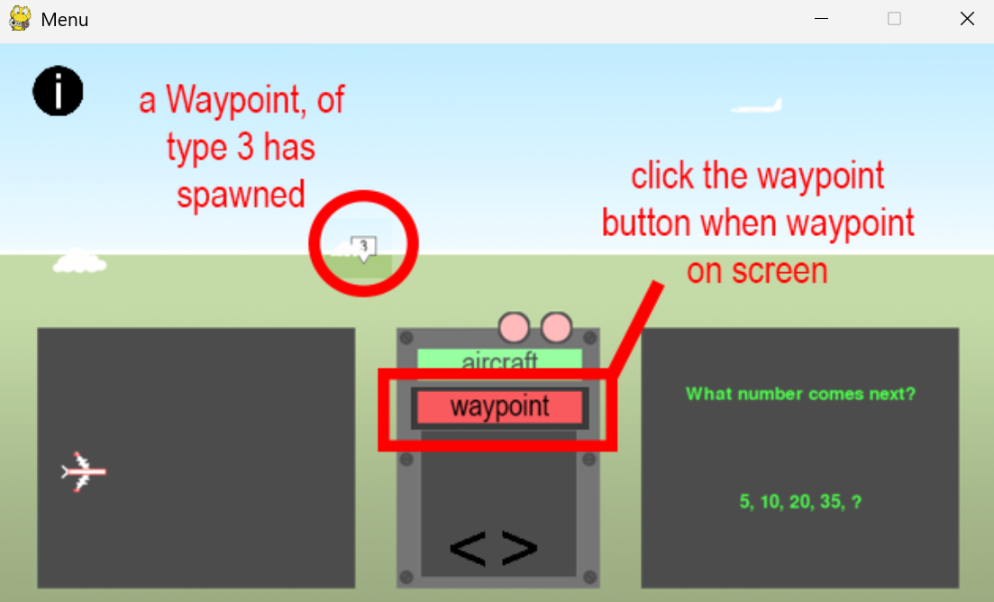

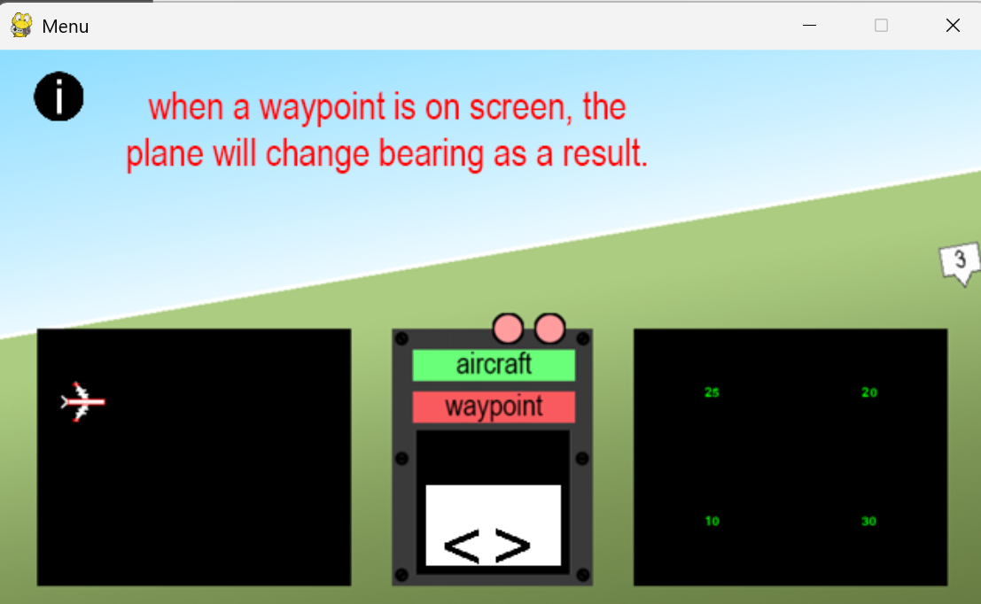

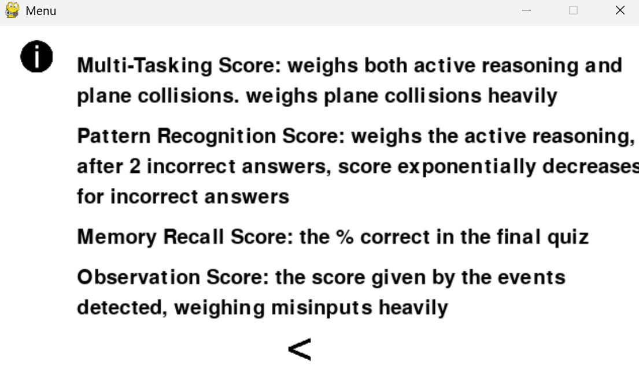

This code changes the information section, adding image guides with heavy and practical annotation to combat newer users being deterred from reading about how to use the software, and it also explains the different scores and how they weigh different statistics at the end, therefore fully satisfying the requirements for this criterion.

#### Accessibility / Usability Features – Dark Mode

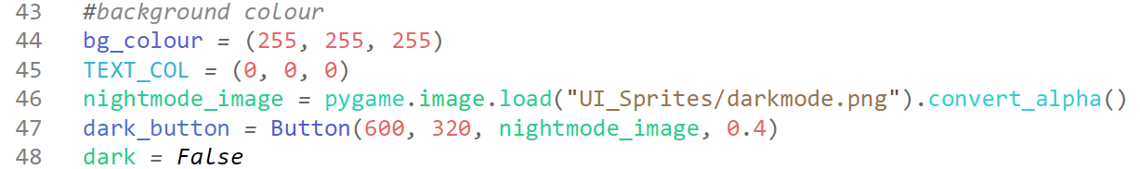

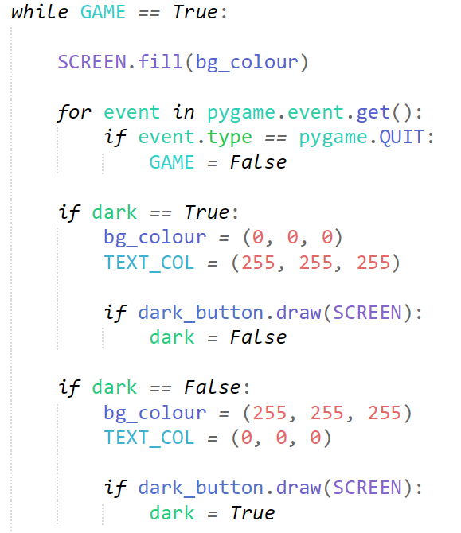

Output:

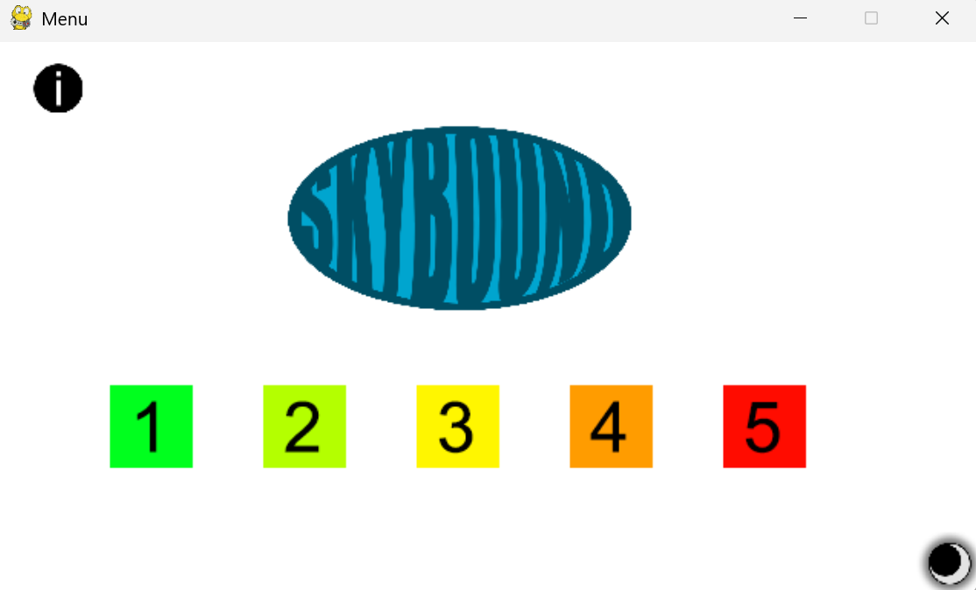

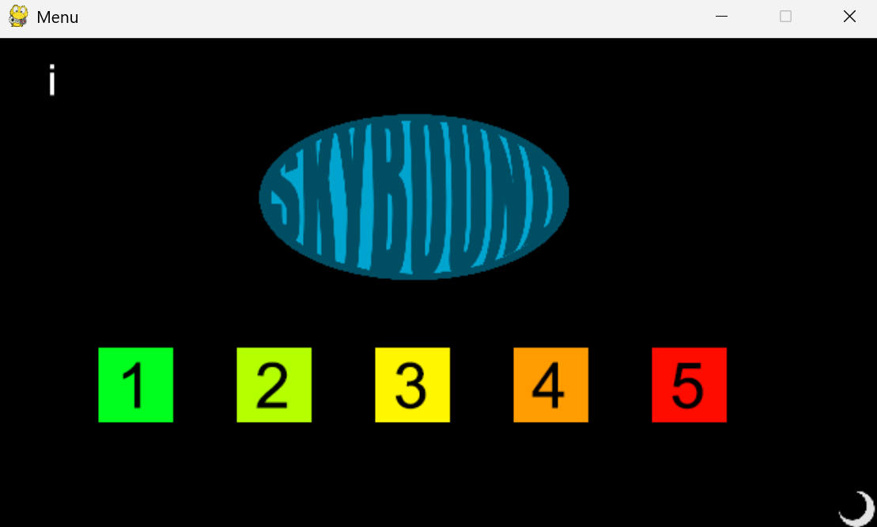

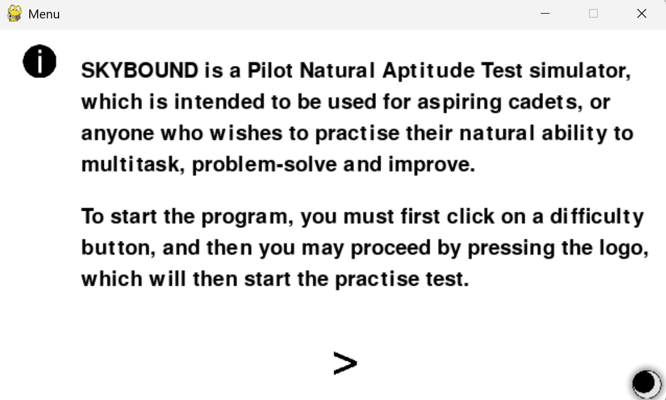

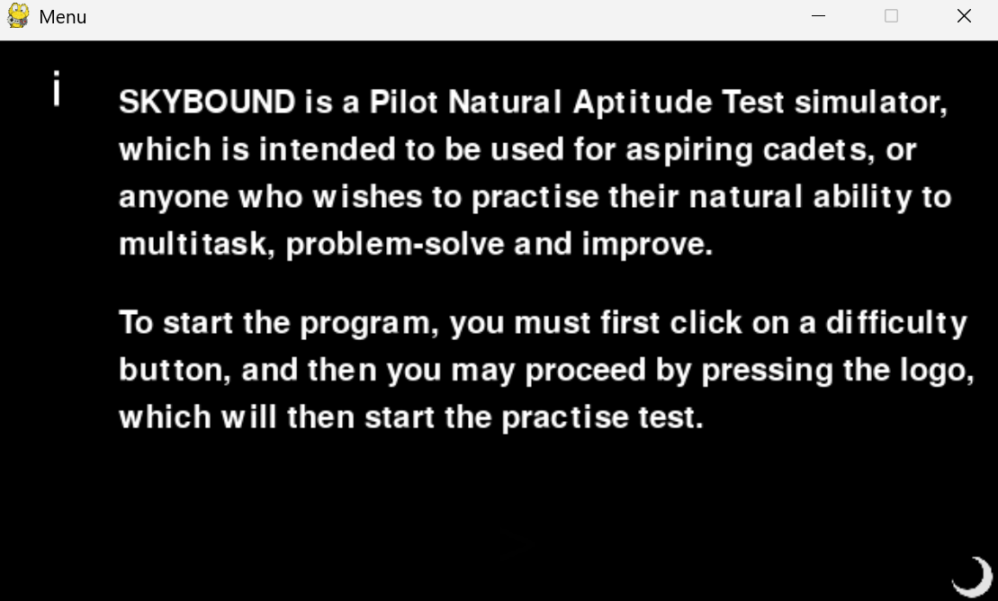

This adds an easily understandable dark mode button on the menus, allowing users to press it and change their systems colour scheme, including the background colour and the text colour, this allows users with sensitive eyes or users that often use the software during later hours to create a virtual environment more suiting to their usability and accessibility needs, thus fully satisfying the criterion.

## System Maintenance

The maintenance of the system should be easy to access within each module, as every subroutine and class has comments and description, and due to the organization of main modules such as the TER_main.py module, they should be relatively easy to understand. The use of separate files to store important structures such as general set up variables also helps improve maintainability, giving some users easy access to altering values they want to be changed.

Unfortunately, many systems within the solution are slightly hard to alter, such as the dimensions of the window. Whilst in itself the values of window dimensions are easy to alter, it will be difficult to adapt all other windows around it. Many modules account for this by basing all their positional calculations on the width and height of the screen, however many values are too specific to use these, and therefore use raw integer values. As a result, changing dimensions of windows can cause consistency errors that I have experienced firsthand importing modules such as the plane minigame and active reasoning challenges into the terrain and event rendering module.

An example of the issues which may arise include can include changing the TER window dimensions will not proportionally alter the dimensions of the plane minigame window and its contents, such as cloud spawn size, location etc., all of which will need to be altered manually to fit the new proportions.

However, for regular end users, the solution is very portable, making it accessible to a wide range of users regardless of their operating system and device. One of its key strengths is that it only requires Python and the Pygame library, which are both freely available and easy to install. The flexibility stems from the development of the solution in python, a language known for its cross-platform capabilities, and since the only required dependency is Pygame, a lightweight and widely used library for game development, the complexity of installation compared to software that relies on multiple framework or external services is minimal.

The system requires very little data storage, with total file sizes being only 35MB, meaning data storage should not be an issue, and backups will not be required as the game can simply be fully restored by re-downloading the source code since there is no internal retained storage aside from the difficulty, which is negligible and ever-changing.

## Future Updates

The system does not require any specific updates to be run and used, as its current state fully encompasses the desired product requested by stakeholders.

However, updates can serve to add useful features to the game which would make the game more suitable as a direct practise software for the FAST, such as implementing the second attempt after the quiz, where identical events occur and the user is given the same questions, testing the users improvement between the two attempts into a visualised graphical representation of their statistics over time and between the attempts, calculating an improvement score.

Another update could be the inclusion of auditory signals and feedback, such as contact with air traffic control, giving you more information to process and remember. This could be incorporated into the quiz, where the user could be asked questions about the details provided by air traffic control.

Creating a more difficult to identify events system, such as creating more decoy waypoints to disguise the actual waypoints would be a good addition, similar to SkyTest’s solution. This encourages the user to pay a closer attention to their surroundings, instead of simply being able to process the presence of a waypoint in their peripheral, so this is a currently existing feature which could be improved.

# Code Appendix

## Plane Minigame

### PM_setup.py

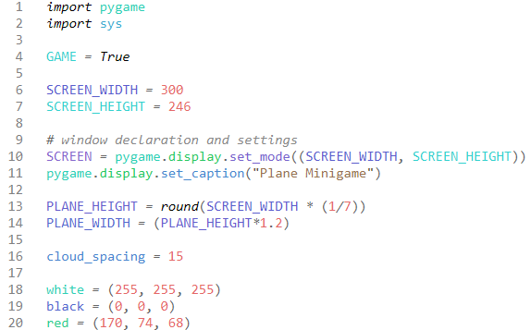

### PM_plane.py

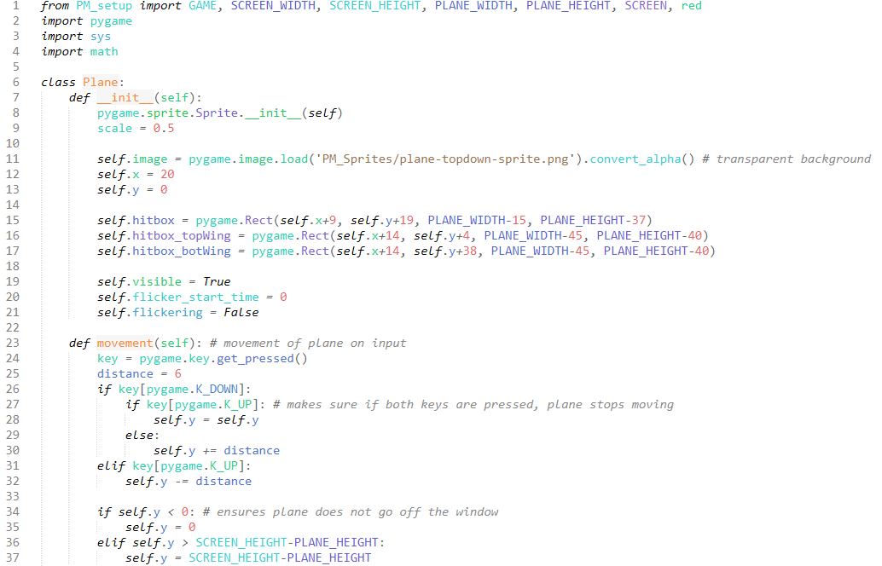

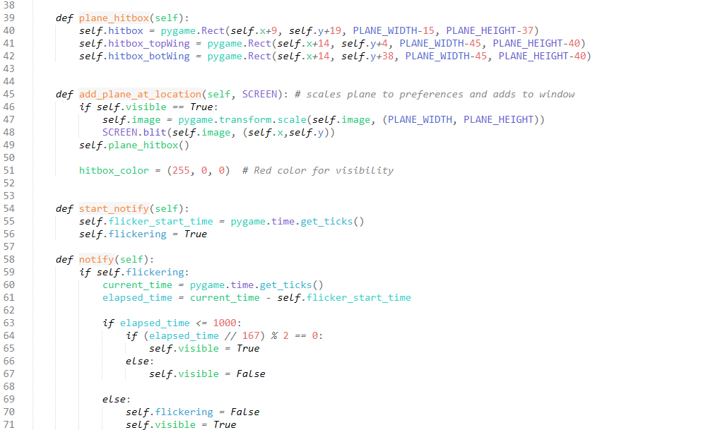

### PM_clouds.py

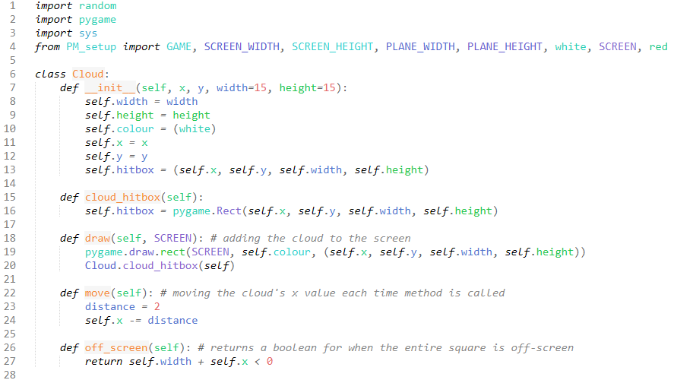

### PM_hitbox.py

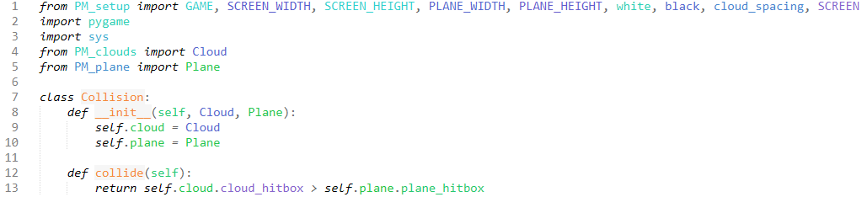

### PM_main.py

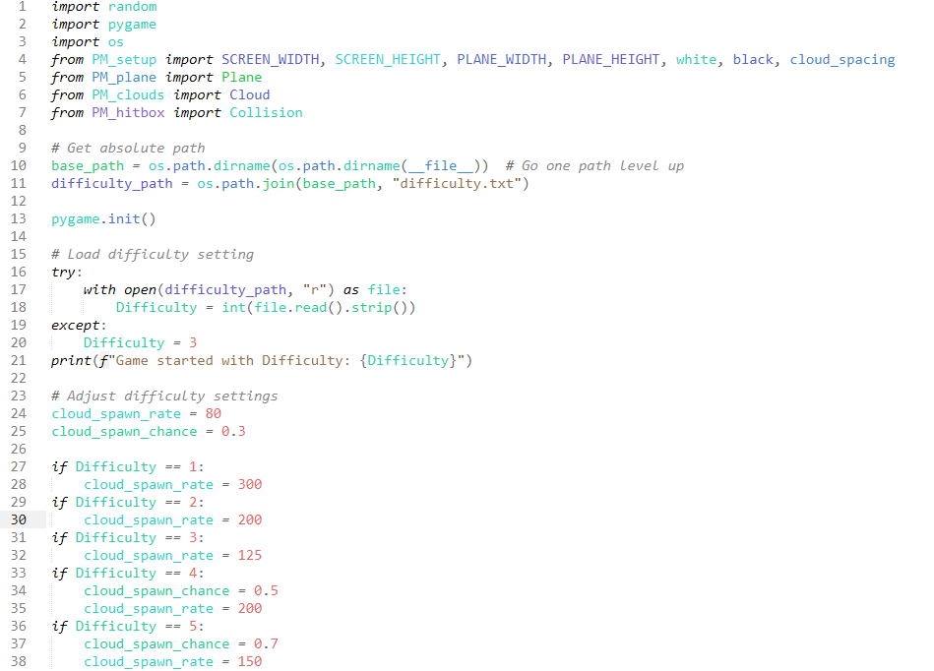

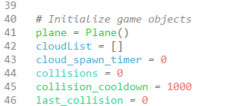

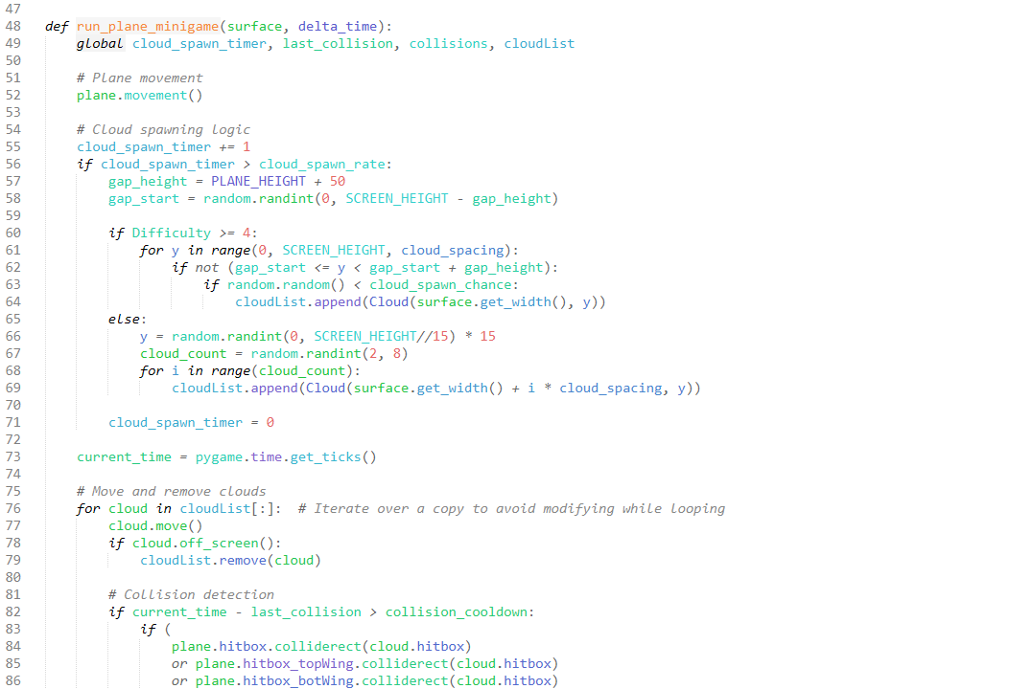

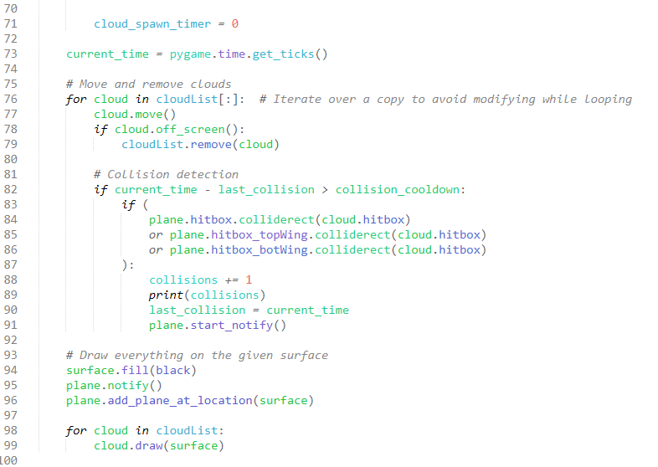

## Active Reasoning Challenges

### ARC_button.py

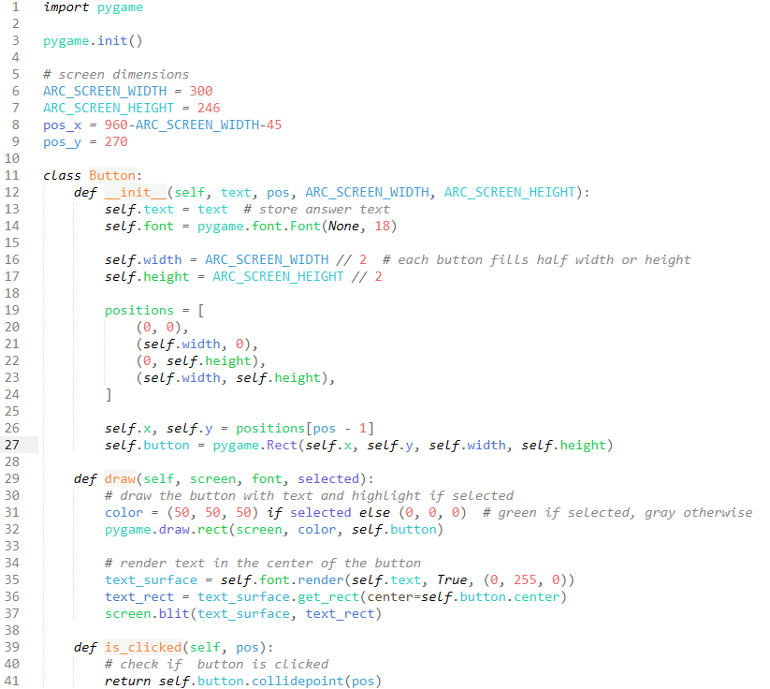

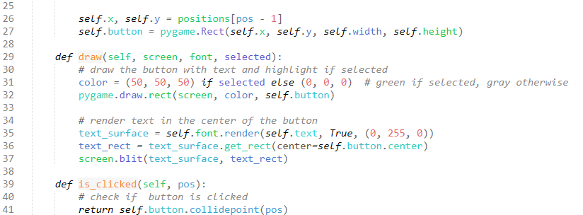

### ARC_DB.py

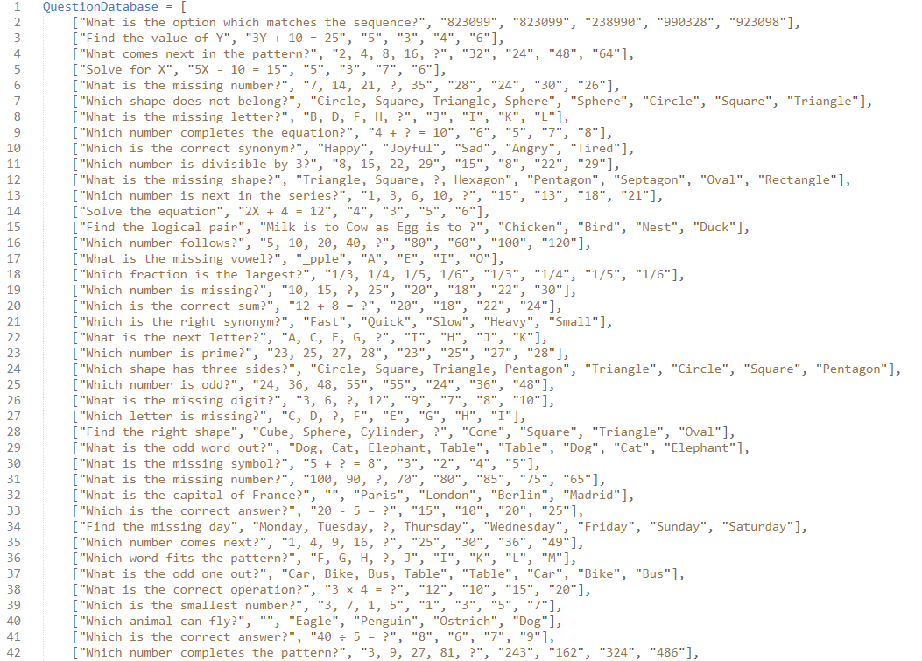

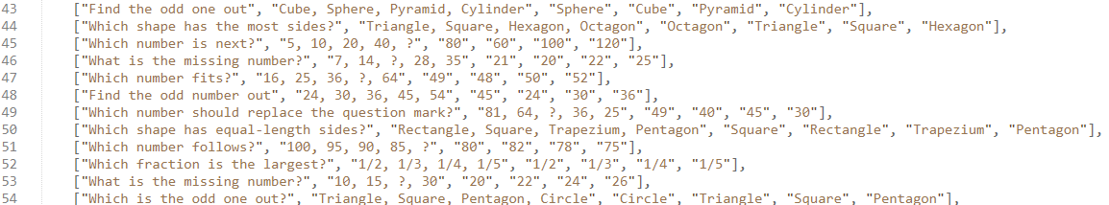

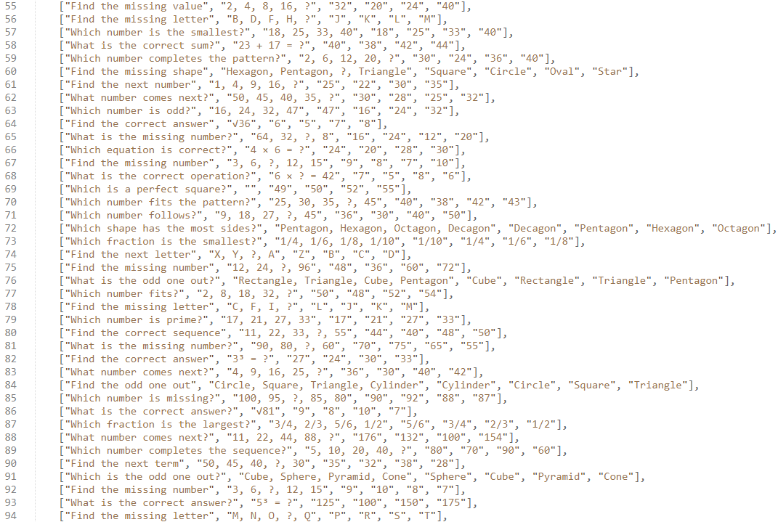

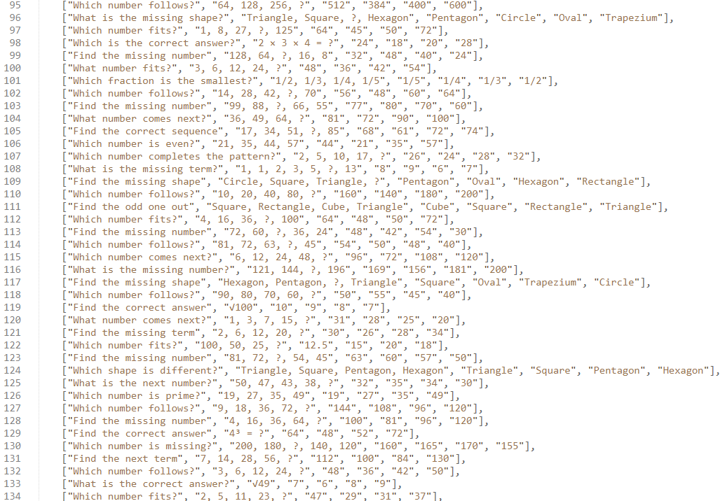

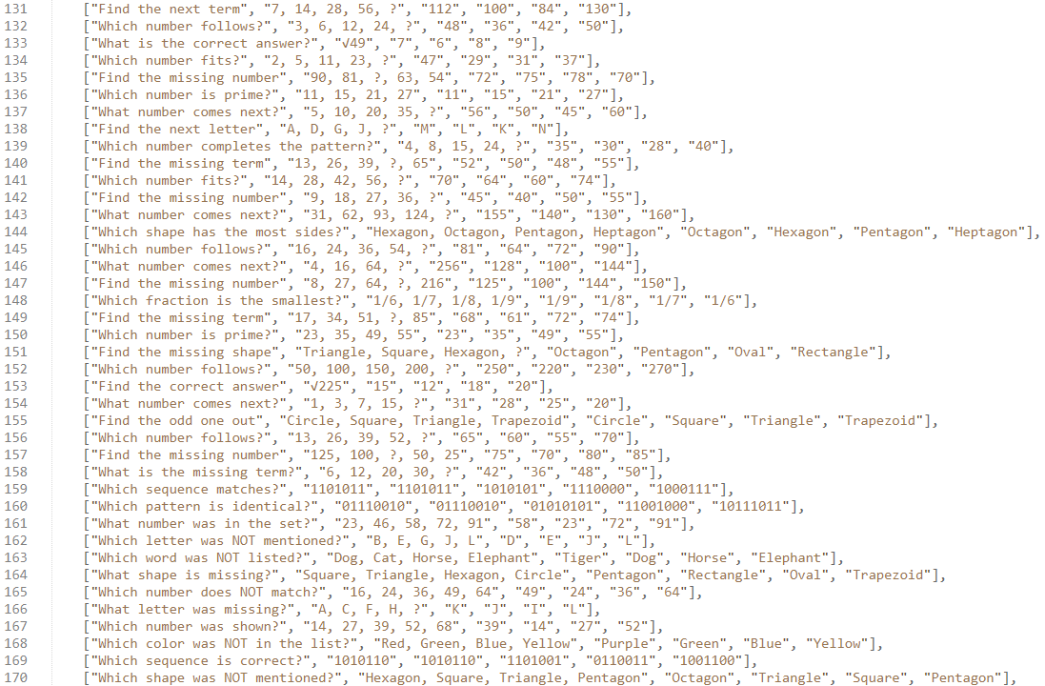

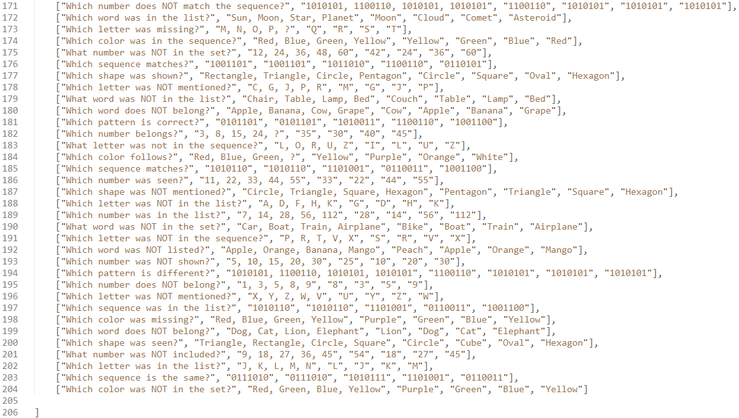

### ARC_main.py

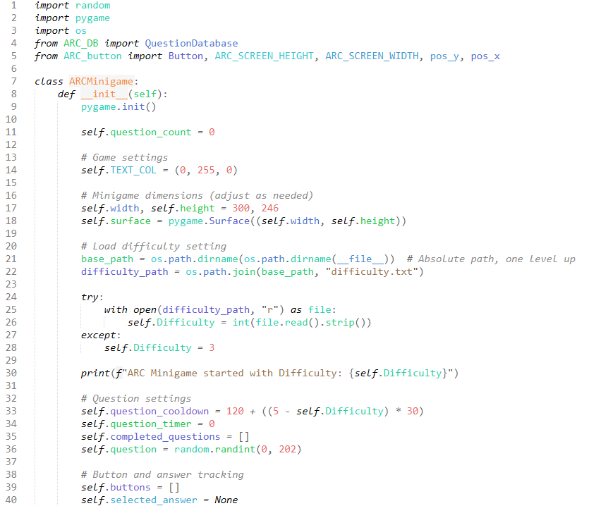

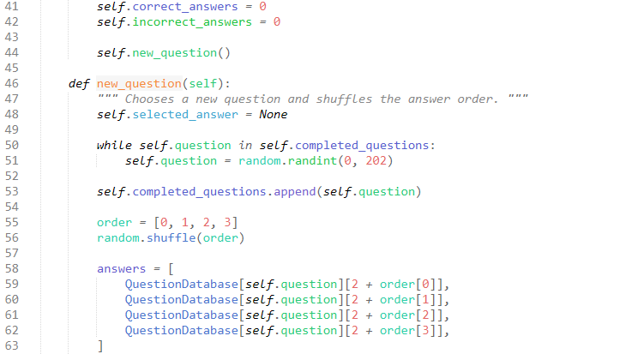

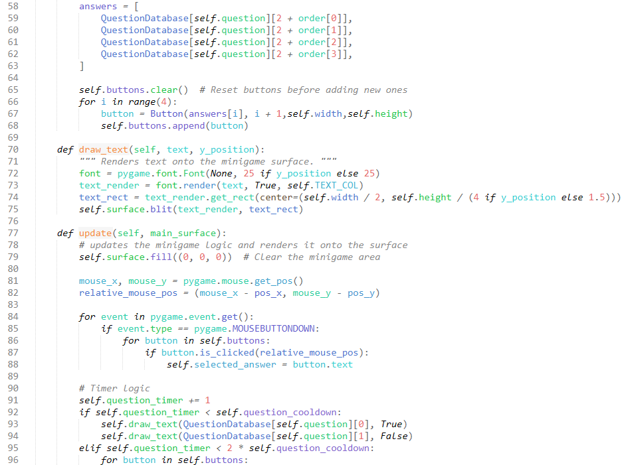

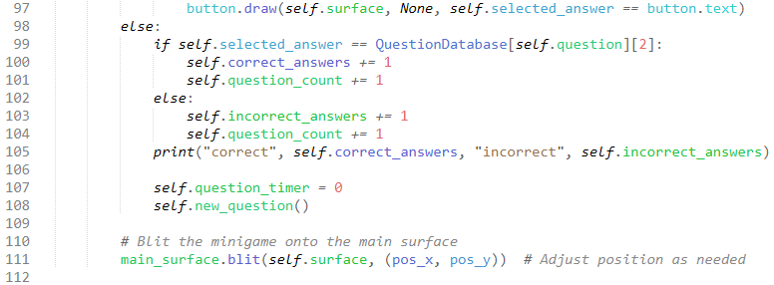

## Passive Reasoning Challenges

### PRC_main1.py

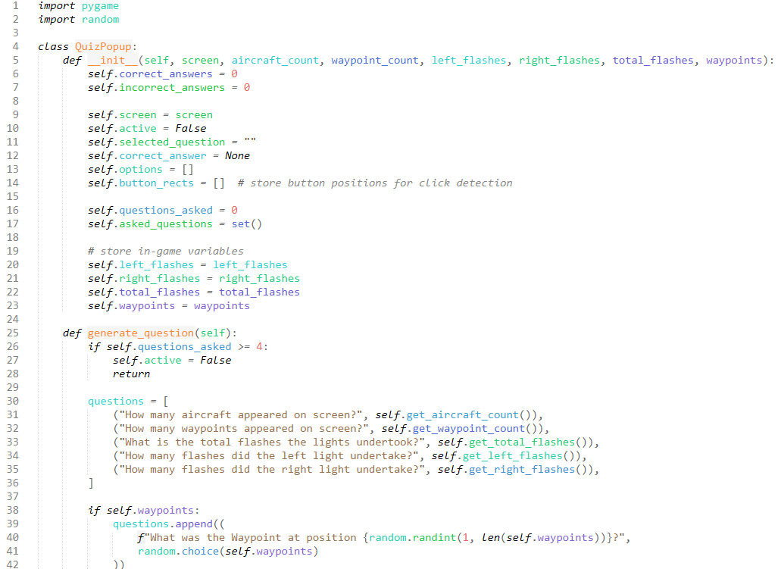

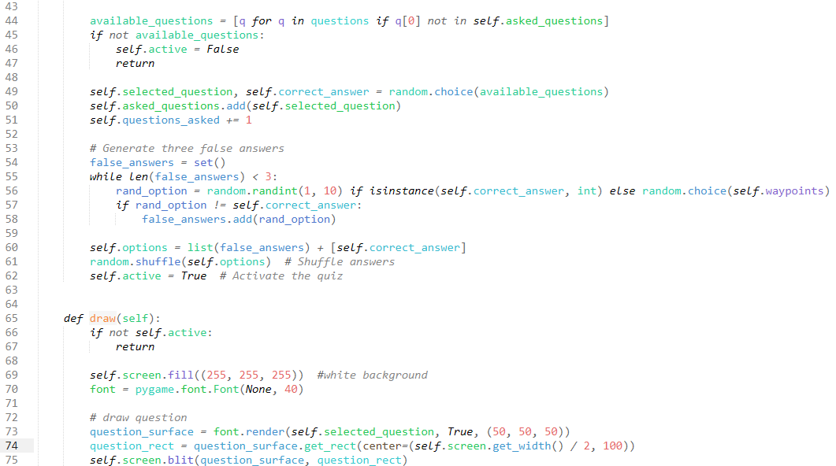

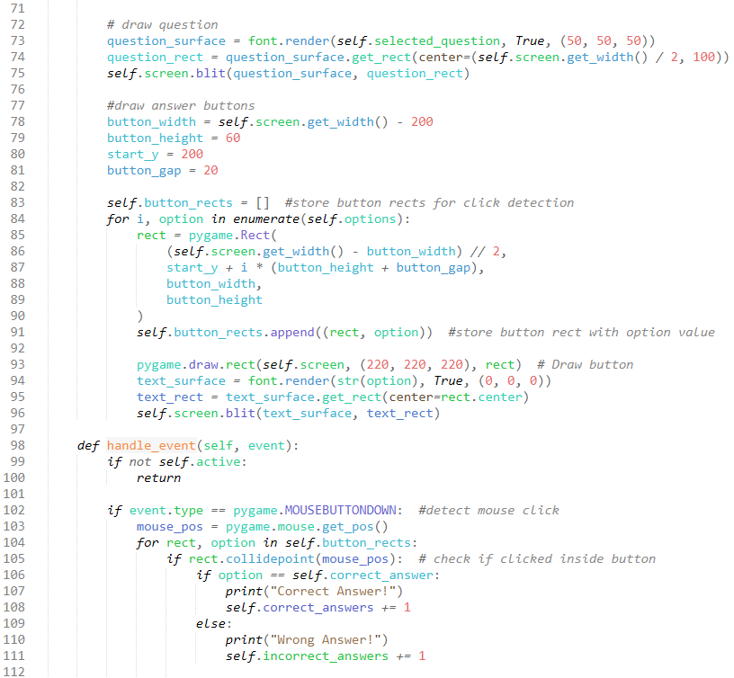

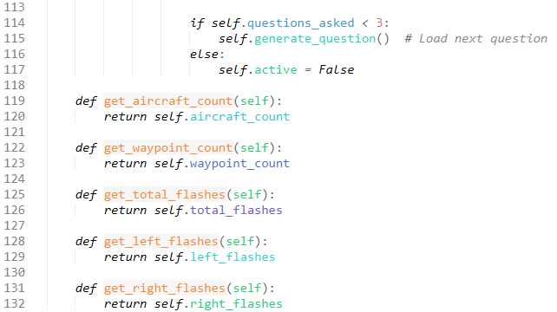

## Terrain + Event Rendering

### TER_aircraft.py

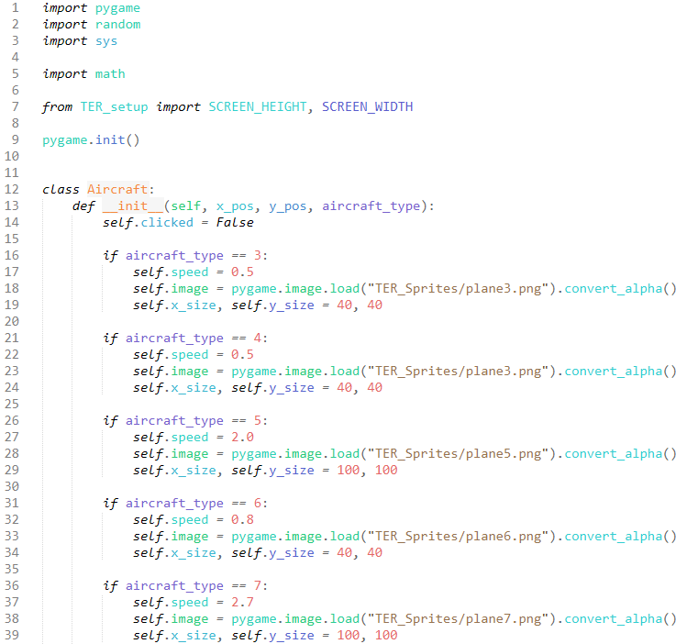

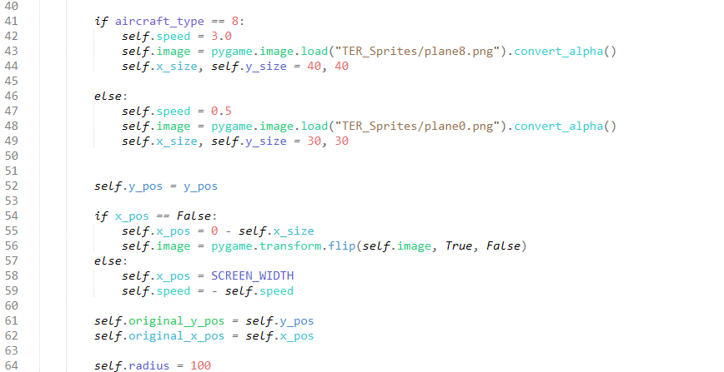

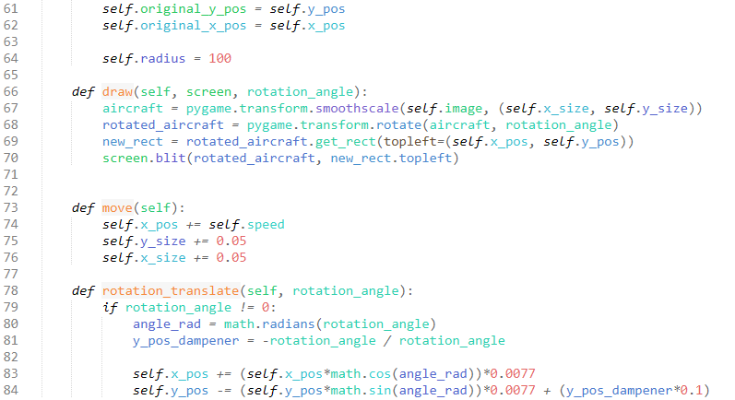

### TER_buttons.py

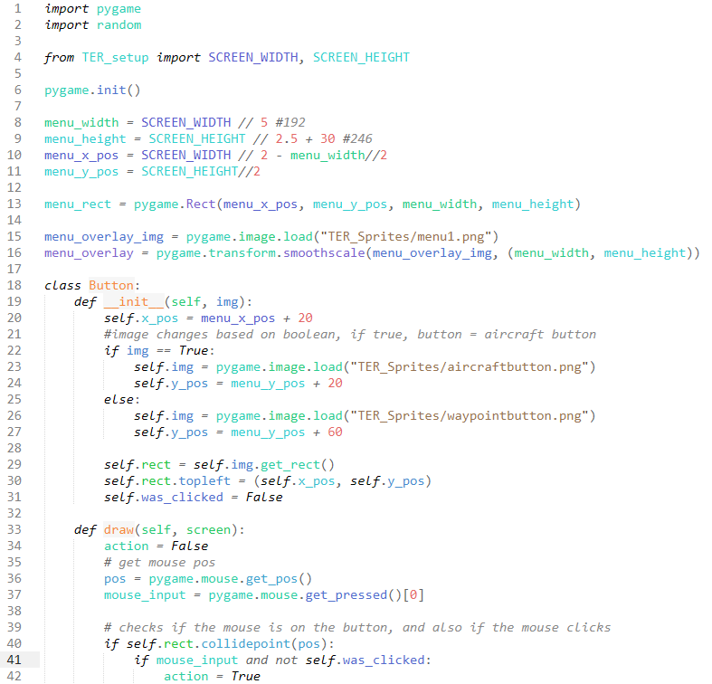

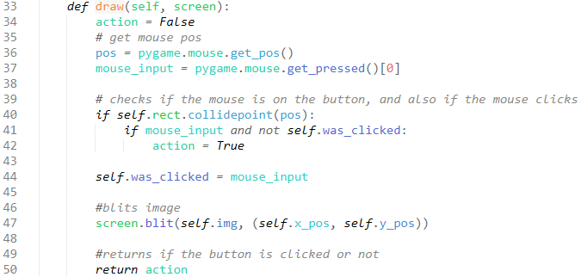

### TER_lights.py

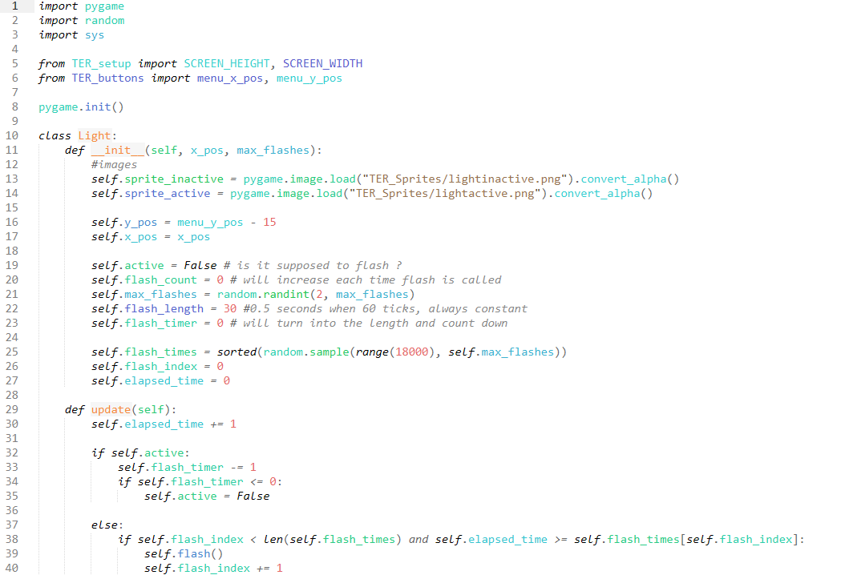

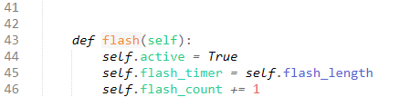

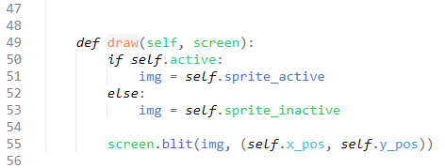

### TER_main.py

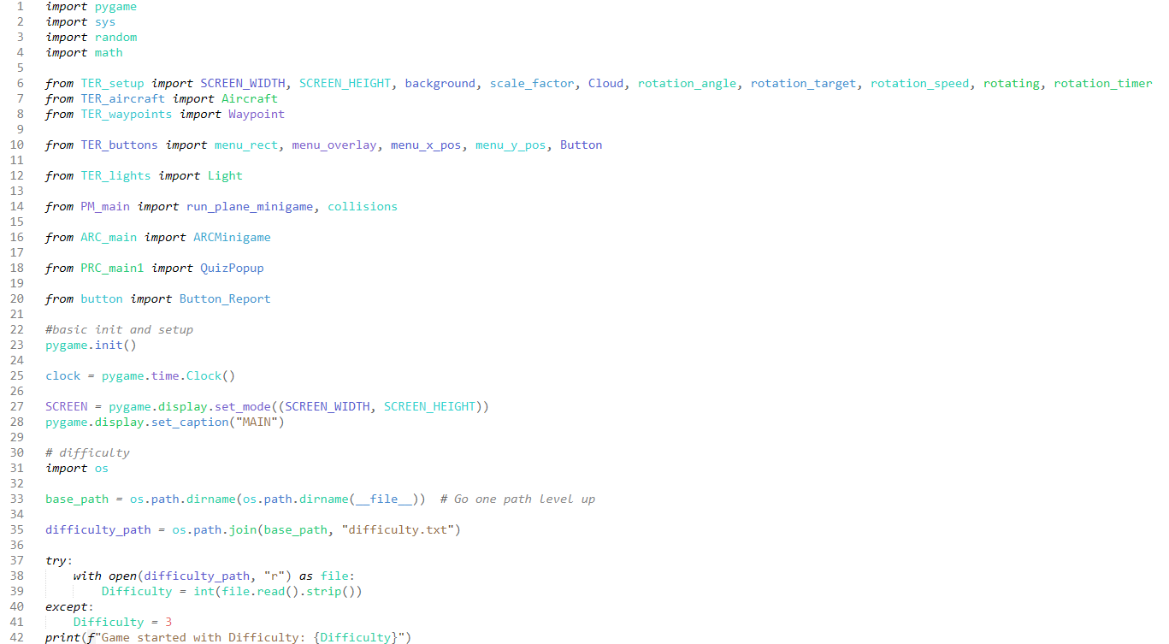

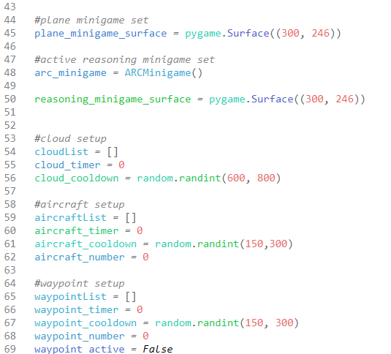

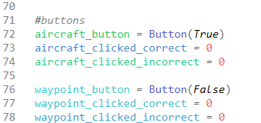

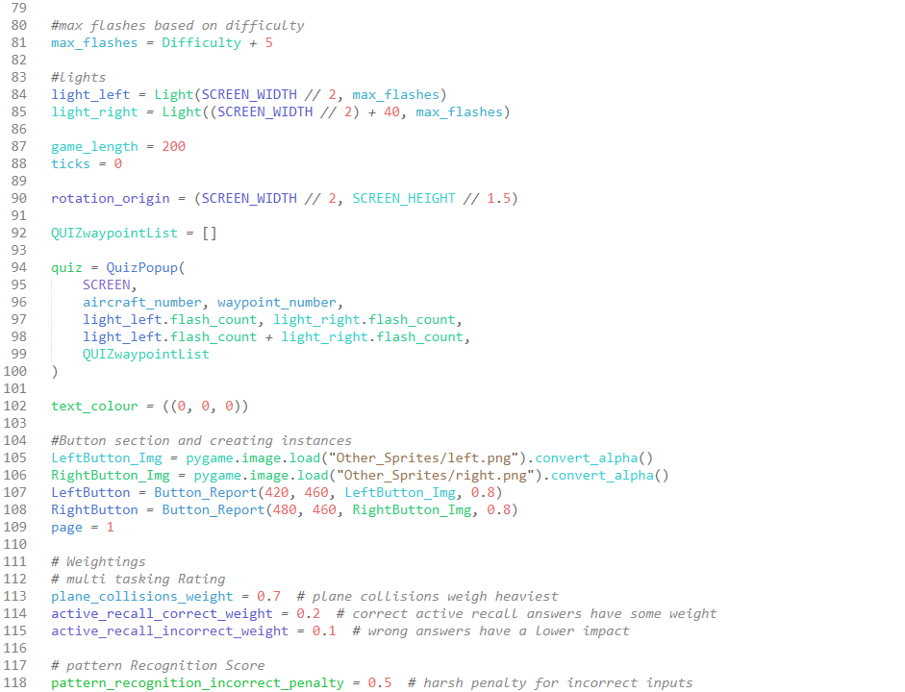

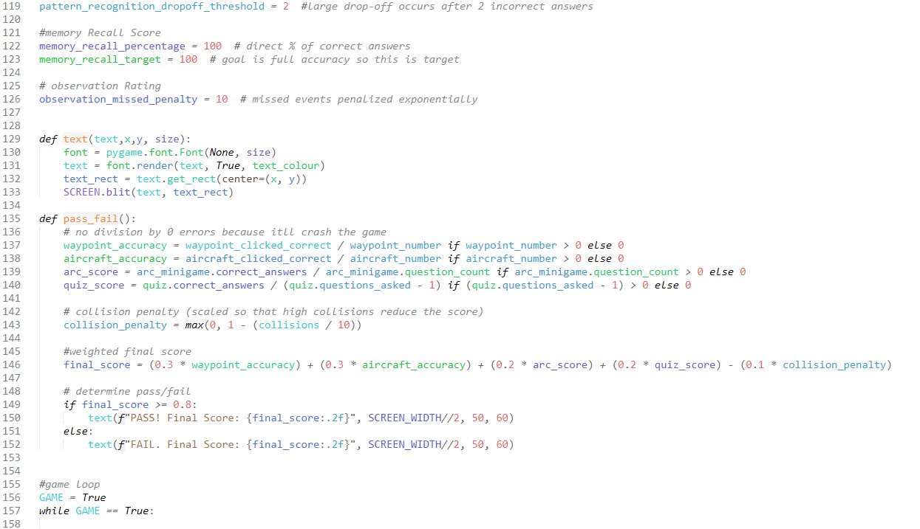

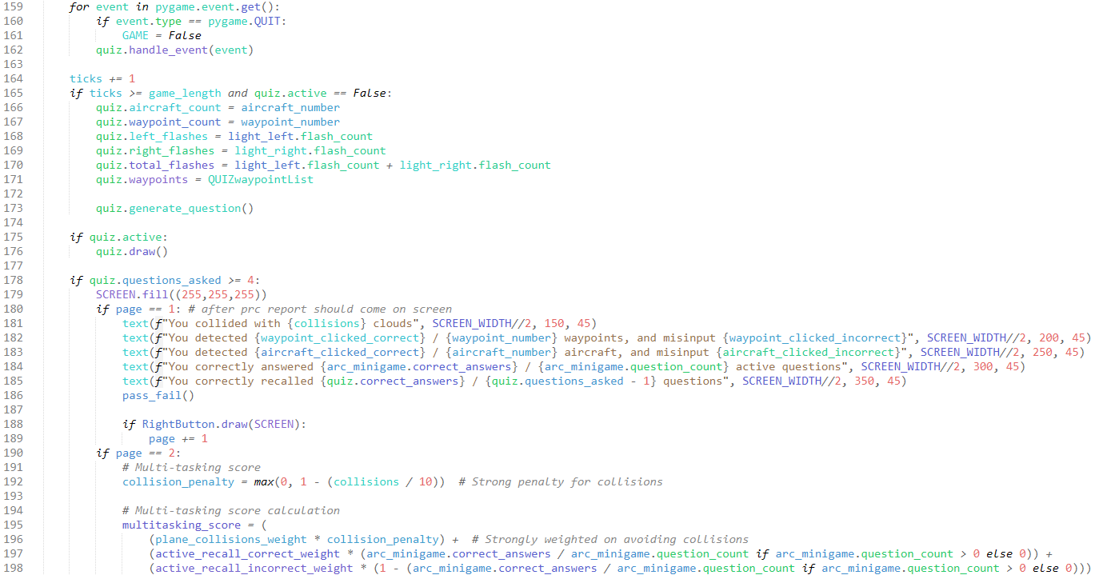

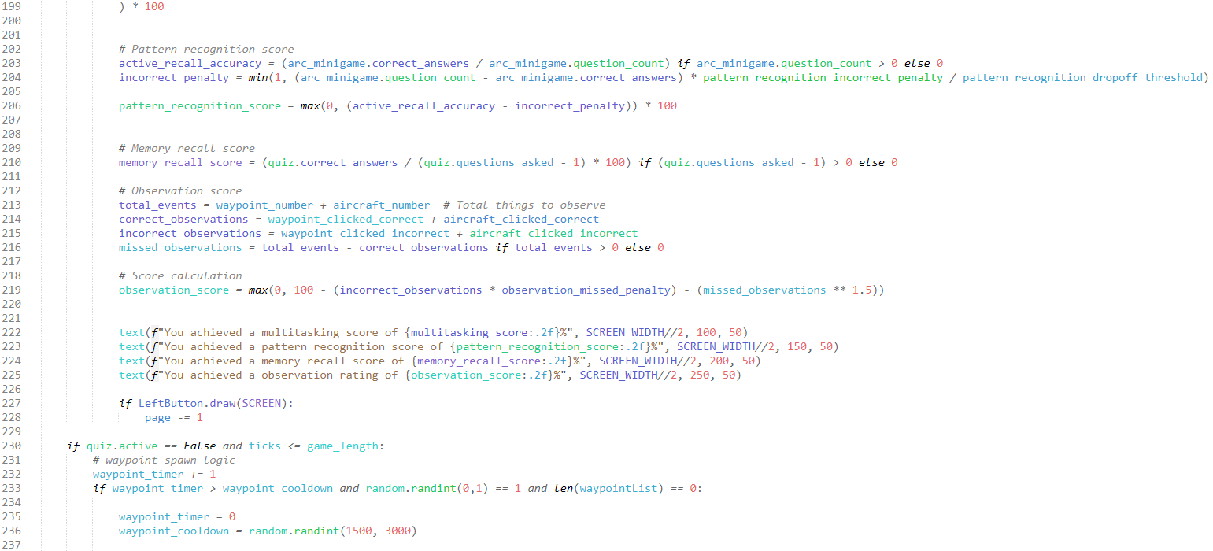

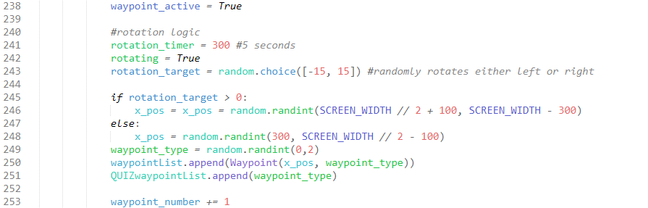

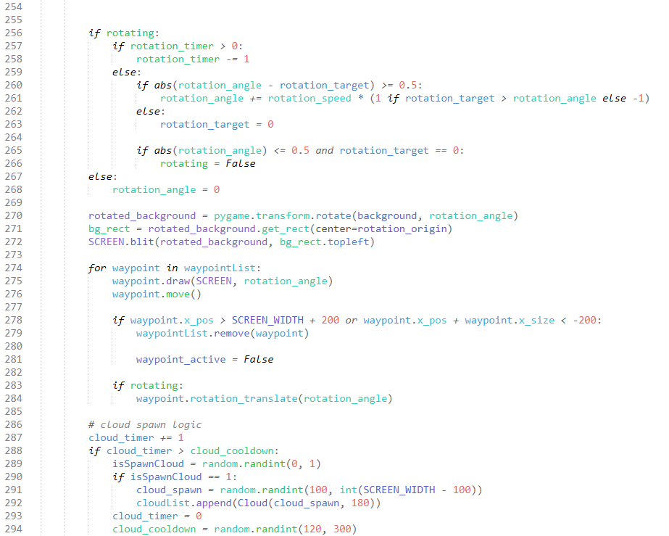

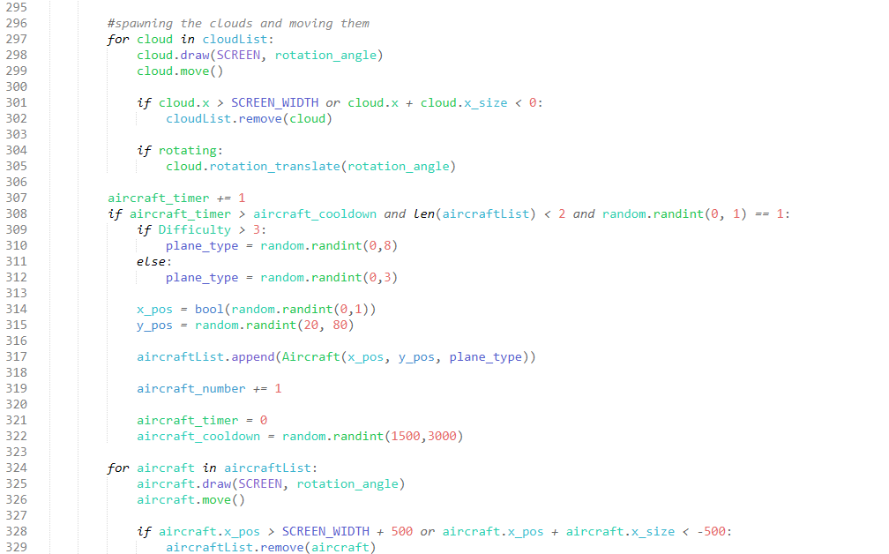  
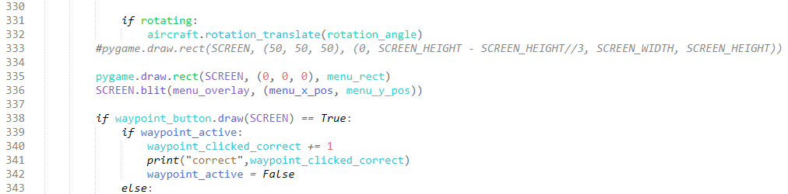

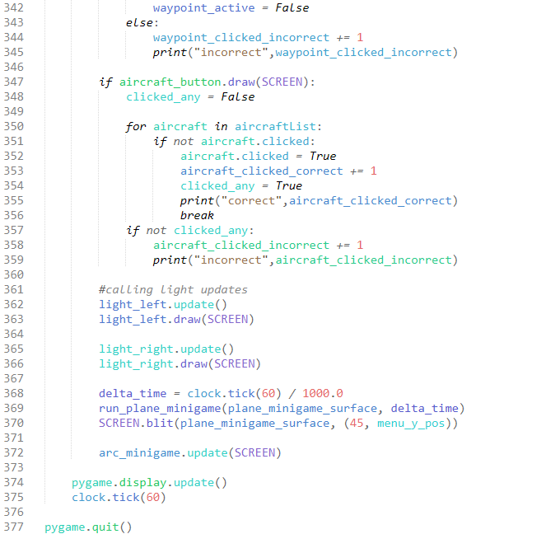

### TER_setup.py

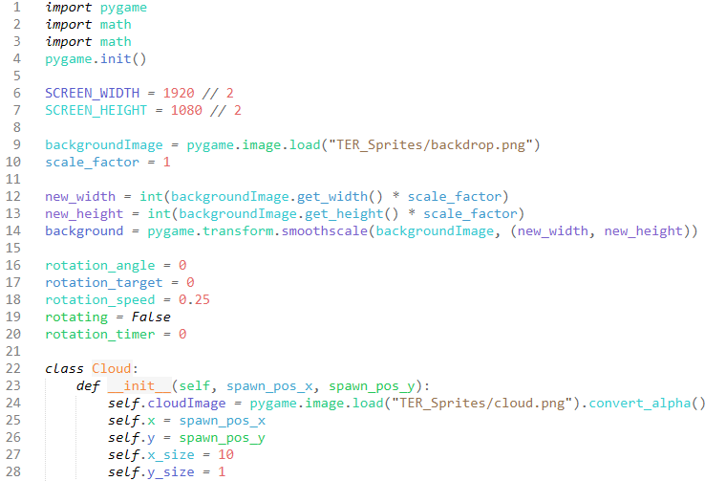

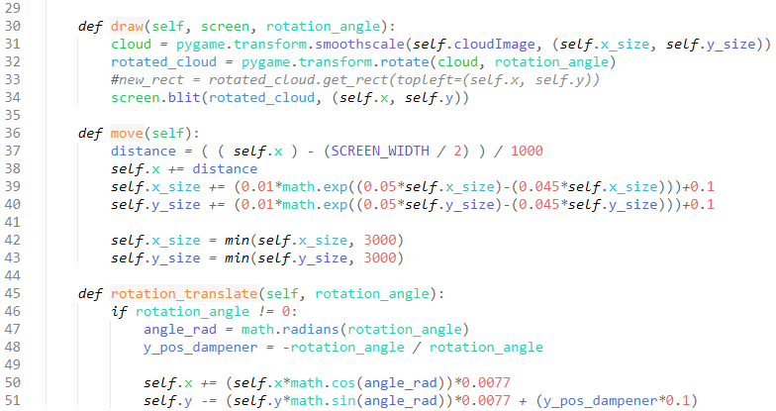

### TER_waypoints.py

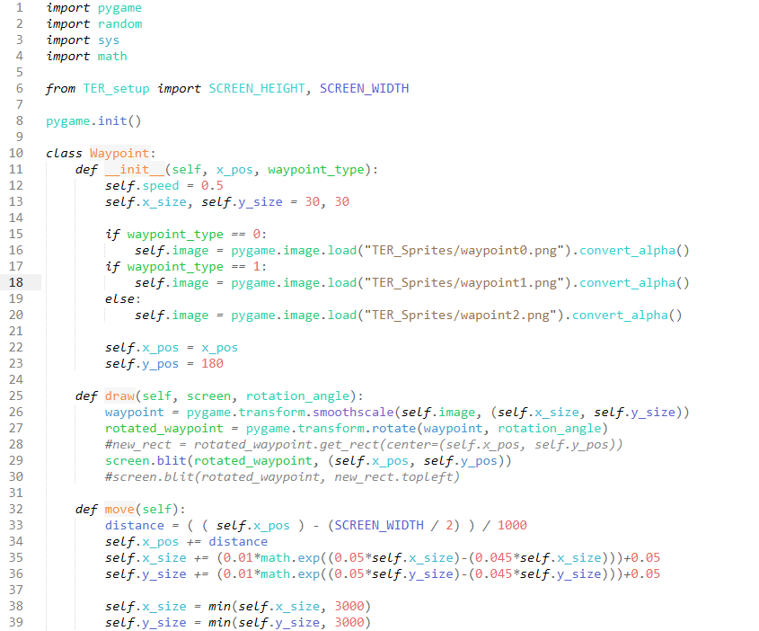

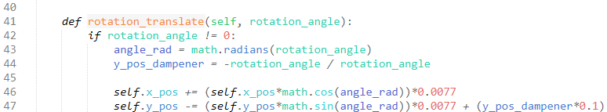

## Difficulty / GUI

### button.py

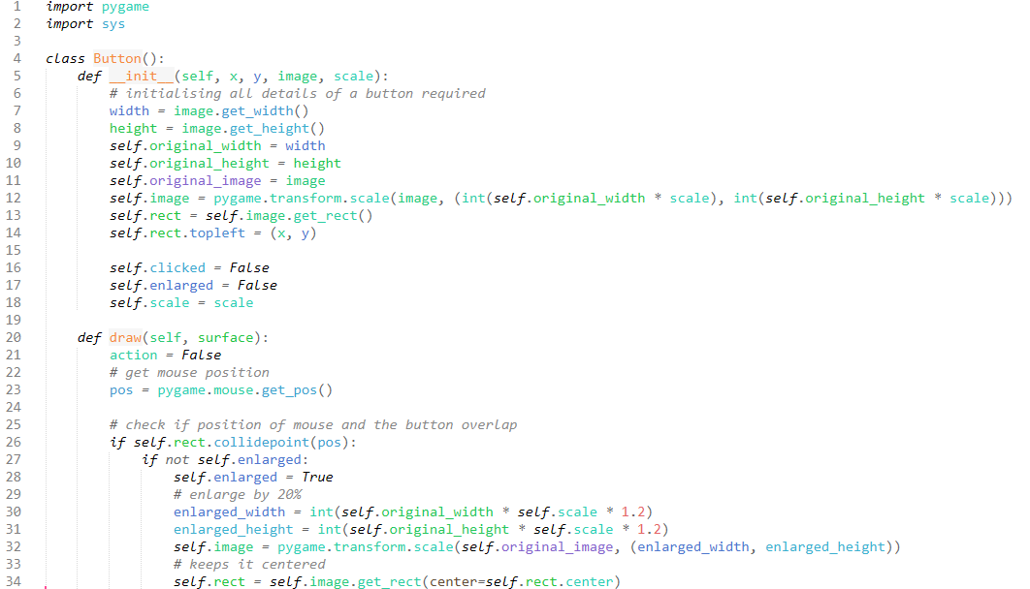

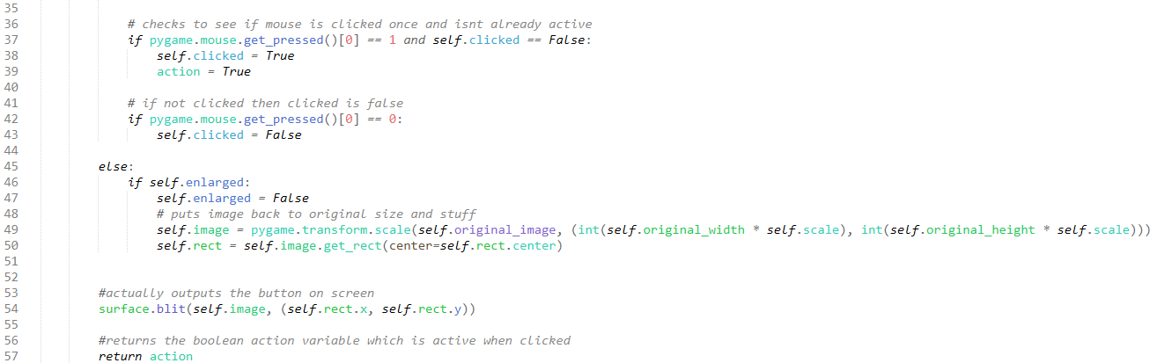

### DifficultyMain.py

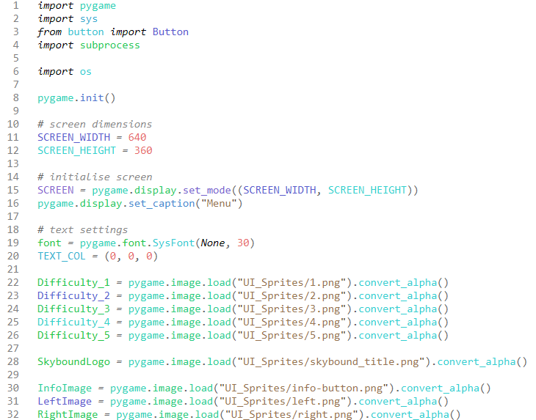

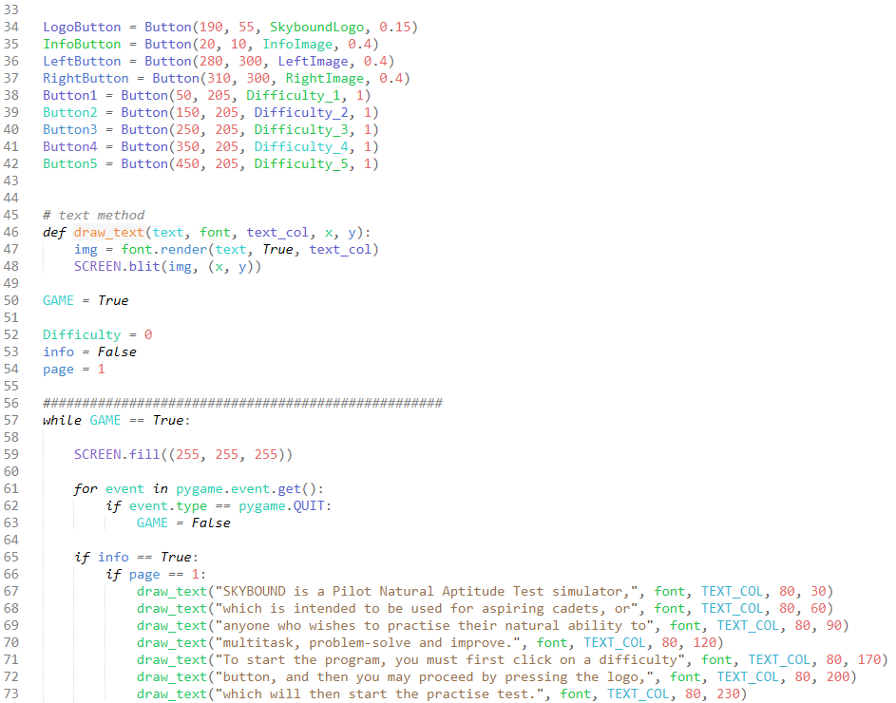

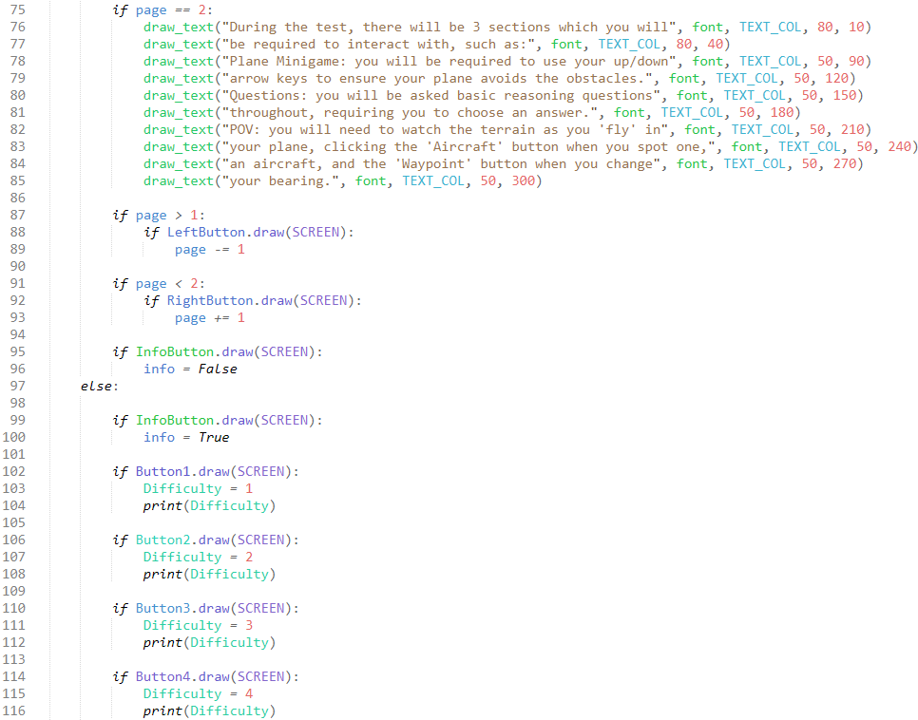

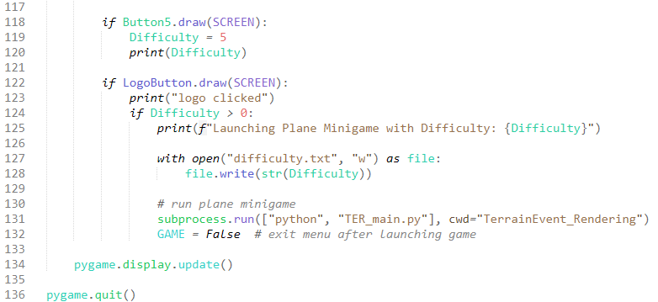

## File Organization

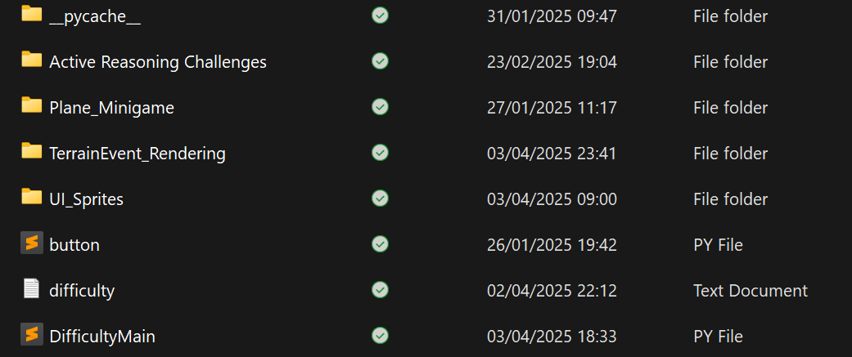

### __pycache__

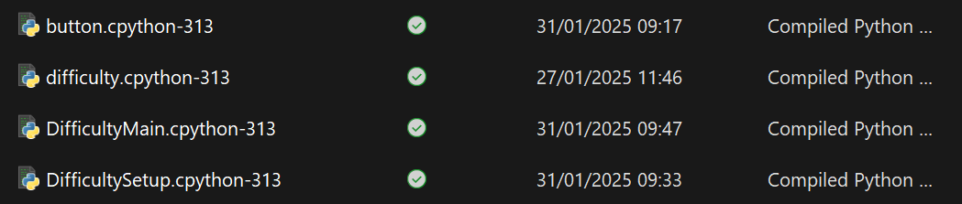

### Active Reasoning Challenges

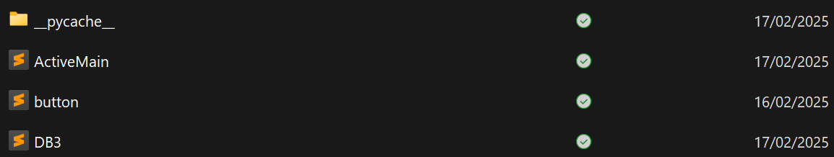

### Plane_Minigame

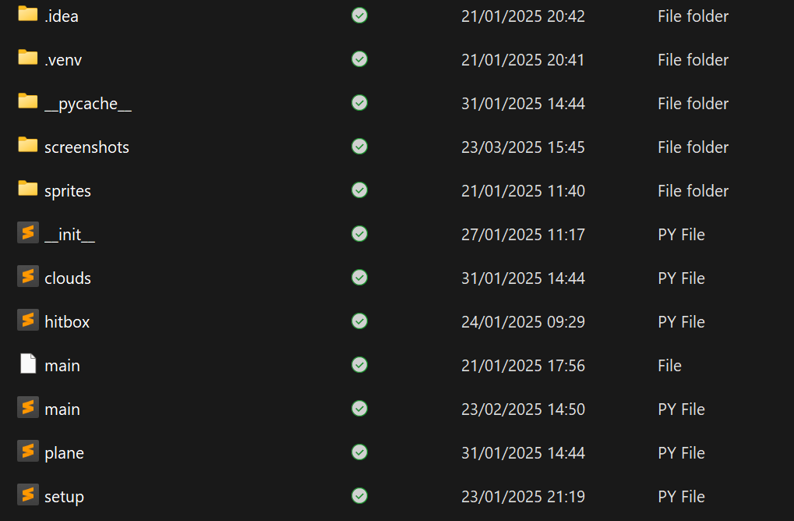

#### Sprites

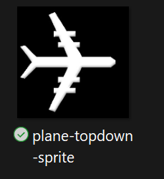

### TerrainEvent_Rendering

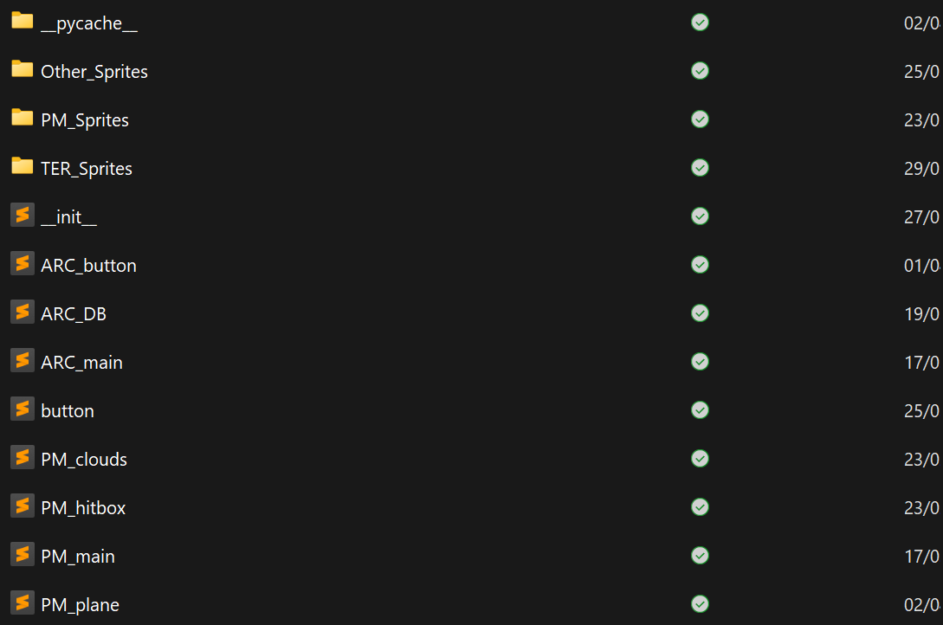

#### Other_Sprites

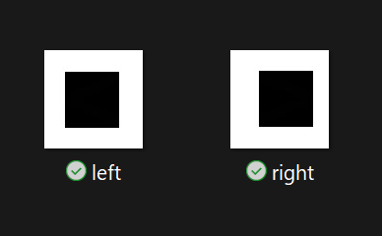

#### PM_Sprites

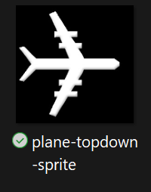

#### TER_Sprites

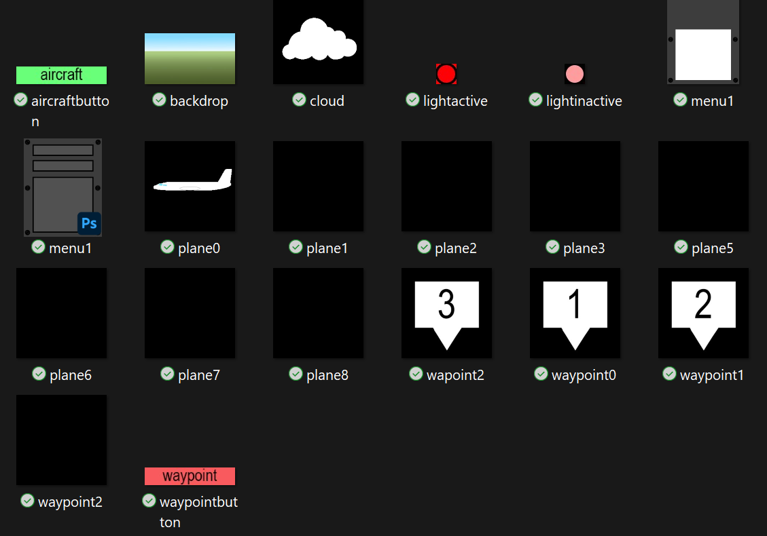

### UI_Sprites

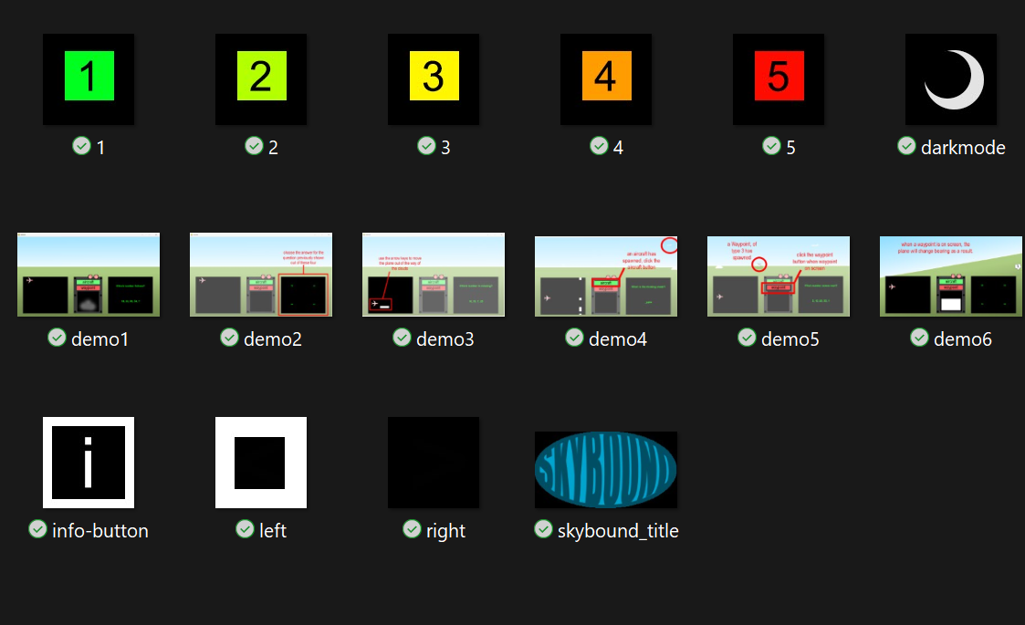

All referenced and evidenced files have been purposefully created and either used for the final implementation, or used to solve the challenges iteratively. Other files have been created automatically as a result of the programming. All image files have been created by me in Adobe Photoshop 2024, with no use of external images.

# Bibliography

ChatGPT. (2025, April 4). *ChatGPT*. Retrieved from ChatGPT: https://chatgpt.com

CodingWithRuss. (2022, May 25). *How to Create a Menu in Pygame*. Retrieved from YouTube: https://www.youtube.com/watch?v=2iyx8_elcYg&ab_channel=CodingWithRuss to help me

Tech, M. R. (2020, August 9). *Pygame Tutorial - Part 11 - Hitboxes*. Retrieved from Youtube: https://www.youtube.com/watch?v=4BURZ5WTIKg&ab_channel=MaxRohowsky%28MaxonTech%29